Re-education – background notes

A good deal of information about the camps comes from reports about visits to review ‘re-education’.

The word ‘re-education’ was disliked by many as sounding condescending – maybe even a little sinister. In practice, it was quite harmless and conducted with positive intent.

Even at the start of the war it was recognised that many pows – Germans in particular - would need some form of re-education. Adolf Hitler had seized power in January 1933 – many German troops had grown-up under the Nazi dictatorship and been subjected to years of Nazi propaganda and training in youth organisations, most obviously the Hitler Youth (Hitlerjugend) which had existed well before 1933. Interrogations of the first German pows confirmed this need:

“The prisoners arriving straight out of Nazi Germany betray so clearly the effect of their intensive Nazi training and their isolation of recent years from the rest of Europe that it becomes evident that, sooner or later, some sort of political re-education of these German prisoners will have to be seriously considered as part of the preparation for the ultimate settlement of Europe.”

[Memorandum by the Secretary of State for Foreign Affairs, Anthony Eden, 18 December 1939, WP(G)(39)157]

Overall responsibility for re-education was passed around various departments, mainly within the Foreign Office, (though the War Office had administrative responsibility for pows) according to the aims at the time, e.g. there were different aims pre-VE Day to after.

The Special Operations Executive’s propaganda department (SO1) started some re-education work in 1940. They produced plans which included making libraries of selected German and English books, films, and BBC broadcasts, available to pows. This was limited in scope because at that time it was not intended to keep pows within the UK, but to ship them elsewhere.

The Political Warfare Executive (PWE) was formed in August 1941. It reported on its work with pows to the Prisoner of War Department (POWD) of the Foreign Office. It became increasingly involved with the re-education of pows, amongst many other areas. This included the re-education of Axis pows held in India, the Middle East, and by liaison with Canada.

The focus of re-education was always German pows. There were plans for political re-education for Italians set out in a proposed paper by the PWE in December 1942 – ‘Plan For Political Warfare in Italian P/W Camps’. These were similar to those that were later set for Germans. However, the Italian Armistice made it necessary to reconsider these plans and very little was developed. ‘Home-grown’ activities in Italian camps did occur, but they were not part of the original planned national re-education programme.

After D-day, with many thousands of German pows arriving in the UK, re-education gained importance, though it was limited by a lack of trained personnel and resources, (e.g. paper rationing). The Cabinet requested that the PWE, through the POWD, take formal control of the re-education of German pows on 18 September 1944.

In December 1945 a leaflet was sent to camp commandants outlining the goals for re-education:

1. To eradicate from the minds of the prisoners, belief in the military tradition and the National Socialist ideology, of which the basis is that might is right and that the necessity of the state knows no law.

2. To impart to the prisoners an accurate understanding and a just appreciation of the principles of democratic government and their implications for the conduct of men and nations; in particular, to encourage the application of democratic principles to German conditions as a basis for the peaceful re-absorption of Germany into the European Community, which is a vital British interest.

3. To present the British Commonwealth of Nations as an example of a democratic community in action, while avoiding the projection of Britain as a model to be slavishly copied.

4. To remove German misconception about European history of the last 50 years and especially about the origin, conduct and results of the two world wars.

[POWD pamphlet, October 1945].

The POWD developed re-education activities to match these goals through the German Section of the Political Intelligence Department (PID) - and then, from 1946, through the Control Office for Germany and Austria (UK) – (COGA) - which was in turn dissolved in April 1947 and incorporated into the German Section of the FO.

Development of Re-education within the camps. Leaflets and instructions were distributed to the camps and ‘Training Advisers’ (TA) were sent from the POWD to assist in the development of re-education activities.

It is important to note that the camps were not maintained in order to promote re-education, but to hold pows securely, and, especially after the war, to provide an additional labour force. If a commandant did not support re-education, then there would usually be little progress and only meagre provision in the hands of the pows themselves. Few commandants were ‘hands-on’ and actively involved, but it needed their support to allow British staff, often the Interpreter Officers, the time to work with the pows and develop an effective programme. The commandants were appointed by the War Office – and so, even if they did not support the Foreign Office supported activities, they were not removed from their positions.

Camps where re-education was not supported by the commandant, were not necessarily unsuccessful at creating a positive outlook for the pows. Visitors to some camps noted high morale due to pows being treated fairly and with respect by the British staff. Many had a wide range of other activities such as sports, games and entertainment that were not re-education. The employment of pows could also help – with pows commenting about how they had felt more positive about themselves as they worked on farms, as bakers or shoemakers….

Re-education activities mainly concerned providing propaganda to the pows. ‘Propaganda’ was meant in a positive, educative sense, as information to persuade, rather than the negative ‘brain-washing’ sense. The main purposes were seen as;

1. Re-education to change the views of pows who had been brought up under a regime of political violence
and dictatorship to see the opportunities and virtues of democracy.
2. Create positive views about the UK amongst pows before they returned to their homelands.
3. Encourage pows to work in the UK.
4. Combat Nazi influences amongst pows within the camps.

“Such propaganda was of value in assisting to solve the problems of manpower during the period of their captivity…. Secondary results were to exploit a valuable medium of Political Warfare to the enemy, to prevent plans for enemy resurgence being made in Ps/W [prisoner of war] camps, and to influence public opinion favourably to Britain after their return.”

[The Secret History of PWE – David Garnett – St Ermin’s Press - 2002]

Above all, the main purpose of re-education activities was simply to get pows to discuss and consider democratic ideals.

There were only two compulsory activities;

1. All pows had to attend the film made by the US Office for War Information about a German concentration camp.

2. When the Youth Camp (for under-25’s) first opened, many of the first intakes were compulsorily transferred there.

All other re-education activities were optional, and many pows chose not to be involved.

There was a standard list of re-education activities that TAs / inspectors reported on. Each of the activities was linked to a section at the POWD in London; e.g., one section published Wochenpost, another recruited and organised lecturer’s visits… For many of the activities the materials were supplied, but the production of information was largely under the control of the pows, e.g. the paper required for publication of camp magazines was supplied by the POWD, but the content was largely up to the pows. Censorship was certainly used in some instances, but in most cases the pows were free to produce the articles, and hold the discussions that they chose.

The standard list:-
1. Wochenpost / Der Ausblick

A weekly news-sheet was produced – ‘Wochenpost’ – from early 1941. It was sent directly to the camps. During the war years, it was rejected by many pows as enemy propaganda. [A report stated that Wolfgang Rosterg asked for a copy of Wochenpost when he arrived at Comrie Camp 21, and this was one reason why Nazi attention and suspicion was drawn to him, leading to his murder].  During the Summer of 1942, as pows were being shipped to Canada, the Wochenpost became just a single sheet – re-named ‘Lagerpost’. Gradually, and especially when the policy to retain pows within the UK was applied, Wochenpost was revived in late 1944 and attracted pow readers and contributors of articles. For a short while during the Nuremberg trials, the Wochenpost was supplemented by a daily newsletter. The pow paper lasted until Autumn 1948. | 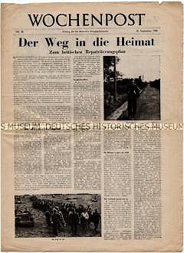
Wochenpost No.10 1945
German Historical Museum
Copies of Wochenpost were issued on the ratio of 1 paper per 6 pows. Editions were also sent to other countries where the British held pows.

For most editions the paper consisted of 8 pages. The first 2 pages covered news items, especially focussing on events in Germany. Articles concerning politics and culture were printed on the next four pages. The final two pages concerned pow news, letters, sports and entertainment.

News items were at first detailed without comment, but by 1946 editorial comment was used as, “a direct projection of democratic thought and life.” [POWD Report, March 1946]. Like any newspaper, the pow readers accepted or rejected commentaries according to their own views.

The Movimento Libera Italia, (an anti-fascist movement) proposed in February 1942 that a newspaper for Italian pows – similar to the German language Wochenpost, should be produced. This idea was supported by the PWE and taken up by the Italian Section of PID.

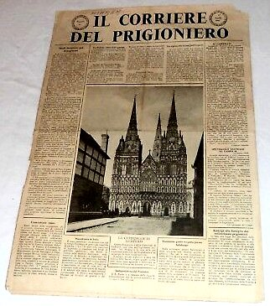
Starting in June 1942, 2000 copies of ‘Il Corriere del Prigioniero’, (The Prisoner’s Courier) was produced as a 4-page experiment. It was issued as a newsletter with official war bulletins – including the enemy’s – without political comment; it also had other news, sports, crosswords and entertainment. It was entirely rejected by Italian fascists, but became popular with other Italian pows. It was expanded to 6-pages and re-named ‘Il Corriere del Sabato’, (The Saturday Courier). After the Italian Armistice the paper became openly anti-fascist in its commentaries. Supporting articles and news were contributed by Italian pows. The paper increased for a while to 8-pages, then as Italian repatriation was steadily underway, it reverted to 4-pages in February 1946. The last publication was in August 1946.

- - - - - - - - - - - - - - - - - - - - - - - - - - - - - - - - - - - - - - - - - - - - - - - - - - - - - - - - - - - - - - - - - - - - - - - - - - - -

Der Ausblick (The Outlook) was a magazine for pows. It was first published by the POWD in March 1945. From September 1945 it was taken over by the American Central Office of Information and also made available in Germany under the title, ‘Neue Auslese’  “Ausblick is a 128 page illustrated digest of good intellectual level containing articles, stories, poems, selected from a wide field.” [Re-education of German Prisoners of War – POWD – December 1945]. | 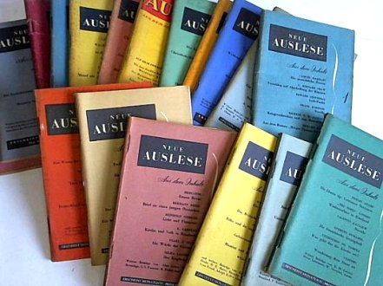
It seems to have had very little impact at all. There are few references to this publication in pow memoires other than it being of a too high standard for many pows.

“Der Ausblick, a high-minded cultural magazine read almost exclusively by the officers…” [From – ‘Trautmann’s Journey’ by Catrine Clay].

2. Newspapers

British and foreign newspapers and periodicals were sent to the camps. Some were provided by the POWD from the end of 1944 onwards, others were purchased through camp Welfare Funds, and others were purchased privately by the pows. Welfare Funds were raised from the profits of sales in the camp canteen.

Most of the popular British newspapers were received. German newspapers were acquired, but often with some difficulty, especially as Germany had been zoned. Swiss newspapers were also popular – for a while limited copies were supplied for free, but after November 1946, due to a currency shortage, pows were required to pay for these papers themselves. Censorship of newspapers from abroad was rare – there was one case of a news magazine from South America being banned.

Distribution of the papers amongst pows, or between camps and hostels, often created problems. Some camps made a display board of selected papers.

Periodicals, magazines and other texts were also sent, e.g. some camps received copies of Hansard.

3. Library

These varied considerably from totally inadequate, to libraries with many 1000’s of books, including German language editions. Most were considered to be ‘adequate’. Officers’ camp libraries were well stocked – e.g. Crewe Hall, 1946: Library – 2,186 books – 852 in English / 1,185 in German / 149 in French.

Books were supplied mainly by the Literature Section of POWD, (they also reviewed and if necessary censored books from other sources), YMCA and the ICRC (International Red Cross). Switzerland sent a large supply of books and gave 30,000 Swiss francs to purchase books and pay for lecturers. Members of the public also donated books.

Problems arose with repatriated pows taking books with them, and books falling into disrepair from being passed round.

4. Films

The compulsory showing of the film about a German concentration camp was often met with extreme reactions – from shame and horror, to outright derision. In interviews conducted after the film, most pows claimed to have been unaware of the camps. In some camps, after watching the film, statements were issued condemning Nazi atrocities - in others it was claimed that the film had been faked.

The YMCA were the first to show films, mainly entertainment, to Italian and German pows from the early 1940’s. A small charge was made to cover expenses.

The POWD sent documentary films to the camps from August 1945. These films had free admission.

Rank Film Company and then the Travelling Film Company supplied some films, but higher charges for hiring their films limited this.

Although some camps had their own film projectors, most required the equipment and films to be transported to them, and there were often transport difficulties. Some German language films as well as British and American films were shown.

5. Visiting Lectures

The quality of these varied greatly. Many of the lecturers were German refugees – others were mainly German speaking British and Swiss. There was an attempt to introduce some English language lectures, but these failed. Popular lectures included talks given by those who had recently visited Germany, or those discussing the future of Germany. Titles from one camp included:

‘Modern German Literature’
‘1848 and Karl Marx’
‘Family Life in Britain and Germany’
‘The German Peasant War’
‘Current Affairs’
‘The Women’s Position and Duty’ (Given by Miss Struitdaln, one of the few female lecturers).
‘German Universities’

Problems arose with poor administration – lecturers turning up unexpectedly, no transport… and from the time of the year, e.g. lectures during harvest when pows were working exceptionally long hours were not generally appreciated.

Some lecturers were clearly not suited for the task. They were given very short tours of camps, and were not asked back again. However, some were exceptional and were in very high demand.

Reports were submitted after each lecture, supposedly by the commandant, but more often by one of the other British staff. There were cases of commandants objecting to lectures for either content or quality.

Lecturers were also expected to give a report about the reception of their talks – many went further than this and raised issues about the camps themselves.

6. Wireless

From April 1945 to February 1947, camps could use £25 from the POWD to purchase a wireless set. By VE day, most camps had wireless sets that could receive German Stations as well as the BBC.

Reception of broadcasts varied according to the location of the camp and quality of the equipment. At first access was under the guards’ control, but after the war in many camps the wireless was located in the pow Camp Leader’s office. Some had loudspeakers and microphone systems to broadcast throughout the camp, (e.g. Camp 23 Sudbury which was able to transmit to various compounds).

When pows were sent to the UK from the USA some brought their own radio sets which they had purchased in the States.

The BBC broadcast seven weekly Prisoner of War programmes – see notes for ‘The Ascot-Brondesbury Scheme’ under Camp 32.

7. Discussion groups

These were established where there were pows capable of leading them. Some thrived until a leader was repatriated. Discussions most often centred on the news. There were also pamphlets sent to the camps by the POWD to suggest titles – e.g. ‘National Socialism and Germany’. These were supplemented by a wider range of pamphlets for discussion groups and study groups on a wide range of interests such as health, farming, the place of women in society….

8. Exhibitions

These were held in huts often used as information or reading rooms in some camps. Exhibitions of text and pictures supplied by the POWD could be sent to the camp for display - titles included; ‘The British Parliament’ – ‘Rebuilding Germany’. Some of the materials were produced by pows at Brondesbury Camp 32, the same place where pow radio broadcasts were created. Materials were also sent to British pow camps in other countries.

A few camps organised their own exhibitions, usually if one of the pows had attended a course at the special training centre at Wilton Park.

9. Camp magazine

Highly varied – some only lasted for one or two print runs - others were of such high quality that additional copies were printed for circulation to other camps. So much depended on the editor and his team.

The main problems were; quantity of material to print if fellow pows did not submit articles; quality of the articles; turnover of pow editorial staff; printing equipment; paper supplies.

In most cases censorship was not required, though some problems did arise with internal censorship. One commandant insisted on approving every article in advance, but this was rare. Content was sometimes politically dubious with complaints raised against British pow policy, or with a Nazi or Communist outlook – a visit from a Training Assistant often followed up on this content.

10. Press reviews

Sometimes held as small discussion groups where the news was read out and the audience gave comments. At other times, selected newspaper articles would be displayed on walls, some with comments.

11. External Links and Visits

During the war and up to late 1946, fraternisation of civilians with pows was illegal. As restrictions were eased, links and visits were added on to the standard list of re-education activities. Problems of providing transport, and from petrol rationing, often limited visits.

Small groups were organised to visit official local agencies such as Council offices, sometimes even to attend meetings. Links were forged through organisations such as the YMCA, Toc-H, and Quaker groups.

Education links were made with local secondary schools and with higher education such as Cambridge University.

Of all the activities, contact with local citizens was the most commented on by pows – nearly always positively. To be welcomed into the homes of ordinary people had a lasting effect on many pows – many continued to keep contact even after their repatriation.

There was some resistance to the idea of hosting pows. In one area the bus drivers with the United Counties Omnibus Co. refused to carry any pows from local camps around Northamptonshire.

12. English Language Instruction  POWD formed an English Teaching Section in February 1945 and instruction was usually reported on separate pre-set report sheets by one of its 11 English Inspectors. When visiting a camp, apart from reporting on the arrangements for teaching, the inspectors also gave brief details of pow teachers, gave lectures, and set exams.  Texts were sent to the camps by the POWD, though some pows bought their own materials to study. Popular texts included ‘GOS’ –a language study method.  [GOS = Gaspey-Otto-Sauer, three contributors to the original texts - Professor Thomas William Gaspey (1819-1872), the revolutionary Emil Otto (1813-1878) and the Schoolmaster Karl Marquard Sauer (1827-1896)].  English Diplomas were recognised in the British Zone of Germany. | 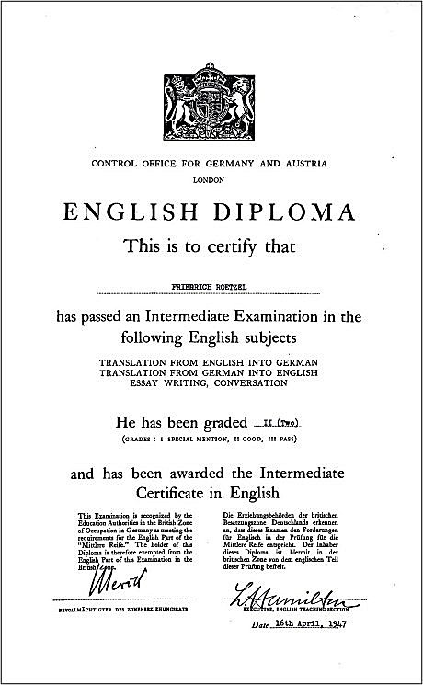

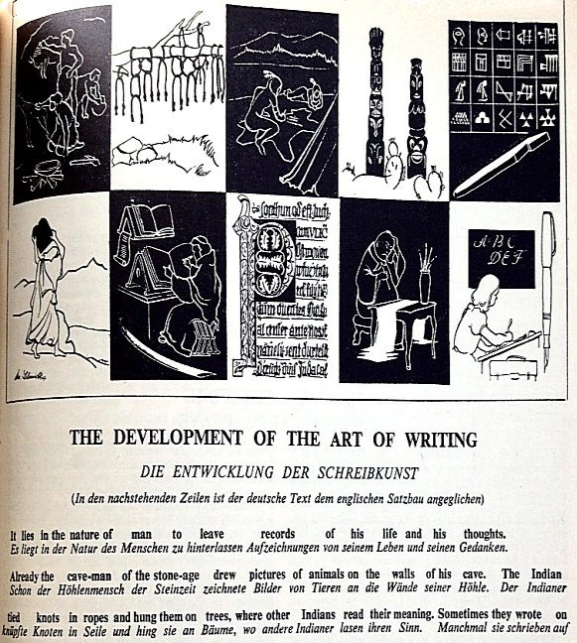 | < English For All – was a 16-page periodical first produced in April 1946 by the English language section of PID.  Short articles were written in English and German, or just English, on popular subjects.  The publication was popular for pows learning English and 40,000 copies were printed monthly. It later went on sale in Germany up to 1948.  Re-education training courses held at Special Training Camps.  In January 1946, Camp 20 at Wilton Park which had been used as the Combined Services Detailed Interrogation Centre, became Camp 300, a special re-education training centre. The centre held six-week courses with an emphasis on developing democratic principles for pows. It was hoped that the pows would return to their camps and develop activities – and later,
when repatriated, they would be a positive influence for democracy. By the time it closed in 1948, 4000 pows and 500 German civilians had participated in the courses.

(Youth = Under-25)

Studies by SHAEF and the PWE reported that Nazi ideas were strong with many Germans under the age of 25. It was recognised that this age-group was unlikely to be swayed merely by the standard re-education activities and needed greater personal contact and role-models. A proposal made in October 1945 (“Suggestions for the Political Re-education of Young German Prisoners of War”, 22 October 1945, FO 371/46744) led to some camps creating separate areas or hostels for youth pows led by older, trusted pows. The report also suggested that a separate camp for political re-education should be created. This camp was to have 85% youth pows mainly B / C graded, with the rest of the prisoners being older, anti-Nazi teachers and pows working with Training Advisers.

The proposal had a mixed reception with some in the War Office opposing the idea of having a separate camp – while the YMCA and the ICRC supported it.

The Youth Camp 180 at Radwinter was set-up in July 1946. The pows worked as in other camps, except that one day per week was allocated for re-education training lessons. Some courses were standard educational subjects such as geography, history, literature, professional courses…. Some sessions raised political awareness through lectures and discussion. The youth pows had opportunities to visit factories, schools, and local events.

In July 1947 the Youth Camp was transferred to Trumpington. Cambridge University collaborated to provide additional opportunities through its Board of Extra Mural Studies.

Other activities, not regarded as re-education, were also reported on by the camp visitors from POWD - Religion, Education Courses and Entertainment. Sports and games were rarely mentioned and yet many camps established good links with locals through sports.

Reviews of re-education work in camps were mainly carried out by visits from TAs and Camp Inspectors from the PID/COGA. Some reviews were also undertaken by Segregation Officers and English Instruction Inspectors. Occasionally special visits were carried out to review specific problems that arose in a camp.

The quality of the TA reports varied greatly - none would meet any modern standard of inspection. Evidence for statements was rarely given – over-generalised and vague comments were frequent. Pows were often described in terms such as; ‘he is of a good type’, including a few examples where pows were later charged with war crimes. Some reports totally contradicted others, for example at Garswood Camp 50, an Interpreter referred to by one TA as ‘outstanding’, was then described by another as doing ‘more harm than good’.

After a visit, TAs would sometimes advise Commandants on how to develop activities and would issue recommendations. In some instances, there were requests for British or German staff to be urgently replaced as they were unsuitable – but, in a great many cases, there was no follow-up at all.

Visits and reports by Segregation Officers were not directly concerned with re-education, but indirectly their classification of pows according to their politics (A-white / B-grey / C-black) led to pows likely to hinder re-education being removed from some camps and concentrated in others – and to the identification of ‘A’ classified pows who might be used as re-education activists.

WOCHENPOST : LAGERZEITUNG FUR DIE DEUTSCHEN KRIEGSGEFANGENEN IN ENGLAND

WOCHENPOST : LAGERZEITUNG FUR DIE DEUTSCHEN KRIEGSGEFANGENEN IN ENGLAND
How successful was re-education?

Looking at various diaries and histories published by the pows themselves – one activity stands out – contact with local citizens. The other standard activities may get a passing reference – but very few.

There were camps which simply failed the pows – even turning them against democracy and / or the British. They could be badly organised, or with bullying staff, or unfair treatment with blatant enmity. (One Commandant stated he would like to see all of his pows drowned). Re-education was futile in such camps.
Thankfully, from the evidence of Red Cross Inspection reports, POWD visitor reports and testimony by many pows – failing camps were in the minority.

There were some excellent examples of re-education which achieved notable success. Reports from pows in these camps described how their outlook on life changed from being an indoctrinated believer in Nazism, to active workers and influencers for democracy in Germany. For a great many pows it simply allowed time for them to reconsider their own and their nation’s recent history. This was a difficult prospect for many when faced with accounts of the holocaust and their acceptance and support of the system that created it, sometimes with their active participation.

The number of pows who requested to remain in the UK is also evidence for the development of successful positive relationships with pows.

From an analysis of reports made to the POWD by the TA’s:

(1) About 3% of the POW claimed to have acquired in captivity a new, positive philosophy of life.

(2) About 30% considered intolerance, objectivity and esteem for human dignity the basis of their new social attitudes. The word ‘tolerance’ was the commonest new concept among the POW. They were proud of it.

(3) About 20% claimed to have changed their political outlook. For almost all of these men that meant a conclusion in favour of democracy.

(4) About 4% remained faithful to the old National Socialist norms. For these men the re-education efforts were enemy propaganda.

[Figures from; ‘Group Captives’ – Henry Faulk – Chatto & Windus – 1977. Presumably the missing 43% felt no change at all].

