Camp 77 - Annsmuir Camp, Ladybank, Fife

Included in the 1945 ICRC camp list – Labour Camp. 77. Annsmuir Camp, Ladybank, Fife.

1947 Camp list
77(G.W.C.) | Annsmuir Camp, Ladybank, Fife | Sc | Priswar, Ladybank | Ladybank 92 | Ladybank | Lt.Col.D.H.G. McCririck | v/1453/2

Prisoner of War Camps (1939 – 1948) - Project report by Roger J.C. Thomas - English Heritage 2003
OS NGR | Sheet | No. | Name & Location | County | Cond’n | Type 1945 | Comments
 |  | 77 | Annsmuir Camp, Ladybank | Fife |  | German Working Camp | Scotland

Location: NGR NO 310 115. By Annsmuir House. About 1.5 km N of Ladybank; 23 km SE of Perth.  Before the camp: Farmland. Area used for army training camp in 1939 with tented accommodation. The site is alongside the ‘Fife Stop Line’, a second world war anti-invasion defense ‘barrier’.  Pow camp: Building work was completed in December 1942. A ‘Progress Chart’ (below) shows a recreation ground with the comment; ‘Tented Camp Completed 26 VI 42’ this was likely to have been the area used by the pows and Pioneer Corps while constructing the site.  The Pow compound was surrounded by a barbed-wire fence with lookout towers at each corner. There was an area outside of the main compound for guards’ huts and offices. There was a recreation hut, medical centre, detention block, barbers, tailors, sports ground and a canteen.  Listed as an Italian working camp / labour battalion to at least 1945, then a German working camp until 1948.  26 May 1943 - International Red Cross inspection - Italian prisoners, capacity 750.  1943 – List of Italian camps recorded that there were 3 hostels – Cambee (Spelling?); Forgandenny; Blairadam – and soon after a 4th unnamed hostel was added.  May and November 1944 - The camp was listed as an Italian Labour Battalion under the Scottish Command area, (+Pioneer Corps Groups), (WO 32/10737). The pows were ‘co-operators’.  July to December 1945 – The camp changed from an Italian to a German pow camp. The Italians would have been moved to billets or other camps. During the transition, Italian and German pows would have been held separately, either in compounds within the main camp, or in separate hostels. | 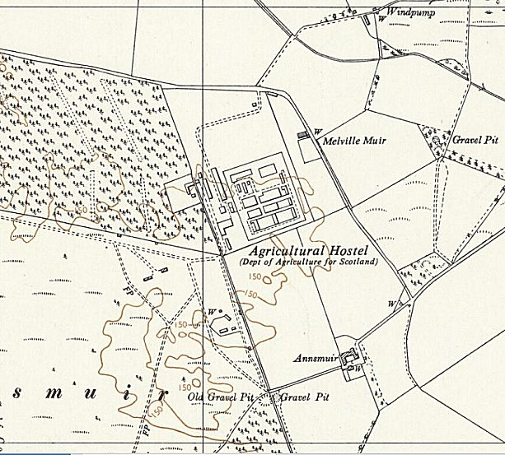
 | Ordnance Survey 1959 The buildings appear as large blocks – the aerial picture below shows the separate huts before this.
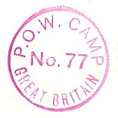
< Postmark in use 1945.

15 August 1945 – A visit was made by Mr James Grant to inspect re-education activities. He began his report by stating that; “This is a rather new camp.” By this I believe he meant it was a new camp for German pows. Facilities for re-education were just starting, but the Commandant Lt.Col McCrerick [sic] was regarded as “keen”.

Some English language classes had begun, and other courses included Russian, Maths, German and history, though there were no text books. There was a Lutheran clergy man – Col.Dűring.  Progress chart dated June / July 1942 by architects ‘Dick Peddie, McKay and Jamieson’ based in Edinburgh. >>>  27 December 1945 – Mr Grant returned for an English Educational Visit for German, not Italian pows. He noted the lack of a suitable library, with just 149 books in the main camp. He stated there were two hostels and others may open for Germans working as agricultural labour.  A note was made that; “There are a number of younger Ps/W who, according to the Camp Leader refuse to go to any lecture as they dismiss them as propaganda.” Political screening does not appear to have been carried out.  Only one hostel is named – Bogside Farm where there were 300 pows.  12 June 1946 – Mr Grant returned for an English Inspection. The political complexion of the camp was ‘grey’.  Total strength 1851 – 790 in the main camp, 868 in 9 hostels, 193 billetees. (Further breakdown in the chart below).  Commandant: Lt.Col D H G McCrerick  Lagersprecher: Hans Bolt. Pol “B”  Interpreter: Staff Sgt Engelmayer  All pows in camps/hostels were accommodated in huts. There was a theatre which could hold an audience of up to 230.  There were two pow English teachers. A request was made for additional teaching books.  10/16 January 1947 – Mr Grant returned.  Total strength 1618 - 694 in main camp, 731 in 8 hostels, 193 billetees.  Commandant remained the same, but no Lagersprecher was recorded. Just one English teacher.  13/17 January 1947 – at much the same time as the previous English report, Mr P H MacDonald visited the camp to make a report on the ‘Progress of re-education.’  Strength 1618 – 3 officers and 1615 other ranks. | 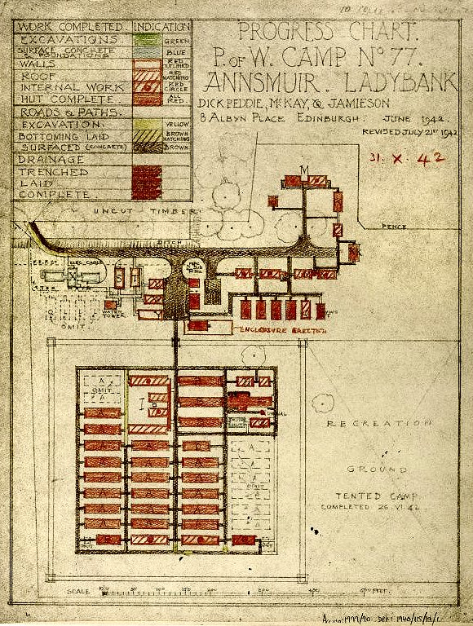
Commandant: Lt Col McCririck Camp leader: Stabswm. Boldt (B)
Interpreter: None Deputy C/L: Wm Praetzas (B regraded B+)
German M/O: Stabsarzt Reichel (B) [Listed by one visitor as ‘straightforward and amiable].
Unterarzt Krecker (C) dentist

Political screening numbers:

A+ | A | A- | B+ | B | B- | C | C+ | Unscreened
- | 7 | - | 55 | 805 | 77 | 208 | 1 | 465

350 pows had been repatriated from this camp to date.

Despite the previous comment that the Commandant was ‘keen’, this inspector recorded; “The Commandant is sceptical of the value of re-education but gave me every assistance during my visit, and good relations have been established for the future.” There was no interpreter and none of the British staff were developing re-education.

Although most of the German staff had been in place since July 1945, it was noted that there were few re-education / cultural activities. The studienleiter, Wm.Kunz (B) was criticised – “He is an opportunist and his superficial enthusiasm allied to his uninspiring character has done persistent harm to progress in this sphere.” It was planned to replace Kunz with two pows, (Uffz.Willi Reincke (B+) and Ogefr.Kurt Humpert (B+)) who had recently attended the Training Centre at Wilton Park.  Despite the lack of re-education activities, morale was regarded as; “…surprisingly good. A high standard of discipline and administration is maintained and Ps.W appreciate the efficiency of the camp and the interest shown by British staff in their welfare.”  Many of the younger pows who had been seen as potential trouble in an earlier report were regraded from C to B. However, there were 50 young Waffen SS in the main camp who still held negative attitudes.  Standard re-education activities were listed, but they were limited:  Newspapers – some received, but not enough.  Library – 1000 books  Lectures – these were being held regularly, but with mixed response.  Discussion Groups – about to start.  Films – Every 3 weeks from YMCA. Gaumont British visited, but with a charge of 12/6 (12 shillings and 6 pence) + 6d per man, it was too expensive.  Wireless – one in each dining hall, but few able to receive German stations. | 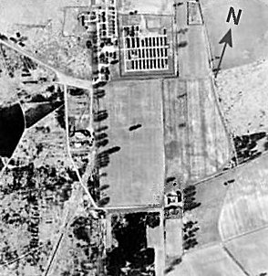
 | 1946 aerial photograph - Camp 77 at top.
Camp magazine – 200 copies of ‘Querschnitt’ (Profile) produced by 1 man, but ‘potentially very good’.
Press reviews – only in 3 hostels.
English instruction – being inspected
Information room – none.

Other activities:
Religion – 1 Roman Catholic and 1 Protestant padres.
Education – Apart from English language, very limited especially in the hostels – Stenography, philosophy and French.
The main camp had a theatre hut, chapel, and a lecture room. There was a small orchestra.

17/18/19 May 1947 – English Inspector’s Report by Mr James Grant. Strength 1720, including 778 pows in 7 hostels.

There was a new Commandant – Lt Col W R Flemming, MC. The camp leader was the same as before.

There was surprise that one of the pow teachers was regraded as C+ and transferred to Camp 165 Watten – but no further details given.

24-27 June 1947. Re-education survey carried out by S Denham Jacobs. Strength 1546 – 2 officers, 1544 ORs.

Commandant as before. Camp leader: Ofw. [Wilhelm] Geier (B)
Interpreter: Sgt Frey German M.O.: S/Arzt Reichel (A)

Screening figures: | A | B+ | B | B-
 | 12 | 164 | 1051 | 319

753 pows had been repatriated to date.

The new camp leader was regarded as; “not sure of himself and timid in the use of authority; but he has the solid support of the older and more sober-minded P.W. and there has been no trouble from a recent large intake from 165 camp.” (Watten)

The protestant padre O/Pfarrer Doering (A) was regarded as; “a fine character who has been here since the camp’s inception” – [i.e. inception as a German Camp]. The padre however was due to be transferred.

The Study Leader Schur (B); “is a doctor of law. He edits the camp newspaper and although inclined to be academic has good ideas. He is recommended for the Training Centre.”

Morale was generally good except in two hostels, see below. 40% of the pows were ‘youths’ (under-25), including 120 ex C+ political category. They were seen to have made good political progress and only a few clung on to the ‘old ideas’.

Standard re-education activities had developed a little more:
Newspapers – range of British papers, no German papers other than Wochenpost.
Library – 1550 books [In the next report this was corrected to 850, as copies of teaching books had been included here].
Lectures / Discussion Groups / Films / Press Reviews – regular.
Wireless – “The position is adequate, but sets are used for entertainment rather than re-education.” [Can’t blame them].
Camp Magazine – 300 copies per month, the editor wanted to increase this to 500 if paper could be supplied.

Other activities:
Religion – Protestant Padre again mentioned as being, “an immense influence for good”.
Education – French classes in the main camp and Bookkeeping at the Bogside Hostel.
Entertainment – Bogside had a cabaret group.

Outside contacts had been established with St Andrews University and Lathokar Hostel; possible contacts being made with Fife Council.

Between June / September 1947 – Dunino satellite camp and four hostels were added to Annsmuir camp.

30 September – 10 October 1947 – Mr Denham Jacobs returned for another Re-education Survey. Strength 2483 – 3 officers, 2480 other ranks.

The only change in the senior personnel was a Deputy Camp leader – Oscha.Rustlet (B-)

1052 pows repatriated to date.

This visitor’s comments were a lot less positive than previous reports – “The C.O. and his officers are co-operative and helpful during a T.A. visit, but it is my experience that proposals and ideas are not followed up. Furthermore the C.O. quoted a letter from Col.Whitbread of Scottish Command on petrol economy, stating that W.D. transport will not be used for P.W. recreation. He was unwilling to see the difference between recreation and re-education and pointed out that in any case his petrol allocation of 300 gals. per month for H.Q., one satellite and 10 hostels was insufficient for the barest essentials. The interpreter is re-educationally useless.” [T.A. = Training Advisor]

This conflict between re-education activities demanded by the Political Intelligence Department and those in charge of the camps is frequently seen in reports. The main task of the Commandants was to supply a pow workforce for the local area – ‘re-education’ was not compulsory and was often seen as an additional burden. In this case the Commandant was not just conflicted with the statement by the Scottish Command, but also on the limited supply of petrol needed to run a camp that was spread over a very wide area. Many of the pow workforce would need transport to their place of work, supplies and mail needed to be distributed from the main camp, etc. It is understandable that the Commandant would not prioritise additional trips for pows, no matter how re-educationally valuable they were.

A large increase in the number of pows was explained in comments about morale and political progress: “There has been considerable deterioration since the last T.A. visit due entirely to the resentment felt by the big intakes from East and South-East England six and seven months ago…. [This must have been to Dunino Satellite and its hostels which were part of Balhary Camp 63 at that time, before they were merged with Annsmuir].
…These Ps.W (circa 1100) refuse to appreciate the difference in farming and living conditions between the fertile parts of England which they know and the relatively infertile parts of Scotland which they are getting to know. They have been accustomed to the easy sociableness of the south and make no attempt to understand the dourness of the Scots. They expect too much and are discontented and sullen when they don’t get it. Besides which most of them have been unemployed since arrival until this week. The hostels affected are Dunino, The Beeches, Auchtermuchty and Camilla Loch. H.Q. and the remaining hostels have suffered very little change and morale continues to be fairly good, disturbed only by a few youths.”

A new Protestant Padre had started – Kriegspfarrer Smith. He was not regarded as good as his predecessor, “but in spite of narrowness of outlook he does his work consientiously and well.” The Roman Catholic padre Jamar (B-) was “a shade too ready to bring up his own grievances of B- and repat[riation] delay as P.P. [Protected Personnel]; but he has a Christian sense of duty towards his fellow Ps/W here and towards youth in the future.”

The standard list of re-education activities was given, but it was considered that re-education in general had been very bady damaged due to the new influx of pows.

30 October / 1 November 1947 – English Inspector’s report by A Robinson. Strength 2168 in Main camp, 11 hostels and billets.

The Commandant and Camp leader were the same.

The petrol shortage meant the Inspector only visited the main camp and The Beeches hostel. English teachers were asked to come to the main camp using ration trucks, but only three turned up to report. There was little English teaching at the main camp or the hostels.

14 November 1947 - Camp number included in an ‘Urgent Memorandum’ (FO 939/270) regarding inspection of food parcels.

1-11 December 1947 – Mr Denham Jacobs returned for a third visit to inspect re-education. Strength 1617 – 3 officers and 1614 other ranks.

There had been a large decrease in pow numbers, mainly from Dunino camp which was being wound down.

Commandant: Lt Col Fleming M.C. Camp leader: Osvha. Rustler (B-) – “a fine, straightforward young man with sound ideas, and is respected by everybody”.
Interpreter: S/Sgt Frey Study leader: Oscha. Mattner (B-) – “a lively intelligence and was given a good report by the Training Centre.” *
German M/O: Stabsarzt Reichel (A)

* Mattner was actually a suspected war criminal - see further notes below and under Forgandenny hostel.

1359 pows had been repatriated to date.

The Inspector’s view was much the same as before, “The C.O. possesses a certain amount of inertia which is difficult to overcome, but once he can be persuaded to take action in a certain direction he is fully co-operative. His difficulty all along has been the instability of the camp, first of all due to the large intakes during the late summer and secondly to the rapid rundown.” However, the general comments gave a more positive image:

“The attitude of the C.O. towards the Ps/W under his command, his efforts on their behalf and his interest in their welfare (he holds a weekly question hour) have helped to raise morale considerably, and most Ps/W have now recovered from disappointment of being transferred from southern England.”

“The C.O. is the only member of the British staff who co-operates, [with re-education] and then only under pressure.”

The Inspector had not changed his view of the Interpreter: “…good as such, but is totally devoid of ideas and interest.”

Morale was regarded as being mixed. Positive factors included being able to work and to take Christmas leave. Negative aspects derived from; “…a deep-rooted tiredness of P/W life and dull resentment, even among those who knew quite well that they will be worse off in Germany; the result is an apathy which is difficult to combat.”

The political complexion of the camp was seen to have improved, and anti-British feeling declined, although still present in some.

“Ps/W are now convinced that partition of Germany into East and West is inevitable and hatred of Russia is increasing steadily. There is no evidence of Communism, but I am convinced that several loudly vocal anti-Communists with homes in the Russian zone have already decided to swim with the tide.
Belief in the efficiency of totalitarianism is very much alive, and many Ps/W put the point of view that political parties in Germany will only squabble and get nowhere…”

The already limited re-education activities were in further decline. This was stated to be mainly due to the nature of the camp with regular changes of pows. The library had improved with 1300 books. The camp magazine had stopped when the previous editor attended the Training Centre (Wilton Park) – it was hoped to restart under a new editor. Some outside contacts had been made for the main camp and hostels.

Entertainments were mentioned in this report; “The camp band is good and has the C.O.’s full support. Light concerts are given at HQ and occasionally in hostels as transport permits.” As with other reports, activities such as sports and games, were not mentioned though they would have played a major part in many of the pow’s lives.

2-6 February 1948 – Final Re-educational Survey by S Denham Jacobs. Strength 767 – 3 officers and 764 other ranks. Main + three hostels & billetees.

Commandant: Lt Col Fleming M.C. Camp leader: Bernhard
Interpreter: S/Sgt Deutsch German M/O: Stabsarzt Reichel (A)

The new interpreter was regarded as “an intelligent and able Viennese; a great improvement on his predecessor.”

The camp was due to close during February, so it is difficult to see why this visit took place. Re-education activities were being ended, there was little to survey. The HQ and four remaining hostels were to be taken over by Balhary camp 63.

“128 Ps/W are being civilianized for the former hostels at Auchtermuchty, Dunning and Lathockar”.

Although morale was rising with the nearness of repatriation, there was news that 35 of the pows were to be transferred to Watten Camp 165 as war criminals. Pows were generally apprehensive about their return to Germany. One man in particular is mentioned – “the camp will suffer a severe blow shortly, as Mattner (T.C. and Educ Representative) is to be transferred to 165 Camp on February 12 on Serial No.162 (War Criminals).” Mattner had previously been listed as Camp leader of Forgandenny Hostel.

The final conclusion is even more damning than previous comments:

“The promise of an Indian Summer which was indicated early in December, has been amply fulfilled. Indeed it was the only real blossom time in the camp’s history, if reports by the few remaining original Ps/W [i.e German pows – not the Italians who were here before] are correct, and it took a long time to eradicate the evil traditions of a ruthless C.O. and equally ruthless C/L (the latter appears to have been murdered in Germany).”

[As ‘it took a long time’ this must refer to the previous commandant Lieutenant Colonel McCririck. However, this comment is very much at odds with the January 1947 report which stated – “A high standard of discipline and administration is maintained and Ps.W appreciate the efficiency of the camp and the interest shown by British staff in their welfare.”]

“Democratic institutions only came to be known late in the camp’s life and all along there has been local antipathy to combat, except in the more enlightened centre of St.Andrews, Dunfermline and Perth. I am sure that those Ps/W who have taken the trouble to attend functions in these three old and famous cities will have something worthwhile to put against memories of the dull and irksome pettiness of P/W life in 77 Camp.”

Camp commandants:
? - 1947 Lieutenant Colonel D H G McCririck, from the Somerset Light Infantry.
1947 – 1948: Lieutenant Colonel William Rithet Fleming, MC, from the Royal Scots Fusiliers. Awarded Military Cross and Bar in WW1.

Numbers of pows

 | Open |  |  | With other camps |  |  | Unknown |  |  | Not listed / not open

 | 1943 (Italian) | 12/1945 | 6/1946 | 1/1947 | 5/1947 | 6/47 | 10/47 | 11/47 | 12/1947 | 2/48
Main | Capacity 750 | ? | 790 | 694 | 761 | 686 | 653 | 658 | 561 | 429
Auchtermuchty |  |  |  |  |  |  | 122 | 104 | 122
BDU Tayport |  |  |  |  |  |  | 22 | 9 | 23
Blair Adam |  | ? | 72 | 63 | 76 | 69 | 70 | 73 | 69
Bogside Farm |  | 300 | 291 | 253 | 311 | 282
Bonnytown |  |  | 93 | 78 | 97 | 83 | 93 | 88 | 92
Camilla (Loch) |  |  | 73 | ** | ** | ** | 55
Crieff |  |  | 42 | 63
CSD Balgowan |  |  |  |  |  |  |  |  | 12 | 30
Dunning |  |  | 68 | 68 | 79 | 67 | 59 | 72 | 77 | 33
Dunino Satellite |  |  |  |  |  |  | 660 | 443 | 25 | 80
Forgandenny |  | ? | 67 | 67 | 68 | 66 | 73 | 71
Halbeath |  |  |  |  |  |  | 213 | 226 | 220
Lathockar |  |  | 68 | 74 | 73 | 63 | 75 | 71 | 63
Myreside |  |  | 64 | 65 | 70 | 68 | 71 | 70 | 85
The Beeches |  |  |  |  |  |  | 202 | 176 | 171 | 130
“Sundries” |  |  |  |  |  | 23 |  |  | 4⁺
Billetees |  | ? | 193 | 193 | 181 | 143 | 115 | 107 | 97 | 65
TOTALS | Actual ? | ? | 1851 | 1618 | 1720 | *1550 | 2483 | 2168 | 1617 | 767
** Camilla not listed and no details given during these months. It could have been closed temporarily, or perhaps transferred to another camp during this time.
⁺ Attached to Balhary Camp 63.

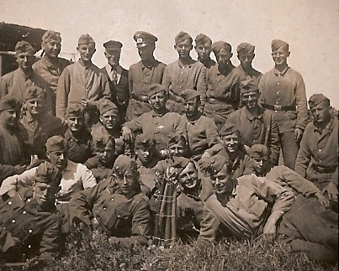
< A group of pows held at Annsmuir, date unknown – and probably a local farmer in the back line.

https://www.geocaching.com/geocache/GC15KVY_fife-stop-line-pow-camp-77?guid=d5235dd4-4ca2-42aa-8171-f9fb64900c01

After the camp: The site was used to house displaced persons, many Polish, and as an Agricultural Hostel. Now a mobile home and caravan park. There is a memorial plaque to the camp at the entrance with the dates for the German Camp of 1945 to 1948 - but no mention of the time Italian pows were held here.

The site today - https://repatriatedlandscape.org/pow-sites-in-scotland/pow-camp-77-annsmuir/

Further information:

National Archives FO 939/157 – 77 Working Camp, Annsmuir Camp, Ladybank, Fifeshire. Dated 1945-1948.

Canmore - http://canmore.org.uk/event/648828

The prisoner-of-war camp is visible on large scale (1:5000) vertical air photographs (106G/UK 1385, 6321-6323, flown 9 April 1946),

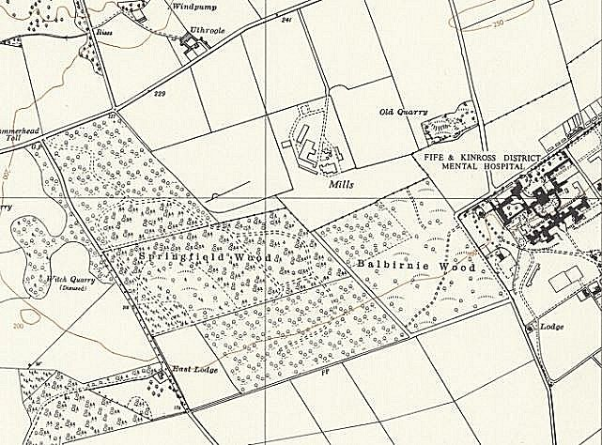 | Balbirnie / Springfield ?  I have seen a reference to pow camps numbered 77 called Balbirnie and Springfield. These were recorded as separate places - 1 in the small town of Balbirnie, the other at Springfield Wood just NE of the village of Springfield.  However, looking at the 1959 OS map, I think these 2 sites were likely to have been the same place. The map shows ‘Springfield Wood’ alongside ‘Balbirnie Wood’ – that seems too much of a coincidence. Springfield Wood is still marked on OS maps – NGR NO 341 128, whereas Balbirnie Wood is not shown. The site is 4km away from Cupar.  This is the right general location for hostels to Annsmuir – however, neither site is listed in the inspection reports from FO 939/157. The reference is vague and suggests that the site was only a possible location for a camp, which was later built at Annsmuir.

Satellite Camp and Hostels

Auchtermuchty, 8 miles from main camp. It is believed that the camp was located at Low Road Park, Auchtermuchty.

No reference in reports prior to October 1947, may have been attached to another camp.

October 1947 Camp leader Uffz.Hechtfisch (B+) – and December 1947

December 1947 contact had been established with Rev Mr Fraser of Bridgend Perth.

 | 1943 | 12/1945 | 6/1946 | 1/1947 | 5/1947 | 6/47 | 10/47 | 11/47 | 12/1947 | 2/48
Auchtermuchty |  |  |  |  |  |  | 122 | 104 | 122

Blair Adam, [also referred to as Blairadam near to Gairneybridge] – 21 miles from main camp.

Hutted camp.

1943 – Italian pows

June 1946 2 teachers of English – Freiderich Műller / Karl Burgert

January 1947 – Camp leader Stfw. Krauss, Walter (B) & June 1947 – “has common sense and the gift of humour and is competent to run a small hostel.”

October 1947 – Camp leader Ofw. Diemer (B).

December 1947 – Camp leader H/Wm. Koenig (B) – “efficient and willing, but rather dull.”

 | 1943 | 12/1945 | 6/1946 | 1/1947 | 5/1947 | 6/47 | 10/47 | 11/47 | 12/1947 | 2/48
Blair Adam |  |  | 72 | 63 | 76 | 69 | 70 | 73 | 69

Bogside Farm – NGR NO 3298 0307 – 14 miles from main camp.  Hutted camp.  300 German pows reported in December 1945.  June 1946 – 3 teachers of English - Paul Műller / Hans Heuser / Kurt Meyer  January 1947 – Hostel leader: Ofw. Kretschmer, Herbert (B). A new studienleiter – Gefr.Schmitz (B).  “Bogside hostel has a group of progressive students, well on the way to a positive democratic outlook, but lacking training. This group infuses an interest in the rest of the hostel.”  Kretschmer still there in June 1947 – in a “fine active hostel.” Despite this, the visitor made a rather strange comment that political progress in this hostel; “causes misgivings because it is close to a rather arrogantly communistic area.”  There was an entertainment group and a large recreation hut. Instruments were borrowed from local citizens for a small band.  1943 12/1945 6/1946 1/1947 5/1947 6/47 10/47 11/47 12/1947 2/48  Bogside Farm 300 291 253 311 282 | 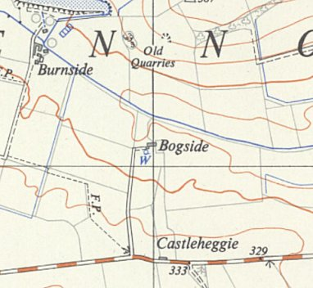
 | Ordnance Survey 1951

Bomb Disposal Unit, Tayport

No further information

 | 1943 | 12/1945 | 6/1946 | 1/1947 | 5/1947 | 6/47 | 10/47 | 11/47 | 12/1947 | 2/48
BDU Tayport |  |  |  |  |  |  | 22 | 9 | 23

Bonnytown, Boarhills – NGR NO 5452 1245  Small hutted camp located just SW of the main farm building shown on the OS map.  Canmore records that Italian pows were held here – this would be before the camp inspection reports starting in June 1946. However, a survey carried out in 2004 * found the buildings (pre-cast concrete huts), but no evidence of Italian pows.  January 1947 – Camp leader Hfw. Engmann, Alfred (B)  June 1947 Camp leader Ofw Zimmermann (B+) – “A teacher by profession he was a Jungdemokrat until 1933 and has later joined the party. He has tact and patience and should be a success”. This C/L had recently been appointed following two others who had caused problems. Same CL in October 1947.  December 1947 – Camp leader Uffz. Schuler (B) – “unhelpful, but no change was made as the hostel will close this month.”  1943 12/1945 6/1946 1/1947 5/1947 6/47 10/47 11/47 12/1947 2/48  Bonnytown 93 78 97 83 93 88 92  https://canmore.org.uk/site/256062/bonnytown-prisoner-of-war-work-camp  Vertical air photograph (106G/Scot/UK5, 4205, flown 14 April 1946). | 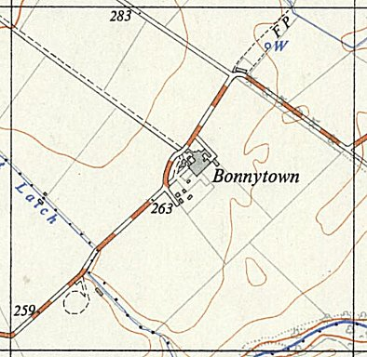
 | Ordnance Survey 1956
* Bowler and Smith, D P and C. (2004) 'Bonnytown POW work camp, Dunino, St Andrews, standing building recording', Discovery Excav Scot, vol. 5, 2004. Page(s): 64

Camilla (Loch) – 25 miles from the main camp. Camilla is located on the edge of the small village of Auchtertool (NT 2151 9090) – the loch is 0.75km to the NE.

Hutted camp.

June 1946 strength 73. Noted in report – “…the hostel was opened for some special construction which was immediately cancelled. They are depressed as the other hostels are much better situated and have electricity which means cinema and wireless besides. The Commandant worries over the situation as there is no work at all for the men but so far nothing can be done.”

January – June 1947: not listed.

October 1947 listed as ‘Camilla Loch’. Camp Leader H/Wachm.Koening (B)

 | 1943 | 12/1945 | 6/1946 | 1/1947 | 5/1947 | 6/47 | 10/47 | 11/47 | 12/1947 | 2/48
Camilla (Loch) |  |  | 73 | ** | ** | ** | 55

Crieff – 42 miles from the main camp.

Hutted camp.

January 1947 – Camp leader Oscha. Mattner, Karl (B-). Transferred to Forgandenny Hostel.

 | 1943 | 12/1945 | 6/1946 | 1/1947 | 5/1947 | 6/47 | 10/47 | 11/47 | 12/1947 | 2/48
Crieff |  |  | 42 | 63

CSD Balgowan – NGR NN 9921 2261 (Central Supply Depot?)  Canmore – “A military site is visible on RAF vertical air photographs (B93, 106G/UK/0037 4070). The image shows a military complex with a row of large nissan style sheds in pairs located along the N side of the site next to railway sidings. The rest of the area has a scattered arrangement of buildings. The arrangement of the large sheds is suggestive of armament depot. Information from RCAHMS (AKK) 21 October 2013.”  1943 12/1945 6/1946 1/1947 5/1947 6/47 10/47 11/47 12/1947 2/48  CSD Balgowan 12 30  http://canmore.org.uk/site/332937 | 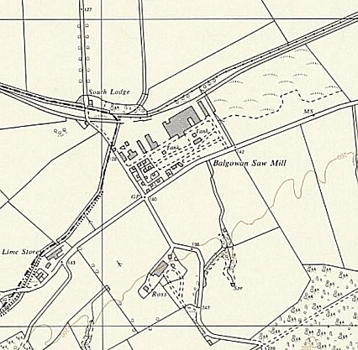
 | OS Map 1958 – site shown as Saw Mill.

Dunino – Satellite Camp, 22 miles from main. (NGR for Dunino – NO 5398 1100).

Dunino and Bonnytown are often recorded as being the same site, but the Dunino site was much larger than the Bonnytown Hostel.

October 1947 – Camp Leader O/Masch. Neumann (B) – “still on the way to realising the difference between patriotism and Nazism. He has a most difficult task.”

A comment about the German M.O. S/Arzt Toepal (B+) as “a genial, middle aged practitioner; just too much so in view of his Nazi background.”

An entry regarding provision of wireless sets gives an indication to the camp itself: “consists of 5 sites. Four speaker extensions are needed, but as the C.O. considers that Dunino will close down again soon he is unwilling to drain the welfare fund to such an extent.”

December 1947 – no Camp leader listed.

February 1948 – Camp Leader Sold. Hinsel.

March 1948 – recorded as being under administration of Camp 63 Balhary.

 | 1943 | 12/1945 | 6/1946 | 1/1947 | 5/1947 | 6/47 | 10/47 | 11/47 | 12/1947 | 2/48 | 3/48
Dunino Satellite |  |  | With Balhary Camp 63 |  |  |  | 660 | 443 | 25 | 80 | C 63

Dunning – 25 miles from the main camp.  Location described in article - “Along Auchterarder Road, where the Glebe now stands…” (‘The Dunningite’ Magazine – No.79 Spring 2012 – Dunning Parish Historical Society). NGR NO 0172 1439.  Hutted camp.  June 1946 - 1 teacher of English – Arno Henkeshoven  January 1947 – Camp leader Ogefr. Heukeshoven, Arno (B+) [same person as above with spelling variation].  June 1947 Camp leader Wm. Schneider (B) – “The hostel seems to have been in a poor state when he took over but I think he will achieve some success.” Same C/L in February 1948.  December 1947 – some outside contact had been established with Rector McKinnon of Dunning.  1943 12/1945 6/1946 1/1947 5/1947 6/47 10/47 11/47 12/1947 2/48  Dunning 68 68 79 67 59 72 77 33 | 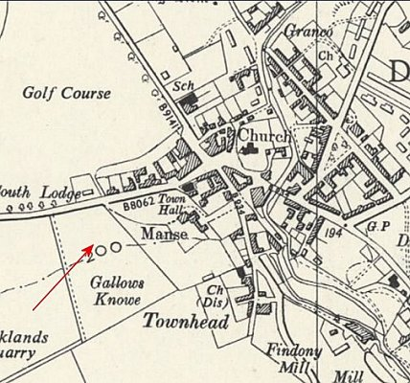
 | Ordnance Survey 1959

Forgandenny, Perth – 20 miles from main camp.

Hutted camp.

1943 – Italian pows.

June 1946 - 4 teachers of English – Robert Staets / Kurt Weuffen / Erich Blitz / Gunther Carius

January 1947 – Camp leader Ofw. Hartwig, Karl (B)

June 1947 – Camp leader O/Scha. Mattner (B-) “a striking young P.W. with enlightened ideas and the personality to put them into practice. He is an excellent leader of men. He is recommended for the Training Centre”. Transferred from Crieff hostel. However, he was also on the Automatic Arrest list. o/Scha = SS-Oberscharfűhrer.

October 1947 – same Camp Leader. By February 1948 he is recorded as being in the main camp.

 | 1943 | 12/1945 | 6/1946 | 1/1947 | 5/1947 | 6/47 | 10/47 | 11/47 | 12/1947 | 2/48
Forgandenny |  |  | 67 | 67 | 68 | 66 | 73 | 71

Canmore only lists a WW1 pow camp at Forgandenny.

Halbeath – 25 miles from main camp. Hutted. May have been linked to another main camp prior to October 1947.

October 1947 – Camp Leader Ofw.Kretschmar (B) (probably the same man as at Bogside prior to this ?) Same December 1947.

December 1947 - “Halbeath Hostel Choir is well received by local organisations. Halbeath also has a theatre group under Dosse, which is good for entertainment, although limited in scope.”

 | 1943 | 12/1945 | 6/1946 | 1/1947 | 5/1947 | 6/47 | 10/47 | 11/47 | 12/1947 | 2/48
Halbeath |  |  |  |  |  |  | 213 | 226 | 220

Lathockar – 16 miles from main camp. NGR NO 4892 1088.  Hutted camp  June 1946 - Noted in report – “Teacher at Lothockar useless and in jail. He will be replaced by a teacher from 174.”  January 1947 – Camp leader Uffz. Raabe, Kurt (B-)  June 1947 Camp leader H/Scha Pollak – “sound and efficient. He is in touch with St. Andrew’s University.” Same C/L in December 1947.  December 1947 contact had been established with Dr.Mulligon of St Andrews University.  1943 12/1945 6/1946 1/1947 5/1947 6/47 10/47 11/47 12/1947 2/48  Lathockar 68 74 73 63 75 71 63  Canmore - http://canmore.org.uk/site/204119  Air photographs (106G/Scot/UK 5, 3213-3215, flown 14 April 1946) to the S of the public road. Six to seven huts are visible on the air photographs.  Site demolished in 2018. | 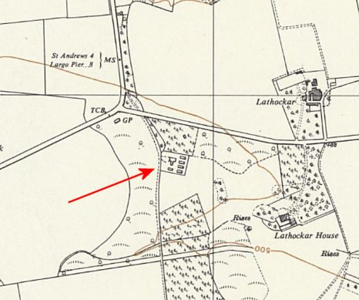
 | Ordnance Survey 1959

Myreside – 24 miles from main camp. Myreside Farm shown on map. NGR NO 055 255  Canmore – “Methven (Myreside) was a maintainance airfield [built 1940]…The site would appear to have occupied three fields in an area stretching from Myreside in a NE direction… The accommodation area of wooden and Nissen huts were situated amongst the trees on the S side of the A85 road and the minor road to Tibbermore (NO c.048 251). There was no Officers Quarters on this site.  At the end of the war the hutted camp had become an 'open' Prisoner-of-War camp housing firstly Italians, and latterly Germans... Many of the huts had small garden plots around them…”  June 1946 - 1 teacher of English – Werner Gast  January 1947 – Camp leader Fw. Geissler, Helmut (B)  June 1947 Camp leader O/Masch Kolberg (B+) – “seems weak as a personality, but he is quite willing to do all he can.” The conditions at Myreside were described as “damp and dreary with a correspondingly depressing effect on the Ps.W | 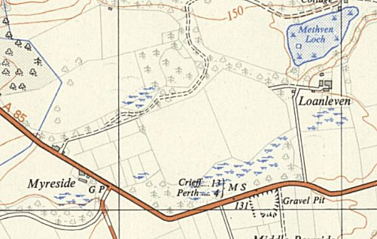
 | Ordnance Survey 1956
October 1947 – Camp Leader Sfw.Sonnemann (B-) – “a 34 year old professional soldier who has benefitted vastly from contact with genuine C+’s at Watten camp. His intentions seem excellent.” Same December 1947.

December 1947 contact had been established with Rev Mr Fraser of Bridgend Perth.

 | 1943 | 12/1945 | 6/1946 | 1/1947 | 5/1947 | 6/47 | 10/47 | 11/47 | 12/1947 | 2/48
Myreside |  |  | 64 | 65 | 70 | 68 | 71 | 70 | 85

http://canmore.org.uk/site/88111

The Beeches, Ladybank. A short distance from the main camp. Hutted.
October 1947 Camp Leader O/Wachm. Wollensack (B)

December 1947 Camp leader Fw. Klarenaar (B) – “a steady and alert type with an appreciation for his responsibilities.” Same in February 1948.

December 1947 contact had been established with Rev Mr Fraser of Bridgend Perth.

March 1948 administered by Balhary camp

 | 1943 | 12/1945 | 6/1946 | 1/1947 | 5/1947 | 6/47 | 10/47 | 11/47 | 12/1947 | 2/48
The Beeches |  |  |  |  |  |  | 202 | 176 | 171 | 130

