Camp 275 Topsite Camp, Thames Ditton, Surrey

Prisoner of War Camps (1939 – 1948) - Project report by Roger J.C. Thomas - English Heritage 2003
OS NGR | Sheet | No. | Name & Location | County | Cond’n | Type 1945 | Comments
TQ 15 67 | 176 | 275 | Topsite Camp, Thames Ditton | Surrey | 5 | German Working Camp | Precise location not identified, NGR given for Thames Ditton.

Location: Close to Camp 193 Hampton Park. I cannot find a place called ‘Topsite’ in Thames Ditton. The address used on camp correspondence was; Topsite Camp, Claygate Lane, Thames Ditton, Surbiton, Surrey. Further information puts the camp at Greenwood Road / Claygate Lane – NGR TQ 163 659.  Before the camp:  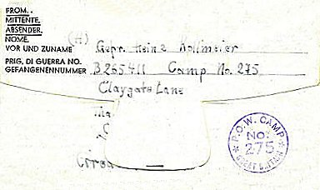  Pow Camp: Administered by the Pioneer Corps.  No records of any Italian pows – probably opened 1945? Accommodation was in tents. No record of any hostels.  21 January 1946 – Commandant; Major T Toomey (Pioneer Corps). In a letter about a recent lecturer, he stated that there were 499 pows in the camp. Recreation/dining huts had recently been built.  Pow letter-sheet from 1946.  6 April 1946 – A visiting lecturer noted that many of the pows were depressed due to receiving very little news from home – especially those with families in the Russian Zone.  A picture in the book ‘Children in the Second World War’ (by Amanda Herbert-Davies, 2017) has a caption; “German prisoners at Thames Ditton POW Camp, Greenwood Road, Thames Ditton, Surrey, in October 1946”. | 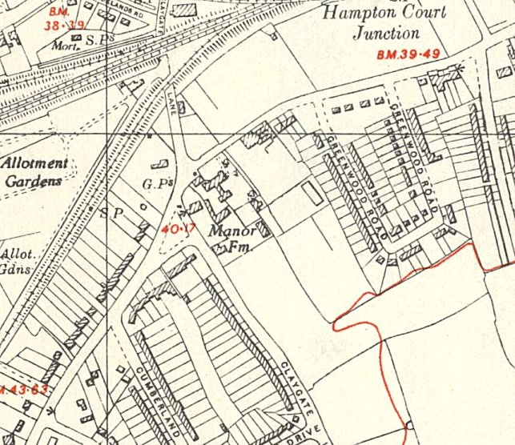
 | Ordnance Survey 1948
7 May 1946 – Dr. W Milch, a visiting lecturer, gave a report that was more informative than others –
“Tented camp; moral standard; good: intelligence level; average: about 200 p/ws still unscreened….. Camp leader good and efficient… Very good work done by the (obviously German born) S/Sgt. [K Stanley, he was the interpreter].

Main trouble: no teachers in the camp… no men suitable to do the job… Even no English class last month owing to lack of experienced teachers!”

June 1946 – In early June, 20 pows and the Commandant, Major Toomey, were sent from this site to establish a new Camp 275 in Friockheim, Scotland. Presumably the Topsite Camp closed at around this time. I have not found any reference to it becoming a hostel for a larger camp, and it was not included in the 1947 list of camps.

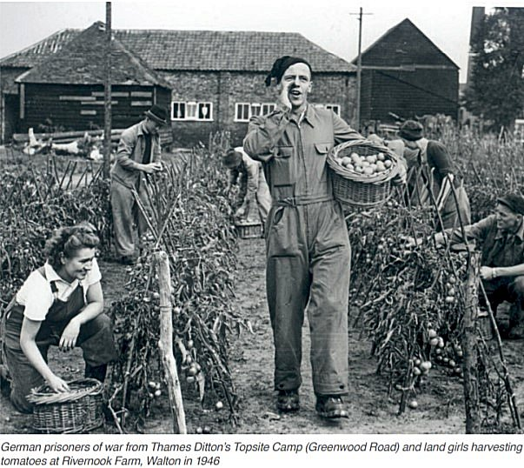 | After the camp:  Further Information:  National Archive FO 939/303 – has documents related to visiting lecturers at the camp from February 1946 to May 1946  (The file’s title at the NRA is - “275 Working Camp, Kinnell Camp, Friockheim, Angus”, the camp that later used the same number).  National Archives FO 1120/240 – Re-educational survey visit reports for camps 266 to 276. Dated 1 January 1946 – 31 December 1948
https://residents-association.com/images/thamesdittontoday/spring2020.pdf
Residents Association Magazine Spring 2020.

