Camp 275 / 275a Kinnell Camp, Friockheim, Arbroath, Angus

Prisoner of War Camps (1939 – 1948) - Project report by Roger J.C. Thomas - English Heritage 2003
OS NGR | Sheet | No. | Name & Location | County | Cond’n | Type 1945 | Comments
 |  | 275 /275a | Kinnell Camp, Friockheim, Arbroath | Angus |  | German Working Camp | Scotland

There are issues regarding this entry.

The EH record above indicates that Camp 275/A was a German Working Camp in 1945. This is incorrect. Reports (FO 939/303) from the camp, show that Camp 275 was originally at Topsite, Thames Ditton - and did not move to Scotland until June 1946.

Canmore records the location of this camp as being in Friockheim, (see map below) - but this site does not match descriptions given in reports made by visitors to Camp 275; “a dispersed hutted camp permitting more freedom of movement than most camps” and “housed in spacious RAF buildings and has no barbed wire at all”.

There is the ambiguous name and address of the camp which raises a question, why call it Kinnell, if it is in Friockheim?

There is also the camp numbers 275 and 275A – this indicates that there was one main camp and a smaller, associated camp (hostel).

I believe that:

1. Kinnell Camp 275 was based at Kinnell Airfield. The airfield closed in 1945 and had been used for storage and maintenance for a while. The site matches the name and the descriptions. Disused airfields were frequently used for this purpose. There were three accommodation areas for the airfield: a. a small group of Nissen huts set out in an L-shape at NO 6160 5230; b. a larger group of huts within a square enclosure at NO 6170 5198; c. the largest, a combined three hut building and a detached hut at NO 61374 52266.

This camp operated as Camp 275 from June 1946 to January 1947 when it became a pow satellite / hostel for Camp 75 – details below.

2. The Location identified in Friockheim by Canmore was a hostel for Italian and then German pows from 1943 to November 1946 linked to Balhary Camp (No.3/63). The documents (FO 939/144) for Balhary give details of this hostel.

The records for Friockheim hostel end in November 1946 – either it closed, or possibly it became Camp 275A as a hostel for the main camp 275 at Kinnell.

1. Friockheim POW Camp 275.
June 1946 – National Archive file FO 939/303 shows that a new Camp 275 was opened using the address ‘Kinnell, Friockheim, Angus’, (the telephone number was ‘Friockheim 261). This was a German Working Camp. Descriptions of the location are mentioned above.

27/28 July 1946 – W G W Aston recorded that he was the first Training Assistant to visit the camp from COGA (Control Office for Germany and Austria – overseeing re-education for pows). He visited in order to; “Organise re-education / Ascertain screening position”.

Strength: 0 officers; 381 O.R. Only 38 of the pows had been politically screened – the visitor estimated the camp to be politically Grey / Black.

Commandant: Major T Toomey Camp Leader: Hptfw Ritscher (B)
Interpreter: S/Sgt R Williams Deputy C/L: Obwm Ehrentrant (est.B)
German m O: None

The Commandant and the deputy Camp Leader had been transferred from the Topsite Camp to form this camp in Scotland.

The Camp Leader came from Cowden Camp 242.

The abilities of the interpreter S/Sgt to influence re-education was doubted.

The current pows were made up from:

Early June 1946 – 20 pows from 275 Camp (Topsite) were received. (Topsite Camp was given the address ‘Hinckley Wood’, a district next to the site of the camp).
July - 38 pows from 242 Camp (Camp 242 = Cowden, Perthshire).
July - 323 pows from Camp 21 (ex Belgium) (Camp 21 = Comrie, Perthshire).

The first 20 pows were picked by the Commandant when he was at Topsite to form the nucleus of the pow staff.

Overall, the pows were satisfied with conditions in the camp and a generally low morale was improving. Pows from Belgium had previously been badly treated in the camps and were described as being cynical and unfriendly to the pow staff. Not all of the pows had been allocated work.

A high proportion of the camp were Youth pows, (under-25). Many of these had known no other political ideology other than Nazism, but it was hoped they could be guided by others. 2 youth and 2 older pows had been recommended to attend the special training courses held at Wilton Park (Beaconsfield).

The standard list of re-education activities was given, but very little had started:

Wochenpost: 70-100 copies received

Ausblick: No copies so far.

Newspapers: Copies of the Times Weekly and Manchester Guardian Weekly were received. Others were on order. 6 German papers were received fortnightly.

Library: None

Lectures: None

Films: None

Wireless: 1 in recreation room with a loudspeaker in the dining hut. It seems to have been very limited as only BBC programmes are mentioned.

Camp magazine: hoped to start soon.

Press review: being considered.

English Instruction: 2 teachers hoping to start soon, but teaching materials lacking.

Other activities –

Religion – no activity yet.

Education – none yet.

Theatre etc – There was a hall to seat 400, but no theatre group. No musical instruments available. A football field, but no sporting gear.

13 September 1946 – Paul Senft gave a report on his lecture at the camp. 300 out of 375 pows attended.

He reported on the mood of two groups of pows in particular. Those who had been transferred from Belgium still showed resentment and bitterness after their experience, but their morale was improving. A second group had been transferred from camps in the USA where they had been mistakenly informed that they would be returned to Germany. There were “strong antagonistic currents” in some pows. These observations were repeated by lecturers over the next few months.

31 January 1947 – Camp 275 disbanded as a unit and the site became a satellite camp attached to North Hill Camp 75 at Laurencekirk.

2. Friockheim Hostel for Balhary Camp 3/63 – and possibly Camp 275A attached to Kinnell Camp 275.
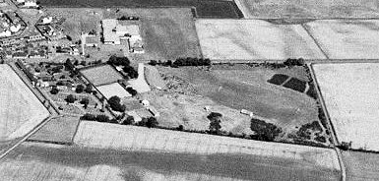 | Location:  NGR NO 5992 4959. Area shown as recreation ground on the 1959 OS map.  This site confirmed by local memories and aerial photographs.  Canmore records that this was a small camp with aerial photographs in April 1946 showing at least four large and two smaller huts + a small rectangular area | 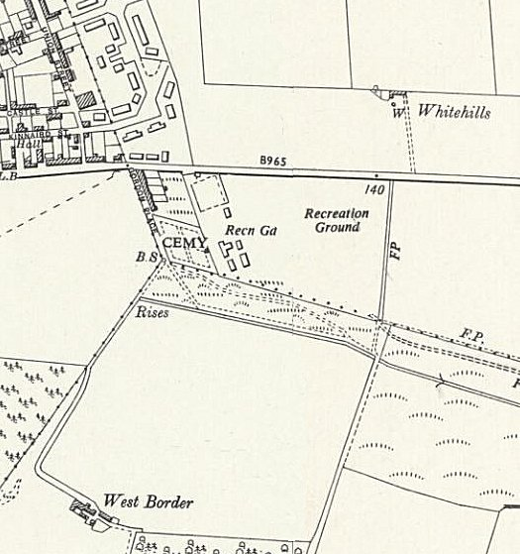
with paths can be seen situated centrally between the huts. As Friockheim Camp 275 did not open until June 1946, this must be the site of the Balhary POW Hostel – it also matches the hostel description as being a site with 6 huts.

1943 / 1944 - listed as a hostel for Balhary with Italian pows.

June 1946 – recorded as being 6 huts.

July 1946 – Hostel Leader; O/Wm Grimm (C)

November 1946 – Hostel leader; Obermaat Heinz Berger (C). “Very backward hostel. 50% US intake. The Nazi atmosphere already reported by Capt Drucker has not improved since the former Nazi Hostel Speaker Grimm has been replaced by another Nazi.” 21 out of 66 pows were graded ‘C’.
 |  | Ordnance Survey 1959

No further record of this site as a hostel for Balhary after November 1946.
Hostel | Open |  |  | With other camps |  |  | Unknown |  |  | Not listed / not open

 | 12/42 | 43/44⁺ | 6/46 | 7/46 | 10/46 | 11/46 | Later
Friockheim |  | + | 74 | 71 | 61 | 66 | Hostel 275A?

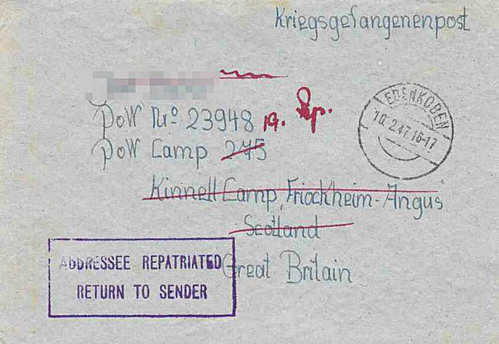 | After the camp: 2020 recreation ground.  Further Information:  National Archives  FO 939/303 – 275 Working Camp, Kinnell Camp, Friockheim, Angus. Dated 1946-1947. Used above.  FO 1120/240 – Re-educational survey visit reports for camps 266 to 276. Dated 1 January 1946 – 31 December 1948  Canmore - http://canmore.org.uk/site/272560  Vertical air photographs - 106G Scot/UK 6, 3244-3245, flown 14 April 1946.
February 1947 cover to Kinnell / Friockheim

