Camps – uncertain location / details.

1. Camps where I am looking for confirmation - or were sub-camps/hostels.

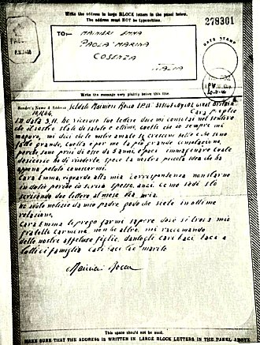 | Camp 44 Haswell House Camp, Somerset. Name appears in WO 32/10737 – with a sub-camp at West Lambock, Martock, Somerset. (C44 is listed as Goathurst Somerset – Haswell does not appear in any other list I have seen – possibly a sub-camp for Goathurst?)  Camp 218 ? National Archive reference WO 166/14168 – 218 Prisoner of War Camp. Camp moved from Aldershot, Hampshire, to Kempton Park; From there to Sunbury on Thames; from there to Coleford, Gloucestershire; from there to Rugeley, Staffordshire; from there to Didlington, Norfolk. Dated November 1942 to November 1943.  Camp 221 ? National Archive WO 166/16296 – 221 Prisoner of War Camp at Lavington. Camp moved from Lavington to Bustard, July 1944. Dated July 1944.  Camp 223 ? National Archives WO 166/16297 – 1944 223 Prisoner of War Camp at Aldershot, Hampshire. Moved to Haltwhistle, Northumberland; from there to Cumnock; from there to South Woodford. Dated February to April 1944.  Camp 225 ? National Archives WO 166/16299 – 225 Prisoner of War Camp. Moved from Haltwhistle, Northumberland, to Maybole, Ayrshire; from there to Girvan; from there to Thorpe Bay, Essex. Dated February to June 1944.  < Airgraph from Italian Pow Company 602. Camp not listed.  Camp ??? Article from July 1946 about 3 escaped pow from Upland Road, Handsworth, Birmingham Camp. The last sentence states “There are 148 prisoners in the camp.” Almost certainly a hostel >>>>>>>>>>>>>>>>>>>>>>>> | 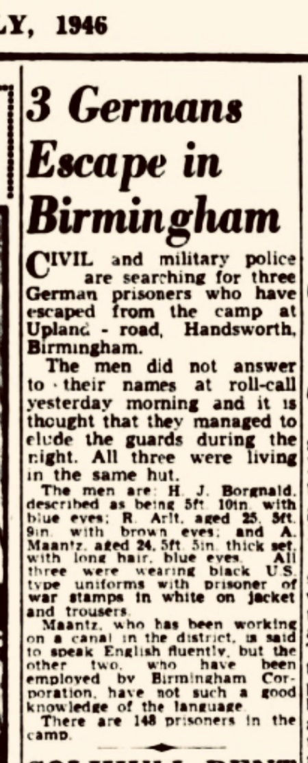
Camp 603 / 604 Black North Camp, Arncott, Devon – Cannot trace ‘Arncott’ in Devon.

Camp 606 Beanby Camp, Beanby, Invernessshire – I have found 1 indirect reference to a Beanby, Invernessshire; in The British Medical Journal of 1912 a Dr Thomas MacDonald was recorded as living there.

Camp 597 Ashanda, West Lulworth, Wareham, Dorset – No references found to ‘Ashanda’
Camp 611 Hutted Camp, Buckinghamshire – too vague to discover.

Camp 901 – referred to in 2 reports about Russians at Camp 905. It may have been in the Worthing area and only for a short time in 1945.

Lingfield Racecourse Camp, Surrey – National Archives WO 222/71 ‘Report of special medical investigation on Italian prisoners of war at Racecourse camp, Lingfield’ – dated 1942.

2. POW Camps listed by Harrington Museum, Northamptonshire.

The full list includes military premises within 30 miles of Harrington. I think some of the entries in the list refer to listed camps, but under a different name - many entries are satellite camps or hostels.

Village/ Town | Name of Premises | Location / Address | Distance to Museum | Use
Daventry |  | SP 561 635  Northamptonshire | 25.9 km | The accommodation huts formerly used by the anti aircraft battery was used by German prisoners of war. They assisted in clearing snow from roads during the severe winter of 1947.  The site then became part of the Timken ball bearing factory post war.
Daventry | Braunston Road | SP 568 628 approx Northamptonshire | 25.7 km | PRISONER OF WAR CAMP & LAND ARMY HOSTEL  Demolished shortly after WW2 and Council houses were built on the site
Denford parish |  | TL 008 757  Northamptonshire | 24.2 km | Between Briggs Lodge and Denford village are the remains of a wartime German POW camp. The men worked on local farms. Briggs Lodge Farm is east of Denford village at TL008757. Location of the camp remains undetermined  Additional information from Martin J Richards – Systonimages:  On enquiring at the farm I was told by the lady there that the PoW Camp was located further down the road at a small holding that was now called “Camp Farm” because of its former usage as a PoW Subcamp.  The location of this site has thus been up-dated From: TL 008 757 To: SP 9989 7600
Edmondthorpe | Edmondthorpe Hall | SK 8605 1748  Leicestershire |  | During the Second World War the Hall (built by Sir Roger Smith in 1621) was used as a prisoner of war camp for Italian personnel, but was destroyed by fire in 1943
Fineshade | Fineshade Abbey | SP 972 977  Northamptonshire | 27.7 km | Demolished in 1956. It had been damaged during use as a POW camp during WWII. Only the stable block remains.
Kenilworth | Goodrest Farm | SP 275 693  Warwickshire |  | ANTI AIRCRAFT BATTERY & PRISONER OF WAR CAMP  Known as the H25 Bannerhill Battery it consisted of 5 3.7 ich anti aircraft guns in an arc around a control room constructed of concrete blockwork.. In the field alongside the battery were Nissen hut accommodation used as accommodation for the battery. Towards the end of the war these Nissen huts were used as a prisoner of war camp
Lubenham |  | Leicestershire |  | ITALIAN PRISONER OF WAR CAMP
Pickworth | Woolfox Lodge | Rutland |  | Used to house POWs after WW2
Potterspury Parish | Wakefield | Northamptonshire |  | There was an Italian POW camp at Wakefield near Potterspury.
Sulby |  | Northamptonshire |  | PRISONER OF WAR CAMP  Also used as a displaced persons camp after WW2

3. Scottish Camps
Camp Number - Name - Location | Notes
Balado Bridge | Known that 113 Polish pows were moved from Camp 905 on 15 December to Bolado Camp, Kinross. Balado Bridge was a RAF airfield with various accommodation sites. The airfield closed in June 1944 and the site acquired by the War Office. Two large accommodations sites were:  Turfhills (NO 1079 0286) to the southeast, a substantial camp, larger than would have been needed to service RAF Balado, and assumed to have been used to accommodate other units, and Polish troops, both during and after the war. Canmore notes that it may have housed Polish troops before and after the war – I wonder if this might have been Polish Pows?  Braidmyre Wood camp (NO 0823 0362) comprised some thirty assorted hut types.
Brucklay, Aberdeenshire. NJ913501 | Hut bases remain.
Capeldrae, Westfield, Ballingry, Fife. NT19639777 | Possibly former Bevin Boy camp.
Culreoch Camp, Stranraer. NX06915829 | Housed Italians postwar. Former AA battery astride A71. RCAHMS entry, Culreoch AA battery
Duddingston House, Edinburgh. NT28607270 | Destroyed.
Hampden Park Football Stadium, Glasgow. | Scottish Command holding cage. Extant.
Hayton Camp, Hayton Road, Aberdeen. NJ93250900 | Destroyed. RCAHMS entry, Hayton Road
Kinlochleven, Argyll & Bute. NN20656070 | Destroyed.
Kirkton camp, former RAF station, possibly SLG. | The Northern Times, Mr D Stewart, 7 Moray Drive, Balloch, Inverness. April 10, 2008.  Sir – Further to your previous correspondence regarding the RAF camp at Kirkton Farm, after the RAF left Kirkton the camp lay empty for a short period and then became a prisoner of war camp for Italian POWs.  After that, German POWs occupied the camp and many of them worked on farms in the area. Several of the German POWs remained in the area after the war, in fact the entire Golspie football team half back line were former POWs, namely Arnold, Bruno and Gustav.  Arnold and Bruno eventually returned home but Gustav married a Golspie lass, Chrissie Macdonald. Sadly Chrissie and Gustav are deceased but their children live in Golspie.
Leet Water, Coldstream, Borders. NT83603970 | Destroyed, now a golf course.
Leucahtsbeath Cottages, Cowdenbeath. NT16379277 | Possibly former Bevin Boy camp. Destroyed.
Maidens/Kirkoswald camp. NS216078 | Now Redgates caravan park, Kirkoswald Rd, Maidens.
Methven Airfield/Loanleven. Perth & Kinross. NO055255 | Former wartime satellite airfield. Some buildings remain.
Mortonhall, Edinburgh. NT25856808 | Displaced persons camp postwar. Hut bases remain.
Peterculter Camp, Coronation Road, Aberdeen. | Destroyed. No trace found.
Rickarton Camp, near Stonehaven, Kincardineshire. | Demolished and now houses.
Sheuchan School, Stranraer | School closed 1938, ARP stores during the war, then PoW transit camp. Destroyed. cf #571
Stobs Camp, Hawick, Borders. NT49920943 | Destroyed.
Tealing Airfield Angus. NO40423717 | PoW accommodation. Destroyed.
Tullos Hill, Aberdeen. NJ95650339 | Destroyed. Former Peterseat AA Battery, used for German PoWs postwar. RCAHMS entry, Tullos Hill

4. Welsh Camps

Camp ??? Letterston, Bwlch-Y-Defaid, Pembrokeshire

Location: NGR SM 9332 3027  Before the camp:  Pow Camp: HER DESCRIPTION – “A prisoner of war camp during the Second World War. Consisting of eight huts of which 7 have been demolished and one remaining. This is a barrack hut, rectangular in plan, timber framed, corrugated galvanized steel and asbestos cement clad pitched roof. Based on record by RJC Thomas in 1994, site no 419/000. Alice Pyper 2017”  After the camp:  Further Information:  Aerial photographs - RAF 1946 Sortie No 106G-UK-1472 Frames 4092-4093 | 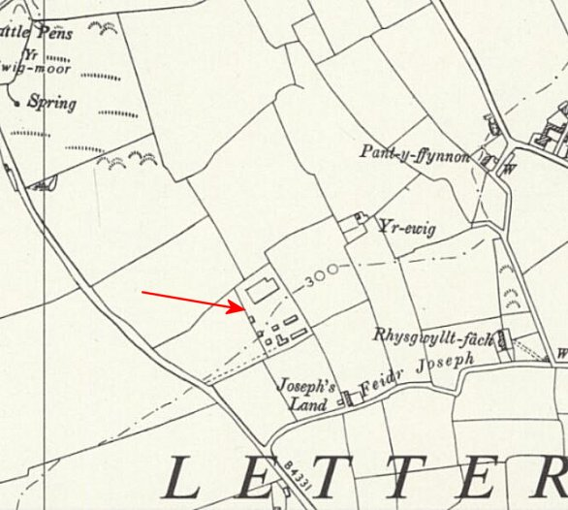
 | Ordnance Survey 1964

Camp ??? Peniarth

Location: SH 6118 0601.  Before the camp:  Pow Camp:  Coflein – “World War 2 camp for prisoners of war, consisting of several huts to the North of Peniarth house (nprn:- 28633) and recorded by RCAHMW aerial reconnaissance 2nd June, 2009.”  After the camp:  Further Information: | 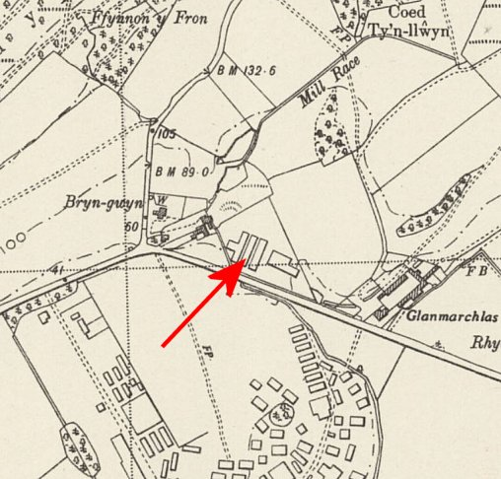
 | Ordnance Survey 1953

Camp ??? Treglog, Carmarthenshire

Location: SN 5954 3502. Treglog shown in NE of map.  Before the camp:  Pow Camp:  Listed by Coflein – no details given  After the camp:  Further Information: | 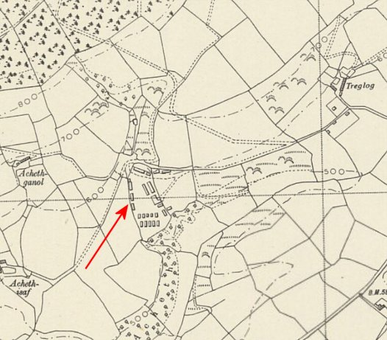
 | Ordnance Survey 1953

Camp ??? Y Sgwar (Square and Compass), Mathry, Pembrokeshire

Location: SM 8517 3131. Square and Compass is the name of the Public House shown on the map.  Before the camp:  Pow Camp: HER DESCRIPTION – “A hostel and camp for the Women's Land Army. Consisting of a combined ablution and accommodation block and a further accommodation block. Three curved asbestos garage/implement stores, a septic tank and filtration bed. It later became a Prisoner of War camp for mostly Italians captured in North Africa. Recorded by RJC Thomas as site no 406. A Pyper 2017”  After the camp:  Further Information:  Aerial photograph - RAF 04.05.46. Sortie No. 106G-UK | 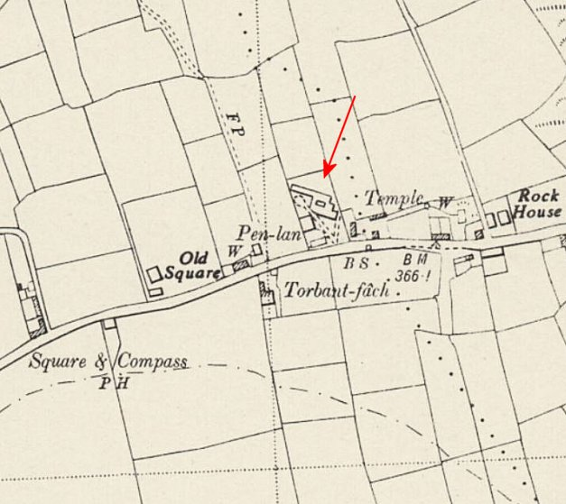
 | Ordnance Survey 1964

Camp ???

Location:

Before the camp:

Pow Camp:

After the camp:

Further Information:

Ordnance Survey

