Camp 1005 Barby Camp, Willoughby, Rugby, Warwickshire

1947 Camp List
1005(G.W.Coy) | E | Barby Camp, Willoughby, Nr.Rugby, Warwick | Rugby 3461 Ext.37 | 9 | V/1270/4

Prisoner of War Camps (1939 – 1948) - Project report by Roger J.C. Thomas - English Heritage 2003
OS NGR | Sheet | No. | Name & Location | County | Cond’n | Type 1945 | Comments
SP 5432 7039 | 140 | 1005 | Barby Camp, Willoughby, Rugby | Warwickshire | 5 | German Working Camp | Precise location not identified. NGR for centre of village.

NOTE: There were 2 sites called Barby. One site was a hostel located at the edge of the village of Barby (SP 545 706). Further information about this site – see Byfield Camp 87  Location – NGR SP 513 700. Within Barby Parish.  Before the camp: Site used as a supply depot.  Pow Camp:  POW mail seen for August 1946 / November 1946  After the camp:  Now - H.M.Prison  Further Information:  National Archives – FO 939/327 – 1005 Working Camp, Barby Camp, Rugby, Warwickshire. Dated 1946-1947. | 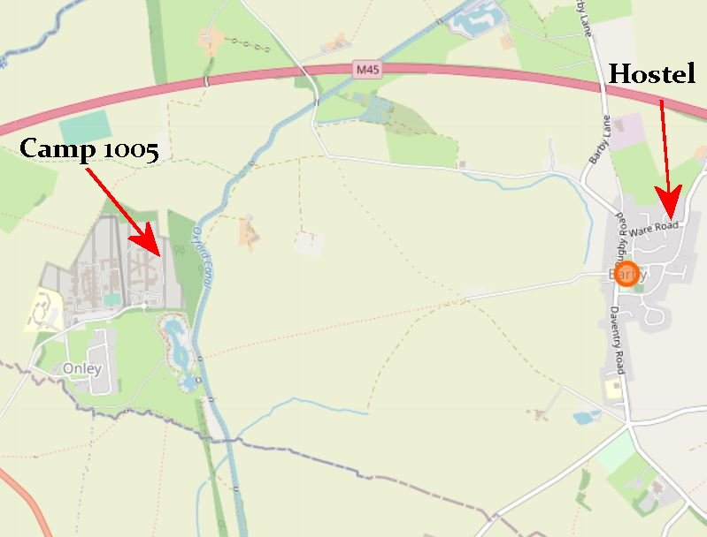
 | Open Street Map

