Camp 98 - Little Addington Camp, Hill Farm Estate, Irthlingborough Road, Little Addington, Northamptonshire

Included in the 1945 ICRC camp list – Labour Camp. 98. Little Addington Camp, Kettering, Northants.

Prisoner of War Camps (1939 – 1948) - Project report by Roger J.C. Thomas - English Heritage 2003
OS NGR | Sheet | No. | Name & Location | County | Cond’n | Type 1945 | Comments
SP 960 731 | 141 | 98 | Hill Farm Estate, Irthlingborough Road, Little Addington | Northhamptonshire | 3 | German Working Camp | STANDARD type.

Location: Just S of Little Addington; 10 km SE of Kettering.  Before the camp: Farmland  Pow Camp: Listed as Italian working camp / labour battalion to at least 1945, then a German Working Camp.  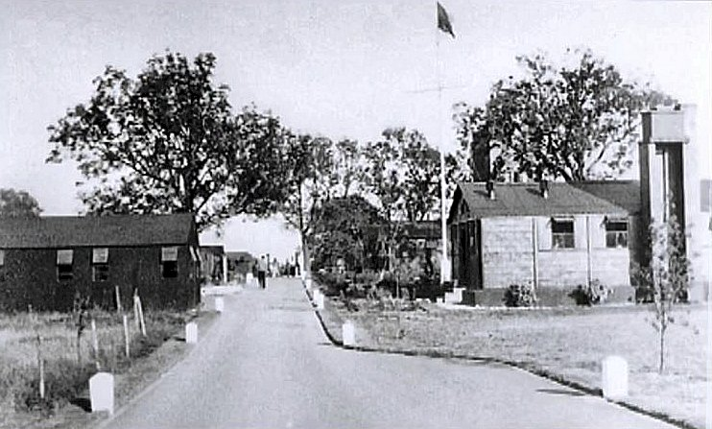  The site had a standard layout with a main pow compound, with guards’ huts and offices at the front towards the road. Common buildings and facilities at standard type camps included water towers, offices, officer's mess, a canteen, guard rooms, barrack huts, ablution blocks, cell blocks, a camp reception station (medical facility/hospital), a cookhouse, dining rooms, recreation rooms and living huts.  Pictures with thanks from Robert Moore. | 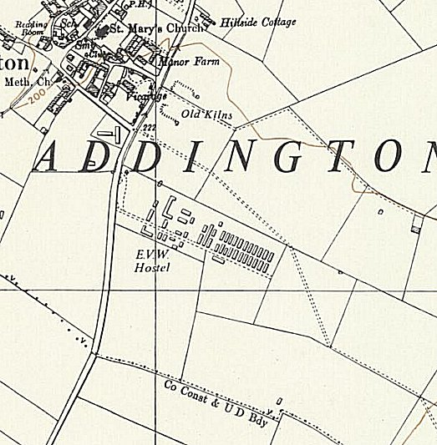
 | Ordnance Survey 1958
From the photograph, the buildings appear to be mainly wooden construction, with some brick-built buildings requiring a more stable foundation such as the cookhouse.
The Italian pows were listed as co-operators. They were responsible for building a sewer through the village and also helped at the local farms. There was an Italian Chapel built inside one of the huts.
There was an International Red Cross visit on 6 January 1944 - Italian prisoners, capacity 560.
The camp was listed as an Italian Labour Battalion under the Eastern Command area in May 1944 and November 1944, (WO 32/10737).
On 1 August 1945 an urgent memorandum was sent to this camp, and others, about maintaining records of Italians who were classed as ‘co-operators’. At this point many, sometimes all, of the Italian pows were in hostels / billets.
Hostels listed for pows from this camp on 15 September 1945, (WO 32/10737):
Farndish, Wollaston, Bedfordshire – later taken over as a hostel for Ducks Cross Camp 72.
Upper Dean, Risley, Bedfordshire – later taken over as a hostel for Ducks Cross Camp 72.

July 1946 – Listed as a Satellite camp for Weekley Camp 259 (separate details)

Postal items seen: Mail to Italy dated May 1943 and April 1945.
After the camp: Camp for European Volunteer Workers. 2019 industrial estate.
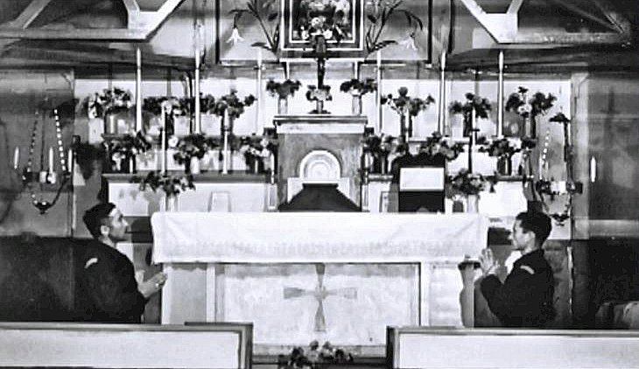 | Further Information:  National Archives - FO 1120/223 – ‘Re-educational survey visit reports for camps 93 to 99’. Between 1946 to 1948 inspections were carried out at various camps for German pows regarding the provision of re-education programmes. The quality and detail of the reports vary greatly.  < The Italian Chapel built inside a hut.

