Camp 184 Llanmartin, Magor, Monmouthshire

1947 Camp List
184(B.C.) | Llanmartin Camp, Magor, Newport, Mon | E. | Priswar, Magor | Newport 71216 | Magor | Lt.Col.E.G.H.Clarke M.C. | v/202/2

Prisoner of War Camps (1939 – 1948) - Project report by Roger J.C. Thomas - English Heritage 2003
OS NGR | Sheet | No. | Name & Location | County | Cond’n | Type 1945 | Comments
 |  | 184 | Llanmartin Camp, Magor | Monmouthshire (Gwent) | Base Camp | Wales

Location: NGR 386 890  Before the camp: The camp at Llanmartin was originally built to house the US Army prior to the D-Day landings.  Pow Camp: Reported to have opened very soon after D-day. Possibly held Italian pows. Used to hold other ranks up to August 1946, then officers who were initially from Crewe Hall (191), Llanover Hall (200) and Lodge Moor (17) camps.  Reports note that there were few political category A ‘white’ officer pows. The camp also received officers who were sent from camps in the US and Canada, who had expected to be sent back to Germany.  There was a very extensive library and an active theatre group. There was a camp magazine – ‘Die Aussprache’ (The Pronunciation – ‘Way of Speaking’?). Dr Kurt Blohm developed English teaching and edited a camp magazine in English – ‘The Onlooker’. There is also a record of a magazine called ‘Echo’.  17 November 1944 – 3 Luftwaffe pows escaped:  “RESTRICTED  Herman LANGE  Thedor HOLZ  Herman AHRENDT | 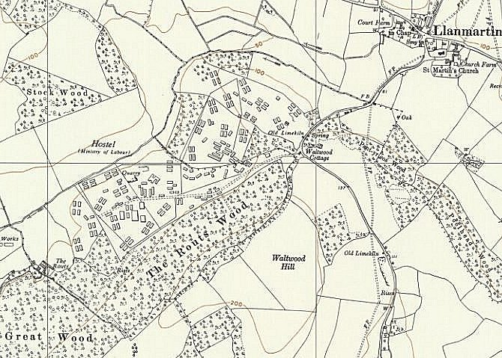
 | Ordnance Survey 1956
At about 22.00 hours on 17 November 1944 the above-named German PW escaped through the perimeter wire of 184 PW Camp. They were recaptured at HOLYHEAD whilst attempting to board a steamer for EIRE on the afternoon of 23 November 1944. During the night of 17/18 November 1944, the PW walked to CHEPSTOW. At the time one was wearing Luftwaffe trousers and a leather jacket, another was wearing dark blue trousers and a knee-length drab wind-jacket with zip fasteners, and the third was wearing complete Luftwaffe uniform without badges. One PW could speak poor French and fair English, by no means fluent or free from accent; another could speak very little English indeed; the third could speak only German…..

….Their ‘passports’ or Identity Documents, which were made whilst in the camp, were poor specimens. The ‘stamp’ was produced by placing a French franc under the card and taking a rubbing.” (Wiltshire Record Office F5/530/3).

The pows had changed a 1000-franc banknote at a branch of Barclays in Chepstow and bought train tickets to Birmingham. Lange sold his watch to the owner of a fish and chip shop for £12 and they travelled by train to Liverpool spending 2 nights in a YMCA hostel. In Liverpool they bought second-hand clothes and tickets to Dublin, posing as French volunteers. They travelled on to Holyhead and were arrested trying to board the steamer. During their travels they had shown their poor fake papers to various people, and had spent time in pubs and restaurants. (Further details taken from ‘For Fűhrer and Fatherland’ – R De Normann – Sutton Publishing Ltd – 1996).

16 December 1946 - The Bishop of Berlin visited prisoner of war camps in Britain, including Llanmartin. The South Wales Argus reported on 16 December 1946 that he answered various written questions during his visit. I am not sure how inspiring his visit was. He told the pows that many people back in Germany, "had given up hopes of ever reviving a standard of life worth living". He added that many were saying, "What is the good of trying to do anything? We build our country, then comes a war and it is destroyed, we build again and the same thing happens". He said that everyone should fight that attitude by being good Christians. Prisoners asked him to dispel any ideas the German people may have that they were in fact not prisoners and that: "their life was so good it did not amount to confinement".

Some of the people at Caerleon organised events and activities for the pows. Caerleon Town Hall was used for the pows to hold services and meet local people. There is an account of a local citizen, John Jones, breaking into the camp by invitation of a Captain Winterfeldt on Christmas Day, 1946:

“…Winterfeldt was waiting under an oak tree out of sight of the gate. He had a prisoner uniform with him. John recalls the scene: "Put this on" Winterfeldt said. Thrusting a pass into his hand he said: "just keep your mouth shut when we go through the guard post." The guard barely looked up at the pair, which was just as well as John recalls: "the picture on the pass looked nothing like me." Also, he admits: "Who would be daft enough to escape into a PoW camp?"

The prisoners welcomed their guest in typical German fashion. "The room was full of officers and when Captain Winterfeldt introduced me, they all stood to attention and clicked their heels, then burst out laughing. It seemed that everyone, apart from the authorities, knew about my presence."

John remembers how festive the men's spartan home had been made. "We were in a Nissen hut which they had painted to a very high standard with murals or religious scenes like the Madonna and child. They used the hut as a Lutheran and Catholic chapel."

They then sang hymns in German in a scene which John clearly recalls nearly 70 years on. "I heard carols sung like I had never heard them sung before; with great harmony and an awful lot of emotion. The service closed with the singing of "Holy night, Silent Night" in German. I saw six-feet tall German officers, standing with tears running down their faces as they sang". (Report from the South Wales Argus).

March 1948 - The last report noted very negative attitudes of the pows towards the British. This had a lot to do with the very much disliked ‘Commandant D-‘. However, many accounts reported on excellent relationships with the local population. One pow’s account:

“Walking out one day I passed some Welsh roadworkers. The first time they just greeted me. The next time it was, ’How’s that Commandant up there? Bit of a swine, isn’t he?’ The next time one of them came round, very delicately, to the question of food which was short at the time and, standing apart from the others, said quietly, ‘When are you coming again? I’ve talked to my wife…’ A few days later, so that the others didn’t have to notice, he gave me a sandwich. I thanked him and he said, ‘In this country we have a saying: the poor help the poor.’ This man then invited me home and for the first time I ate with a family. I wanted to pay him back. There were some officers very clever with their hands and I exchanged some cigarettes for a lovely little wooden car. But how was I to get it out of the camp? The Commandant said that all the wood used in the camp was ‘King’s property’, including all the toys we made. He used to put his sergeants out on the road to see if we didn’t have any contraband on us. So I reached my friends by taking a roundabout way through a wood and gave them my little present” (Kurt Schwederski in Thresholds of Peace).

The cells at Llanmartin were without lights after dark which caused a protest – it was dismissed.

14 November 1947 - Camp number included in an ‘Urgent Memorandum’ (FO 939/270) regarding inspection of food parcels.

Camp commandant c1947 Lieutenant Colonel E G H Clarke M.C. from the East Surrey Regiment.
Camp commandant c1948 Lieutenant Colonel D- (reference did not use his full name).

The camp closed in 1948.

After the camp: The Underwood Estate was developed from the camp. Some of the huts were still visible until the early 1990s when they were demolished. Part of the site was used for storage by the Post Office.

Further Information:

National Archives - FO 1120/231 – ‘Re-educational survey visit reports for camps 177 to 186’. Between 1946 to 1948 inspections were carried out at various camps for German pows regarding the provision of re-education programmes. The quality and detail of the reports vary greatly.

Thresholds of Peace – M B Sullivan – 1979 – Hamish Hamilton

The German Federal Archive has a copy of the camp magazines Die Aussprache, Echo and The Onlooker. IWM has a copy of Echo dated June 1947. Ref LBY E.J. 390

