Camp 269 Potton Manor Camp, Potton, Bedfordshire (aka Mansion Potton)

Prisoner of War Camps (1939 – 1948) - Project report by Roger J.C. Thomas - English Heritage 2003
OS NGR | Sheet | No. | Name & Location | County | Cond’n | Type 1945 | Comments
TL 220 490 | 153 | 269 | Mansion Potton Camp, Potton, Sandy | Bedfordshire | 5 | German  Working Camp | Precise location not identified, NGR  given for village.

Location: The site was in the grounds of Potton Manor, (not Mansion). The Historic Environment Record [HER 17965] places the camp at NGR TL 226 496.  Before the camp: The site was used as a military camp. Wikipedia states that the Manor House was used as a laboratory during the war, but with no further details.  Pow Camp: German pows.  A German pow, Arno Reinhardt, was sent to Camp 269, in August 1945 with 500 other prisoners – this may have been the first batch.  Memories – ‘Margaret Stacey has lived in Potton all her life and remembers her aunt taking her as a little girl for walks, stopping to talk to the prisoners at the manor gate on Gamlingay Corner. On one occasion, a PoW made her a parrot from wood which swung back and forth on a perch.  “We didn’t have many toys in those days,” said Margaret. Thrilled, she kept it until her mother moved, along with Christmas cards sent by another prisoner.’ (www.biggleswadetoday.co.uk/ )  The camp became a satellite camp to Ducks Cross Camp 72 in June/July 1946.  Satellite camp or hostel? – Old Woodbury Hall, formerly camp 561. [Potton Manor was later taken over by Ducks Cross Camp 72 – Old Woodbury is not listed, but a camp called ‘Everton’ was – Everton is very close to Old Woodbury Hall and it is possible that it is the same camp].  Cockayne Hatley Hostel - about 20 Nissen huts by Old Rectory (TL 260 495). Later attached to Ducks Cross Camp 72 in June / July 1946.  After the camp: The Manor House was demolished in 1982. 2020 residential area  Further Information:  National Archives FO 1120/240 – Re-educational survey visit reports for camps 266 to 276. Dated 1 January 1946 – 31 December 1948  Aerial photograph RAF 1946 FA11 CPE/UK/1635 | 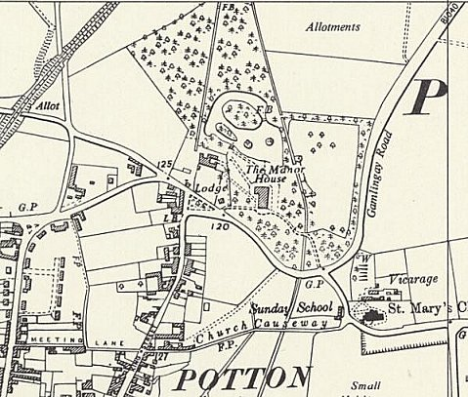
 | Ordnance Survey 1960

