Camp 668 Chiseldon (Halt + aka Chisledon), Wiltshire. (+ Tidworth)

Locations: (1) Tidworth – in a field with the use of some Nissen huts, probably near to the North Tidworth, Aliwal Barracks.  (2) Chiseldon (aka Chisledon). A clue for the location was given in a letter from the camp where it was called: ‘Chiseldon Halt Tented Camp’; Chiseldon Halt was the small station at the NE corner of the camp (NGR SU 195 782).  Before the camp: Area used for army and hospital during WW1. Site used by US forces before it was a pow camp – it was the first site to receive US troops during WW2.  Pow Camp:  18 – 20 June 1945 – TIDWORTH - Mr E A P Helps visited the camp for a ‘Reconnaissance Visit’. His report was headed ‘Tidworth, Wilts’ – probably near to the Aliwal Barracks where the Company moved to later). This was a mobile working company which had very recently been set-up. Strength 425 German pows.  “This working company has only just started on the site of a former American Camp. It is 5 miles from Pioneers Southern Group Command at Chaldecott…. The nearest station for London is Andover Junction.”  Most of the pows had transferred from Glen Mills pow camp in Oldham. Accommodation was in tents with some Nissen huts, “used for other purposes” – offices, cooking, ablutions, etc.  Commandant: Major Beer [Reed] Camp Leader: Stfwbl Georg Muller  2nd i/c: Captain Leeke Deputy C/L: Fwbl Keoppe [Köppe]  Interpreter: Sgt Bierer M.O. Oberarzt von Delft.  The spellings of some names were incorrect – either in this report or the next. The | 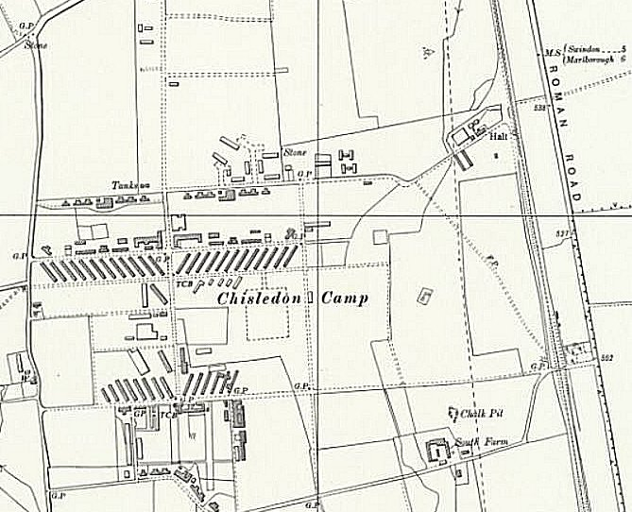
 | Ordnance Survey 1960
Commandant is recorded here as ‘Beer’ – the next report stated ‘Reed’, and in the next it was ‘Reid’, but no change of commandant was noted – I think Reed is correct.

The Interpreter was an Austrian Jew by origin who had been in Dachau concentration camp. Later, he served with the Pioneer Corps in France and was an instructor in “C.C.M.S. section” (?)

The camp leader (Lagerfűhrer) was an N.C.O., “not very intelligent but evidently satisfactory from the point of view of discipline and maintenance”. The deputy was “an intelligent commercial type who calls himself ‘non-political’.

Overall health good – 2 pows were in hospital. 80% of the pows were working.

This was still ‘early days’ for the development of a standard list of re-education activities, but a similar list was given:

Wochenpost - one consignment received. Not generally liked as seen as political, but read by some.

Newspapers – popular English newspapers were received on the day after issue. The visitor suggested that Swiss newspapers should be supplied.

Atrocities film – all pows were required to attend. “The effect of this film in a camp probably depends upon the reaction of the leaders in the community. As the leaders in this camp are very true blue German, the immediate effect of the tension caused by the film was apparently a tightening up of patriotic feeling.” Many of the pows expressed disbelief, recorded comments included;
- ‘the general effect was devastating, but on reflection one could pick holes in almost very picture shown.’
- ‘It is inconceivable that Germans should have allowed piles of corpses to accumulate, it would have started an outbreak of disease’.
- ‘there were people with long hair, this would never be allowed in a concentration camp.’
- children in a concentration camp is an impossibility.’………

The visitor noted that in the nearby Fargo camp the film was very successful in its intended effect.

Religion - ¾ of the camp were protestant. A first service for 40 pows had been held by Uffr. Ehrenpforth in a hut. A Catholic priest visited the camp. The commandant had got the loan of a piano.

Education - classes not yet started, but expected shortly.

Library – none

Recreation – they only had a stuffed football. 2 footballs and 20 packs of cards were requested.

15 July 1945 – CHISELDON - the 668 Pow Working Company relocated to Chiseldon – staff and pows remained the same.

5-6 October 1945 – The camp was visited by Capt Sunley, Capt Deveson and Lt Stewart. Strength 1 officer; 437 ORs. German pows.

Commandant: Major Reed Camp leader: Stbs.Fwl Muller
2nd i/c: Capt Leeke Deputy C/L: Fwl. Koppe
M.O.: Stbarzt. Von Delft

Major Reed was recorded as having little interest in politics or re-education – “He believes in work and discipline and considers that it is too early to have free political discussions in camps as it might lead to trouble. He had placed a ban on open political discussion.” Later in the report it stated that he had agreed to lift this ban. Major Reed also pointed out the difficulties of arranging re-education activities in a tented camp, with a working company, and in winter – the report writer agreed with him on this. An additional difficulty was that there was no British Interpreter; interpretation was conducted by pow O/Fwl Grumbrecht.

Although Major Reed was not persuaded by the Political Intelligence Department’s activities for ‘re-education’, later references to him gave a much more positive picture. We find that he spoke German fluently - high praise was given that he did everything in his power to make his men happy – and, when located in decent accommodation, the 668 Company was described as a ‘happy camp’.

Living conditions were unsatisfactory. Pows were accommodated 12 to a tent with no lights. The dining hall was the only indoor space for recreation being used for reading, wireless room, lectures, films, indoor games…. Mud and cold was a major factor on low morale throughout the winter months.

Morale was also affected by lack of news from home and bad news about Russian occupied Germany. About 100 pows were ‘youth’ (under-25). Their attitude was described as demoralised and indifferent.

Re-education was not progressing within the camp. Apart from the Commandant’s position and the conditions, there was a general lack of interest shown by the pows. The one postive factor noted was that Nazism was a “dead letter”.

Standard re-education activities:

Wochenpost – 100 copies received - sufficient. Apparently more popular than before.

Ausblick – 38 copies received – 60 wanted.

Library – only 50 books received from the YMCA. More needed.

Lectures – 2 so far.

Wireless – One speaker in the dining hall.

Camp magazine – none, but being considered.

English Instruction – separate report.

Other activities:

Religion – no German padre – urgently needed.

Music – a choir and a piano, but no orchestra. Little interest shown.

Theatre Group – None. No theatre space.

16 – 17 October 1945 – A short report was issued by Major J.N.W. Gwynne. Strength 437.

Commandant: Major W S Reid Camp leader: S/Fw Georg Mueller
Interpreter: None Deputy C/L: Fw. Lothar Koeppe

“The Provost Staff consist entirely of German Ps/W sent from Devizes, and the inmates of the camp were unscreened Ps/W from Glen Mills, Oldham, one of the blackest camps in England.” Despite the poor tented accommodation, some of the pows stated that they preferred it to Oldham.

Political screening of the pows gave A-56; B-345; C-20; giving an overall complexion of ‘grey’.

It was noted that amongst the pows were still some Austrians.

2 March 1946 – ‘Report of Move’. The camp was moved from Chiseldon to Aliwal Barracks retaining the number 668.

After the camp: Returned to army use. Camp closed in 1972.

Further Information:

National Archives – FO 939/321 – 668 Camp, Aliwal Barracks, Tidworth, Hampshire. Dated1945 – 1947 (Includes documents related to the Tidworth / Chiseldon sites).

