Camp 609 (& 663) Parkhouse Camp, Shipton Bellinger, Hants

Included in the 1945 ICRC Camp List – Labour Camp. 609. Parkhouse Camp, Shipton Bellinger, Nr.Tidworth, Hants.

Prisoner of War Camps (1939 – 1948) - Project report by Roger J.C. Thomas - English Heritage 2003
OS NGR | Sheet | No. | Name & Location | County | Cond’n | Type 1945 | Comments
SU 2326 4539 | 184 | 663 | Park House ‘A’, Shipton Bellinger, Tidworth | Hampshire | 5 | German Working Company | Precise location not identified. NGR for centre of village.

Location: NGR for the main Parkhouse Camp SU 2185 4580. Just to the E of Shipton Bellinger.  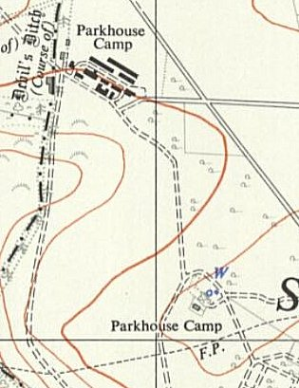  However, the 1958 map to the left shows another site labelled ‘Parkhouse Camp’ just to the SE, (NGR SU 2220 4510). This site is labelled only as ‘Down Barn’ on the 1961 map. The camp was tented, so would have been near to the built camp.  Before the camp: The army camp was built at the start of WW1. Military use up to at least 1944.  Pow Camp: Italian Labour Camp and then German Working Company.  10-11 April 1946 – * Report by visiting lecturer, W J Milch. He recorded that the strength was about 650 German pows, rising from 440. Many of the pows were ‘youth’, (under-25).  Pows were accommodated in tents.  “Camp speaker, deputy and other camp officials (including Doctor) reliable. Camp running smoothly. Good atmosphere. Good contact between officers and P/Ws.”  Morale very good, though negative effects were:  - waiting for repatriation.  - lack of cigarettes – only 15 per week.  - lack of books – 50 for 600+ pows.  - few newspapers, and Ausblick not received for three months. | 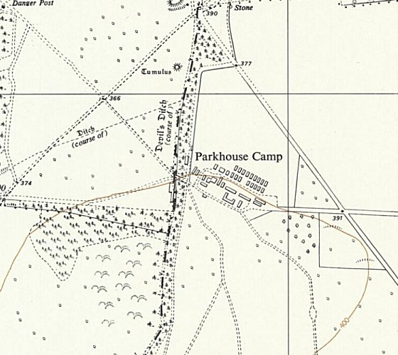
 | Ordnance Survey 1961

“Though most of the P/W’s are working on specialised jobs there are some cultural activities: nice band (a violin badly needed – is there any chance to get one from the violin makers in camp 174?) [Norton Park, Nottinghamshire] – English and Russian classes. Democratic Discussion group. Camp paper (rather weak).” There were issues – time, space for classes and insufficient teachers.

After the camp: Used for a short while to accommodate service families. Appears to be open space on modern maps.
Further Information:
*Report filed under FO 939/321 for Aliwal Camp – the lecturer visited both sites.

