Camp 292 Donna Nook Airfield, North Somercotes, Louth, Lincolnshire

1947 Camp List
292(G.W.C.) | Donna Nook Airfield, North Somercotes, Louth, Lincs | N | Priswar, North Somercotes | North Somercotes 239 | (Blank) | Lt.Col.R.M.Mayhill | v/1453/2

Prisoner of War Camps (1939 – 1948) - Project report by Roger J.C. Thomas - English Heritage 2003
OS NGR | Sheet | No. | Name & Location | County | Cond’n | Type 1945 | Comments
TF 424 979 | 113 | 292 /b | Donna Nook Airfield, Ark Road, North Somercotes | Lincolnshire | 3 | German Working Camp | Former RAF Donna Nook. Precise location not identified, NGR given for approx centre of dispersed sites.

Location: 2 probable sites shown either side of Ark Road  Before the camp: Farmland. The nearby RAF Donna Nook Airfield to the east was opened in 1940 and closed in 1945. RAF huts – possibly army as well (see House of Commons report below).  Pow Camp: Pastscape stated that the camp was known as 292 and 292b – which may explain the two sites on either side of Ark Road. (292a was Kirmington satellite camp).  The pow camp opened in late 1944. Recorded as a German Working camp, but with mixed nationalities. Polish and Ukrainian pows were also held here – German and Polish pows were kept at separate sites.  There was a mention of the camp in the House of Commons in 1946:  “Mr. Osborne asked the Secretary of State for War if he is aware that Army huts near North Somercotes, Lincolnshire, are being broken up and used for firewood by men of the P.O.W. No. 292 Camp; what disciplinary action he intends to take; and what steps he is taking to preserve this public property.  Mr. J. Freeman - My right hon. Friend no longer has any responsibility for this camp, apart from the section used by prisoners of war, which has suffered no damage. Only one case of damage by prisoners to the other hutting has been reported. This occurred on 11th October, and disciplinary action has been taken. My right hon. Friend is, however, bringing the Question to the notice of my right hon. Friend the Minister of Works.  Mr. Osborne - Is the hon. Gentleman aware that I have a letter here from a farmer on whose ground these huts stand, in which he says that two large huts and two small ones were destroyed on 24th September? My evidence is contrary to that of the hon. Gentleman.  Mr. Freeman - I also have a letter from the officer responsible, and my information is different, but if the hon. Gentleman will let me see his evidence, I will look into it.” (Hansard, 22 October 1946, Volume 427). | 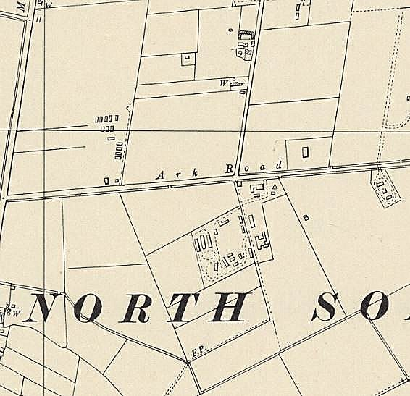
 | Ordnance Survey 1956

26-28 August 1947 – W G W Aston visited the camp for a re-educational survey. Strength 2152 other ranks, of which:

987 were at the main camp at Donna Nook, “claiming Polish nationality”.
44 also at the main camp due for repatriation.

580 were at Kirmington Satellite camp (36 miles away from the main camp). Officer i/c Capt F J Ringer. Interpreter S/Sgt W MacDonald.
265 were at Kirmington Hostel (35 miles)

196 at Elsham Hall Hostel (41 miles)

75 in billets

4 - 2 employed and 2 sick in Lincoln, (I think this means the 2 were employed at the hospital in Lincoln).

1 CRS Holton

Commandant: Lt.Col. R M May-Hill (from the Welch Regiment). Camp Leader: Ogefr.Kokocinski, Bronislaw (B+)
Interpreter: S/Sgt L Vayden. Deputy C/L: Ogefr. SMALEC, Michael (B).
German M.O.: U/Arzt Szopka, Rudolf (B)

Political screening figures: | A | B+ | B | B-
Those claiming Polish nationality | 6 | 103 | 868 | 10
Others | 40 | 201 | 739 | 185

393 pows had been repatriated to date.

It was noted that there was hostility between the Donna Nook main camp with Polish pows, and the large satellite camp at Kirmington and two hostels with German pows. Administration of all sites was carried out at Donna Nook. S/Sgt Vayden was at Donna Nook.

The nationalities for some of the pows at Donna Nook must have been in doubt:

“Ogefr Kokocinski Bronislaw (B+) Camp leader for the pro-Polish component of this camp at Donna Nook (HQ). He is 40 years of age, savings-bank bookkeeper in Poland before the war, a large person with personality, states that he is Polish and has little interest in Germany, and is being repatriated to Poland.”

The deputy C/L stated he was Polish, but wanted to stay on in the UK.

“The Protestant padre Gefr. Cerecki Adolf (A) is Polish claiming German nationality… Pechuta Constantin (A) the RC padre who arrived just as I was leaving. He is claiming Polish nationality.”

Morale was regarded as fairly high throughout the camp. Some pows had been transferred from RAF pow camps and were not so satisfied with conditions at Kirmington. Morale was raised as pows had a ‘walking out’ limit of 10 miles and many expected to be repatriated in the near future.

For the pro-Polish pows at Donna Nook, most were democratically minded, with just 2 considered to be still Nazis, and four communists. The German component was seen to still have a few Nazis, but there were no problems arising. About 30% of the pows were ‘youth’ (under-25), but they did not present a problem.

With the two distinct nationalities, re-education activities were organised separately. There were different interpreters for Polish / German pows. At Donna Nook a lot of re-education was religious based as most pows were Roman Catholic – the two padres led these activities.

The visitor was mainly focussed upon activities that happened in the German ‘component’ – Kirmington and the two hostels. Re-education was limited partly due to the lack of leadership outside of the HQ site. The list of standard activities in his report referred mainly to the German pows:

Newpapers: Wochenpost and Ausblick received. 12 daily British newspapers; some periodicals such as Picture Post; some from Germany and Switzerland.

Library: 1468 German books, but 500 of these were the Gospel of St John, and 380 English textbooks. [The Polish camp also had 1647 German books].

Lectures: Regular and with good attendance, though it was noted more would attend if they were not tired after working overtime at this time of the year.

Discussion groups: Not so successful in the German component, though the youth showed greater interest. Greater success at Donna Nook where it was led by the protestant padre.

Films: YMCA and Travelling Films Ltd on alternate weeks.

Wireless: Kirmington had a radio room with amplifier and 6 loudspeakers. The two hostels had their own radios.

Camp magazine: 100 copies of ‘Der Monatspiegel’ [The Monthly Mirror] were produced. [None recorded at Donna nook].

Press review: Being developed.

English instruction: 43 pupils with 5 teachers + 50 of the 75 billetees. Uptake was higher at Donna Nook, but many were studying on their own.

Information room: also the reading room. Just one exhibition to date. [None at Donna Nook].

Other activities:

Religion: There was a chapel at Kirmington used by the RC; a padre from Willingham House Camp 256 also visited – protestant pows attended local churches. At Donna Nook the RC attended churches at Louth and Grimsby and had visits from the padre at Pingley Farm Camp 81.

Entertainments: A theatre group of 15; an orchestra of 9. Donna Nook also had an orchestra of 9.

Kirmington Satellite and hostel had no football pitch and had to play at other camps. Elsham Hall Hostel had a football pitch.

Some outside contacts were being developed –

Donna Nook – Christian Scientist meetings at Louth and Grimsby. Louth local Methodist meetings.

Kirmington and hostels – Brigg was the only town within 10-mile radius – Toc H meetings, Council meetings and local church activities.

29-31 October 1947. A Re-educational survey was carried out by C J St.L Chappell. Strength – 2158 other ranks.

Main camp 1036 Polish
Kirmington Satellite 545 }
Kirmington Hostel 310 } German
Elsham Hall Hostel 190 }
Billetees 77 }
Screening figures had been greatly simplified to: A 25 (24 Polish) – B 2133. 2800 pows had been repatriated to date.

Commandant: Lt.Col. H C Sansom (Pioneer Corps). Camp Leader: Ogefr.Kockocinski, Bronislaw (B+)
Interpreters: S/Sgt L Vayden; S/Sgt MacDonald; S/Sgt Richmond Deputy C/L: Ogefr. SMALEC, Michael (B).
German M.O.: U/Arzt Szopka, Rudolf (B)

The new commandant started in September and was described as; “…definitely a live wire. He both preaches and practices the doctrine of leadership by example…”

The Polish Interpreter S/Sgt Vayden had been joined by two more Interpreters for German. Vayden was described as having; “wide linguistic capabilities and a ‘Card index’ memory; he is apt to be a little dictatorial and rather starves the two German interpreters (who are at Kirmington) of information.” This led to increased problems between the camps.

Morale was seen to be fairly good among the Germans – “who get on fairly well with the Poles on the rare occasions when they are in contact.” The Polish pows had a lower morale as their repatriation was not as well organised and they were being arbitrarily selected in batches through the Polish Council.

35% of the German pows were under-25, but this was not regarded as a problem.

Re-education activities had decreased due to the extremely long hours being worked for the harvest. The Poles continued to have mainly religious based activities. For Germans, the standard list was recorded:

Library – extremely poor. Out of 1100 books, 630 were German and many were in a very poor state.
Newspaper – satisfactory selection
Discussion groups – little interest.
Films – As before. Popular with the Poles, less so with the Germans.
Wireless - satisfactory
Camp Magazine – German editions of 100 copies per fortnight produced on a home-made duplicator – “fairly good”. This report stated that there was a Polish magazine in the Main Camp.
Press review – weekly newspaper cuttings at Kirmington.
English Instruction – postponed during harvest.
Information Room – one show about ‘Das Englische Parlament’ was appreciated and more was requested.
Lectures – Popular.

Other activities –
Religion – strong in the Polish Camp. German Padres from Brigg and Market Rasen visited Kirmington and Elsham once a fortnight.
Education – postponed during harvest.
Entertainments – Theatre group of 10 men + orchestra of 8 men at Kirmington.

Outside contacts were difficult as the camps were so isolated. It was hoped that the new commandant would soon re-vitalise re-educational activities after the harvest was gathered.

14 November 1947 (FO 939/270) Camp number included in an ‘Urgent Memorandum’ regarding inspection of food parcels.
5-6 December 1947 – Dr J Klein, a visiting lecturer, gave two lectures at the camp and hostel on the subject ‘The World Food Situation’. His report damning regarding what appears to have been a vindictive regime against the German pows in the Kirmington Satellite Camp:

“The morale in this camp is bad and is getting worse. The main reason is that they are remote-controlled by the Polish camp. Decisions, taken in Kirmington are never final. Parcels, after having been searched and passed by Capt.Ringer [Officer i/c at Kirmington Satellite] are searched again by the Polish interpreter at HQ [Donna Nook] and things removed. They never know what they are being allowed to take home on being repatriated. Sometimes, they are being stripped of boot-polish, needles, shaving sticks, razor blades and other stuff, bought in the canteen… (A pair of second-hand shoes was refused because soles are banned and there were soles on the shoes!!) What is worst is that they often do not get their stuff back. All this was confirmed to me by the commandant of the satellite camp, Capt Ringer. The main culprit seems to be the interpreter at H.Q”.

He commented that few pows attended lectures at this camp and that many pows were young.

The camp closed in 1948.

Camp commandants
? – September 1947 Lieutenant Colonel R M Mayhill (May-Hill)
September 1947 - ? Lieutenant Colonel H C Sansom

After the camp: Many of the Polish and Ukrainian pows remained in the UK. Site area greatly damaged / demolished by floods in 1953. The Airfield site is a bombing range and nature reserve.

Pictures of the site today - https://repatriatedlandscape.org/england/pow-sites-in-yorks-humber-and-lincs/pow-camp-292-donna-nook/
https://repatriatedlandscape.org/england/pow-sites-in-yorks-humber-and-lincs/pow-hostel-292b-donna-nook/

Further Information:

National Archives –
FO 939/333 – 292 Working Camp, Donna Nook Camp, North Somercotes, Lincolnshire. Dated 1947-1948. Used above.

FO 1120/243 – Re-educational survey visit reports for camps 286 to 293. Dated 1 January 1946 – 31 December 1948

Kirmington Satellite Camp 292a. Caistor, Lincolnshire.  NOTE – there was also a Kirmington Hostel.  There was a separate entry for this camp in; “Prisoner of War Camps (1939 – 1948) - Project report by Roger J.C. Thomas - English Heritage 2003”. The details given were; “Former RAF Kirmington (Humberside Airport). Precise location not identified, NGR given for dispersed site in village.” However, as this was a satellite camp for HQ 292 at Donna Nook, I include it here.  Prior to becoming 292a – Kirmington was listed as under Willingham Camp 256 and Pingley Farm Camp 81.  Location: Kirmington is about 8km W of Immingham. Possible site with huts located just under the word Kirmington on the map. The RAF Airfield was to the SW of the village.  Before the camp:  Pow Camp: In July 1946 the site was listed as a hostel / sub-camp for 256 Willingham. With just 15 pows present, there was a comment that: “not at present in use. Under preparation for intake.”  My guess is that the 15 pows were a workforce preparing the camp for use, and that it was then transferred shortly after to be a sub-camp for Camp 292 Donna Nook.  Kirmington also appears as a hostel for Camp 81 Pingley Farm – was this the large satellite or smaller hostel? | 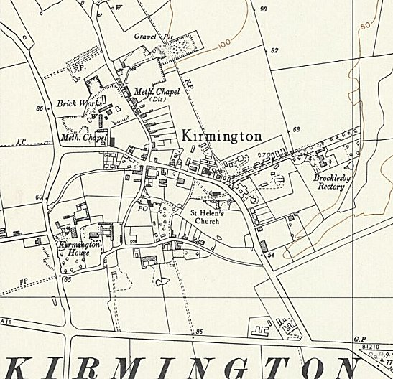
 | Ordnance Survey 1956
26-28 August 1947 – 580 pows.

Officer i/c: Capt F J Ringer. Interpreter S/Sgt W MacDonald.

Camp leader: Uffz.Boerger, Friedel (B) – “…has been in office for 1 month… 25 years of age and is a music student, a quiet respectable person still gaining experience and becoming aware of his duties towards mankind.” Same October 47.

Study leader – Ofw.Kurt Mueller (B+) – “an outspoken person of 28 years, clerk in civil life.”

October 1947 – 2 German interpreters have been appointed, but tensions continue with them and the S/sgt Polish Interpreter at the main camp.

Pictures of the site today - https://repatriatedlandscape.org/england/pow-sites-in-yorks-humber-and-lincs/pow-hostel-292a-kirmington/
https://www.youtube.com/watch?v=hH5JjBwpLbI

Kirmington Hostel

Probably attached to a different main camp before Donna Nook.

August 1947 - 265 pows. Camp Leader Ogefr. Schneider (B-) – “appointed a week ago is a rough opportunistic type who joined the NSDAP in 1930 and had the audacity to state that he had never been a Nazi. He gave his profession as “Theater-wissenschaftler” [theatre scholar? Possibly student?] which defied his elucidation.” He was being given a chance as hostel leader, but the officer i/c was ready to have him removed. Same October 1947 and considered to have greatly improved.

Elsham Hall Hostel

Listed under Camp 81 Pingley, before attachment to Donna Nook.

August 1947 – 196 pows. Camp leader Fw.Mackel, Artur (B+) –“ Hostel leader at Elsham Hall and deputy Camp Leader at Kirmington Satellite camp is a looming Bavarian personality of 37 years, bank inspector in civil life. He affected a taciturn attitude after he discovered that there were some facets of Nazism unknown to him. As he is prospective chief C/L I gave him some hints as to where his weakness lay and reminded him of his duties to mankind.” Same October 47

Study leader – Kurt Schroeder; “24 years of age… a pleasant youngster, clerk in civil life.”

