Camp 199 Haverfordwest, Pembrokeshire (aka Portfield)

Prisoner of War Camps (1939 – 1948) - Project report by Roger J.C. Thomas - English Heritage 2003
OS NGR | Sheet | No. | Name & Location | County | Cond’n | Type 1945 | Comments
 |  | 199 | Haverfordwest | Pembrokeshire |  |  | Wales

Location: NGR SM 9338 1544  Before the camp:  Pow Camp: HER DESCRIPTION – “Complex consisting of 32 rectangular plan gable roofed huts with a number of minor structures all of which have been demolished apart from a gatepost and retaining wall of the main gate. Chiefly used to house Italian POW's. Some German POW's also present.”  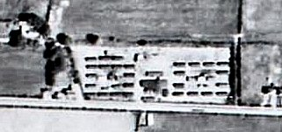  Small, enhanced section of Aerial photograph RAF 106G UK1625 2406  I believe that this camp was taken over as a hostel by Henllan Bridge camp 70 in 1945 (separate details)  After the camp:  Further Information:  http://www.dyfedarchaeology.org.uk/projects/campsandrangespreseli.pdf | 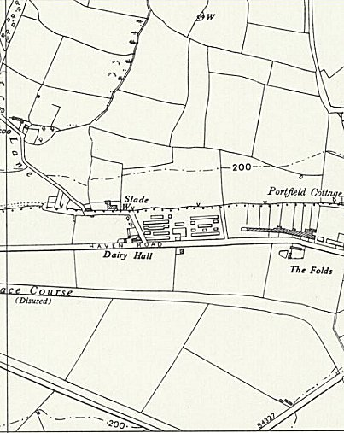
 | Ordnance Survey 1964

