Camp 102 - Llanddarog Camp, Llanddarog, Carmarthenshire

Included in the 1945 ICRC camp list – Labour Camp. 102. Llanddarog Camp, Carmarthen.

1947 Camp list
102(G.W.C.) | Llanddarog Camp, Llanddarog, Carmarthen | W. | Priswar, Porthyrhyd. | Carmarthen 7412 & 3 | Carmarthen | Lt.Col.T.C.L.Redwood | v/1453/2

Prisoner of War Camps (1939 – 1948) - Project report by Roger J.C. Thomas - English Heritage 2003
OS NGR | Sheet | No. | Name & Location | County | Cond’n | Type 1945 | Comments
 |  | 102 | Llanddarog Camp, Llanddarog | Carmarthenshire |  | German Working Camp | Wales

Location: SN 493 165. 1 km W of Llanddarog, 9 km SE of Carmarthen. A survey of sites in Carmarthenshire shows the three small buildings just to the NW of the main compound as being part of this camp.  Before the camp: Farmland  Pow Camp: Listed as Italian working camp / labour battalion to at least 1945, then a German working camp.  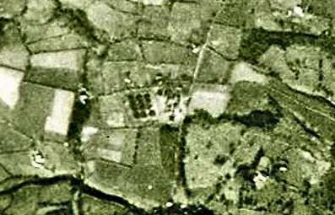  The camp was listed as an Italian Labour Battalion under the Western Command area in May 1944 and as an Italian Working Camp in November 1944, (WO 32/10737).  On 1 August 1945 an urgent memorandum was sent to this camp, and others, about maintaining records of Italians who were classed as ‘co-operators’. At this point many, sometimes all, of the Italian pows were in hostels / billets. | 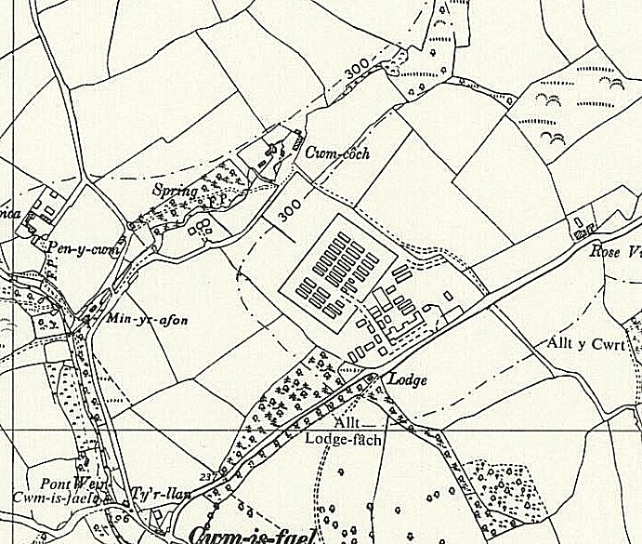
 | Ordnance Survey 1964

Hostels listed for pows from this camp on 15 September 1945, (WO 32/10737): Sketty, Swansea, Glamorganshire

As part of the re-education programme administered by the Control Office for Germany and Austria (COGA), Paul Bondy, a German-speaking refugee gave lectures at the main camp and 7 hostels on 18-20 October 1946. He recorded a camp complement of 2,500.

Camp number included in an ‘Urgent Memorandum’ of 14 November 1947 (FO 939/270) regarding inspection of food parcels.

15 January 1948 - “Camp 70 is to take over Camp 102 (Llanddarog) as a hostel as from 15th January, 1948. It has been arranged with the C.O. of camp 70 that the camp staff and the press group now at 102 will stay after the take-over and that re-educational activities in 102 will continue undisturbed.”

Camp commandant c.1947 Lieutenant Colonel T C L Redwood, from the Royal Northumberland Fusiliers.
There was a monthly camp magazine – Der Leuchtturm – (The Lighthouse).
Postal items: Italian Pow Postcards seen for December 1943 and February 1945. Letter-sheet dated September 1945 to Italy.
After the camp: 2019 farm and farmland
Further Information:
National Archives - FO 1120/224 – ‘Re-educational survey visit reports for camps 100 to 106’. Between 1946 to 1948 inspections were carried out at various camps for German pows regarding the provision of re-education programmes. The quality and detail of the reports vary greatly.

US 1944 US Aerial Photograph, Medmenham Series M1281; 1017

The Imperial War Museum has copies of the magazine, dated June / Christmas 1947, Ref LBY E.J.388. The German Federal Archives also has a copy, date unknown.
Hostels
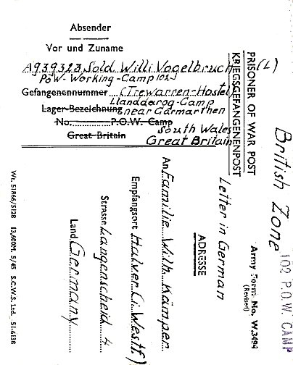
Trewarren listed as a house.

Possible location – Trewarren House – SM 8293 0703. Requisitioned 1942 and used as a HQ for a light Anti-aircraft battery.

Transferred to administration of Henllan Camp 70 late summer 1947.

<<<< Trewarren Hostel 23 July 1946.

