Camp 97 - Birdingbury, Bourton on Dunsmore, Warwickshire

Included in the 1945 ICRC camp list – Labour Camp. 97. Birdingbury Camp, Bourton, Rugby, Warwicks.

1947 Camp list
97(G.W.C.) | Birdingbury Camp, Bourton, Rugby, Warwickshire | N | Priswar, Bourton, Rugby | Marton 314 | Birdingbury (L.M.S.) | Lt.Col.P.W.Dollar | v/1453/2

Prisoner of War Camps (1939 – 1948) - Project report by Roger J.C. Thomas - English Heritage 2003
OS NGR | Sheet | No. | Name & Location | County | Cond’n | Type 1945 | Comments
SP 430 698 | 151 | 97 | Birdingbury, Bourton on Dunsmore | Warwickshire | 4 | German Working Camp | STANDARD type.

Location: About 1.5 km N of Birdingbury; 10 km SW of Rugby.  Before the camp: Farmland / allotments  Pow Camp: In 1943 the first Italian pows were housed in tents while they built the huts. Italian pows until early 1945, then a German Working Camp. German pows started to arrive at the camp in late 1944. Some Italian pows were still attached to the main camp in 1945 – though it is most likely they were accommodated in a separate hostel and billets - they would not have been with the Germans.  The site had a standard layout with a main pow compound (east), with guards’ huts and offices at the front (west), alongside the road. Paths within the camp were concrete. Common buildings and facilities at standard type camps included water towers, offices, officer's mess, a canteen, guard rooms, barrack huts, ablution blocks, cell blocks, a camp reception station (medical facility/hospital), a cookhouse, dining rooms, recreation rooms and living huts or tents.  There was an International Red Cross visit on 14 March 1944 - capacity 560.  The camp was listed as an Italian Working camp in November 1944, (WO 32/10737).  From 1945 a series of visits were made on behalf of the Political Intelligence Department (P.I.D.) / Foreign Office to assess re-education of German pows, (not Italian).  23-24 March 1945. A visit was made to the camp to assess re-education activities. 460 pows were employed on farms – but the total strength was not given. The visitor’s signature is unreadable.  Commandant: Major I.W. Thomson Adjutant: Lieutenant Plane. Interpreter Officer: Lieutenant G E Lovelace  Lagerfűhrer: S/Fwbl.Killat Assistant Lagerfűhrer Fwbl. Stűbner. | 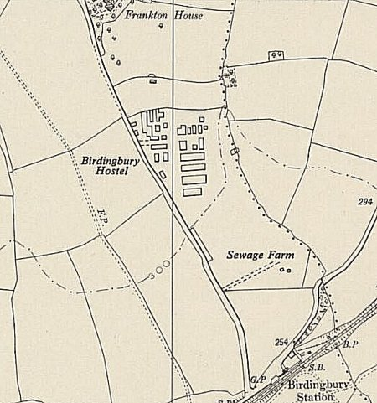
 | Ordnance Survey 1955

The Camp Leader (Lagerfűhrer) was interviewed. He had served 12 years as a soldier. He was described as being Seelenkrank (a sick soul) with anxiety about his family and his country. Regarded as an anti-Nazi. (Other visitors also reported him as being depressed).

The Medical Officer – Unterarzt P Contzen was also regarded as an anti-Nazi - “Tries to put his ideas over with other Ps/W. A pleasant and sympathetic type.”

“Ps/W mess waiters and batmen are employed in Officer’s mess and quarters. This practice, however, is going to be stopped by O.C. Sub-district.”
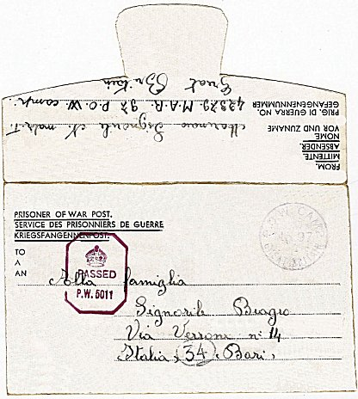 | There were no education courses taking place, other than teaching English. The teacher, Ob.Gefr Magnus Peterich, was regarded as a ‘dark-horse’. He had been a foreign correspondent, had written short stories, and is “a man of some culture”. The stated reasons for the lack of education courses were the late return at 18:30 of the pows from work, and the lack of any driving force in the camp.  There was a library with 900 books, (830 German, 40 English, 30 French) - however many of them were in bad condition. English newspapers were received, also Wochenpost.  There was a radio, theatre and small orchestra. There had been a few films shown. Sports facilities included a football ground and running track – some sports events had been held.  The visitor’s general attitude to the pows was displayed in his comment; “Many of them are of a good open-faced type, but probably not overburdened with brains or given to thought.” He judged the camp to be mainly non-political with just a few Nazis and communists.  The visitor recommended that lecturers should come to the camp to talk about re-building Germany; and give some lectures about history, “in simple language”. Little response was given to these requests until April 1946 when a regular series of lectures was given at the camp.  17 July 1945. A brief report was given about education courses. Very little had changed. Magnus Peterich was still teaching English.
Italian pow letter-sheet dated May 1945

14 – 16 September 1945. A visit by James A Potter to investigate the state of re-education. Oh dear!

Strength was declared as 670, “including 29 Austrians, 12 Poles, 15 Czechs and some other non-Germans” – not sure if these other non-Germans were the Italians.

“The Commandant, Major S W Thomas* has no interest in re-education and is definitely unhelpful.” (*In the last report it was I W Thomson – are these different people or a mistake in the names?). Many Commandants had no interest in re-education, it was not what they were there for; they were there to utilise the pows as a workforce. However, this Commandant appeared to be particularly obstructive.

The visitor believed that the overall political gradings of pows as ‘white’ was incorrect – “there are 61 former party members and 1 SS man…” He found that a number of pows had not been graded at all and he re-graded the camp as white-grey.

Evidence that Italians were still attached to the camp was given – “There are two interpreters, S/Sgt Becker and Sgt Marsgall, who also interpret for the Italian camp and both of these are very helpful.” He did not state where that Italian camp was.

Morale – “The morale of Ps/W in this camp, especially the camp staff is the lowest I have yet encountered. After investigation I attribute this to the following reasons.

Poor camp leadership. [By this he meant the German pow leadership – the Commandant is mentioned below].
Promises said to have been made by other visitors that this camp would be among the first to be repatriated.
Indifference on the part of the Commandant.
Current news from Germany especially the evacuation from the East and prospects of winter starvation.
Feeling created by talks with men from other camps whom Ps/W meet at work that Nazis are better treated than they.
Acute temporary shortage of cigarettes.

Mr Potter stated that the camp leader was, “exceedingly depressed and apathetic and is in a morbid state….. [he] has difficulty in maintaining discipline, and anti-militarism of the wrong sort is prevalent.”

The medical officer, previously commented on as pleasant and lively, was, “in little better heart” than the camp leader. The MO stated that about two-thirds of the camp were unpolitical, but anti-British, and 10% communist, with a few Nazis. “There is certainly Communist propaganda going on in the camp, which flourishes only because of the lack of any positive influences.”

The two young padres were without influence.

The only positive remarks regarding the German staff were for the English teacher – Siegel – “the only live man on the camp staff” and “a good teacher”. He had lived for 10 years in the US – but even he was dissatisfied, “and regularly bombards the War Office with petitions for his release because of the information he gave after capture.”

The pows in general were seen to be; “permeated with nihilism, resented discipline and were cynical about everything.”

There was a theatre, but no theatre group as, “everyone in the camp had lost interest and was completely indifferent” – but, there was a good camp orchestra conducted by a competent man.

English, Swiss and German newspapers were received. The library was good with 1102 books – about half being fiction. There were classes for English, French and Russian. Lectures were very infrequent – the last being two months previous.

A camp newspaper was being considered – but not started - the visitor doubted it ever would as the Commandant refused to allow any facilities. There were no discussion groups. The radio was not working properly, and the Commandant was not interested; “He said that the set had been bought by the Italians anyway, and that the Germans were lucky to have the use of it.”

Mr Potter recommended:

Replace the camp leaders as soon as possible.
Start a series of lecturer visits.
Get a camp newspaper started – typewriter and paper needed.
A man to organise the theatre.
Music and MS paper for the orchestra.
Old American magazines [ - why?]
Copies of political pamphlets and Ausblick
Crystal radio sets were suggested by the English teacher so that pows could listen to BBC programmes.

Some visiting lecturers did arrive at the camp. They gave general reports on their lectures and the response of the pows – but, six months on from the last negative report, the attitude of the commandant had not changed. This is recorded on:

20 March 1946. A visiting lecturer, Dr H L Gottschalk, submitted his usual report about his lecture, but also gave an appendix. He complained about his poor reception at the camp by the Commandant, and “I should like to know what the reason for this treatment of a lecturer was who came on the expressed wish of P.I.D. and wants nothing but the most primitive courtesy to be expected between gentlemen. And this rudeness contrasts sharply with the behaviour of all the other officers whom I met before.”

This was acted upon by Major Robert Seeds of the Lecture Section, P/W Camps Committee. He supported the claims made and stated others had made similar comments. He referred the matter to the POW department at the War Office on 25 March 1946.

10 / 14 April 1946. Report on three visitors to grade unscreened pows. Strength 922. Main camp, 5 hostels, and billets.

Commandant: Major S W Thomas

Lagerfűhrer: St.Fw Walter Killat (A) “has held appointment since 25.9.44; was a clerk in metallurgical works. Fairly well educated. A decent definite anti-Nazi, but lacks personality and decision. Political opinions: social democrat.”

Sub-Lagerfűhrer: Fdw. Otto Stubner (A): “aged 32. Was arrested for investigation of his S.P.D. views and background in 1933. Only detained a few days. No Nazi affiliations. Was considered unreliable by the Nazis and therefore never obtained regular employment. A very good type.”

Overall political complexion: Grey.

“The Commandant is unco-operative and has no interest in re-education. S/Sgt Becker (Swiss), languages very good; will be demobilized next month. S/Sgt Stanleigh: first class English and German. The Adjt. Lt. Fletcher, was helpful in several ways, including arranging for transport.” Becker and Stanleigh were the Interpreter Officers for the camp.

More than half of the pows were, “new or comparatively new arrivals.”

The five hostels were small with under 100 pows. Only two were still open by the end of the year. Larger hostels were acquired or built. (See chart below).

4 December 1946. Report on re-education by L D P Cooper. Strength 1407 – (1 officer, 1406 other ranks). 6 hostels listed.

Commandant: Lt.Col P W Dollar Interpreter: S/Sgt Rodney
Camp Leader: Hfw. Robert Gering (A) Deputy C/L: Fw. Hubert Warmewitz (B) German M.O.: S/Arzt Dr Halten (A)

Political complexion: grey – but only 463 of the 1407 pows had been screened.

There was a new Camp Commandant – whether this was a result of previous complaints, or just the regular change-over of staff that occurred in many camps, is not known. I think the new commandant was Peter W Dollar from the 4th Queens Own Hussars – a major Polo player – ex pow from Colditz - with a file of some of his private papers held at the IWM, (Cat Documents 1 080).

“Commandant afforded every facility for investigation of re-education and is fully co-operative. The S/sgt knows his job, speaks excellent German and is keen”.

“Morale is good on the whole. The fact that repatriation has begun and is likely to increase in volume keeps them cheerful.”

About 500 pows were ‘youth’ – under-25 – but this was not seen as a problem.

Re-education activities were seen as being “rather backward” – but there were signs of improvement. The standard list of activities was given –
Newspapers: English newspapers + Wochenpost and Ausblick
Library: 2000 books.
Discussion group: about 30 pows attending
Films: regular, but not outstanding
Wireless: good, controlled in C/L office.
Camp magazine: started – ‘Aufbau: Lagerzeitung Camp 97’, (Construction – Camp 97 Newspaper). Edited by Gefr. Gottfried Wagener (B-) and Gefr. Gerhard Wegener (B+). No outstanding editorial talent.
English Instruction: held once a week and at hostels – Banner Hill, Bridge End and Tachbrook.

Other activities;
Religion: a hut being used as a church. Protestant padre. A Catholic Priest comes every three weeks from Ettington Camp 31.
Theatre: “There is no available talent.”
Orchestra: 11 performers with leader Gefr Baumgardt (B+).

22 April 1947. A second visit by Mr Cooper concerning a re-education survey. Strength 1258 – 1 officer and 1257 other ranks.

Commandant: Lt.Col P W Dollar Interpreter: None
Camp Leader: Uffz Silberberg (B) Deputy C/L: Fw. Scholz (B) German M.O.: S/Arzt Dr Halten (A)

General screening figures were given: A – 3 B – 1175 C – 80.

Morale was recorded as; “Good. There are excellent facilities for study and sport. The whole camp has been screened and the PsW appear quite happy.”

Re-education activities were noted to be similar as before, but with some progression. The camp magazine had improved in quality. There were classes for book-keeping, French and mathematics. A theatre group had started.

“It is considered that a good effort is being made at this camp to carry on re-education more especially as the outstanding personalities have been repatriated.”

6 August 1947. Mr Cooper made his third visit, together with a C J Chappel. Strength 1207 – 1 officer 1206 other ranks. Main camp, 3 hostels and billets.

Commandant: Lt.Col P W Dearden Interpreter: S/Sgt Dole
Camp Leader: Ufw Franz Silberberg (B) Deputy C/L: Fw. Gerhard Scholz (B) German M.O.: S/Arzt Dr Brendel (B)

Screening had been largely phased out by this time. Figures given; A – 1 B - 1206

The Commandant and interpreter were new.

The camp leader was described: “36 years of age… a mining technician in civilian life. He has never been in the party, and has no marked political tendencies. He carries out his duties satisfactorily. Quite a pleasant and energetic character.”

The deputy: “36 years of age… a mason by trade was called up for the army in 1940. He is a good understudy to the Camp leader. He carries out his duties efficiently. A good type of working man.”

Re-education activities were similar to previous reports. An Information Room had been added which displayed press cuttings and translations of articles. It was noted that longer hours spent at the farms limited the scope for re-education.

The number of outside contacts was one area that had changed. There were groups attending evening classes at Percival Gild House in Rugby. There were visits planned to the Rugby Town Hall, Stratford Theatre and a boxing match. It was hoped that a master from Rugby school would visit to give some lectures.

25 September 1947. A note from a visiting lecturer stated: “Camp 97 has only 2 hostels now, Bridge End and Banner Hill. A third hostel [Tachbrook] was dissolved, recently, and it is rumoured that the main camp itself will be dissolved in a few weeks time.”

14 November 1947 - Camp number included in an ‘Urgent Memorandum’ (FO 939/270) regarding inspection of food parcels.

It is believed the camp closed at the end of 1947. The two hostels, Banner Hill and Bridge End hostels are recorded as part of Ettington Camp 31 by February 1948.

After the camp: A hostel for displaced persons, mostly from Latvia, Lithuania and Estonia. From 1953 emergency council housing for a short time before being dismantled. 2019 farmland.

https://repatriatedlandscape.org/england/pow-sites-in-the-west-midlands/pow-camp-97-birdingbury/

Further Information:

National Archives FO 939/306 – 97 Working camp, Birdingbury Camp, Bourton, Warwickshire. Dated 1945-1947. (Used above).

National Archives - FO 1120/223 – ‘Re-educational survey visit reports for camps 93 to 99’. Between 1946 to 1948 inspections were carried out at various camps for German pows regarding the provision of re-education programmes. The quality and detail of the reports vary greatly.

Aerial photograph – RAF 1947, SP46NW

The Imperial War Museum has copies of the magazine dated February / July 1947. Ref LBY E.J. 672.
Numbers of pows at Marbury Hall Camp
 | Open |  |  | With other camps |  |  | Unknown |  |  | Not listed / not open

 | 1943 | 4/46 * | 12/46 | 4/47 | 8/47 | 1948
Main | Capacity 560 | 564 | 541 ** | 538** | 455
Banner Hill |  | 1944-46 ? | 319 | 240 | 287 | With C31
Bridge End |  | ? | 218 | 200 | 202 | With C31
Bubbenhall |  | 61
Dunchurch |  | 50
Gaydon |  |  | 22
Ladbroke |  | 76 | 77 | 70
Pailton |  | 74 | 75 | 70
Southam |  | 35
Tachbrook |  |  | 155 | 140 | 141
Billets |  | 48 | ? | ? | 122
TOTALS |  | 908 | 1407 | 1258 | 1207
*Approximate – the figures are 14 short of the total given with the reason given that the nominal rolls were inaccurate.
** including billetees.

Hostels
The first mention of hostels in the FO 939/306 file is in April 1946.
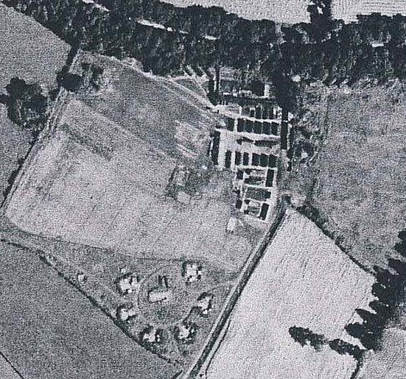  Banner Hill  Huts located just below Goodrest Cottages at NGR SP 2758 6948. Banner Hill Farm was to the west.  1941 – 1944: Heavy Anti-Aircraft site, H25.  1944 – 1946: ?  1946 – 1947: Hostel to Birdingbury Camp 97.  1948 – 1948: Hostel to Ettington Park Camp 31.  Nissen huts for accommodation, cookhouse, canteen and latrines.  “One ex-POW recalls that he was employed emptying waste buckets from homes in Leek Wootton with outside lavatories. He also drove a dust cart for the council. Prisoners were paid for the work in tokens rather than currency. Football matches were played between the prisoners and locals who were generally reported to be ‘friendly’. A reunion of some of the prisoners who could be traced, has been held on the site.”  From - www.geocaching.com/geocache/GC80FGK_banner-hill?guid=9b8b7a68-e784-4018-abd1-9b4cf89441e3  December 1946 the Hostel Leader was Ofw. Dransfield (A).  April 47 the Hostel leader was Fw P Fateiger (B+) – still there in August 1947 | 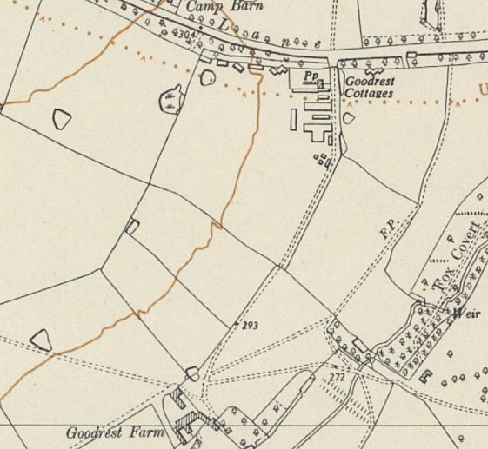
 | Ordnance Survey 1954

February 1948 recorded with Ettington Camp after Birdingbury had closed down.

No. of pows | 1944-46 | 12/46 | 4/47 | 8/47 | 1948
Banner Hill | ? | 319 | 240 | 287 | With C31 - 68

Bridge End  “There was a German PoW camp at the corner of Myton Road with Banbury Road, where the prep school is today.” – listed on ourwarwickshire.org.uk. This would be at NGR SP 2877 6448 (What was the site shown lower on map next to Greville House???)  December 1946 – Hostel leader Leader Ofw. Blume (A)  April 1947 – Hostel leader Uffz. H Schellack (B) – same in August 1947.  February 1948 the hostel is recorded with Ettington Camp 31.  4/46 * 12/46 4/47 8/47 1948  Bridge End ? 218 200 202 With C31 | 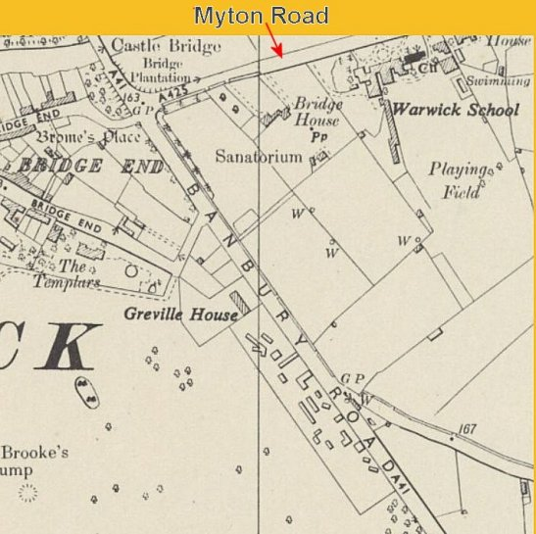
 | Ordnance Survey 1954

Bubbenhall – 6 miles from main camp.

Before 1946?

April 1946 – Hostel Leader: Helmut Welzer, 88327 (B+), O/Maat. Navy: arrived from Canada just one month ago, speaks English: was in Merchant Navy: an anti-Nazi, but he admits his re-education is not yet complete. Makes a frank and decent impression. Mittel Schule education.

Hostel not listed by December 1946.

 | 4/46 * | 12/46 | 4/47 | 8/47 | 1948
Bubbenhall | 61

Dunchurch – 4 miles from the main camp.

May 1946 a visiting lecturer reported that; “In Dunchurch though the greater part are not adherent to nazi-mentality the feelings of the Ps/W are roused by propaganda of a Communist. This man was in the Main Camp prior to his transfer to Dunchurch. Also they had difficulties with him, as the Protestant Padre informed me. According to his own report he has been in Siberia in earlier years. His propaganda seems to have been not without success. That is a pity as there are a good number of younger boys who in themselves make a favourable impression.”

Hostel not listed by December 1946

 | 4/46 * | 12/46 | 4/47 | 8/47 | 1948
Dunchurch | 50

Ladbroke – 7 miles from the main camp  “One of the major changes in the pattern of life in the village was the setting up of a Prisoner of War Camp in Radbourne Lane at the beginning of the second World War, initially as an open prison for captured Italians. It is an indication of the relaxed regime (and of the primitive conditions) that one of the prisoners was allowed to visit Sarah's Cottage in Bridge Lane daily for two large buckets of water since there was no water supply at the camp. The Italians helped in various local farming and drainage projects and became a familiar part of village life; local children found the camp an ideal place to while away their spare time. The inmates were naturally Roman Catholic and it was a familiar sight on Sundays to see them all marching into the Convent in Southam, wearing their uniforms of plain brown material with a large red cross on their backs, as a target for marksmen if they should try to escape into the open countryside.  Towards the end of the war the site was converted to a German Prisoner of War Camp and the whole atmosphere changed. High fences were erected, local people were discouraged from going near and the village had little contact with the prisoners. At the end of the war the camp was changed again and became a centre for displaced persons, mainly from Estonia and Latvia. Over the years it became known as the "Polish Camp", and was maintained under the able supervision of "Ted" (Tadeusz Arczitowski). Gradually the numbers dwindled and the camp was finally disbanded altogether in 1984. The buildings have mostly been demolished and modern bungalows have been built on the site.  Information from - https://sites.google.com/site/ladbrokevillage/history  April 1946 – Camp Leader: Fw Josef Webelacker 6737 (A): Upgraded to A from B. Aged 31. At one time was an R.C. monk in Holland and became a regular soldier. A good disciplinarian, serious minded type and well spoken of by British and PW camp staff. | 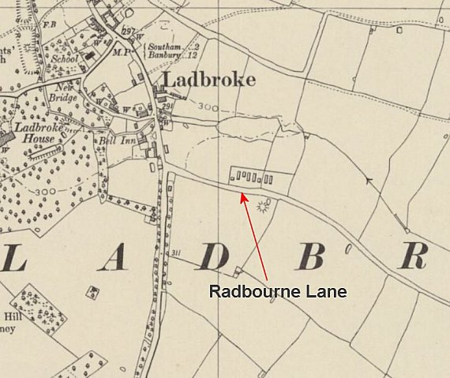
 | Ordnance Survey 1954

December 1946 leader Fw. Ubelacker (B) – still there in April 47.

 |  | 4/46 * | 12/46 | 4/47 | 8/47 | 1948
Ladbroke | Italian pows | 76 | 77 | 70

Pailton – 12 miles from main camp.  Location POSSIBLY at the site marked ‘Hutted Hostel’ NGR SP 4645 8218  Held Italian pows before the Germans.  April 1946 Fw Walter Saelzler 816744 (B): C/L at Pailton Hostel, reported to be rather senile.  December 1946 leader Fw. Salzler (B) – still there April 47  4/46 * 12/46 4/47 8/47 1948  Pailton 74 75 70 | 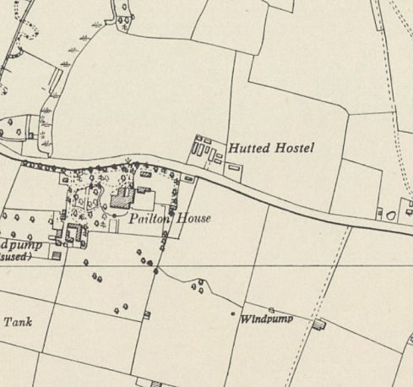
 | Ordnance Survey 1954

Southam – 5 miles from main camp.

April 1946 – Camp Leader: “O/Fw Peter Braun 656785 (B): Not much personality. A simple minded type.”

May 1946 a visiting lecturer recorded that the pows ranged in age from 19 to 42 with younger ones in the majority.
December 1946 not listed.
 | 1943 | 4/46 * | 12/46 | 4/47 | 8/47 | 1948
Southam |  | 35

Tachbrook  Location NOT CONFIRMED – possible site at SP 3275 6128 – shown as Agricultural Hostel in 1954.  Prior to 1946?  December 1946 leader Uffz. W Tweitmann (B) – still there August 47.  Closed end August / early September 1947.  1943 4/46 * 12/46 4/47 8/47 1948  Tachbrook 155 140 141 | 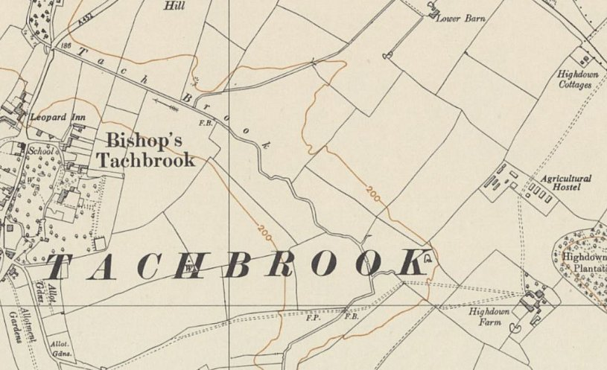
 | Ordnance Survey 1954

DESCRIPT

