Camp 180 (& 189) - Marbury Hall Camp, Northwich, Cheshire

1947 Camp list
189(G.W.C.) | Marbury Hall Camp, Northwich, Cheshire | W. | Priswar, Northwich | Northwich 4385/6 | Northwich | Lt.Col.C.L.Fisher | v/1453/2

Prisoner of War Camps (1939 – 1948) - Project report by Roger J.C. Thomas - English Heritage 2003
OS NGR | Sheet | No. | Name & Location | County | Cond’n | Type 1945 | Comments
SJ 561 449 | 117 | 180 | Marbury Hall Camp, Marbury, Northwich | Cheshire | 5 | Base Camp

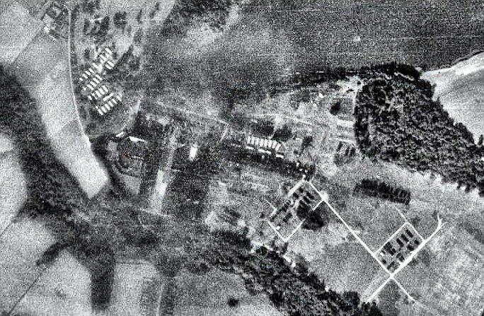  Aerial photograph 1945 | 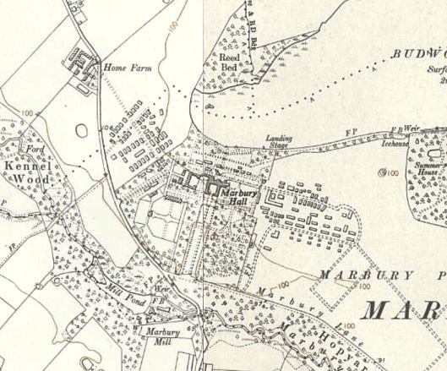
 | OS 1954 - ICI have changed parts of the pow site by this time.

Location: NOTE the NGR given by the English Heritage report above is incorrect. Marbury Hall pow camp was located around SJ 6507 7640. About 4 km N of Northwich.
‘West Camp’ was NW of the hall, ‘East Camp’ under the double rows of lime trees and in the intervening space between them.

Before the camp: Country estate until 1932. Country Club. 1940 Military camp for British, Polish and American troops in the grounds of the estate, mainly on the east and west sides of the hall. The US base built a network of tarmacked roadways at the site.

From the pictures below, the camp appears to have had two main types of buildings:
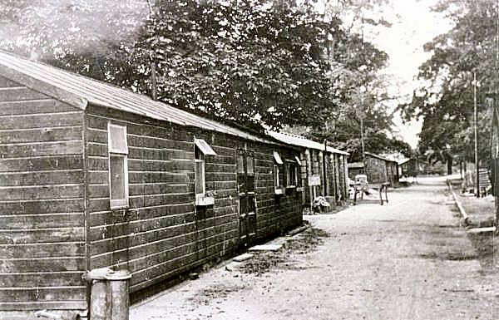 | 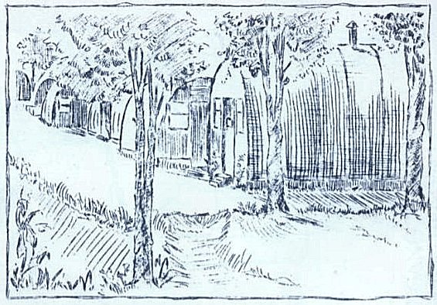
Wooden huts at Marbury – described as Army huts in the 1940’s (probably late 40’s).  www.northwichguardian.co.uk/news/18603565.history-marbury---small-mid-cheshire-village/#gallery0 | Nissen type huts at Marbury – titled ‘Lagerschule’ – Camp school.  Part of book donated to ‘FOAM’ – see further details.

Pow Camp: Base Camp 180 from October 1944 to August 1946, then Working Camp 189 to 1948. The two sides of the camp were referred to as Ostlager and Westlager.

Nationalities. There are references to the camp holding; “Germans, Russians, Poles, Italians and Austrians” – I am not sure this is correct. Although the Geneva Convention stated: “Belligerents shall as far as possible avoid bringing together in the same camp prisoners of different races or nationalities” – this certainly did occur at several camps. However, different nationalities were segregated into different areas / compounds. Quite apart from the Convention, this was necessary to prevent the mayhem that would have occurred with mixed nationalities.

I have found no references to Russians at the camp, though it is possible some slipped through stating they were German. The only information I have seen of Poles was as guards.

Germans and Austrians were usually segregated within camps, with Austrians placed into separate hostels or compounds. Austrians were known to have been at Marbury in 1945 and there is a very brief record of Austrians in a report from December 1946 where it refers to 8 Austrians having been repatriated.

Italians were certainly in the area, and referred to in various sources, but I have not seen any official references to Italians at Marbury. Italians were often used to build camps – and so may have been on-site extending the camp prior to the arrival of US troops. They were also used in many cases to convert existing army camps after D-day for pow use. The nearby camp at Comberbach, a hostel for Tarporley camp until 1946, held Italians and these may have been employed as a work-force at Marbury.

23 October 1944 camp opened as a base camp for German Other Rank pows.

Recollections, from ‘Children of The Blitz’, Penguin, 1995 – “As the tides of war swayed in our favour, trainloads of German POWs arrived at Northwich Station. They were lined up four abreast and marched to Marbury Hall. I and hundreds of other youths often went to watch their arrival, to hoot, jeer and shout at these our enemies, whole lines of unkempt men, with few possessions, unshaven, weary, red-eyed and in some cases ill-clad, these once-proud remnants of Hitler's armies, escorted by perhaps a dozen or so armed troops, as they marched the two or three miles to their camp.

Gradually people became used to these arrivals, and feelings towards them gradually tempered. The Italian POWs were the first allowed out of camp to work on farms and in local factories, including ICI.” (Boy, aged thirteen, Cheshire)

[Note the reference to Italians].

December 1944 - Four pows escaped from Marbury and were apprehended only a few miles away at the USAAF Burtonwood Aerodrome near Warrington.

“The Luftwaffe men would never reveal how they got out of the camp but about midnight, Private Arthur Seher, a military policeman from Oklahoma saw a glimmer of light in the dark nose of a Marauder bomber on the Warrington aerodrome. He crept up to the aircraft and was surprised to see feet jutting from the bomb bay. ‘Come out, you,’ he said, still not thinking that he would come face to face with a German prisoner…. Seher flashed his torch into the aircraft and saw three other men tinkering with the controls…
’There was just one control I didn’t understand or we’d have been off the ground,’ said the prisoner who claimed to be a pilot. ‘Hell,’ he added to the guard, ‘I expect you’d like to be home at Christmas, too!’” (‘A Taste of Freedom’ – Robert Jackson – Arthur Baker Ltd – 1964).

24 February 1945 – premiere of a concert performed by the playgroup of pow camp 180. Programme cover from ‘FOAM’ article >  10-11 October 1945 – Report on English Instruction, (FO 939/176). Strength 1597.  “The camp is divided into Ostlager and Westlager. In the former there is one teacher of English” (Paul Booms) – it is expected that a new teacher will start soon, (Willi Tschoepe). R D Miller, the inspector, requested some English teaching books.  2 February 1946 – Report on English Educational Visit.  “Reception was quite good; though the Commandant thinks that re-education is being over-emphasised, he is friendly and not obstructionist.  The two compounds into which the camp was formerly divided have now been reduced to one, which facilitates instruction. Another change is the establishment of a small hostel, at Blakemere, a bakery with 69 Ps/W…”  The Blakemere hostel seems to have been very short lived as there are no further references in the reports to this site. The books requested in October had still not arrived – the two pow teachers were providing English lessons.  6 May 1946 – 180 Base Camp - “Special Objects of Visit –  Assess suitability of proposed candidates for B’field.  Select Candidates for Theatre Group.  Report on Hamburg Radio.”  Strength 1315 German pows – 4 Officers and 1311 Other Ranks. Camp (political) complexion - grey. | 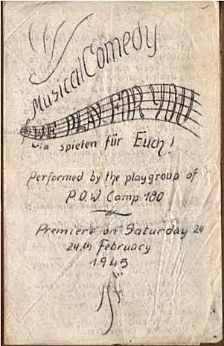
Political screening figures:

A+ | A | A- | B+ | B | B- | C | C+ | Unscreened | Candidates for B’field
nil | 85 | nil | 7 | 591 | 3 | 138 | 14 | 477 | 2

Personnel:

O.C. Lt.Col H.D.Scowcroft, O.B.E. Camp Leader: H/Fw. Kurt Hengstmann (B)
Interpreters: Capt. Ulanowsky. Fw. Engelbert Eidherr (A)
S/Sgt. Ford. Deputy C/L: Fw. Valentine Scmitt (A)
S/Sgt. Peters. German M.O.: O/Arzt. Hans J Poser (C)

“This is a hutted base camp established in October, 1944. The staff were appointed by the Commandant. They appear well chosen and carry out their work satisfactorily. They are keen on re-education, and lectures and classes are generally well attended.

Morale on the whole is good… Morale is adversely affected principally by there being no official statement of how long PW will be kept in this country and by the absence of regular mail from the zones other than British.”

The camp had a fluctuating population as it was a base camp. At this time there were 400 youth pows (under-25), but these were not regarded as a problem. Not surprisingly, considering the disruption throughout Europe, delivery of mail from abroad was an issue in all camps. Pows with families in the Russian zone would receive very little, and for many, none at all, causing a great deal of anxiety.

The standard ‘re-educational’ activities were listed:

Newspapers: English, Swiss, German + Ausblick and Wochenpost.

Camp magazine – due to start.

Library – 400 books.

Lectures – frequent.

Discussion groups – none.

Films – regular from PID and YMCA. PID = Political Intelligence Department.

English Instruction – 2 lessons weekly for beginners, medium and advanced pupils.

Wireless – Set not very powerful. Cdt.gets Hamburg Radio. Set controlled from the Camp Leader’s office. There are 8 loudspeakers.

Other activities listed:

Religion – services on Sundays for both Protestants and Catholics.

Education – French; painting and drawing; mathematics; book-keeping (due to end).

Theatre – there is a stage but “no dramatic talent at present”.

Orchestra – “there is a good orchestra who play classical and jazz music. They are much appreciated and play an important part in camp life.” As fraternisation restrictions were eased, the camp gave concerts to the public, and small groups of musicians even visited people’s homes.

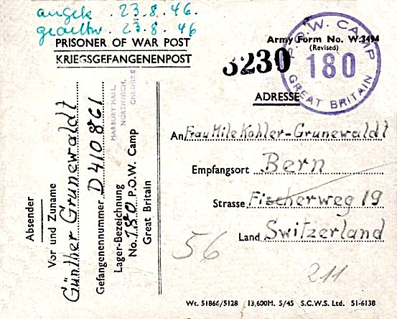 | Pow postcard July 1946:  Dear Cousin Mile.  You will be astonished to get this note from England now. I have been here since May. I hope to come home at the end of the year. I am healthy, I feel fine according to the circumstances. Have you received your mail from over there? Please write too. I salute you and wish you well. Gűnther.  The first two sentences may indicate that Gűnther was held in another country before being sent to Marbury. | 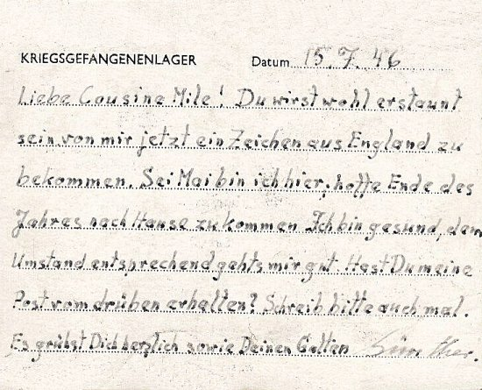

July 1946 - a major re-organisation occurred which resulted in re-numbering of some camps, including Marbury.

A large group of youth pows were transferred to Radwinter North Camp which took the number 180.

Marbury Hall was re-numbered as Camp 189, which had previously been allocated to Dunham. Dunham became a ‘hostel’ (sub-camp) for Marbury for a short time before it closed.

15 September 1946 – English Inspector’s Report. Camp 189. Strength 3500 = 2300 main camp + 1200 in 6 hostels, (the figures given in the report add up to 3589 – see table below).

There were 3 classrooms in huts with electric lighting and stoves for heating. The report gives a very brief description of the pow teachers and books available.

27 September to 20 October 1946 – Visit by members of the ‘Segregation Section’. It was general policy not to place Category C / ‘Black’ pows in separate camps, but to segregate them within a camp – usually placing them in separate hostels.

Strength 3537 in the main camp, 13 hostels and billets.

Commandant Lt.Col Fisher. Assistant Commandant Major Douglas. Adjutant Capt Warmsley. Interpreter S/Sgt Stuart

Camp leader B302732 Hptwm. Raer, Frederich. “Not an outstanding personality but good disciplinarian and appears to give satisfaction all round… Category B.”

Organiser of studies Fw Fiedler Heinz-Guenther. “He is a quiet, reserved type and has also been to Wilton Park. Category A”.

Many of the pows were re-screened and the final figures were:

A+ | A | A- | B+ | B | B- | C | C+ | Unscreened
2 | 117 | nil | 523 | 1686 | 530 | 608 | 51 | 20

“With the exception of one or two of the smaller hostels… the political complexion is rather on the black side. With the closing down of 126 Camp and transfer of some of its Hostels to 189 and other changes connected with 180 Camp the policy seems to have been to dump all the blackest elements into the Sale Hostel. Recent screening establishes that this is still the blackest hostel whilst the Main camp runs a close second.”

126 Camp = Melland Camp, Sandfold Lane, Gorton, Manchester. 180 Camp = Radwinter set up as a Youth Camp.

“The fact that this is an NCO Camp is probably the main reason for the political complexion as stated. There are however, certain other difficulties hindering political re-education:” Edited version:

a. Negative influences recorded were the number of ‘C’ and ‘B-‘ classed pows. “In one respect it is fortunate that they are concentrated in four of the largest centres – Dunham Park, Marbury Hall (the main camp), Sale Hostel and Audenshaw Hostel – (near Manchester, recently transferred from 126 camp).
b. Long distances between the camps limiting contacts.
c. Shortage of paper, material and reference books.
d. Recent changes to the camp organisation and leaders being repatriated.
e. Lack of English newspapers, poor or non-existent radio equipment.
f. “Rank consciousness of an NCO camp – given outward expression by their refusal to work alongside other ranks – which is still flavoured with arrogance.”

Positive work in the main camp was being carried out with the camp magazine and some news and discussion groups.

“…among good influences, must be recorded the hard work, tireless efforts and good example set by the two camp inyerpreters – S/Sgt Stuart and S/Sgt Tuck – both of the Jewish faith – who are not only scrupulously fair in their dealings with the Germans, but fulfill the duties of this exacting and unenviable job to the satisfaction of both British staff and Germans alike.”

The report recommends that a Training Assistant should be sent to the camp for at least 10 days to sort out matters relating to re-education. TA’s usually only visited camps for very brief stays.

At some time, the camp was guarded by Polish troops, possibly the 3rd Polish Guard Company. After a fatal shooting incident at Sudbury camp in October 1946, all Polish guard companies were removed from pow camps. (See Hansard 22 October 1946, Vol 427, Col 1469 – “Polish guard companies have been employed at certain camps in relief of British manpower. Some have been withdrawn and the remainder will cease to be available for these duties in the near future.”).

12-16 December 1946 – Re-education visit. Strength 2631. 4 Officers and 2627 Other Ranks,

A+ | A | A- | B+ | B | B- | C | C+ | Unscreened
35 |  |  | 380 | 1277 | 416 | 462 | 8 | 53

Number of pows repatriated to date – sick: 1065 / Groups 15. A’s 80 / Specials 11 / Austrians 8. [No description of ‘specials’ – they were often pows who were repatriated for compassionate reasons, or those with special work backgrounds needed back in Germany].

Commandant Lt.Col Fisher R.A.. Interpreter S/Sgt Stuart H.E.

Camp leader B302732 Hptwm. Raer, Frederich, (or Fritz – repatriated January 1948). Deputy Camp Leader A968347 Hfw.Schroeder, M. German M.O. B150004 St.Arzt Schneichel, W.

There were problems for re-education activities within the camp. Notably regarding the commandant – “He is not interested in re-education and very much inclined to resent any political distinction among his prisoners.”

Commandants had a major influence on what activities were carried out within the camps. This was not necessarily being anti- re-education - it depended on the nature of the camp. Using pows as a workforce was the priority in many camps, not re-education.

It was also noted that one of the highly regarded interpreters – S/Sgt Tuck had left the camp and S/Sgt Stuart (Stewart?) did not have the time with all his other duties to help with re-education activities. “It is essential that another interpreter be drafted to this by no means easy camp.”

Morale was affected by adverse factors –
1. the bad news from home.
2. the unrest created by re-patriation.
3. the publication of screening results. The majority of pows considered that their screening was unfair – however, the visitor thought that the camp might be worse than the screening figures showed, due to the lack of political re-education.
4. Haphazard distribution of news to the hostels, causing rumours.

Little was seen as positive by the pows except the; “fair treatment by the British Staff”. It was hoped that a large number of C pows would be shipped out soon.

Despite a large group of youth pows having been sent to Radwinter Camp, 20% of pows at Marbury were under-25. This was now seen as a problem within a camp with so many C grade prisoners. A list of 30 suitable candidates for the Radwinter youth camp was submitted – however, they were not selected later.

Some limited re-education activities were being carried out. The somewhat despairing visitor listed:

Newspapers – only 12 papers which was totally insufficient for a camp of this size.

Library – 1100 books. Further recommendations were made.

Lectures – “Most significant reactions were Pastor Niemoeller. According to his own statement he had here the least reaction of all the camps he visited (A significant point to the true atmosphere in the camp).”

Discussion Group – not well attended.

Camp magazine – “This was hardly read, unpolitically and journalistically bad…”

Press review – under development.

English instruction – fallen off.

Other activities;

160 active Catholics and 140 Protestants. “Both priests are not active apart from their clerical duties. Their help has also been enlisted for the camp magazine.”

Education – classes in mathematics, German, shorthand with about 10 students. An ‘abitur’ [High School] course with 11 students.

Entertainments – “Music and theatre are completely unpolitical.”

11-12 March 1947 – English Inspector’s Report. Strength 1985. Main 1147; 7 Hostels 593; Billets 135. Brief details of English teaching. The figures show that a very large number of pows have been either repatriated or sent to other camps.

1 May 1947 - Camp 74 Tarporley, became a satellite camp and most of its hostels also came under Marbury’s administration.

12-16 May 1947 – Re-education Visit. Strength 3623. 5 Officers and 3618 Other Ranks. Main camp, 18 hostels + billets. Ledsham was also a separate camp, and became a Marbury hostel.

Screening figures have largely been discontinued by this time and have been simplified to: A – 41 / B – 3582. Note that the C pows have been removed from the camp. The number of pows repatriated to date 1879.

A new commandant was appointed on 7 April – Lt Col. J B Norton – he is later recorded as having a great interest in re-education. The interpreter had also been changed to Capt C H G Brann. The camp leader and his deputy remain the same as December 1946. The German M.O. was St.Arzt Kurt Knapp.

This report was far more upbeat than the previous, with re-education work developing. S/Sgt Stewart was mentioned for his good work.

Morale is recorded as much higher than previous reports; “Morale in this camp is higher than the average because of the fair and interested treatment by the British staff, the good organisation of the camp both as regards recreational and educational facilities. Nevertheless, in common with other camps, morale has sunk over the last three months owing to general factors: (a) the negative result of the Moscow Conference (b) the apparent permanently hopeless conditions in German.”

[Moscow Conference – France / UK / USA / USSR – failed to agree on peace terms with Germany and Austria].

I would think the removal of the previous commandant and the C class pows also had some major positive effects upon re-education, though these are not mentioned.

Re-education activities were similar to those listed before, but at an improved level. Some links had been established with Manchester University and Chamber of Commerce. 20 pows had been allowed to visit the University, Manchester Guardian and Public Library.

19-21 May 1947 – English Inspector’s Report. Strength 3702 = 1124 main camp; 2148 in 19 hostels; and 430 billettees. Basic details for English language provision reported.

5-9 August 1947 – Re-education visit. Strength 3309 – 6 officers and 3303 Other Ranks. Screening – A 12; B+ 596; B 1577; B- 1124.

The lead interpreter, Capt C H G Brann, was about to leave and S/Sgt Stuart taking over - he had a good reputation and was mentioned in previous reports.

Morale and political progress as before. Re-educational activities were recorded as “satisfactory”. Brief descriptions were given of some of the pows:

“The driving force behind all educational activities is Dr.Eckhardt (ex TC, B+). A lawyer and former official with the Ministry of Finances (Ministerialrat), he joined the party in 1933 and later on the SA, both nominally. Eckhardt is a dominating figure, a man of outstanding intelligence and ability and with a deep knowledge of philosophy and politics. Several documents of qualified personalities in Germany testify his hostility towards the Hitler regime. Eckhardt’s grading can only be A+ or C+, it is now under review.”

[‘TC’ referred to was the Training Centre at Wilton Park].

“Dr.Geissler (B), a secondary school-teacher at Copenhagen, is acting as study leader, but he does not take part in political activities. He was a member of the SA and party and – as “Amtsleiter” – belongs to the automatic arrest category. He does, however, a good job in the camp and can be considered trustworthy.”

[Amtsleiter – Head of Office. Certain groups of people were liable for ‘automatic arrest’ – Dr Geissler came under the ‘Nazi Party Officials’ category].

Other activities have also progressed. There was a Theatre Group of 10 men providing serious plays and light entertainment – the theatre in the main camp could hold up to 300. There was a 20-man orchestra. The two groups visit the hostels and perform some concerts for the public. There was a great variety of sports.

A wide range of outside activities and contacts were being developed with courses and visits to - Manchester University / Holly Royd College / Whitworth Art Gallery / Workers’ Education Alliance / Libraries / Manchester Guardian; and links with Society of Friends / Chester town council / Theatre Workshop players.

The camp newspaper was called; ‘Die Bruecke’ (The Bridge). “Edited by a committee of 6 men, led by Eckhardt. Enough contributions are available. 380 copies, sold at 1d each, are issued weekly. The high standard of the paper is praised in a letter by Prof Gilbert Murrey OM of the 26 March 1947.”

“This is a good camp, the standard of re-education is much above average.”

11-12 August 1947 – English Inspector’s Report. Strength 3276. 16 hostels.

6-11 October 1947 – Re-education Visit report. Strength 2641 – 6 officers and 2635 Other Ranks. Screening – A 4; B 2637. 3260 pows repatriated to date. Morale was largely good except at Tarporley satellite camp, (see below).

25-28 October 1947 – English Inspector’s Report. Strength 2632. 13 hostels.

14 November 1947 Camp 189 included in an ‘Urgent Memorandum’ (FO 939/270) regarding a relaxation of inspection of food parcels.

16-20 February 1948 – General Survey. Strength 1313 – 7 officers and 1306 Other Ranks.

There was a new camp leader – ‘Fischer’.

“This has been a very good camp. However, repatriation of educational keymen and orders to disdband the camp (War Office has now decided to keep the camp open till 1 May) have upset educational activities.”

“A recent War Office UM (1495, 26.1.48) forbidding Ps/W to speak at public meetings or where press reporters are present and discouraging them from taking an active part at private gatherings, has not proved to be helpful or stimulating.”

1 May 1948 – camp closure, according to above report.

Bert Trautman, German paratrooper and later Manchester City goalkeeper was held at the camp for a short while.

Camp commandants:
Lieutenant Colonel P V A Reid, 24 October 1944 – July? 1945. (I think he was from the Royal Artillery).
Lieutenant Colonel H D Scowcroft O.B.E., July 1945 – August 1946. (From the Royal Artillery)
Lieutenant Colonel C L Fisher, August 1946 – April 1947. (I think he was with the Royal Artillery).
Lieutenant Colonel J B Norton 7 April 1947 – camp closure mid 1948. (From the Lancers).

Numbers of pows at Marbury Hall Camp

 | Open |  |  | With other camps |  |  | Unknown |  |  | Not listed / not open

 | Marbury Camp 180 |  | Marbury Camp 189
 | 10/44 | 2/46 | 9/46 | 10/46 | 12/46 | 3/47 | 5/47 | 8/47 | 10/47 | 2/48
Main |  |  | 2300 | 1703 | 1518 | 1147 | 1124 | 726 | 656 | 431
Altrincham (Dunham) | Camp 189 |  | 400 | 414
Audenshaw | With Camp 126 |  |  | 209 | 67 | 65
Blakemere |  | 69
Broxton (founded 3/46) | With Camp 74* |  |  |  |  |  | 53 | 43 | 30
Comberbach (founded 3/46) | With Camp 74* |  | 63 | 64 | 45 | 39 | 51 | 57 | 46 | 20
Davyhulme |  |  |  | 108 | 57 | 10 | 9
Delamere Camp, Cuddington |  |  |  | 24
Eddisbury (founded 3/46) | With Camp 74* |  |  |  |  |  | 39 | 36 | 27
Hankelow Court | With Camp 74* |  |  |  |  |  | 106 | 87
Holmes Chapel | With Camp 74* |  |  |  |  |  | 108 | 93 | 87
Kinnerton | With Camp 74* |  |  |  |  |  | 52 | 51
Ledsham | Camp 283 |  |  |  |  |  | 273 | 282 | 215 | 75
Malpas | With Camp 74* |  |  |  |  |  | 38 | 39 | 26 | 18
Mobberley | With Camp 74* |  | 128 | 155 | 114 | 96 | 146 | 130
Rowton (founded 3/46) | With Camp 74* |  |  |  |  |  | 27
Red Brow | With Camp 74* |  | 131 | 131 | 85 | 82 | 110 | 122 | 87
Sale |  |  | 260 | 333 | 307 | 275 | 251 | 255 | 320 | 152
Sandbach | With Camp 147 and 74* |  |  |  |  |  | 40
Tarporley (Satellite) | Camp 74 |  |  |  |  |  | 540 | 430 | 326 | 278
Thurstaston |  |  |  | 99
Walgherton | Camp 147 and then with Camp 74* |  |  |  |  |  | 103 | 92 | 152 | 55
Warburton | With Camp 74* |  | 29 | 33 | 26 | 26 | 35 | 33 | 31
Warmingham | With Camp 191, 147 and 74* |  |  |  |  |  | 41 | 37 | 26
W.D. detachments |  |  | 150 | See below | 274 |  |  | 166 | 53 | 87
W.D. 44 Chester |  |  | See above | 54 | See above |  |  | See above
RAF Ringway |  |  |  | 40
539 Coy R.A.S.C. Chester |  |  |  | 28
Weston | With Camp 74* |  |  |  |  |  | 126 | 146 | 122
Billetees |  |  | 128 | 142 | 138 | 135 | 430 | 484 | 437 | 197
Total | ? | ? | 3589 | 3537 | 2631 | 1985 | 3702 | 3309 | 2641 | 1313

* Some of these hostels were ‘transferred’ between other camps.

In late 1947 the remaining pows were presented with a printed booklet of drawings of the camp.  After the camp: Used by ICI to house foreign workers. The Hall was demolished in 1968. Marbury Country Park opened after the site was cleared up in the 70's.  Further Information:  National Archives  FO 939/176 – used above - although titled; “180 Working Camp, Trumpington Camp, Trumpington, Cambridgeshire” there are also a few documents relating to Camp 180 Marbury.  FO 939/177 – used above - 189 Working Camp, Marbury Hall Camp, Northwich, Cheshire. Also includes an inspector’s report (by James Grant, dated 11 October 1946) for 188 Working Camp, Johnstone Castle Camp, Johnstone, Renfrewshire. Dated 1946 – 1948  FO 939/336 – 180 Working Camp, Marbury Hall Camp, Northwich, Cheshire. Dated 1945 – 1946.  FO 1120/231 – ‘Re-educational survey visit reports for camps 177 to 186’. Between 1946 to 1948 inspections were carried out at various camps for German pows regarding the provision of re-education programmes. The quality and detail of the reports vary greatly.  The German Federal Archive has a copy of the camp magazine. | 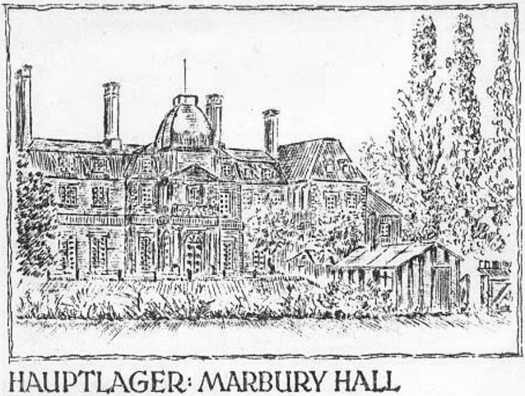

FOAM – The Friends Of Anderton and Marbury (Caring for and celebrating Northwich Woodlands) – have an excellent history of the area and a chapter about the army / pow camp - https://foam.merseyforest.org.uk/wp-content/uploads/2012/10/Section-5-Second-World-War-years-rev61.pdf

Marbury Hall Camp - Hostels

Audenshaw – ‘23 miles ne of main camp’. About 8 km e of Manchester. Approximate NGR SJ 925 964  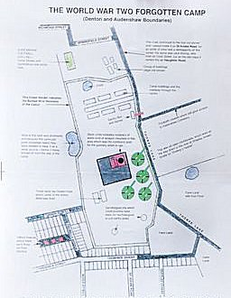  An article in the Manchester Evening news showed the location of the camp sketched out by George Seddon. The plan is now held by the Tameside Local Studies and Archives Centre, (Accession number 4566).  From an article by the Centre – “During the Second World War, a sprawling prisoner of war camp existed on the Denton – Audenshaw boundary. It later became a resettlement centre for Polish troops who did not wish to return home to a country under Soviet control.  Since the 1940s, all trace has disappeared, making it difficult for staff at Tameside Local Studies and Archives Centre to answer occasional inquiries. Help has arrived in the shape of George Seddon who grew up on Frederick Street, Denton, in a house overlooking the camp. He has drawn a detailed map of the site and sketches of some of the buildings. George said: “It’s surprising how a place like that could simply seem to disappear but I suppose the camp was built and run by the Government so the old Denton and Audenshaw urban district councils wouldn’t have had anything to do with it. I can remember seeing it as a boy. There used to be some huge searchlights on the site, too. I expect these were mounted on lorries.”  There are memories of Italian and German pows.  The camp began as a hostel (sub-camp) for Melland Camp 126 (Sandfold Lane, Gorton, Manchester). Melland Camp was included in an International Red Cross list as having an Italian Labour Battalion up to 1944/45 – so it is likely that the Audenshaw site also held Italians before being replaced by German pows.  When the Melland Camp closed in Autumn 1946, Audenshaw hostel was transferred to Marbury Hall Camp 189. | 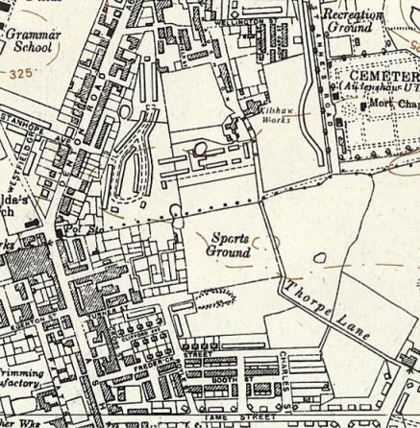
 | Ordnance Survey 1954
October 1946 Segregation Section Report (FO 939/177) - recorded that a high number of C (Black) and B- (Gray) pows were within this hostel. (‘C’ graded = Nazi sympathisers / party members / Waffen SS etc).

The hostel pow leader was; “A833301 Herrmann Hans, Ofhr. Has been Lagerfuehrer for about 3 weeks, but was Camp Leader in America. After rather a bad experience in USA is most agreeably surprised at treatment in England. He has no Party record, is an intelligent type and his influence is reflected in the very happy atmosphere noticeable in this hostel. Category B+.” He was still there in December 1946.

Audenshaw hostel closed 15 March 1947.

Number of pows: | Marbury Camp 180 |  | Marbury Camp 189
 | 10/44 | 2/46 | 9/46 | 10/46 | 12/46 | 3/47 | 5/47 | 8/47 | 10/47 | 2/48
Audenshaw | With Camp 126 |  |  | 209 | 67 | 65

Blakemere.  Location: Just off the Chester Road, Sandiway, by Northwich. NGR SJ 5979 7028  This seems to have been a very short-lived site as a pow hostel - there is only one reference in the Inspection Reports for Marbury:  2 February 1946 – English Educational Visit reported on; “the establishment of a small hostel, at Blakemere, a bakery with 69 Ps/W…”  Blakemere was a training centre for RASC army bakery companies using the outbuildings.  After the camp: Reportedly used as a Polish refugee centre. The hall was demolished in 1950. Now a shopping and craft centre. | 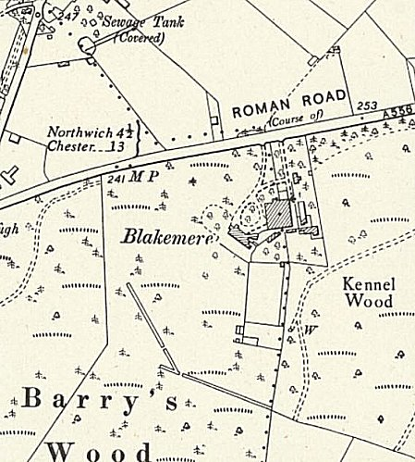
 | Ordnance Survey 1954

Number of pows: | Marbury Camp 180 |  | Marbury Camp 189
 | 10/44 | 2/46 | 9/46 | 10/46 | 12/46 | 3/47 | 5/47 | 8/47 | 10/47 | 2/48
Blakemere |  | 69

Broxton  Located at a former anti-aircraft / searchlight site. ‘Pastscape’ entry: “The site of Second World War searchlight battery section 10 number 41 in the parish of Broxton. It was manned by 352 Company of 38 (The King's Regiment) Anti-Aircraft Battalion Royal Engineers. The battery was operational by 6 January 1940. For an unspecified period before this date it was manned by the 350 Company. This battery was positioned to protect Liverpool from air attack. Searchlight sites typically comprised a small ring-ditch to provide the crew with shelter during an air raid, a predictor emplacement for calculating the height and range of targets, a light anti-aircraft machine gun pit, a generator and hutted accommodation for the crew.”  NGR SJ 490 538 – approx. centre of map.  Founded 6 March 1946 as a pow hostel for Tarporley Camp 74.  In August 1947 it was recorded that a high number (50%) of the pows were under-25 (youth).  Camp leaders:  May 1947 – Fw. Heinrich Gramann (B+).  August 1947 – Uffz.Surma (B) – still there in October 1947. | 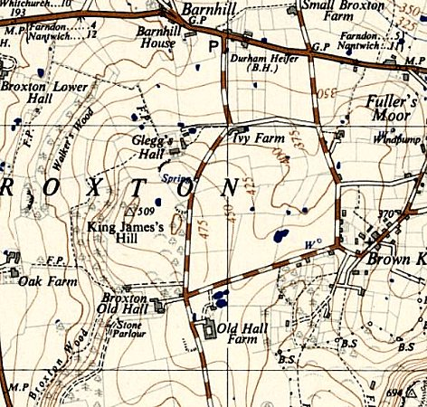
 | Ordnance Survey 1949

Number of pows: | Marbury Camp 189
 | 9/46 | 10/46 | 12/46 | 3/47 | 5/47 | 8/47 | 10/47 | 2/48
Broxton (founded 3/46) | With Camp 74 |  |  |  | 53 | 43 | 30

Comberbach, Northwich – “2 miles nw of main camp”.

Details from Camp 74 Tarporley - Hostels listed for Italian pows from this camp on 5 May 1944, (WO 32/10737): Comberbach, Nantwich, Cheshire.

(Re-) Founded 6 March 1946 as a German pow hostel for Tarporley Camp 74.

October 1946 – Hostel leader “B228717 Soldat Dechow Claus – age 24. A young and intelligent type with sensible views. Was in America for three years and interested himself in Democracy by reading good political literature. Has done quite a lot of translation from these books for the camps. In the HJ 1936 and NSFK 1941. Category B+.”

May 1947 – Hostel leader St.Fw. Emil Kaminski (B-). In August 47 it was recorded that Kaminski was; “falling under the automatic arrest category (allg.SS rank)” and was due to be replaced – however, he was still leader in October 1947.

[St.Fw = Stabsfeldwebel / Waffen-SS Rank Sturmscharfűhrer or Regimental Sergeant Major – automatic arrest was usually for officers within the SS].

February 1948 - Hostel leader – Wachtm. Schmauser.

Number of pows: | Marbury Camp 180 |  | Marbury Camp 189
 | 10/44 | 2/46 | 9/46 | 10/46 | 12/46 | 3/47 | 5/47 | 8/47 | 10/47 | 2/48
Comberbach (founded 3/46) | With Camp 74* |  | 63 | 64 | 45 | 39 | 51 | 57 | 46 | 20

Davyhulme, Salford – “14 miles nne of main camp”.  Location: NGR SJ 7710 9590  Information from Trafford Local Studies Centre - “The Davyhulme camp was located on an area of land that today spans part of Kingsway Park and Queensway. It started life as an army camp, set up to defend the local area [Trafford Park Industrial Area] from air raids. When the threat of air attack diminished as the war went on, the large anti-aircraft guns were replaced with wooden replicas, to fool enemy photographers.  The area was turned into a POW camp and, like Dunham’s camp, it housed both German and Italian prisoners. They were transported by lorry to work on farms in Flixton, Carrington, and Barton. Later the area was used as a resettlement camp for Polish servicemen, displaced by the war, and was known as the ‘Davyhulme hostel’.  Memories – “I remember the POWs in Urmston, during and after the war... First there were the Italians, in their green uniforms, they mainly could be seen standing around the four corners,(Station rd/Crofts Bank rd)... I never saw them do any work... Later there were the Germans, they wore a gray uniform with coloured patches on, and they worked mostly cleaning up bomb sites, and on the farms...” (urmston.net – forum).  October 1946 – Hostel leader – “AA123170 Wm.Ramm Kurt. Age 28 (Dairyman). Lager-fuehrer since July. Good organiser. Popular with his men. In D.J. 1935-38. Category B+” | 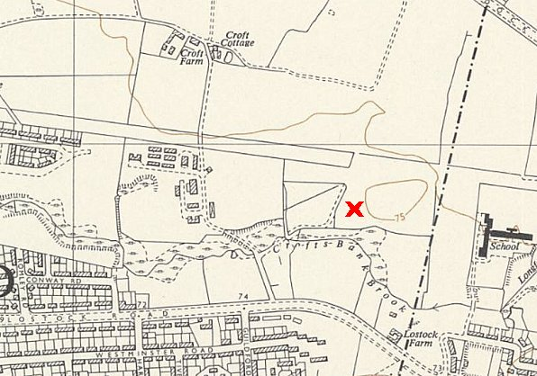
 | Ordnance Survey 1956
December 1946 Camp leader – Doeffinger, H (B+)

After the camp:

A commemorative artwork sculpture in Kingsway Park marks the location of the AA gun emplacement.

Number of pows: | Marbury Camp 180 |  | Marbury Camp 189
 | 10/44 | 2/46 | 9/46 | 10/46 | 12/46 | 3/47 | 5/47 | 8/47 | 10/47 | 2/48
Davyhulme |  |  |  | 108 | 57 | 10 | 9

Delamere Camp, Cuddington
Appears to have been very short lived, unless it was transferred to / from another camp.

Not sure if this site was located in the huge army camp located in Delamere Park.

Number of pows: | Marbury Camp 180 |  | Marbury Camp 189
 | 10/44 | 2/46 | 9/46 | 10/46 | 12/46 | 3/47 | 5/47 | 8/47 | 10/47 | 2/48
Delamere Camp, Cuddington |  |  |  | 24

Dunham Park, Altrincham – see Camp 189.

Eddisbury  Eddisbury Farm – NGR SJ 9376 7326  Founded 6 March 1946 as a hostel for Tarporley Camp 74. Former anti-aircraft / searchlight site.  Memories by Robin Ackerley – “In the latter years of the war the Lancashire Fusiliers left the artillery battery on land at Eddisbury Hill Farm, just above Rectory Farm and the site became a prisoner of war camp housing mainly Italian prisoners. Many of them worked on local farms and settled in happily to local life.”  Hostel leader May 1947 – Uffz.Fritz Schmidlin (B) (Still listed as leader - October 1947).  Number of pows: Marbury Camp 189  10/44 2/46 9/46 10/46 12/46 3/47 5/47 8/47 10/47 2/48  Eddisbury With Camp 74* 39 36 27 | 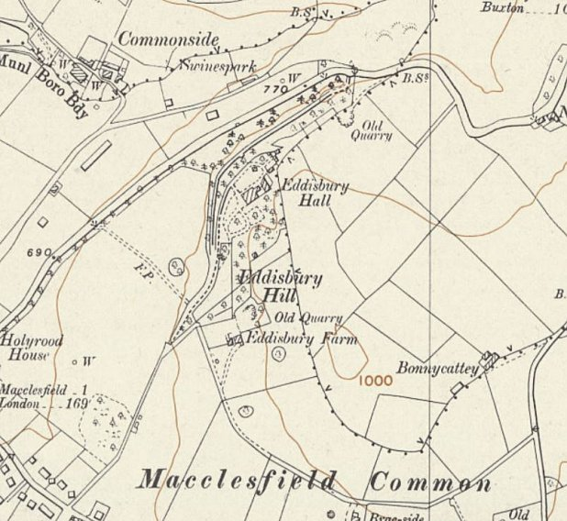
 | Ordnance Survey 1954

Hankelow Court  Location NGR SJ 6688 4570. Former British army camp, then US troops.  Hostel leader May 1947 – Wm.Paul Niederhagen (B+). In August 1947 he was due to be repatriated and be replaced by Stichel.  Marbury Camp 180 Marbury Camp 189  10/44 2/46 9/46 10/46 12/46 3/47 5/47 8/47 10/47 2/48  Hankelow Court With Camp 74* 106 87 | 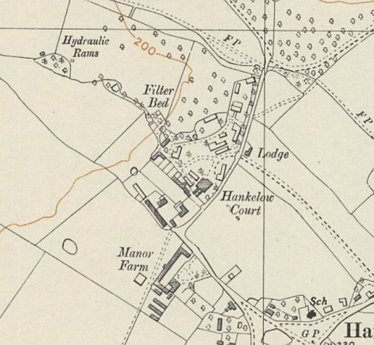
 | Ordnance Survey 1954

Holmes Chapel  Italian and then German POWs stayed at the Bull’s Head and Sandiford Cottage (aka Sandiford House).  Homes Chapel listed as a hostel for Boar’s Head Camp 147 – then, from July 1946 with Tarporley Camp 74 – and from May 1947, with Marbury Hall Camp 189.  The Bull’s Head – “the top floor of three served initially as accommodation for Italian POWs working on local farms” *¹  Sandiford House – NGR SJ 7623 6727 - requisitioned as a billet for troops. Billet for black US GIs – with white GIs housed at The Hermitage. After D-day became a hostel for German pows.*¹  *² “…allocation of POWs to farms was conducted by the CWAEC (Cheshire War Agricultural Executive Committee) whose headquarters were at Reaseheath. A local branch was at what was known before the war as “The Fontainebleau Café”, which was a roadhouse and café for travellers in the 1920s/30s. The site became Alteys at some point and is now the location of a small housing development. During the war it was referred to by the CWAEC as “The Fontainebleau Hostel”. I don’t think any POWs were ever housed there, as I believe it was used to house Conscientious Objectors who were also working on local farms. There was also a hostel at Ravenscroft farm which I believe housed Land Girls & possibly also C.O.s” | 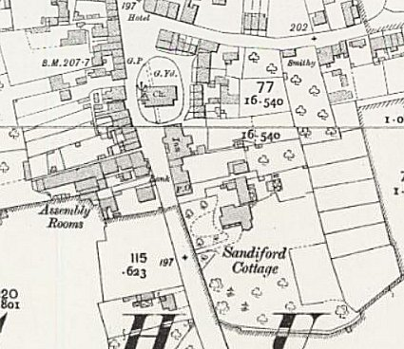
 | Ordnance Survey

Hostel leader May 1947 – Fhr. Hans Siekmann (B+) – (still there October 1947).

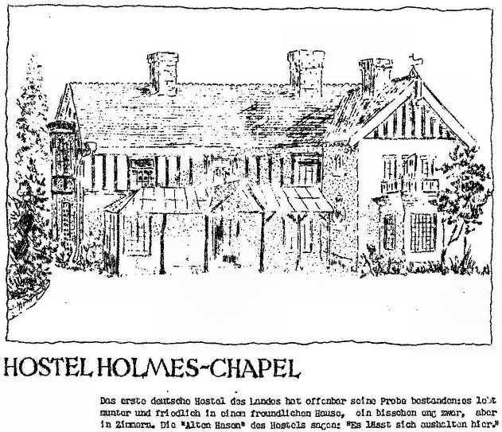 | < From the Marbury Hall sketch book referred to above. *²  Text - Das erste deutsche Hostel das Landes hat offenbar seine Probe bestandenies lebt munter und friedlich in einer freundlichen Hause, ein besschen eng zwar, aber in Zimmern. Die “Alton Hasen” des Hostels sagen: “Es lässt sich aushalten hier”.  Translation - The country's first German hostel has apparently passed its test - it lives happily and peacefully in a friendly home, a bit cramped, but in rooms. The hostel's “Alton Bunnies” say: “You can endure it here”. | 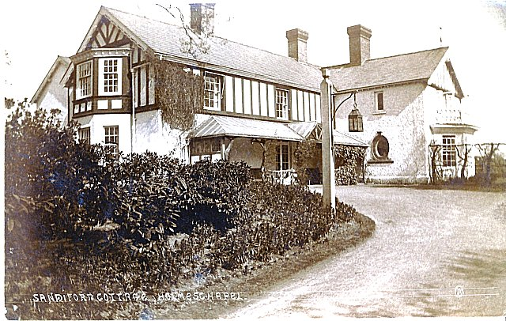
 |  | Sandiford Cottage *²

 | Marbury Camp 180 |  | Marbury Camp 189
 | 10/44 | 2/46 | 9/46 | 10/46 | 12/46 | 3/47 | 5/47 | 8/47 | 10/47 | 2/48
Holmes Chapel | With Camp 147 and 74* |  |  |  |  |  | 108 | 93 | 87

*1 Information from; Holmes Chapel: A Stroll Through the Past – 2001 – Rosemary Dear – Holmes Chapel History Research Group.

*2 My thanks go to Val White and Rod Cameron of the U3A Holmes Chapel History Society - for supplying additional information. The history group also have a photo of the centre of Holmes Chapel Square partially showing The Bulls Head public house.

Kinnerton

Hostel leader May 1947 – O.Maat. Adolf Eckel (B)

August 1947 it was recorded that about 50% of the pows were under-25.

 | Marbury Camp 180 |  | Marbury Camp 189
 | 10/44 | 2/46 | 9/46 | 10/46 | 12/46 | 3/47 | 5/47 | 8/47 | 10/47 | 2/48
Kinnerton | With Camp 74* |  |  |  |  |  | 52 | 51

Ledsham - see Camp 283.

Malpas  Location NGR SJ 4854 4708 – Church Street, Malpas.  From ‘Malpas, Cheshire’s Town in the Marches’ by David Hayns, 2016 – “the buildings in Church Street, built in the late 19th century as racing stables which in the 1950s became the house known as Cobblestones, were used at various times to accommodate voluntary farm workers, RAF personnel, and Italian prisoners-of-war; and the Bolling Cottage (now called Cobblestones Cottage) was the headquarters for the local Home Guard.”  May 1947 Hostel leader – Fw. Helmut Quaak (B) – still there August 1947. October 1947 Camp leader – Ofw. Eichenhauer (B). February 1948 Camp leader – Uffz. Stobbe  Number of pows: With Marbury Camp 189  5/47 8/47 10/47 2/48  With Camp 74 38 39 26 18 | 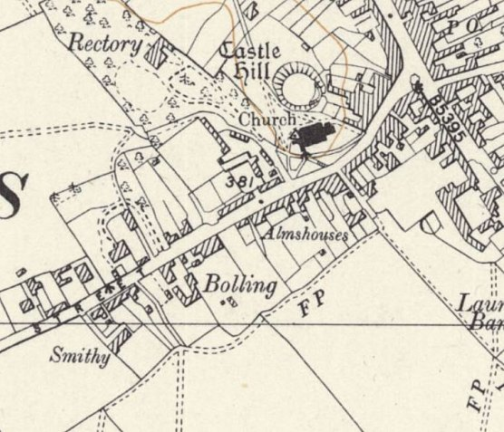
 | Ordnance Survey 1953

Mobberley, Knutsford - 10 miles east of main camp.  Location – “nissen hut camp that was roughly where Park Farm (not really a farm) on the North side of Hall Lane is now (near the entrance to Sunrise/Barclay Hall”. NGR SJ 7948 7963  October 1946 – Hostel Leader “B866943 Ofw.Doeffinger, Willi – age 32 (steel engraver). Bright, cheerful and honest type. Keeps good discipline. Is popular with Germans and the British Staff. Has no Party Record. Category B+.”  Hostel leader May 1947 – Hwm. Willi Doeffinger (B+) – still there in August 1947.  August 1947 it was recorded that the camp had a theatre and an orchestra.  Marbury Camp 180 With Marbury Camp 189  10/44 2/46 9/46 10/46 12/46 3/47 5/47 8/47 10/47 2/48  Mobberley With Camp 74* 128 155 114 96 146 130 | 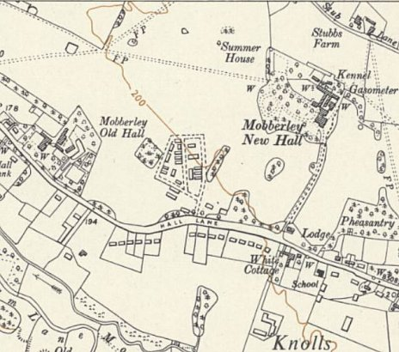
 | Ordnance Survey 1954

Rowton  Founded 6 March 1946 – part of Tarporley Camp 74. Recorded as part of Marbury camp for just a short time – May 1947 – 27 pows.  Hostel leader May 1947 – Uffz. Walter Surma (B) | 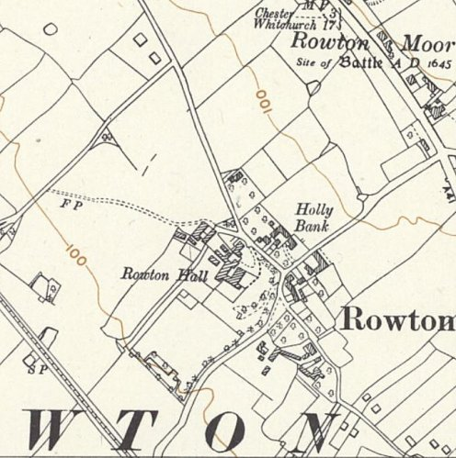
 | Ordnance Survey 1954

Red Brow, Warrington Hostel – 6 miles nw of main camp.  Red Brow was formerly a heavy anti-aircraft battery site (M78) on a prominent hill near to Red Brow Farm, near Daresbury. NGR SJ 5708 8170  October 1946 – Hostel Leader “B866008 Ofw.Woscheck, Rudolf. Age 31 (Merchant). Was in the ?? for three months in 1935. Believed in Hitler to the end of the war. Now convinced anti-Nazi and gives honest impression. Category B+”  December 1946 – camp leader as above  Hostel leader May 1947 – Ofw. Rudolf Woschek (B) – still there October 1947.  No. of pows Marbury Camp 189  9/46 10/46 12/46 3/47 5/47 8/47 10/47 2/48  Red Brow With Camp 74* 131 131 85 82 110 122 87 | 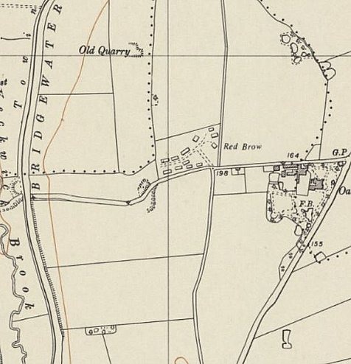
 | Ordnance Survey 1954

Sale - 14 miles ne of main  The pow hostel was located on the former Heavy Anti-Aircraft battery - Carrington Moss, Heavy Anti-Aircraft Battery H5, on the Carrington Road next to Ackers Farm. NGR SJ 7545 9278.  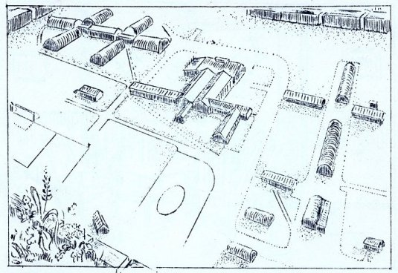  A diagram of the camp was included in the Marbury Hall sketchbook mentioned above. The description, originally in German, is:  HOSTEL SALE - MODEL. At the entrance to the hostel you will find a unique work, a model of the hostel. We can see the whole area at a glance, how it divides the kitchen and dining room building. We can also quickly find the way to the “pub” or the reading room with the help of the model.”  October 1946 Inspection Report – Hostel leader “B302511 Ofw. Vogel Helmut. Age 32 (Druggist). Tries to make a good impression. Is said by the Commandant to be doing a good job as this is the blackest hostel. (14 C+, 94 C and 48 B-). Vogel himself is the typical Nazi type (Pg. and SA 1933 Oberscharfuehrer) and makes an outward show of wanting to assist D684967 Fw. Zoll, Richard, responsible for re-education – himself an old Party member making every effort to wipe out the past. It is obvious however, that these two do not hit it off very well together. Category C.” | 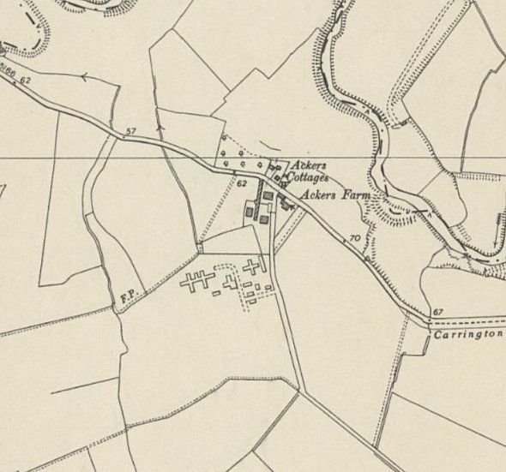
 | Ordnance Survey 1954

December 1946 camp leader as above. Vogel is described as “a bad (C)” and his removal is recommended.

Hostel leader May 1947 – Fw. Guenther Dienstuehler (B+), he is still there in February 1948.

The camp had its own theatre.

October 1947 – the English Inspector states that; “Here the two English classes have been interrupted by a new order prohibiting the use of coal for heating the class-room (among other rooms).” – this is the only hostel recorded doing this.

With thanks to the ‘Sale and Ashton History Society’ for providing the clues that helped me to locate the site; and to FOAM – The Friends Of Anderton and Marbury, for providing the sketch which confirms the site.

No of pows | Marbury Camp 180 |  | Marbury Camp 189
 | 10/44 | 2/46 | 9/46 | 10/46 | 12/46 | 3/47 | 5/47 | 8/47 | 10/47 | 2/48
Sale |  |  | 260 | 333 | 307 | 275 | 251 | 255 | 320 | 152

Sandbach  Location – Sandbach Heath; NGR SJ 7728 6094.  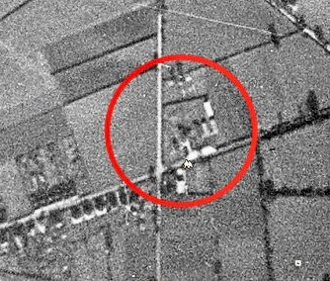  Only a very short time attached to Marbury with just one entry in Camp Visit Reports.  Hostel leader May 1947 – Fw. Helmut Lippelt (B+)  Aerial photograph from - https://historyug.wordpress.com/2014/12/21/ww2-pow-camp-sandbach/  No of pows Marbury Camp 189  5/47 8/47 10/47 2/48  Sandbach With Camp 147 and 74* 40 | 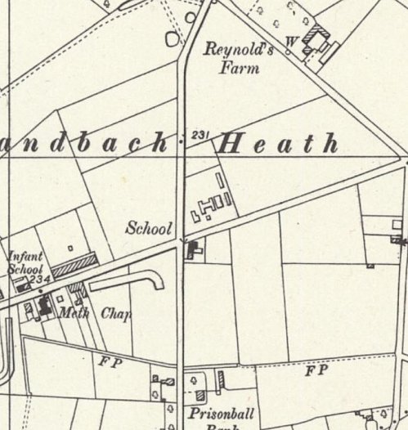
 | Ordnance Survey 1954

Tarporley see camp 74.

Thurstaston  Location – Former heavy anti-aircraft site GG/H28 at NGR SJ 2383 8341. The nearby railway station was used to unload munitions to service the anti-aircraft guns that had been installed nearby on Lever Brothers camp site. Buildings to the NW of the station.  Only linked to Marbury Hall for a short time in 1946.  No of pows Marbury Camp 189  9/46 10/46 12/46 3/47 5/47 8/47 10/47 2/48  Thurstaston 99 | 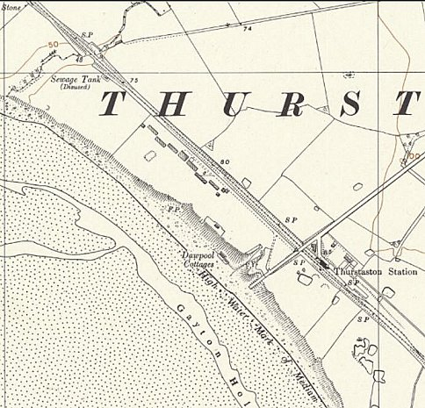
 | Ordnance Survey 1954

Walgherton – see Camp 147.

Warburton, Altrincham – 9 miles nne of main camp.
With Tarporley Camp 74 until September 1946.

October 1946 – Hostel leader “D684253 Fw. Horn Heinz-Hugo. Age 32. Has a brief Party record – SA 1933 – 34 and Studentenbund 1938 – but is an intelligent type with sensible ideas. Has no particular troubles with his men, appears to have a good influence and seems to be doing a good job. The political complexion of his hostel is distinctly on the white side. Category B+.”

December 1946 camp leader as above.

Hostel leader May 1947 – Ofw. Josef Bibiella (B). He was still there in October 1947.

No of pows | Marbury Camp 180 |  | Marbury Camp 189
 | 10/44 | 2/46 | 9/46 | 10/46 | 12/46 | 3/47 | 5/47 | 8/47 | 10/47 | 2/48
Warburton | With Camp 74* |  | 29 | 33 | 26 | 26 | 35 | 33 | 31

Warmingham

Wikipedia entry – “A prisoner-of-war camp was located at Donkinson's Oak, near the southern edge of the parish, during the Second World War, and there was a heavy anti-aircraft battery near Bottoms Farm in 1940–41.”

Listed as a hostel for Crewe Hall Camp 191 – then with Boar’s Head Camp 147 (listed 15 September 1945, WO 32/10737) – then with Tarporley camp 74 – and from may 1947 with Marbury Hall.

May 1947 Hostel leader – Gefr. Herbert Kerber (B)

August 1947 leader – Fw.Huesch (B)

No of pows | Marbury Camp 180 |  | Marbury Camp 189
 | 10/44 | 2/46 | 9/46 | 10/46 | 12/46 | 3/47 | 5/47 | 8/47 | 10/47 | 2/48
Warmingham | With Camp 191, 147 and 74* |  |  |  |  |  | 41 | 37 | 26

WD / RAF Hostels

Please note these are 4 separate hostels – I have listed them together as the numbers of pows were often recorded together.

WD 44 Chester - February 1948 Camp leader – Fw. Tordy.

 | Marbury Camp 180 |  | Marbury Camp 189
 | 10/44 | 2/46 | 9/46 | 10/46 | 12/46 | 3/47 | 5/47 | 8/47 | 10/47 | 2/48
W.D. detachments |  |  | 150 | See below | 274 | Not recorded |  | 166 | 53 | 87
W.D. 44 Chester |  |  | See above | 54 | See above |  |  | See above
RAF Ringway |  |  |  | 40
539 Coy R.A.S.C. Chester |  |  |  | 28

Weston  Next to Snape Farm; NGR SJ 7423 5185. |  | 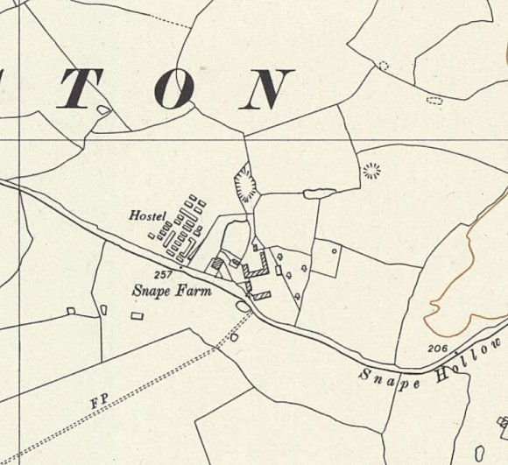  Ordnance Survey 1954
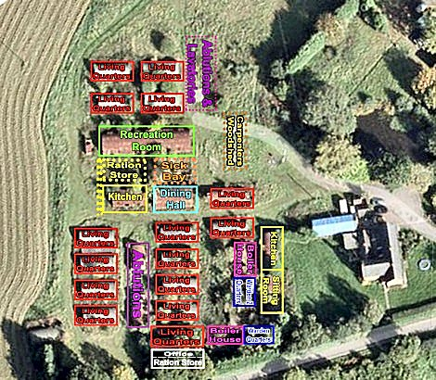 | Several accounts state that the site was first requisitioned as a Heavy Anti-Aircraft battery, but that it was only partially built.  Held Italian pows, possibly as early as 1942, and later German pows.  A hostel for Tarporley Camp 74, then from May 1947, a hostel for Marbury Hall Camp 189.  Up to 38 huts (some still existing – 2020), mainly Nissen with some wooden huts. Steve Houchin drew this plan of the site with information from the previous owners of Snape Farm –  https://historyug.wordpress.com/2015/01/04/pow-camp-weston-layout/
 | May 1947 Hostel leader – Wm. Oskar Jacobi (B-); still there in August 1947, but due to be repatriated and replaced by Uffz. Pfotenhauer (B).

 | Marbury Camp 180 |  | Marbury Camp 189
 | 10/44 | 2/46 | 9/46 | 10/46 | 12/46 | 3/47 | 5/47 | 8/47 | 10/47 | 2/48
Weston | With Camp 74* |  |  |  |  |  | 126 | 146 | 122

