Camp 180 - Radwinter North Camp, Radwinter Manor, Walden Road, Radwinter, Essex

1947 Camp list
180(G.W.C.) | Radwinter North Camp, Wimbish, Saffron Walden, Essex | E. | Priswar, Thaxted | Saffron Walden 2383 | (Blank) | Major F.J.Woodnott | v/1452/2
The entry above has been crossed out in blue crayon and the following details handwritten on.
 | Trumpington Camp, Trumpington, Cambridge |  | Trumpington | Trumpington 351/2 | Cambridge | Name not changed

Prisoner of War Camps (1939 – 1948) - Project report by Roger J.C. Thomas - English Heritage 2003
OS NGR | Sheet | No. | Name & Location | County | Cond’n | Type 1945 | Comments
TL 596 375 | 154 | 180 | Radwinter North Camp, Radwinter Manor,  Walden Road, Radwinter | Essex | 4 | Base Camp | Large complex of huts. Some  cropmarks visible

Location: About 5.5 km E of Saffron Walden. Radwinter Manor was also shown as ‘Rectory’ on some OS maps. A quiet, sparsely populated area.  Before the camp: Rectory and grounds.  Pow Camp: Opened as a Base Camp towards the end of the war in the grounds of the old rectory.  The Base Camp was closed for a short time, and re-opened in June 1946 to become a Youth Education Camp for German POWs, (official opening noted in one report as 7 August 1946).  The site was described as; “The camp is nissen hutted. In addition to the usual C.R.S. and Dental Centre, both of which are well equipped, six nissen huts are used for educational classes. There are spacious information and reading rooms, a Chapel, and separate quarters for Padres and Doctors.” (FO 939/311)  C.R.S. = Camp Reception Station, which included medical facilities/hospital. There would also have been huts for cooking, dining, washing, etc.  The pows were mostly aged 18 to 24, (Youth = Under 25), with some older pows mixed in. 542 prisoners were held here at the start, rising later to 1300. They would spend 3 months at the camp before being sent back to other camps, or later, being repatriated. The camp was still listed as a German Working Company as the youth pows continued to work at local farms, but each pow received education courses on one day each week.  There was an account that the idea behind the camp was opposed by some members of the War Office who | 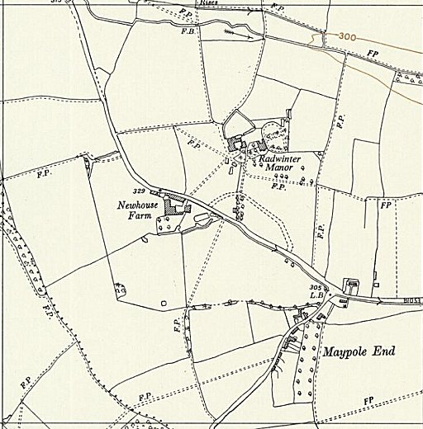
 | Ordnance Survey
preferred segregation and education provision within camps, rather than a separate camp. Supposedly, they reluctantly allocated the ‘poor’ camp at Radwinter – with no proper paths and shabby huts. Physical conditions, especially mud and cold classrooms put many pows off attending lessons. Work was carried out in the early months to bring the camp up to a decent standard, and by early November a progress report noted that; “the derelict appearance has been changed, urgent minor repairs completed, huts re-tarred and partially painted.”

A large number of the Youth intake were ex-Waffen-SS members and politically classified as ‘black’, category C Nazis. At one point this included 300 young men from the troubled Lodge Moor Camp 17 in Sheffield and another large cohort of C class pows from Watten Camp 165. Some alarm was expressed about having such a concentration of young Nazis, especially with the relaxed security in operation at the camp. Twenty experienced and trusted pows were selected and transferred from the well-regarded Carburton Camp 181; they acted as camp staff. There were some excellent Camp administrators and British staff.

The well-experienced commandant for the Youth Camp was Major F J Woodnott from the Pioneer Corps;

“An imperturbable man, he used regulations in a human way and punishments sparingly. When a POW struck a superior he naturally gave him twenty-eight days, but quite soon had him fetched out of the cells and for two days made him accompany him on his rounds to demonstrate how much care and trouble it took to maintain an orderly camp. Once he gave a lift to a man who turned out to be one of his own prisoners in civvies trying to hitch to the London docks. ‘You’d better get a lorry back to the camp,’ he told him, and on his return he said to the camp spokesman, ‘Count more carefully next time, and when the man gets back see that he changes his clothes.’ No one tried to get away twice. The camp leadership, in fact, asked for more discipline, promising to give the Commandant their full backing. But Woodnott refused, In his final report he comments that he could not have acted as he did with British troops: he would not have dared give them so much latitude.” (p314-315, ‘Thresholds of Peace’ – M.B.Sullivan – Hamilton 1979).

The camp also greatly benefitted by having a remarkable camp interpreter - Charles Stambrook; an ex-Viennese business man, originally named Karl Starnberg. He had assisted Jews in Austria, escaped to Britain in 1939 where he joined the Pioneer Corps, and had gained experience at Carburton Camp.

The camp was run on mainly democratic principles. Though there were some pows who rejected this arrangement, the camp was noted for its successes with many of the pows. Visitors to the camp frequently expressed their surprise that so many prisoners changed their attitudes and outlook after having been brought up all of their lives under the Nazi regime.

The camp was visited regularly to review ‘re-education’ and English lessons. Reports were also submitted by, and about, visiting lecturers. The quality and information within the reports varied greatly – selected extracts below.

11-13 September 1946 – Re-education Report / Screening of Camp Staff. (1st visit). Strength – 2 (medical) Officers and 927 Other Ranks. Screening figures:

A+ | A | B+ | B | B- | C | Uns.
9 | 138 | 1 | 253 | 196 | 96 | 326

Personnel:

O.C. : Major I.G. Woodnot [F.J.Woodnott]
Interpreter : S/Sgt Stambrook
Camp Leader : Uffz.Eppendorfer, K. (A+)
Deputy C/L : Uffz Beck, I (A+)
German M.O. : Dr.Kranz (A+)
Study Leader : Syben, I (A)

The first mainly, youth pows were transferred from Camp 180 Marbury, “and they were joined on 24 July 46 by 300 from Germany, in August 46 by 300 from Canada and on 2nd Sept.46 by 100 from Canada. Among the PW who came from Germany there is a large proportion of SS-men.”

Pows were sent based on their age, and not selected by suitability for this kind of camp. This made the work far more difficult in the camp.

“Morale varies between the different drafts. The morale of the original personnel and the intake from Germany is fairly high, but the arrivals from Canada are sullen and non-co-operative. Their attitude is reflected in their often repeated statement that after 5 years of captivity they want to be sent home and not educated. The teachers are mostly hard-working men who show much good-will and understanding. There is, however, no inspiring personality among them and, taken as a whole, they are unpolitical.

Political progress – The original personnel represent the democratic element in the camp. The arrivals from Germany have seen destruction and misery in their homeland and lived through the final stages of the war, which makes them susceptible to democratic influences. The youngsters from Canada, however, are still strongly under the spell of their former ideas.”

[In the early days of the war, British policy was not to detain pows within the UK, but to ship them to Canada as soon as possible.]

On their education days, pows had 3 classes in the morning and made 2 choices in the afternoon – at the end of lessons there was a discussion group. Classes were held for:
English / French / Economics / Political questions / German History / Arithmetic / Shorthand / Drawing / Music / History / German literature / Geography. Evening classes were tried, but abandoned as the pows were often too tired after being out at work during the long harvest days.

There were plans to increase the range of studies to include trades / vocational training.

Standard re-education activities included:
Newspapers – English newspapers received + Wochenpost. Few German papers received.
Library – 260 books – more needed.
Lectures – frequent - “appreciated, except by the Canadians who boycott the lectures”.
Films – YMCA films ever 3 weeks.
Wireless – newly arrived with speakers.
Camp magazine – “A colourful camp magazine “DER NEUE WEG” is published fortnightly.
Information room – “One of the greatest assets of the camp is the well-organised and interesting information room which contains ABCA material, press review, German news-cut, topical cartoons, etc.
English Instruction – part of the curriculum, but in need of organisation.

Other activities included:
Religion – padres of both denominations
Theatre – a dramatic circle newly formed.
Music – instruments needed.

There were also sports and games activities, but these are rarely commented on in the reports.

Resentment was caused as pows lost a day’s pay when attending education day classes. The need to replace teacher pows who were being repatriated, and finding teachers able to give vocational courses were also issues.

9-10 October 1946 – English Inspector’s Report. Strength 872 German pows.

There was a new Camp Leader – J Mayer. Brief details were given for the four German pow English language teachers, two of whom had been trained at the YMCA study camp 174 at Norton Park.

“The idea of running this camp is “confidence”. There is no wire whatsoever. Ps/W are put on their honour to “play the game” and efforts are made to inculcate the “team spirit…. This treatment seems to be having good results. No attempts to escape have, so far, been made. Ranks are not used and no rank badges worn.”

November 1946 – ‘Progress Report’. Strength 1079 and looking to obtain further huts from the Ministry of Works to expand to 1800. There were 6 pow teachers. General comments – Morale: “Fairly High / Generally the discipline and the behaviour of PWs is very good / No complaints from local inhabitants.”

Labour carried out by the pows on 5 days was directed by the Ministry of Agriculture on local farms. There had been a few minor complaints from farmers, but the reporter stated; “the PWs work quite well.”

The local vicar allowed pows to conduct their own services in the church at Radwinter. The camp choir gave a performance after a church service which was a success.

10 November 1946. A visiting lecturer, H A Kluthe, gave a lengthy report on his visit to the camp. He began by expressing his surprise that so many attended his lecture (600 over 2 lectures) as there had been many visiting lecturers recently including Niemöller the day before.

“I discovered a considerable number of ‘old acquaintances’ among the audience, former inmates of the ‘Naturschutzpark’ for die-hard Nazis in Wick (Camp 165)… it seems to me to be highly dangerous to swamp this Youth Camp with such a great number (300!) of the worst Nazis one could possibly find in this country… And yet, Lt.Stambrook and the general atmosphere of this camp have already considerably modified the behaviour and even the outlook of these men. In Wick, they would not even listen to me and walked out when I said a harsh word about their ‘beloved Fűhrer’. Now, only 3-5 people tried once again the walking-out stunt, but nobody followed them. There were some weak murmurs of protest now and then, but they all listened attentively. This seems to me a remarkable achievement among hard-boiled Nazis.”

He expressed concern that some of the Nazis would still make their mark on the camp.

21-22 November 1946. Paul Bondy, a German-speaking refugee gave lectures at the camp – and again on 28-30 May 1947. He commented on the conditions in the camp as being unsuited to educational purposes; “The camp itself stands in a vast expanse of mud and, despite constant endeavours, the commandant has so far been unsuccessful in his attempts to procure a sufficient quantity of the materials necessary for making solid paths.”

3 December 1946 – English Inspector’s Report. Strength 1070 German pows. Little change from above. Russian language classes have started.

10 December 1946. Training Adviser’s usually visited camps to give advice. For this Youth Camp a TA was allotted permanently.

In late 1946, when regulations about fraternization were relaxed, the Camp and the local community developed some strong relations. One character from Saffron Walden was Bessie Midgley, a Quaker who welcomed pows into her large home. The Reverend (Michael) Roy Sinker at Saffron Walden called the pows “ambassadors in chains” and led the local churches in calling for pows to be welcomed into people’s homes. Some opposition was voiced against this – understandably from those who had loved ones killed in the war, and from one British soldier who had been one of the first to enter Belsen. However, many supported the call to welcome the pows – concerts, garden-parties and a sports festival were held.

27 February 1947 – English Inspector’s Report. Strength 1022. A new Camp Leader (Lagersprecher) – G Rubahn.

“Radwinter is clearly an exceptional camp. The educational activities are showing very encouraging results.”

March 1947 – Monthly Report. March saw a turn-around of the pows held at the camp. For the new intake starting on 31 March, the length of time spent at this camp was set at 14 weeks. Screening figures were:

A | B+ | B | B- | C | C+
5 | 53 | 220 | 142 | 23 | 32

Total = 475 – so another 700 or so expected.

The random way in which groups of pows were sent to Radwinter was changed to selection by Training Assistants. The new intake were seen as being very keen with just a little resistance to the organisation. 4 pows refused to work on arrival, but that was soon reduced to just 1.

The R.C. Padre spent his time at both this camp and at Trumpington Camp 45. A new Protestant padre arrived from Easton Grey Camp 89.

Morale had considerably improved, due to forthcoming repatriations, the more free conditions, “hand-picking” of pows, and better weather with more outdoor activities.

Not all of the new prisoners were youth-pows. Some older pows were sent in to fulfil administrative work. This caused a row with the German Camp Leader Rubahn, who resigned in protest – he was replaced by a 37-year old B-grade, Hans Hermann.

Physical changes - Some of the huts had been dismantled for transporting to other sites. Gardening became possible with the better weather and prizes were awarded at Easter.

The pow teachers were being trained to allow for discussion of the subjects taught rather than sticking too strictly to the syllabus. The hoped-for vocational training started with Agriculture/Market Gardening and Elektrotechnik (electrical engineering) – courses planned included carpentry, bricklaying and bookbinding.

A half-hour sports session was included in the pow’s training days. A football team from Debden RAF played here at Easter, and other matches were planned. There were opportunities for theatre groups and music performances.

Tom Driberg, M.P. and journalist, stayed at the camp over the Easter weekend. He took a particular interest in this camp and visited and lectured here several times.

10 April 1947 – English Inspector’s Report. Strength 1153. Lagersprecher – Hermann. TA surname – MacDonald.

18 April 1947. Tom Driberg MP raised the camp in the House of Commons:

“Mr. Driberg asked the Chancellor of the Duchy of Lancaster if he will publish in HANSARD, in tabular form, the results of the latest screening of German prisoners at Radwinter Youth Camp, ​ showing the numbers of prisoners in the various categories from A to C+ before and after this screening.

Mr. J. Hynd - Yes, Sir. I am circulating a table in the OFFICIAL REPORT.

Mr. Driberg - Would my hon. Friend say whether that table will show that satisfactory progress is being made in this very important experiment?

Mr. Hynd - I think that when my hon. Friend reads the figures in the table he will be satisfied that considerable progress has been made.

Following is the table:

GRADING OF GERMAN PRISONERS OF WAR AT RADWINTER YOUTH CAMP.
Category. | Number in each category.
 | Before the latest screening on 22.2.47. | After the latest screening on 22.2.47.
White - A | 5 | 76
Grey - B | 438 | 823
Black - C | 203 | 124
Ardent Nazis—C+ | 343 | 26
Unscreened | 60 | —
Total | 1,049 | 1,049

(House of Commons - 16 April 1947, Volume 436).

Tom Driberg was keen for other camps to follow the example he saw at Radwinter and raised the matter again in the House of Commons asking for the results from the camp (and Wilton Park) to be published and the ‘experiment’ to be extended. A proposal for this was being considered and; “Meanwhile we shall continue with educational activities in the prisoner of war camps, including Wilton ​ Park and Radwinter, and wherever possible shall extend to other camps at least some of the features of the latter. Particular attention will be devoted to young prisoners. The Control Commission is studying the possibility of extending re-educational activities in Germany, and of securing help from repatriated prisoners of war in this task.” (House of Commons, 18 June 1947, Volume 438).

30 May 1947 – English Inspector’s Report. Strength 1180. Lagersprecher ‘Horstmann’. Considering the brief details the Inspector has given over several reports, he comments:

“It is unnecessary to report at length on this camp; its arrangements and class work are exceptional.”

August 1947. The Youth work carried out at Radwinter was transferred to Trumpington Camp 45 - which was then renumbered 180. Radwinter continued as a ‘hostel’ for Trumpington. The Commandant, Major Woodnott, also transferred to Trumpington along with the Lagersprecher and TA. Nearly all the education courses ended at Radwinter as the teachers were transferred - one was sent back in September to restart some basic classes.

The reports for the man camp at Trumpington no longer listed Radwinter after December 1947.
- - - - - - - - -

The artist Karl Weschke (1925-2005), was a pow here and attended history of art courses, ‘Wesen der Sprache der Kunst’ (The Nature and Language of Art) arranged by the extra-mural studies board of Cambridge University at St John’s College.  Weschke was one of the many pows who visited, and was encouraged by, Bessie Midgley in Safron Walden. In the camp he painted theatre scenery and worked on the camp newspaper. After Radwinter (via Trumpington?) Weschke went to Wilton Park. He visited the House of Commons to observe debates - by arrangement of Tom Driberg M.P.  The sculpture shows a weeping mother and child. It was created using clay from Radwinter North camp. It is believed he gave the sculpture to Kelvin Osborn, a YMCA Welfare Officer at Radwinter. It is now in the Saffron Walden Museum.  After the war Weschke settled in England.  https://saffronwaldenmuseum.swmuseumsoc.org.uk/tag/radwinter/  After the camp: Farmland  For excellent images of the site today - https://repatriatedlandscape.org/england/pow-sites-in-eastern-england/pow-camp-180-radwinter-north/  Further Information:  National Archives FO 939/211 – Radwinter youth camp. Dated 1945 – 1946.  National Archives FO 939/311 – 180 Working Camp, Trumpington Camp, Trumpington Cambridgeshire and Radwinter Camp, Saffron Walden, Essex. Dated 1946-1948.  National Archives FO 938/176 – T.Driberg, MP; notes on visit to 180(G) prisoner of war camp at Radwinter. | 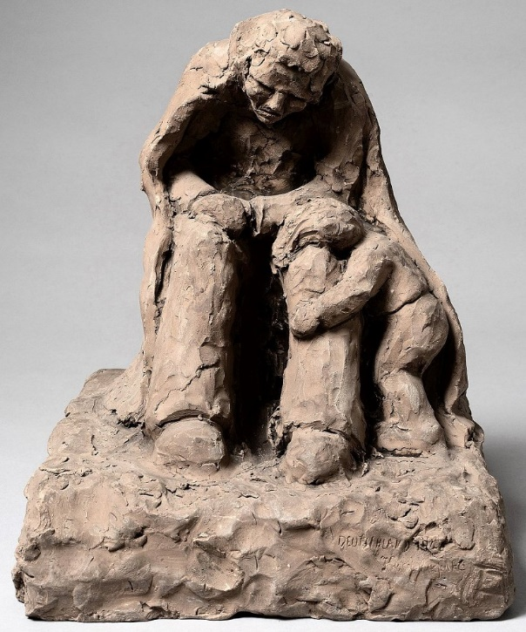  “Deutschland 1946”
National Archives - FO 1120/231 – ‘Re-educational survey visit reports for camps 177 to 186’.
National Archives FO 939/176 – Although this has the title ‘Trumpington Camp’ – it also includes documents about Camps 180 Marbury and 180 Radwinter.

