Camp 256 Willingham House, Market Rasen, Lincolnshire

1947 Camp List
256(G.W.C.) | Wellingham [sic] House, Market Rasen, Lincs | N. | Priswar, Market Rasen | Tealby 255 | Market Rasen | Lt.Col.W.V.Tyrrel | v/1453/2

Prisoner of War Camps (1939 – 1948) - Project report by Roger J.C. Thomas - English Heritage 2003
OS NGR | Sheet | No. | Name & Location | County | Cond’n | Type 1945 | Comments
TF 142 885 | 113 | 256 | Willingham House, Market Rasen | Lincolnshire | 3

Location: Near Market Rasen.  Before the camp: Large country house and estate.  Pow Camp: Possibly held Italian pows before the Germans, but I have not seen any evidence for this. The description of the camp shortly after it opened for Germans suggests otherwise.  Camp opened for German pows in August 1945.  By September / October 1945 the camp had some huts, but was mainly tented and lit by hurricane-lamps. There was a dining hall with a capacity of 250/300 and a small platform. This building also served as a study, recreation room, and lecture hall. The pows were German. An assembly hall and further huts were built during spring 1946, but by July the camp was still 50% tented. All the main camp was hutted by November 1946.  A series of camp visits, mainly regarding re-education in the camp, were made on behalf of the Foreign Office. The National Archive file 939/312 also contains reports written by visiting lecturers, and some reports about them.  19-22 September 1945. The first visit was to look at the organisation of re-education, it was conducted by Mr.W.J.Thomas. There were 500 pows - 1 officer, 155 N.C.O.’s and 344 Other Ranks. The pows had been politically screened, but the information was not available and so the visitor assessed the camp as ‘grey’. The pows had been transferred to this camp in August from Camps 22 (probably Pennylands, Scotland), 5 (Monrush, N.I.), 10 (Gosford, N.I.) and 12 (Elmfield, N.I.). | 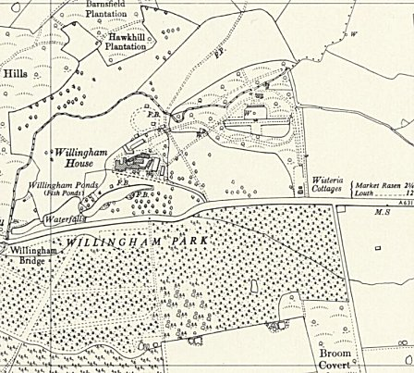
 | Ordnance Survey 1956
“This Camp, mostly tented, was started a month ago as a working camp. The Ps/W have constructed permanent buildings from bricks strewn about, thus providing housing for tailors, shoemakers and workshop. Two or three brick buildings house the more elderly Ps/W, cook-house etc….”
It was hoped that a large garage in the grounds would be converted for classes, but it is not recorded whether this happened.

During his visit to the camp Mr Thomas met the German Medical Officer, Ob/Arzt G Martius. He assessed the MO to be ‘black’ and recommended his removal – “Obviously MARTIUS will never collaborate with us, and in a camp where political opinion can be so easily swayed, he is useless for P.W.E. purposes in this key position of M.O.” [P.W.E. = Political Warfare Executive]. He also submitted a report to Major Henry Faulk, the officer responsible for organising re-education activities in camps, reporting his finding about the M.O. and a meeting he had with Dr Maurice Mamie, a member of the International Red Cross team inspecting pow camps in the UK. He recorded that Dr Mamie was an ‘anglophile’ who recommended visiting lecturers as part of a re-education programme.

30/31 October 1945. A visit to inspect English education, by a Mr Dadley-Potter, did not go at all well;

“Outwardly courteous but unco-operative in the sense that only what is necessary will be done. No effort will be made to further our work…. The general attitude which, I can only describe as one of veiled antagonism to P.I.D. in general. There was clearly a cut-and-dried plan, headed by the C.Cdt, not to do more than was absolutely necessary…. [P.I.D. = Political intelligence Department]

CITRONENBAUM [listed as S/Sgt, Interpreter: L [Leo] Citronenbaum, (Polish Jew of 22) did his best to help but mentioned the unco-operativeness of the Commandant citing i.a. that although there was £60 in the Welfare Fund, he could not induce the C.C. to buy anything for the Ps/W with it.

DR.BÖHLER: P/W in charge of Education, is a sinister figure and is non co-operative.”

It may be that Mr Dadley-Potter just got off on the wrong foot - he re-visited in May 1946 and gave a much more positive report.

26/29 March, 1946. The objective of this visit was stated as; “Investigate cause of dissatisfaction at billeting selection”. The political screening figures for the camp were:

A | B | C | C+ | Unscreened
1 | 163 | 223 | 60 | 56

This is a high number of ‘C’ grade / black pows. The overall camp grading was grey/black. However, the inspector stated that he did not think this was a true picture, and many pows should be down-graded.

A brief history of re-education and the cause for the billeting dissatisfaction at the camp were given:

“Since my last visit in mid-January 150 men, grade B, have arrived from Camp 183, and 150 suspected blacks have been posted away. The new intake are mainly men of low mental grade and contain a fairly considerable communistic element.

There has also been an intake of 34 ‘C’s ex camp 166. 2 hostels were formed on 22nd.February, 1946, with men from camp 296, mainly grade B.

The 150 men from 183 were to satisfy billeting demands and this has caused some dissatisfaction among the original inmates of the camp, who had been looking forward to reaping the rewards for hard and conscientious work among the farmers. It has, however, made them realise that they must do something about re-education and has given a new enthusiasm for it. Tents are soon to be replaced by better living quarters.”

There was a comment that re-education activities have greatly improved, (though they were still limited) due to the work of the S/Sgt and Camp Leader (Ernst Jungst). Perhaps this was due to the previous complaint made? Activities listed were: publications received – Wochenpost, Ausblick and British newspapers; a poorly stocked library; 2 lectures; a discussion group; no films; a wireless (“News and the Nuremberg trial are the most important items”); a weekly camp magazine produced in magazine form and as a wall-sheet; weekly religious services at the main camp; education lessons for English, German, arithmetic, shorthand, book-keeping, tailoring and geometry. There were no theatre, band or choir groups.  29 April 1946. A report given by visiting lecturer Harald von Waldheim gave a very positive image:  “This small camp has an excellent camp leader [Ernst Jungst] and a small band of men who have real spiritual and general leadership (Pastor Johannes Műller is equally first class); an exceptionally excellent British staff (now most soon demobilised), the Major (C/O) a wonderful, calm, experienced, human man, have made the most of this favourable background. A further incident has rocked the whole camp and made the most stupid think: | 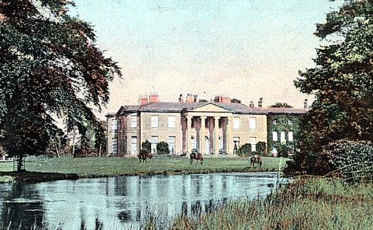
 | Willingham House

This is one of the camps which has received a few (about 20) of the PWS from Belgium out of that camp where starvation conditions ravaged. (I have not inquired into details, nor spoken to any of these young men, but one could still recognize them at once in the crowds as men emerging from hell).

The Major is at present employing these a little on more or less invented work as they are still too weak for any ordinary occupation, and is helping the camp to feed them up.

The camp is housed in a large manor house, the former winter garden serves as lecture hall. It is pitifully small. Part of the men are still under tent.”

The comment about Pastor Műller does not accord with comments made by others – see Holton hostel details below.

19/20 May 1946. Mr Dadley-Potter’s second visit for English Education found his reception to be; “Courteous and co-operative in marked contrast to the suspicious attitude so painfully in evidence at my first visit…” He gave a lecture and tested the English abilities of two pow teachers. There were 120 pows at 79 farms in the area, but numbers for other parts of the camp were not given.

A new hostel at Holton was opened on 16 May, 1946. Many of the pows at this new hostel were transferred from camps in the USA.

9/11 and 16 July 1946 – See appendix 1 for extracts. Main camp + 4 hostels.

25/26 November 1946. English Inspector’s Report. Main camp + 5 hostels. All 480 pows in the main camp were recorded as accommodated in huts.

8/10 January 1947. ‘Re-educational survey / Screen and re-screen P/W staff’. Total pows = 1 officer + 1538 O.R. Screening figures:

A | B+ | B | B- | C | C+ | Unscreened
9 | 43 | 315 | 53 | 200 | 41 | 878

It was recorded that 152 pows had been repatriated, including 12 Austrians.

Morale: “Although fairly high throughout the camp many Ps/W are beginning to feel depressed because of slow repatriation. Despite the efforts of the good leading Ps/W, morale is showing signs of deterioration at Holton Hostel, where about 90% are from the Russian Zone. The 41 C+ Ps/W are depressed as they are precluded from leaving the camp. At Stainfield where living and working conditions are not favourable to re-education, morale is low. These Ps/W are engaged on shift work over the 24 hours, there is no wireless set, while the quarters are poor. They are all volunteers and owing to the circumstances of shift work and accommodation, the Commandant can do little to improve conditions and stated that this was only a seasonal arrangement. Morale is highest at Northorpe hostel where the Ps/W feel satisfied in their comfortable quarters.”

Re-education activities were similar to previous reports, but had developed further, there were films, more education activities, and a theatre group, orchestra and choir.

29/31 May 1947. ‘Re-educational Survey’. 2 officers and 1166 O.R. Screening showed that all C classed pows had either been re-classified or moved elsewhere, and that there were; “no discernible Nazi elements left”:

A | B+ | B | B-
38 | 234 | 716 | 180

543 pows had been repatriated to date.

At the same time as the survey, a visiting lecturer, Kurt Pflűger, commented: “The intellectual level of Camp 256 seems to be exceptionally high. I heard comparatively few complaints and everybody was full of praise for the Commandant and the local population.”

Although other reports are mixed, especially regarding some of the hostels, several other lecturers commented on the intelligence and eager participation of pows. There is no way of knowing if the pows were of higher intellect than in other camps, or whether this was a perception gained from the enthusiasm of the pows in this particular camp.

13/15 June 1947. English Inspector’s Report. 1224 total pows. Teachers at De Aston Grammar School were asked if they would come to the camp to give some lessons, and one teacher did so.

26/28 August 1947. English Inspector’s Report. 1010 total pows. Educational activities have declined considerably due in part to other attractions in the long Summer evenings, and partly to the repatriation of some of the pows who led the courses.

3-5 September 1947. Re-educational Survey. Total pows = 2 Offs and 1014 ORs. Although political screening officially ended on 1 July, 1947, many inspections continued to use the grading:

A | B+ | B | B-
3 | 226 | 624 | 163

744 pows repatriated to date.
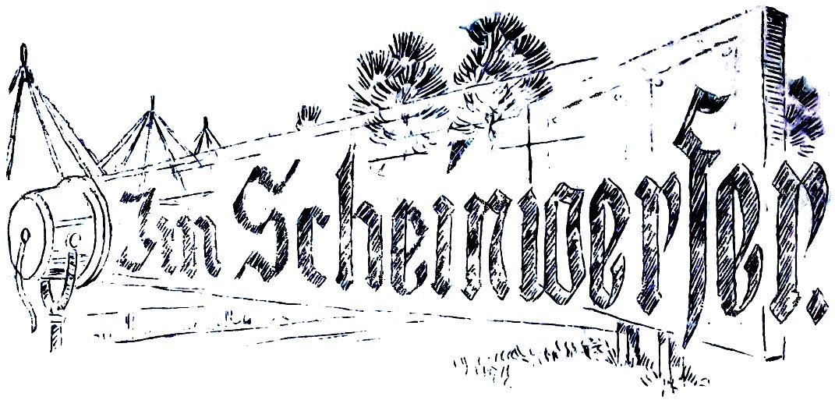
5-8 November 1947. Re-educational Survey. 1 officer and 781 O.R.s. Screening only recorded as ‘B - 782’. Lack of mail was raised as an issue in this, and other camps.

14 - 16 January 1948. The last report in the National Archive 939 files given by a visiting lecturer.

The camp magazine was called – Im Scheinwerfer! Lagerzeitung des Deutschen Arbeitslagers 256. (In the Searchlight - Camp news for German Labour Camp 256).

The camp closed during Spring 1948.

Camp commandants:
September 1945 – July 1946 Major E Thomas.
July 1946 - c1947 Lieutenant Colonel W U Tyrrell

After the camp: Ministry of Defence training camp. The house was blown up by the army on 7 June 1967.

Further Information:

National Archives
FO 939/181 - 256 Working Camp, Wellingham House camp, Market Rasen, Lincolnshire. Dated 1945 - 1947. Used for report above.

FO 939/312, description as above, dated 1945 – 1948. Used for report above.

FO 1120/237 – Re-educational survey visit reports for camps 252 to 256. Dated 1 January 1946 – 31 December 1948

The Imperial War Museum has copies of the camp magazine dated December 1946 and July 1947. Ref LBY E.J. 371.

Numbers of pows in Camp 256

 | Known to be open |  | No record |  | Not open

 | 9/45 | 3/46 | 5/46 | 7/46 | 11/46 | 1/47 | 5/47 | 6/47 | 8/47 | 9/47 | 11/47 | mid1/48
Main HQ | 500 | 468 | ? | 437 | 480 | 445 | 400 | 412 | 398 | 365 | 365 | 260
Hallington from Feb 46 |  | 93 | ? | 88 | 80 | 81 | 94 | 95 | 60 | 83 | 61 | 40
Yarburgh from Feb 46 |  | 37 | ? | 43 | 34 | 35
Holton from May 46 |  |  | 500 | 489 | 550 | 581 | 532 | 573 | 395 | 408 | 241 | 260
Kirmington |  |  |  | 15 | Became part of Camp 292 at Donna Nook
Northorpe |  |  |  |  | 102 | 102
Stainfield |  |  |  |  | 112 | 113
Billets |  | 77 | 120 | 162 | 202 | 182 | 142 | 144 | 157 | 160 | 115 | ?
Total | 500 | 675 | ? | 1234 | 1560 | 1539 | 1168 | 1224 | 1010 | 1016 | 782 | ?

Satellite Camps / Hostels –

Hallington.  15 miles from the main camp. (About 3.5 km SW of Louth). NGR for Hallington: TF 3055 8565.  One of 2 hostels formed on 22 February, 1946, with men from camp 296, mainly grade B. Camp 296 was either Doncaster Racecourse or Potter’s Hill – I think it was the Racecourse site as it closed down and transferred its pows.  Location: “The POW camp was at Hallington House Farm, (towards the top of the map) Halfpenny Lane, LN11 9QX. This is the big house on the left as you go out from Louth, under the by-pass towards Hallington. POWs were in the house, but there were also temporary buildings in what is now the grass field on the left before you reach the house. It is thought that there is one building still remaining.” Thanks to Ruth Gatenby and Martin Chapman – www.louthmuseum.org.uk  Hallington accommodation was recorded as being in buildings and huts.  1.12.46 – a visiting lecturer commented about the pows in this hostel; “Really worried and bitter as their families are mostly living in the Russian Zone, and that no parcels can be sent there. Their whole interest is concerned with the rumours about the Russian Zone, and they were pleased to hear that not all news are bad, I get from my family and my friends there. It brought some comfort to them. They seem to be a decent crowd without any Nazi mentality.” [FO 939/312]  Mail to and from the Russian Zone was severely restricted by the Russians. Many pows in UK camps received none at all while they were in captivity. | 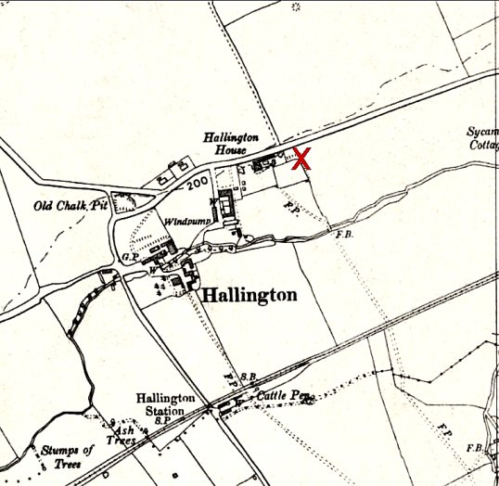
 | Ordnance Survey 1956
POW Numbers:
3/46 | 5/46 | 7/46 | 11/46 | 1/47 | 5/47 | 6/47 | 8/47 | 9/47 | 11/47 | mid1/48
93 | ? | 88 | 80 | 81 | 94 | 95 | 60 | 83 | 61 | 40

Holton  Recorded as 9 miles from the main camp. An ex-WAAF building and huts, the camp was described as comfortable. There was a system of loudspeakers left by RAF throughout the camp.  Location: In one report it is listed as “Holton (Wragby)”. Just NE of Wragby is Holton-Cum-Beckering. Next to this village was the RAF base at Wickenby, and WAAF were stationed there with 626 squadron. Part of the description of the RAF site was: “A number of the buildings were to the east (Communal Site, Living Quarters, WAAF Quarters) and stretched to and beyond the Lissington Road”. The most likely place for the camp at the ex-WAAF buildings is marked ‘x’ on the map – NGR TF 1142 8132.  Holton was opened for pows on 16 May, 1946. The first 500 pows were transferred from camps in the USA. Their morale was very low at the time as they had expected to be returned to Germany from information falsely given to them in the USA.  5-6 July, 1946. The Rev.Dr D Meyer-Kluegel gave a lecturer at this hostel. He later reported that: “At Holton the camp-pastor, a Prussian army-Chaplain of the 2 world-wars, tried to deliver a speech, but he is very much disliked by almost all the men of Willingham House Main Camp and Hostels. He is a real Nazi, and lecturer told him so. He wrote articles for the Camp-paper which were so subversive that they had to be stopped. The men feel that he is misusing his capacity as a chaplain and that he should be prevented from preaching his Nazi ideas camouflaged as Christianity. The men gave lecturer the enclosed copies of the Camp-paper which show the type of Nazi propaganda which this man is making.”  The next official camp visitor in July recommended: “That the removal of the Protestant Parson, Mueller, be considered.” | 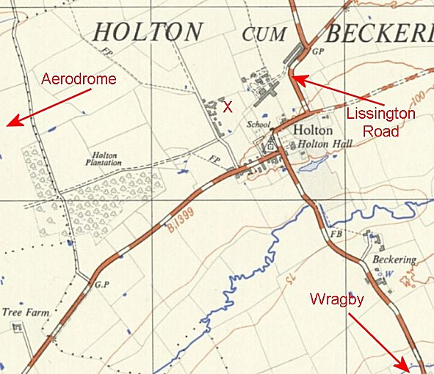
 | Ordnance Survey 1953

January, 1947 - Morale: “Despite the efforts of the good leading Ps/W, morale is showing signs of deterioration at Holton Hostel, where about 90% are from the Russian Zone.”

23-25 June, 1947. Apart from the chaplain mentioned above, another character at the camp – this time one of the guards - was commented on by a visiting lecturer, Ruth Körner. She reported how the lecture had been well received by the pows and a good discussion followed, but then: “Any attempt of re-education must, however, fail as long as men of the type of the sergeant in charge are at work. His conduct has already been the subject of an investigation of the Swiss Red Cross, and I had myself an opportunity not only to witness his behaviour towards the men when he came to the hostel (spreading an unfortunate scent of alcohol) but I also experienced his considerable rudeness and hostility.”

Pow Numbers:

 | 9/45 | 3/46 | 5/46 | 7/46 | 11/46 | 1/47 | 5/47 | 6/47 | 8/47 | 9/47 | 11/47 | mid1/48
Holton from May 46 |  |  | 500 | 489 | 550 | 581 | 532 | 573 | 395 | 408 | 241 | 260

Kirmington

16 miles from the main camp. Opened for German pows in July 1946. Just 15 pows are recorded there at that time with the comment – “not at present in use. Under preparation for intake.”

The 15 may have been part of a workforce preparing the camp. It is then listed as Camp 292A, so probably a sub-camp/hostel for Camp 292 Donna Nook.

Northorpe

22 miles from the main camp. A ‘building’.
Location: ? OS lists 3 ‘Northorpe’ locations in Lincolnshire.
The site was opened between July / November 1946 and was recorded for just a few months as part of Willingham until early 1947.

Jan 1947 - Morale: “Morale is highest at Northorpe hostel where the Ps/W feel satisfied in their comfortable quarters.”

No. of pows:

 | 9/45 | 3/46 | 5/46 | 7/46 | 11/46 | 1/47 | 5/47 | 6/47 | 8/47 | 9/47 | 11/47 | mid1/48
Northorpe |  |  |  |  | 102 | 102

Stainfield  16 miles from the main camp. A ‘building’. Open for only a few months towards end of 1946 / early 1947.  Location: NOT certain. The village of Stainfield is at NGR TF 1098 7312 – shown at the top of the map. This is a short distance from a large sugar beet factory at Bardney, shown at the bottom of the map.  January 1947 - Morale: “At Stainfield where living and working conditions are not favourable to re-education, morale is low. These Ps/W are engaged on shift work over the 24 hours, there is no wireless set, while the quarters are poor. They are all volunteers and owing to the circumstances of shift work and accommodation, the Commandant can do little to improve conditions and stated that this was only a seasonal arrangement.”  The shift work was being carried out in a nearby sugar factory.  A lecturer’s report on her visit to the main camp and 4 hostels commented: “STAINFIELD HOSTEL. 30.11.46 5 p.m. about 70 [pows attending her lecture] Very embittered and many of them still Nazis. They blame everyone but their own people. They pretend to have been awfully treated in British PW’s camps (usually even the Nazis agree that they are being decently treated) and one man said: “Hitler has achieved more in 12 years than the whole silly British Democracy during 300 years”.” | 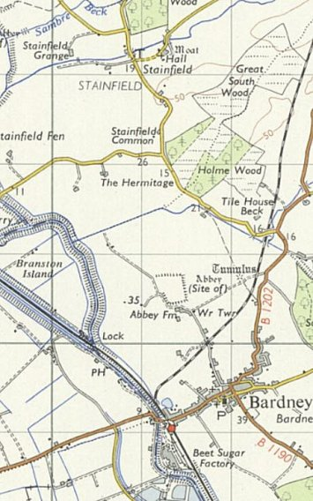
 | Ordnance Survey 1953

No of pows:

 | 9/45 | 3/46 | 5/46 | 7/46 | 11/46 | 1/47 | 5/47 | 6/47 | 8/47 | 9/47 | 11/47 | mid1/48
Stainfield |  |  |  |  | 112 | 113

Yarburgh  One of 2 hostels formed on 22 February, 1946, with men from camp 296, mainly grade B. At that time the site was described as “in two huts”.  General location TF 349 930  December 1946. A visiting lecturer described the pows at Yarburgh as: “The happiest and most thankful crowd I have ever met in a camp. They seem to be socialistic minded and attain a good spirit of comradeship.” | 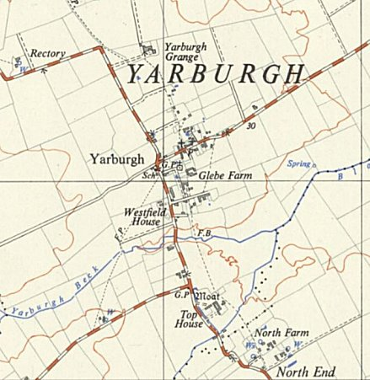
 | Ordnance Survey 1953

No of pows:

 | 9/45 | 3/46 | 5/46 | 7/46 | 11/46 | 1/47 | 5/47 | 6/47 | 8/47 | 9/47 | 11/47 | mid1/48
Yarburgh from Feb 46 |  | 37 | ? | 43 | 34 | 35

APPENDIX 1 – Large extracts from inspector’s report –
9/11th July, 1946 and 16th July, 1946 – Re-education and progress – Visit 5

Strength Offs… 1 O.Rs… 1233 Total: 1234

Of which [list of pow numbers in table above]

Screening figures:-
 | H.Q. | Holton | Hallington | Yarburgh | Total:
A | 6 | 1 | - | - | 7 | Cards completed….. All
B+ | - | 1 | - | - | 1 | Present complexion… Grey
B | 179 | 500 | 83 | 36 | 798 | Candidates for B’field… 1
B- | 32 | 4 | 1 | - | 37
C | 302 | 7 | 4 | 3 | 316
C+ | 53 | 1 | - | - | 54
Unknown | 12 | 7 | - | - | 19
 | 584 | 521 | 88 | 39 | 1232

N.B. These figures include billetees under H.Q. or Hostel of origin.
- - - - - - - - - - - - - - - - - - - - - - - - - - - - - - - - - - - - - - - - - - - - - - - - - - - - - - - - - - - - - - - - - - - - - - - - - - - - - - - - - - - - - - - - - - - - - - - - - - - - - - - - - - - - - - - - - - - - - - - - - - - - - - - - - -
Personnel:

O.C. Lt.Col W.V.Tyrrell Camp Leader: 963516 Hptwm. Juengst. ‘B’
Deputy C/L 74542 Wm. Grossman ‘Unknown’
Interpreter: S/Sgt. Citronenbaum German M.O.: 878179 Unter/Arzt Dr.Schotter, ‘B+’
Hostel Leaders:
Holton: D359160 Fw. Kunze, ‘B’
Hallington: 232014 O.Wm. Graefe ‘C’
Yarburgh: 126612 U.Fw. Grupe ‘C’
Kirmington – not at present in use. Under preparation for intake. [15 listed earlier – possibly work force preparing the site]
- - - - - - - - - - - - - - - - - - - - - - - - - - - - - - - - - - - - - - - - - - - - - - - - - - - - - - - - - - - - - - - - - - - - - - - - - - - - - - - - - - - - - - - - - - - - - - - - - - - - - - - - - - - - - - - - - - - - - - - - - - - - - - - - - -
1. Reception:

Reception was good and all facilities given. Lt.Col.Tyrell, a regular officer recently returned from India, has newly taken over this camp. I found him in the process of studying his new command. He impresses as likely to appreciate and help PID.
The interpreter, S/Sgt Citronenbaum, 13121073, exan.R.A.Fd. Survey Regt., is only 20 years old.

2. History of Camp:

On 16th May 1946, 500 arrived from camp 166, from USA, all B.
The camp spokesman was appointed on the recommendation of his former Camp Commandant and has selected his own staff.
Accommodation at H.Q. is 50% in buildings and huts and 50% in tents. The latter will be reduced by a building by the end of the month. Hallington is in buildings and huts. Yarburgh is in two huts. Holton very comfortably in an ex-WAAF camp.

3. Morale:

PWs are contented and keenly interested in the Paris Foreign Ministers’ Conference. There is no friction with British staff and any with German staff is trifling.

4. Political Progress:

Re-education is making progress and home news from Russian zone is killing any communist tendency. The Lager-sprecher, who is evidently aware of grading system, said a good number deserved a second chance.

5. Youth

These mix well and present no problem.

6. Re-educational Activities

Wochenpost & Ausblick: see Appendix B. [Not attached]

Newspapers: Receive representative selection of British papers. German newspapers are received from all zones except Russian.
Library: In June two lectures were given and well attended.
[Title mixed up here] Mr. Laufer “From the British Empire to the Commonwealth of Nations.”
Mr. Sinsheimer “Potsdam or Weimar”.
Discussion Group: A popular feature is a Brains Trust, ‘Comrade, what do you wish to [be] known?’ Answers are given to questions put in a box in the dining hall.
Films: “Glueck Unterwegs” and “Good morning boys.”
“Ich Vertrave dir meine Frau An” “Schiller”
All were popular; there is a great demand for news films.
Wireless: Have good wireless facilities, Holton Hostel in particular have a system of loudspeakers left by RAF.
Camp Magazine: Edited by Severin. Hpt.Gefr. ‘A’, who has 5 or 6 main contributors, though there are also others. They have insufficient paper.
Press Review: This is also given by Severin, helped by Rudolf, O/Gefr. (B), who is anti-Nazi and anti-Communist of Socialist learnings.
English Instruction: See Appendix A. [Not attached]

7. Other Camp Activities

Religion: The Protestant parson, Mueller, Hptmn. (B) is unfavourably commented on. Camp fears that his publications in camp newspaper will earn them an undeserved
reputation. He is also thought to be turning younger ones from the Protestant Church. The Catholics have the services of a British priest. His influence is limited by his ignorance of German. There is a German-speaking Polish priest in the neighbourhood. Only 15% of RCs are at present church-going.
Boell, Gefr. (B), who has spent two terms at 174 Camp, [Norton Park, theological study camp] is in particular interesting himself in the RCs and has a well thought out programme, which I expect to work an improvement. He should be a good influence on the camp.
Education: Courses at HQ are held in English, German, electrical engineering, book-keeping, and shorthand, mathematics and geometry, and tailoring.
Holton studies biology, French, book-keeping
At hostels English is the main study.
Theatre: A theatre group is headed by Heyn, O.Gefr (Prov B) a clever and decent man. 25 participate in a monthly production. At present doing ‘Der Brautigan meiner Frau’.
Orchestra: There is a 9-man orchestra under Nielsen, O.Gefr. At Holton, which is hampered by shortage of music.

8. Conclusions

British Staff is co-operative and at Holton the helpful attitude of Sgt.Taylor to Ps/W was raised. With the talent available in this camp re-education should progress.

9. Recommendations:

1. The substitution of a German-speaking R.C. chaplain for the British priest.
2. That the removal of the Protestant Parson, Mueller, be considered.

- - -

