Camp 254 Sutton Bridge Camp, Holbeach, Norfolk

Prisoner of War Camps (1939 – 1948) - Project report by Roger J.C. Thomas - English Heritage 2003
OS NGR | Sheet | No. | Name & Location | County | Cond’n | Type 1945 | Comments
TF 487 203 | 131 | 254 | Sutton Bridge, Holbeach | Norfolk | 4 | German Working Camp | Former RAF airfield, largely demolished for agricultural experimental station and a gas fired power station.

Location: Note, the comments in the English Heritage report were incorrect.  NGR TF 483 215 - along the side of the River Nene – “The former PoW is located below what is now the front parking areas for HGV trailers belonging to Roffes Transport.  The site and company is owned by two brothers one of which was in the front office when I arrived at this site. He was able to tell me that the former site was directly under where they park their trailer against the fence as he recounted that when they dug the site out to lay down concrete, they discovered the original hut bases. He then went on to say that they had reused the fence posts and some original fencing, and simply added their own chain link fencing as needed.” (Information from www.systonimages.co.uk/f537064555)  Various buildings still shown on the 1959 OS map.  Before the camp:  Pow Camp: The camp had accommodation for up to 250 pows in wooden and Nissen huts.  An inspection of the camp was carried out by the ICRC on 28 August 1947. There were 160 pows in dormitory barracks with 8 to 14 beds. Pillow cases were changed weekly, but less often for sheets. Electric lighting, new stoves and lockers had recently been installed. At this time the pow camp was due for closure and it was noted that the gardens had been neglected.  After the camp: 2020 Light industrial units | 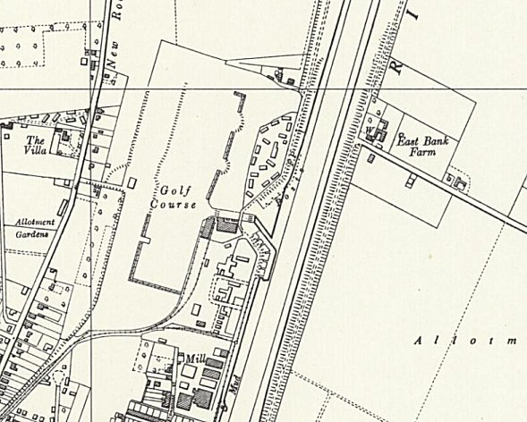
 | Ordnance Survey 1959
Further Information:
National Archives FO 939/180 – 254 Working camp, Sutton Bridge Camp, Holbeach, Lincolnshire. Dated 1945 - 1946
National Archives FO 1120/237 – Re-educational survey visit reports for camps 252 to 256. Dated 1 January 1946 – 31 December 1948
Lincolnshire County Council – Archive Collection Ref. BASS 5; Prisoners of War: Papers relating to the use of POW labour on farms in the Sutton Bridge area, 1943–1949.

