Camp 150 – Cherry Hinton Camp, Walpole Road, Cherry Hinton, Cambridge

Included in the 1945 ICRC camp list – Labour Camp. 150. Walpole Road, Cherry Hinton, Cambridge.

Location: About 6.5 km SE of Cambridge. Walpole Road is shown with dashed lines at W side of Cherry Hinton Hall, TL 481 564. Note, the name does not say ‘Hall’. A local resident stated; “the camp was near the paddocks, not far from where Budgens is now” – this site marked x on map, with residential area by 1960.  Before the camp: Fields in the area marked.  Pow Camp:  June 1945 – War Diary for Camp 150 Italian Prisoner of War Working Camp – see below.  The entry for 1 June – “Canvas erected to accommodate 109 Italian personnel”, this would seem to be an expansion, rather than when the camp opened as there is no mention of personnel etc.  29 June 1945 – the camp expanded to take on hostels and the Commandant, Captain Peddell, became a temporary Major. From the War Diary; “Cherry Hinton, Bolsham, [Balsham] Cottenham and Impington Hostels taken over by No.150 Camp from 45 P.W. Camp.” Camp 45 was Trumpington.  On 1 August 1945 an urgent memorandum was sent to this camp, and others, about maintaining records of Italians who were classed as ‘co-operators’. At this point many, sometimes all, of the Italian pows were in hostels / billets.  Memory – “Land girls who always seemed friendly and waved, later there were Italian POWs from the POW camp at the end of Walpole Road, they were similarly a happy bunch. Later in the war | 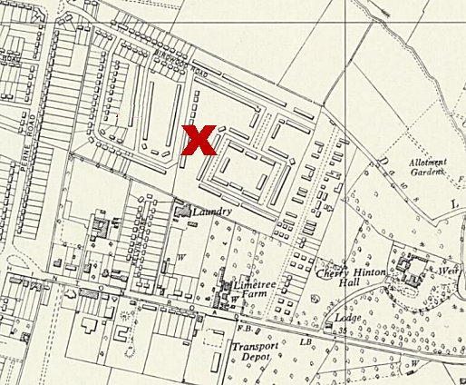
 | Ordnance Survey 1960
Germans took their place and they were not a happy lot, very miserable in fact!” (David Bentley - https://cherry-hinton.ccan.co.uk/).

[Any details of hostels (Balsham, Cottenham, Impington) will be under Camp 45].

Camp commandants –
? – June 1945 Major James Thomas Joseph Murphy (1895-?), Royal Munster Fusiliers / Royal Irish Fusiliers / Pioneer Corps.
24 June 1945 - ? Captain / Major H.L. Peddell from the Pioneer Corps.

Camp 150 is not included in the 1947 list of camps.

After the camp: Residential area.

The site as it is today - https://repatriatedlandscape.org/england/pow-sites-in-eastern-england/pow-camp-150-cherry-hinton/

Further Information:

National Archives WO 166/17823 – 150 (Italian) Prisoner of War camp at Cherry Hinton, Cambridgeshire. Dated June 1945. (See below).
War Diary for June, 1945 (WO 166/17823)

Place | Date | Hour | Summary of Events and Information | References to Appendices
Cherry | 1 |  | Administration. Canvas erected to accommodate 109 Italian personnel. | Variable, Showery.
Hinton | 2 |  | Administration. Comdt.proceeded on Privilege Leave, Capt.A.G.de la Mare, M.C., Asst.Comdt. assumes command. | Heavy rain.
 | 3 |  | Administration. | Sultry
 | 4 |  | Administration. | Showery
 | 5 |  | Administration. Adjt. (Lt.R.G.Lloyd) attended hospital for X ray. | Warm but overcast
 | 6 |  | Administration. | Windy and showery
 | 7 |  | Administration. Cpl.Midghall (ACC) arrived from Stromness, Orkneys. | Rain, windy
 | 8 |  | Transport to Trumpington for A.B. 406 inspection and repainting. Cpl.Twist (ACC) compassionate posting to Ashton-u-Lyne. Administration. | Rain
 | 9 |  | Instructions received for release of Comdt. And Asst.Comdt. w.e.f. 21 June 45 | Showery. Sunny periods.
 | 10 |  | Administration. Personnel to Church. | Rain
 | 11 |  | Administration. | Rain
 | 12 |  | Administration. | Rain
 | 13 |  | Administration. | Rainy
 | 14 |  | Administration. | Fair
 | 15 |  | Administration. | Cloudy
 | 16 |  | Administration. | Cloudy
 | 17 |  | Administration. | Fine and warm.
 | 18 |  | Administration. | Warm and sunny
 | 19 |  | Administration. Adjt.(Lt.R.G.Lloyd) admitted to White Lodge E.M.S. Hosp., Newmarket. | Sunny, hot
 | 20 |  | Administration. | Variable
 | 21 |  | Comdt. (Major J.T.J. Murphy) and Asst.Comdt. (Capt.A.G.de la Mare, M.C.) proceeded to No.3 Military Collecting Unit, Northampton for release. | Variable.
 | 22 |  | Administration. | Sunny and hot
 | 23 |  | Administration. | Warm and sunny
 | 24 |  | Administration. T/Capt. H.L. Peddell (257870) Pioneer Corps reported to take over Command. | Sunny
 | 25 |  | Administration. | Sunny
 | 26 |  | Administration. | Overcast
 | 27 |  | Administration. | Sunny, cool
 | 28 |  | Administration. | Cool
 | 29 |  | Cherry Hinton, Bolsham, Cottenham and Impington Hostels taken over by No.150 Camp from 45 P.W. Camp. T/Capt G.C.Foster (164695) E.Surrey Regt. Reported for duty as Asst.Comdt.
 | 30 |  | Administration.
Cherry Hinton
Nr. Campbridge, [signed] Major,
Cambs. Commandant, No.150I.P.W.W.Camp.

