Camp 1020 Shooter's Hill, Woolwich, London

1947 Camp List
1020(G.Wkg.Coy) | L.D. | Shooters Hill, Woolwich, London | Woolwich 1467 | 17 | V/1270/4

Prisoner of War Camps (1939 – 1948) - Project report by Roger J.C. Thomas - English Heritage 2003
OS NGR | Sheet | No. | Name & Location | County | Cond’n | Type 1945 | Comments
TQ 4442 7643 | 177 | 1020 | Shooter's Hill, Woodlands Farm, Woolwich, London | London | 4 | German Working Camp | Parkland.

Location: Shooter's Hill is a district in SE London within the Royal Borough of Greenwich. The map shows what might have been the perimeter of the camp.  Before the camp: Part golf course, part farmland. The camp was built adjacent to an anti-aircraft battery – a ‘Z Battery’, which used 3-inch rockets. The POW site is just to the W of Woodlands Farm. A US tented camp was on this site prior to the POW camp.  The Shooter’s Hill Golf Club History states – “In 1939, the southernmost 9 holes of the course were requisitioned for the establishment of an anti-aircraft battery and part of the Clubhouse became the headquarters of the Home Guard, and in the latter years part of the course also became a Prisoner of War camp for some 1000 German and Italian prisoners. The camp was surrounded by a 7ft high wire fence, and the cookhouse situated by the 17th green. The remaining 9 holes continued to be played even though the course sustained considerable damage from bombing.”  Pow Camp: The camp opened on 26 June 1946. The prisoners were transferred from Camp 197 The Mount, Chepstow. There was some tented accommodation (bell tents) for a short time when the camp opened, though it soon became all hutted.  Pow morale was low at the start. Three-quarters of the pows had recently been transferred from camps in the USA where they had been mis-informed that they would be returning to Germany, instead they arrived at camps in the UK. The other quarter of pows had transferred from camps in Belgium where conditions were known to have been very poor. The Camp Commandant, Major Leach, ran a well-ordered camp with care for the health and welfare of the pows. He was able to speak Flemish and so was understood by many Germans from the north. He was well respected by the pows who gave him the nick-name; ‘Father of the Camp’.  According to David Lloyd Bathe’s “Steeped In History”, the camp soon included barracks for | 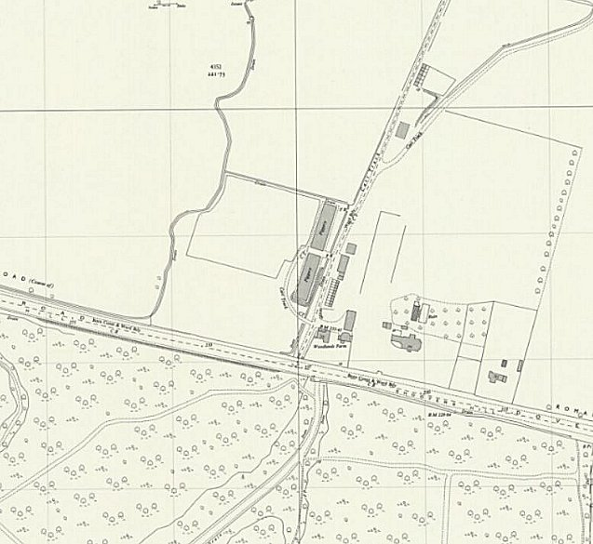
 | Ordnance Survey 1957
the prisoners, a recreation room, kitchen, officers’ mess, infirmary and cobblers and tailor’s shop. The cookhouse was situated near the golf course’s 17th green. The prisoners’ activities included working in the warehouses at the North Woolwich docks and helping with the potato harvest at Woodlands Farm. During the Winter of 1946/47, the pows cleared snow, including; “In the very severe winter of 1946/47, PoWs volunteered to clear the snow from the First Division Charlton Athletic’s football ground so that a regular weekend game could be played. About 300 PoW volunteers were “guests of honour’ at the game. - “When our part in saving the game was acknowledged over the loudspeakers, there was much cheering and backslapping, and many cigarettes came our way!”

13 September 1946 – an Inspector for English visited the camp. 545 German pows were recorded. He made brief comments about English language classes, the German pow teachers, and a play being performed at the camp.

7 October 1946 - there was a more general re-education camp inspection – see below for the full report. 533 pows were recorded. It was noted that the morale of the pows had increased due to the good treatment, food, welfare and activities in the camp.

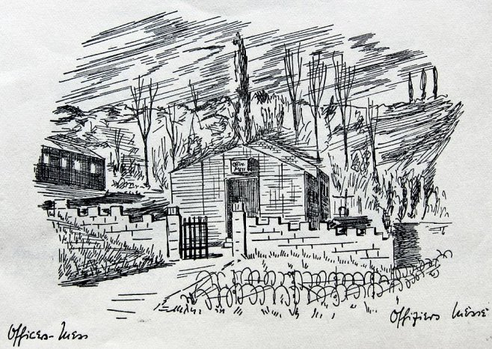 | A memento of the camp was created – ‘Zur Erinnerung’ (In Memory Of). The booklet contains pen and ink drawings by Wolfram Dörge. Dated Christmas 1946, it was dedicated to the Camp Commandant Major Leech.  < Officer’s mess by Wolfram Dörge.  Camp Commandant 1946 – (end?) Major J.B.Leach (Leech?).  No sub-camps or hostels were recorded.  The camp closed during spring 1947.  After the camp: Used as emergency housing for a few years after the war. The area was excavated for archaeology in 2005. The site was included in the July 2007 ‘Time Team’ tv programme. There was an Archaeological Evaluation and Assessment which was published in 2009.  Photographs of the site today - https://repatriatedlandscape.org/england/pow-sites-in-greater-london/pow-camp-1020-shooters-hill/

Further Information:
National Archives – FO 939/191 – 1020 Working Camp, Shooters Hill Camp, Woolwich, London, SE18. Dated 1946. (See below).A copy of Zur Erinnerung is held by Greenwich Heritage Centre.

http://e-shootershill.co.uk/2015/06/11/prisoner-of-war-working-company-1020-shooters-hill/

Report of a visit made to Camp 1020 - 7 October 1946
CONFIDENTIAL  SHOOTERS HILL No. 1020 G.Wkg.Camp Visited: 7.10.46  LONDON, S.E.18  Mr.R.P.Fenwick Handed in: 21.10.46  Woolwich 1467-8 Re-education Visit: 1st.  - - - - - - - - - - - - - - - - - - - - - - - - - - - - - - - - - - - - - - - - - - - - - - - - - - - - - - - - - - - - - - - -  Strength: Offs: 1 O.Rs: 532 Total 533  Screening figures: A+ NIL  A 62  A- 2  B+ 119  B 188  B- 112  C 31  C+ 1  Uns 4  Not known 14  - - - - - - - - - - - - - - - - - - - - - - - - - - - - - - - - - - - - - - - - - - - - - - - - - - - - - - - - - - - - - - - -  Personnel:  O.C. : Major Leach Camp Leader: Uffz.Direnbach (B+)  Interpreter : Pte.Kanfer Deputy C/L: Uffz.Wieglow (B+)  German M.O.: Stabsarzt Grafer (C)  - - - - - - - - - - - - - - - - - - - - - - - - - - - - - - - - - - - - - - - - - - - - - - - - - - - - - - - - - - - - - - - -  1. RECEPTION  The Commandant, Major Leach, is most co-operative and interested in re-education and welfare of his Ps.W. I did not see the interpreter.  2. HISTORY OF THE CAMP  The camp was formed on 26.6.46, the Ps.W. being transferred en bloc from No.197 Chepstow. About 75% of Ps.W. are ex USA and 25% ex Belgium. Camp Leader Direnbach (B+) and his deputy Wieglow (B+) were elected by their fellow Ps.W. shortly after the camp was formed and confirmed in their appointment by the C.O. Both are men of personality, who take their work seriously and take an active part in re-education.  Until recently about 200 men were accommodated in tents. Now, however, all are accommodated in huts though the camp is not yet completed. Within the next fortnight it is expected that two large huts will be available for educational purposes. At present one recreation room, which can hold about 200 men standing, has to serve for all purposes: schoolroom, lecture room, canteen and theatre. |  | 3. MORALE  Morale at first was low, owing to disappointment of Ps.W. ex USA, who had been assured by American officers that they were being repatriated, and discontentment of Ps.W. ex Belgium who alleged they had been badly fed and roughly treated in Belgium. Good treatment, attention to welfare and educational activities on the part of the British staff and better food has now raised morale considerably. Many Ps.W. ex Belgium have gained up to 40lbs in weight and the camp can now be regarded as contented and happy.  Reaction to the Nuremberg judgements was favourable, but there was some criticism at the acquittal of Schacht, van Papen and Fritsche “why should they, who have so much on their conscience, go free, while we are prisoners?”. This had a depressing effect on morale, which has been countered by the news that the three concerned are to appear before German de-natzification courts.  4. POLITICAL PROGRESS  The camp in general is grey. There are still a few men who openly profess National Socialist ideas; but they are treated rather with contempt as being “behind the times” by their comrades. Many with Nazi backgrounds are making a determined effort to learn something better. Communism has little sympathy in the camp. Complete screening was carried out during visit.  5. YOUTH  Approximately 25% of the camp is under 25 years. Quite a number are under 20 years. They are fairly evenly distributed amongst the huts and present no special problem. Interest in re-education is comparatively strong. The majority of the youth, though still shaken by the collapse of the only form of life they knew, are sincerely trying to find something better to replace it and their attendance at lectures etc. is good.  6. RE-EDUCATIONAL ACTIVITIES  The Camp Leader and his deputy take a leading part in re-education. Contentment with the camp and their work has made for receptivity to re-education although expansion of activity is hampered by lack of accommodation.  Wochenpost & Ausblick: 50 copies of Wochenpost. Totally inadequate.  Ausblick is not received. See Appendix B.  Newspapers: Daily Express, Daily Herald, Daily Mail, The Times, News of  the World are regularly received. No foreign newspapers.

Library: Consists of 103 German books, mostly classical and 100 English books, mostly novels. Between 40 and 50 Ps.W. can read English and the English books are more popular than the German ones which are “too heavy”. Supply of German novels is desired. 100 German books were ordered from YMCA some week ago but have not arrived.  Lectures: Two lectures have been given in the camp: Dr. Friedmann “Public Life in England” and Dr. Hirsch “Germany, yesterday, today and tomorrow”. Both were well attended, between 200 and 250 being present, and lively discussions were held afterwards. Some comments on lecture by Dr.Hirsch are attached as Appendix A.  Discussion Groups: At present confined to informal discussion groups held in living huts. A regular discussion group, meeting every week will be started by Stocker (B+) as soon as accommodation is available.  Films: YMCA film unit visits every Tuesday. Films are popular, but news films would be appreciated.  Wireless: A good wireless set is installed in recreation room and about 200 men usually assemble to hear BBC news in German. P.W. programme is popular. German stations are also received in the evening.  Camp Magazine: A camp magazine is in preparation and will be published soon. Editor will be Hermann Dick (B+). Contributions have been asked for from anyone interested. Supply of stencils and paper is good, but duplicator is of the old fashioned hand roller type.  Press Review: Is present 3 times weekly in recreation room, average attendance 150-200 men. Items are selected and translated beforehand by a committee of 4 men: Direnbach (B+) Camp Leader, Wieglow (B+) Deputy C.L., Lass (B+) and Hagebecke (B+). Mr.Churchill’s speech at Conservative Conference was given in full and caused much discussion.  English Instruction: Widespread interest in English.  3 classes for beginners, total 60 pupils. Teachers: Stoecker (B+), Weber (B+) and Freidburg (B+).  1 intermediate class – 30 pupils – Teacher: Hagebecke (B+) includes “Reading Hour”, when extracts from books, English for All, etc are read aloud.  1 advanced class – 21 pupils – Teacher Lass B+.  When accommodation is available another class will be started in response to popular demand. There are sufficient G.O.S. books (some privately owned) for every pupil to posess his own (80 from COGA).  An “English Theatre Group” is preparing an all English variety programme, with English sketches, songs etc. |  | 7. OTHER CAMP ACTIVITIES  Religion: R.C. 200 Protestant 300  A party of about 70 Protestants go every Sunday to Welling Church.  A German speaking priest, Father Buesing visits every Sunday and is trying to arrange for visits to the local church in Dover Road.  Education: Classes are held in:  French – 9 pupils – Teacher: Hofmann Alfred (A)  Spanish – 8 pupils – teacher Dick hermann (B+)  Classes in other subjects, such as shorthand and bookkeeping, building construction etc. will be started when teachers have been found.  Many men study privately.  Theatre: Progress is handicapped by lack of accommodation but an operetta written by a P.W., is in rehearsal.  Orchestra: There is a great desire in the camp for an orchestra, but only a pianist, a guitarist and two poor violinists are available,  8. CONCLUSIONS  There is undoubtedly much interest in re-education which has the wholehearted support of the Commandant. Educational activities will develop when more accommodation becomes available.  9. RECOMMENDATIONS  a) Supply of Wochenpost should be increased to a number commensurate to size of camp (530 men)  b) German newspapers should be supplied.  c) German books (novels) to be supplied for library, if this has not already been done.  d) Lectures to talk on democratic way of life, government etc. are desired. Talks on germany today under Control Commission are also asked for.  e) COGA film unit should visit regularly.  f) If possible a rotary duplicator for camp magazine.  Notes:  Camp leader - Franz Derenbach  Apppendix A and B – not in file  COGA = Control Office Germany and Austria.

