Camp 92 - Bampton Road Camp, Bampton Road, Tiverton, Devon

Included in the 1945 ICRC camp list – Labour Camp. 92. Bampton Road Camp, Tiverton, Devon.

1947 Camp list
92(G.W.C.) | Bampton Road Camp, Tiverton, Devon | S. | Priswar, Tiverton | Tiverton 2115 | Tiverton | Lt.Col.J.A.Macdonald | v/1453/2

Prisoner of War Camps (1939 – 1948) - Project report by Roger J.C. Thomas - English Heritage 2003
OS NGR | Sheet | No. | Name & Location | County | Cond’n | Type 1945 | Comments
SS 952 134 | 18 | 92 | Bampton Road Camp, Bampton Road, Tiverton | Devon | 4 | German Working Camp | STANDARD type. Site occupied by a school

Location: Just to the NW of Tiverton. It was off the A396, which, although it runs towards Bampton, is labelled as Bolham Road on the maps I have seen. The River Exe runs alongside.  Before the camp: Farmland. Part of a racing field in Victorian times. An oval track can be seen at the back of the camp in the 1946 photograph, but does not show on the 1954 or earlier OS maps.  Pow Camp: Italian pows until the end of 1944 / early 1945, then a German Working Camp.  The site had a standard layout with a main pow compound and guards’ huts and offices at the front. Royal Air Force aerial photographs of 1946 and 1947 show at least 50 close set huts in rows. Common buildings and facilities at standard type camps included water towers, offices, officer's mess, a canteen, guard rooms, barrack huts, ablution blocks, cell blocks, a camp reception station (medical facility/hospital), a cookhouse, dining rooms, recreation rooms and living huts or tents.  Reports refer to ‘hostels’ which would usually be considered as a building – in this case it includes satellite camps. | 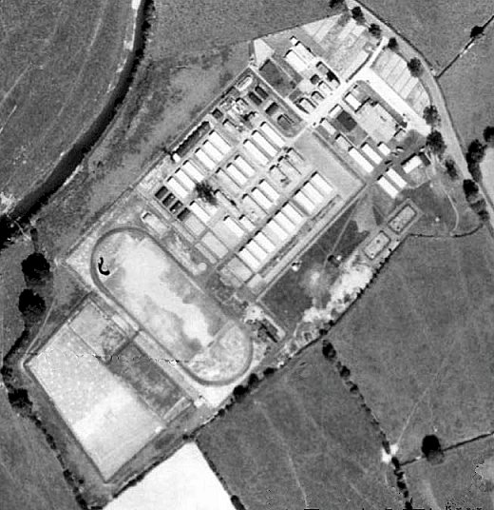 | 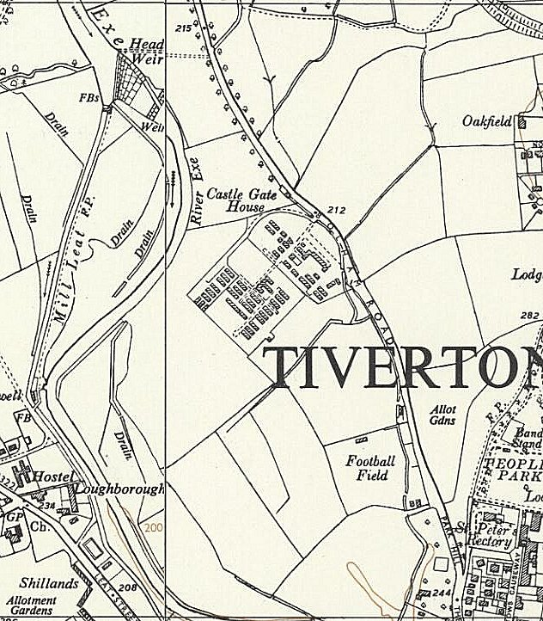
 | RAF Aerial photograph 1946. | Ordnance Survey 1954
Two hostels were listed for Italian pows from this camp on 5 May 1944, (WO 32/10737): Chudleigh by Newton Abbott, Devon and Waterloo Cross, Uffculme, Devon.

The camp was listed as an Italian Labour Battalion under the Southern Command area in May 1944 and as an Italian POW Working Camp in November 1944, (+ Pioneer Corps Group), (WO 32/10737).
During 1944 the Main Camp held Italian pows with ‘subversive tendencies’ – presumably ‘non-co-operators’ as co-operators are detailed as being in billets. They are reported to have caused some disruption in the neighbourhood:

“Lieut.-Colonel Acland-Troyte [M.P. for Tiverton] asked the Secretary of State for War what action he has taken with regard to the bad behaviour of Italian prisoners of war in Tiverton and the neighbouring districts; whether any disciplinary action has been taken against the men involved in the incident in Tiverton on 25th October; and if he will take steps to ensure that discipline is maintained among these prisoners and that they are prevented from wandering about the country and frightening respectable women, particularly near Tiverton and Sampford Peverell.

Sir J. Grigg - The camp at Tiverton houses Italian prisoners who have been removed from other camps because of their subversive tendencies. I have no information of an incident on 25th October. An incident did, however, take place on the night of 27th-28th October when crude pamphlets bearing fascist slogans were distributed in a small area of the town, but so far, the perpetrators have not been discovered, although investigations are still proceeding. A small number of Italian co-operators are billeted in the area who are allowed to exercise within defined limits, and any complaints against their behaviour should be reported to the Commandant, who will deal with them. In this connection I would refer my hon. and gallant Friend to the reply I gave my hon. Friend the Member for Tamworth (Sir J. Mellor) on 14th November.”
(House of Commons, 16 November 1944, Vol 404 – the reference to 14 November was a reply about decreased security measures for Italian co-operator pows).

As the Italian pows were placed in hostels / billets to be replaced by German pows, relationships between the camp and the neighbourhood did not improve. Several comments were made in reports about there being very few outside contacts in Tiverton up to the camp’s closure in 1948.

From April 1945 a series of Educational Visits were made to the camp. These were on behalf of the Control Office for Germany and Austria (COGA) and the Foreign Office. They report on educational activities, in particular English lessons, and ‘re-educational’ activities, which were often in the form of discussion groups, lectures, and exhibitions. (The reports are contained in folder FO 939/172).

20 April 1945 - Report of an English Education Visit to the main camp. A small section details the educational background of the German pow instructors, and gives an outline of teaching content for English lessons. A final sentence, probably refers to the Camp Commandant: “Lt. Col. Becker was away when I left, but I phoned him just before leaving, and gave a report of what had been done.”

2-3 July 1945 – Report of Mr Will Potter’s English Education Visit. A change of Camp Commandant was noted and there is a brief outline of English lessons.

10 December 1945 - Report of an English Education Visit to the main camp + Chulmleigh and Crediton, (stated to be 2 of 3 hostels, but the third is not listed). All German pows. The 2nd in command did not appreciate the visit as insufficient information had been provided. Comment by the visitor – “One has the impression of great efficiency in the management of this camp.”

3-5 May 1946 – Report of Major T Barry’s visit to complete a ‘Brief Education Survey’. He recorded there were then six hostels, but did not give their names or number of pows. He stated that Austrian pows were held at Silverton – and they were expecting to be repatriated in the near future. The Camp Commandant comes in for praise as he, “takes the keenest interest and has the greatest sympathy.”

15 June 1946 – Major Barry made another visit to report on English lessons. The Commandant was Lieutenant Colonel McDonald. There were 849 pows in the main camp and 860 in hostels and billets, (see table below for numbers). He stated that Silverton opened on 13 June with many pows from the Channel Islands, but previously he recorded Austrian pows here – so I assume that the Austrians were repatriated as expected, and the site re-filled with Germans at this time.

The German pows from the Channel Islands had been held at other camps and hospitals before this. During the last months of the Islands’ occupation there were major food shortages – including for the German troops – many needed medical treatment before being sent to Camp 92.

11-15 July 1946 – Report on Re-education and Progress - extracts from this report are given in Appendix 1.

Strength – Officers 3 / OR’s 2075. There were 817 pows in the main camp, 1058 in hostels, and 203 billeted. Political screening had been carried out:

A+ | A | A- | B+ | B | B- | C+ | C | C- | Unknown | Unrecorded
2 | 64 | 6 | 198 | 741 | 228 | nil | 76 | - | 14 | 749

Overall, the camp was categorized as ‘B’ / Grey. The presence of C grade / ‘black’ pows caused problems for the camp as the War Office had issued a directive that they were to be segregated. This decision had been made back in early 1945 after a series of disturbances and at least one murder in other camps. It was not considered to be suitable to have camps with only category C pows, so the order was made to have segregated areas within camps. The commandant at Camp 92 placed the C grade pows in Dulverton hostel. Issues arose from having a site with all Nazis, and how to include them in re-education and democratic activities.

Other issues were raised. The competence of the British interpreter officers was questioned as their language skills were not seen to be good enough - a short while late an “excellent” i/o was appointed to the camp. Some of the German re-education leaders within the camp had not been carefully selected and included Nazis. Another War Office instruction came under question regarding the wearing of military rank badges. This was considered to be counter to the democratic and non-militaristic nature the camp was attempting to promote.

The Commandant (J.A. McDonald) came in for regular praise – “His personal interest and care for the welfare and well-being of Ps/W in his charge together with his good and just treatment are recognised and appreciated by the men.”

The photo shows Camp 92 in the bleak winter of 1945.  There are a few Nissen huts to be seen, but most buildings are wooden type huts.  The centre section of the photograph shows the water tower and compound for guards’ huts and offices next to the road.  To the left of the picture appears to be a guard tower and part of the pow compound. | 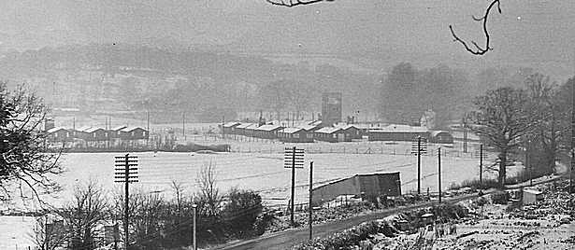

9-12 September 1946 – English Inspector’s Report. Numbers of pow = 2325, (see table below).

19 November 1946 - Report on Camp 92 (Dulverton Hostel). Presumably made as this hostel was listed as containing Grade C pows. Brief notes on education activities.

5-6 December 1946 - Short Report on Visit to No.92 Camp (Honiton Hostel).

25 January; 22 February; 12 and 17 April 1947 - English Inspector’s Reports. (See table below for numbers of pows).

13-15 June 1947 – Introductory and re-educational survey - extracts from this report are given in Appendix 2.

22-24 June; 16-17 July 1947 – English Inspector’s Reports. Very brief details were given.

Throughout all the reports of the camp under Commandant J.A. McDonald, there is praise for his work and attitude towards the pows. A new camp commandant, Lieutenant Colonel G.W.V. Ladds was appointed to the camp in August 1947. He is reported to be overly militaristic and a disciplinarian - attitudes within the camp were soured. The Inspectors had no control over this as their comments went unheeded and Lieutenant Colonel Ladds continued as Commandant until the camp closed in 1948. It should also be considered if the new regime actually suited the War Office at this time. The main reason for retaining pows in the UK was to maintain them as a much-needed additional workforce – and one Inspector commented that Ladds’ aim was; “to have every available PW out to work.” Re-education was certainly not a priority with the new Commandant – or with the Ministers for Agriculture and for Labour.

19-20 September 1947 – English Inspector’s Report. Camp category ‘Gray’ – though this type of screening had largely been discontinued by this time. Details of English lessons carried out. Numbers of pow = about 1300, (see table below).

29 September and 4-6 October 1947 – Routine re-educational survey visit. Pow numbers – Officers 2, Other Ranks 1362 - all screened as category ‘B’. It was noted that hostels in use were changing with some closing and others being acquired from other camps. 748 pows had been repatriated up to that date from this camp. The change in the nature of the camp, with the conflict between the aims of re-education and the demand for pows as a work-force is reflected by the Inspector; “Morale Is going to pieces; and this camp was a short while ago the happiest in the S.W. area.” There is a hint of resigned desperation in the Inspector’s comments. Extracts from this report are given in Appendix 3.

18-22 November 1947 - Progress Report. Officers 2, Other Ranks 1348. The excellent Interpreter Officer Lt Grenville is reported to have left for Camp 157 and a further deterioration in education activities is noted.

5-6 February 1948 - Re-education check. Brief extracts are given in Appendix 4. Officers 2, Other Ranks 585. Activities are being closed down as repatriation continues.

4 March 1948 - English Inspector’s Report. Number of pow = 442, but the number of pows in billets is not recorded, (see table below). The Inspector commented – “The hostels exist little more than in name – the present strengths represent merely anti-squatter parties and the Main Camp numbers are rapidly diminishing.” An outline of lessons and teaching materials was given.

9-11 March 1948 - ‘Final Check’ Education Inspection report - Full transcript below in Appendix 5. Number of pow = 476. The Inspector notes that “In the past six months grumbling and dislike have grown in the camp, one hundred percent” – and he puts this down to the regime established by the new Commandant. It is noted that some of the remaining pow came from the Channel Islands and their, not surprising, resentment that others have been repatriated before them. Dymond’s Farm is added as a hostel – this was previously Camp 76/276.

There was a German weekly newspaper called ‘Die Eule von Tiverton’ (The Tiverton Owl). Publication varied depending on the availability of an editor. In June 1947 a camp inspector wrote: “Edited by Beiler [German Studies Leader] published weekly and entitled “Die Eule”… Beiler has been somewhat injudicious in the past but I found nothing in him to which I could take objection. The newspaper is quite good and has much work put into it.”

Memories - This account was submitted to the BBC People's War website by ‘Storygatherer’ Alison Lear on behalf of Gerald Frankpitt:

“I was eleven at the start of the war. My father was a farmer and I had one brother and three sisters. My father owned a field which was nearly twenty-four acres in size. It was used as a horse racing field in Victorian times. In the war it was requisitioned as a POW camp.

Firstly, there were Italians, and later on Germans as well as displaced people e.g. Yugoslavians. The POWs worked on the land - they were all hardworking except the Italians!
I remember the Italians used to catch wild birds in a trap and eat them. The Germans were so well disciplined they almost ran the camp themselves.”

Known Camp Commandants:
? – July 1945 Lieutenant Colonel Becker (or Becher).
July 1945 - ? Lieutenant Colonel Oliphant
c1946 to July 1947 Lieutenant Colonel J.A. McDonald DSO., M.C.R.A.
August 1947 to closure 1948 - Lieutenant Colonel G.W.V. Ladds from ‘The Glosters’. Previously at High Garrett Camp 98.

Numbers of pows in Camp 92

 | Known to be open |  | No record |  | No record, may have held Italian pows |  | Not open

 | 5.5.44 | 10.12.45 | 15.6.46 | 11.7.46 | 9.9.46 | 25.1.47 | 22.2.47 | 12.4.47 | 13.6.47 | 22.6.47 | 19 .9.47 | 29.9.47 | 18.11.47 | 5.2.48 | 4.3.48 | 9.3.48
Main HQ | No’s ? | No’s ? | 849 huts | 817 | 900 | 745 | 721 | 699 | 677 | 673 | 650 | 695 | Not given. | 325 | 350 | 318
Chudleigh | No’s ? | * |  |  |  |  |  |  |  |  | 100 |  |  | 35 | 22 | 25
Waterloo Cross | No’s ? | * | 120 | 111 | 110 | 91 | 89 | 88 | 97 | 107 | 105 | 71
Chulmleigh | ǂ | No’s ? | 66 | 81 | 90 | 73 | 74 | 74 | 81 | 80 | ? | 70 |  | 37 | 15 | 14
Crediton | ǂ | No’s ? | 70 | 67 | 70
Silverton | ǂ | ǂ | 240 | 233 | 235 | 101 | 93 | 74 | 95 | 93 | 43 | 42 |  | 26 | ? | 5
Axminster | ǂ | ǂ | 175 | 176 | 170
Little Bray | With Camp 42 |  | 181 | 169 | 200 | 168 | 142 | 135 | 138 | 136 | 100 | 105 |  | 46 | 24 | 21
Dulverton | ǂ | ǂ | ǂ | Nil | 90 | 81 | 77 | 76 | 73 | 71 | 80 | 82
Cruwys Morchard | Separate camp - 645/669 |  |  | 208 | 280 | 274 | 200 | 191 | 172 | 155 | 163 | 165
Honiton | ǂ | ǂ |  |  |  | 177 | 163 | 155
Nadderwater |  |  |  |  |  |  |  |  |  |  |  |  |  | 41 | 31 | 28
Dymond’s Farm | Separate camp - 76/276 |  |  |  |  |  |  |  |  |  |  |  |  |  |  | 7
Billets | No’s ? | No’s ? | No’s ? | 203 | 180 | 131 | 132 | 124 | 145 | 145 | ? | 134 |  | 77 | ? | 58
Total | No’s ? | No’s ? | 1709 | 2078 | 2325 | 1841 | 1691 | 1566 | 1478 | 1460 | 1300+ | 1364 | 1350 | 587 | 442+ | 476

* The report from this date states there are three hostels – but only listed 2: Chulmleigh and Crediton. As there is no further record of Chudleigh until 1947 it is probable that the third camp was Waterloo Cross. It is also possible that one or both of these hostels were still in use for holding Italian pows, which is why the Inspector for German pows did not record them.

ǂ Memories of some of the hostels state there were Italian pows before German pows.

Satellite Camps / Hostels

Axminster – hutted camp. Opened (for German pows, it may have previously held Italian pows) on 17.4.1946. First arrivals were pows from USA. There were then 3 reports which list Axminster:  15.6.1946 - 175 pows. 11.7.1946 – 176 9.9.1946 – 170 (no further listings after this).  A probable site was suggested by David Knapman, volunteer with the Axminster Heritage Centre:  “By far the most likely location for a larger group would have been the former US Army Medical Corps 315th Station Hospital at Millwey Rise (off Chard Road, Axminster), which was built for D-Day and then not very substantially used. It was a satellite for the US hospital at Taunton which later became the present NHS hospital at Musgrave Park.  However, if there were POWs there I think they must have moved out by early September 1946, because that is when local families started to occupy the empty buildings, and I cannot believe that POWs and squatters would have been allowed to share space. On the other hand, the presence of POWs would explain why, given the shortage of local housing, families in need of space did not move in sooner.”  The site was at NGR SY 3062 9914. It was certainly large enough for the number of pows listed and fits the description of being a hutted camp. The information that families moved in during September 1946 also ties in with the date of the last report.  [Axminster Heritage have published a booklet; ‘Millwey Rise: A Short History’ which shows the hospital buildings – go to ‘Youtube Millwey Rise’]. | 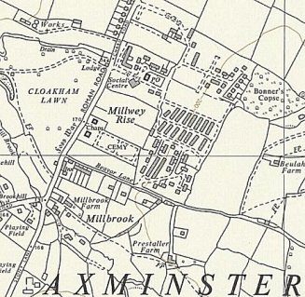
 | Possible site - Ordnance Survey 1963

Chudleigh, (Newton Abbott, Devon) – listed as a hostel for Italian pows in May 1944, then not listed again until September 1947 when it holds 100 German pows. It lasted into 1948 at a reduced size. One report lists the address as Chudleigh, Newton Abbott, Devon – but there is a 7-mile distance between these two places.

Chulmleigh satellite camp / hostel.  The camp was located on the site of what is now the Playing Field and Community Centre in Leigh Road, Chulmleigh EX18 7JL – NGR SS 6803 1430.  Hutted camp. Open from at least late 1945 to 1948.  Information supplied by Ian Jury, a local resident:  “All the buildings top right in the field are the Camp as it was in 1947… the first Community Building was not erected until the early 1980s.  I can remember the wire fence and huts plus going over as a boy to watch the water/watch tower blown up in the early 1950s. All that remains visible is part of the concrete roadway into the camp from Leigh Road. I am told, but have not seen, that in very dry summers you can see the outlines of the foundations of the huts in the grass. If you are trying to find the site on an OS Map it is on the left of the road that runs from the town to the A377 just after the |council houses named Leigh Villas…  - After the war in the early 50s one of the huts was | 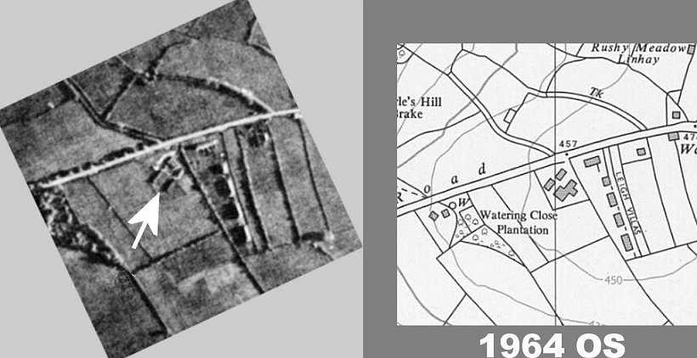
bought by the local Roman Catholics and moved to a site at the top of South Molton Street in the town to become their Church. That has now been pulled down... I guess the huts were a standard design and this one looks very like the ones in a photo I have seen of the Tiverton Camp. I have been told that another hut was bought by a local businessman for his chicken processing plant.

- I have back in Devon a notebook kept by a local man who worked at the Camp which lists which farms etc prisoners were allocated to work at - it is a sort of rota but does
not contain details of the prisoners. Some were bussed to farms in other villages several miles away EG Lapford and North Molton.

- One of the prisoners, Emile? Arthur? from Porz, a suburb of Cologne, was allocated to work with my father who ran a Market Garden. I can just remember him and being
carried on his shoulders up the hill into the village. On 28/5/1947 when he had returned to Germany he wrote (typed) a letter to my parents thanking them for a parcel they had sent to him – there was clearly a very good relationship with him.

- I also have a cutting from the Exeter and Plymouth Gazette dated 11/10/1946 with details of a Harvest Festival Service held in the local Congregational Church during which
“a double quartette was rendered by the German prisoners residing in the Camp at Chulmleigh”.

Number of pows:
 | 5.5.44 | 10.12.45 | 15.6.46 | 11.7.46 | 9.9.46 | 25.1.47 | 22.2.47 | 12.4.47 | 13.6.47 | 22.6.47 | 19 .9.47 | 29.9.47 | 18.11.47 | 5.2.48 | 4.3.48 | 9.3.48
Chulmleigh |  | No’s ? | 66 | 81 | 90 | 73 | 74 | 74 | 81 | 80 | ? | 70 | ? | 37 | 15 | 14

After the camp it is reported to have housed displaced person.

Crediton - listed as a house. NGR SX 8364 9783. Open from late 1945 to Autumn / Winter 1946.  Information from John Heal / creditonhistory.org.uk: the camp was located at Trobridge House. It held Italian and German pows.  Number of pows:  5.5.44 10.12.45 15.6.46 11.7.46 9.9.46  Crediton No’s ? 70 67 70 | 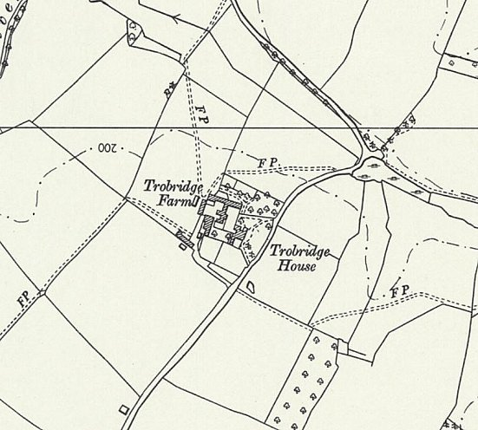
 | Ordnance Survey 1963

Cruwys Morchard – previously Camp 645/669 – see separate details.

Dulverton (Barronsdown House – correct spelling Baronsdown). NGR SS 9327 2889.  Previously a large private house.  Became an Italian hostel. There is a memory that the Italian pows made ‘withy baskets and bowls’ – I expect these were for sale.  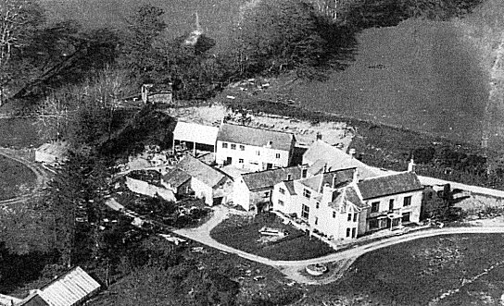  Later described as; “a private house with its own dynamo. It is being opened on 13th July to accommodate the C grade Ps/W arriving on this date. The hostel leader his deputy and the re-education staff have been selected by the Commandant from the main camp. Two small dining rooms serve also for re-education and recreational purposes.” Later this appears to have become a hostel with mixed categories with a comment made 19 November 1946: “MORALE – Repatriation of party members has caused dissatisfaction. Morale otherwise fair.”  Baronsdown House was demolished in the 1960’s.  Above, the house in the mid-1950’s | 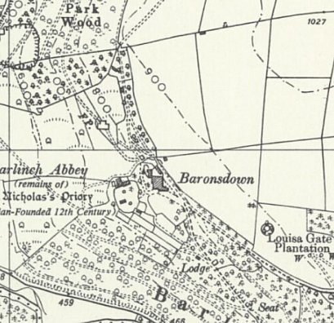
 | Ordnance Survey 1962
Number of pows:
 | 5.5.44 | 10.12.45 | 15.6.46 | 11.7.46 | 9.9.46 | 25.1.47 | 22.2.47 | 12.4.47 | 13.6.47 | 22.6.47 | 19 .9.47 | 29.9.47 | 18.11.47 | 5.2.48 | 4.3.48 | 9.3.48
Dulverton |  |  |  | Nil | 90 | 81 | 77 | 76 | 73 | 71 | 80 | 82 | ?

Dymond’s Farm – previously Camp 76/276 – see separate details.

Honiton. Possibly opened to re-house the pows previously held at Axminster Hostel?  On 5-6 December 1946 there was a re-education visit to the hostel. Number of pows c.150.  Screening A: 11 / B+: 41 / B: 79 / B-: 18 / C: 3.  The camp was then visited on:  25.1.47 – 177 pows 22.2.47 – 163 12.4.47 – 155; no further mention after this.  Location – probable site within square ST 150 000 – and likely to be the huts shown to the front of St Rita’s in the NE corner of the map (ST 1541 0037). I am basing this on two separate sources:  1. Article by Jemima Laing, BBC Devon, 24 September 2010: “PoW story behind Devon wooden carving”  The carving had been made by German pow Otto Krasch, and the date inscribed is ‘Christmas 1946’ - it was a gift to the family at the farm where he worked. It was later donated to Honiton’s Allhallows Museum.  Otto was recorded as being held at Heathfield Camp in Honiton. Heathfield was an army camp and housed US troops until D-day. The Camp is shown on the map  2. Information received from Margaret Lewis B.E.M., Curator Allhallows Museum, Honiton.  “Many years ago a visitor from Australia came into the museum. He told me he was evacuated to Honiton from London, but never attended school. He spent most of his time with Italian POWs who were housed in a hut in a field close to where the St Rita’s Centre/Catholic Church is now - and he learnt how to roll cigarettes for them.  I’ve recently found this article in the Exeter and Plymouth Gazette - Friday 20 September 1946: | 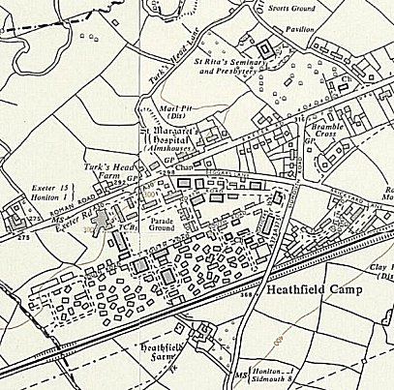
Probable site - Ordnance Survey 1963
Heathfield Camp and Broomhill House/St Rita’s Centre
GERMAN P.O.W. Help In Service At Honiton - Sixteen German prisoners of war camp at Broomhill attended the harvest festival service at the Honiton Congregational Church on Sunday evening. They read the Lessons and sang a hymn in their own language, and the Deputy Camp Warden translated the sermon, delivered by the minister (Rev. J. A. Jones) and accompanied the hymn on the organ a most impressive service. In his sermon the minister, replying to suggestions that owing to the inclement weather, the celebration of the ingathering of the harvest should be postponed, said that by doing so they would be simply pulling down their flag, which they had every reason to keep flying. They had to acknowledge their blessings, not only from local, but from world-wide point of view.

Broomhill House had 21 acres of land which was given to the Catholic Church by Leonard Lindsay. Father Mariano Ortiz took in many Basque refugee children at St Rita’s between 1937 to 1939.”
Broomhill House (NGR ST 154 003) is recorded as being the small ‘Broomhill Camp’ with numerous buildings including about 26 huts, within its grounds. It accommodated US troops before D-day – it was part of the Heathfield Camp. Broomhill House later became St Rita’s Seminary and Presbytery – shown to the NE of Heathfield Camp.

After the camp: Used for a while as a Polish Resettlement camp by the Polish Resettlement Corp, 6 Komp. Zaop. Bryg. (6th Brigade Supply Company) - listed for Honiton.

Little Bray – hutted camp.  This site was transferred to Camp 92 in April 1946, previously with Exhibition Field Camp 42 – “taken over from No.42 Camp on 1st April 1946, is a hutted camp pleasantly situated, electrically lit by its own power unit. The Ps/W are partly es-USA and British prisoners. It has 2 dining huts which serve also for re-educational and recreational purposes.”  Pow Numbers:  15.6.46 11.7.46 9.9.46 25.1.47 22.2.47 12.4.47 13.6.47 22.6.47 19 .9.47 29.9.47 18.11.47 5.2.48 4.3.48 9.3.48  Little Bray 181 169 200 168 142 135 138 136 100 105 ? 46 24 21 | 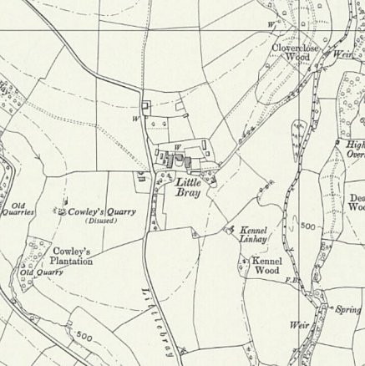
 | Ordnance Survey 1963

Nadderwater.

Nadderwater is a village located on the W edge of Exeter.

Just a brief time recorded as a hostel for the main camp in 1948 – so possibly attached to a different camp before this.

Pow numbers:

 | 5.5.44 | 10.12.45 | 15.6.46 | 11.7.46 | 9.9.46 | 25.1.47 | 22.2.47 | 12.4.47 | 13.6.47 | 22.6.47 | 19 .9.47 | 29.9.47 | 18.11.47 | 5.2.48 | 4.3.48 | 9.3.48
Nadderwater |  |  |  |  |  |  |  |  |  |  |  |  | ? | 41 | 31 | 28

Silverton – hutted camp. NGR SS 955 027. Just S of the Three Tuns Inn and the cottage next door – possibly some huts still showing on the 1962 OS map.  Information provided by Graham Parnell of the Silverton Local History Society; “it was in huts situated in the field in Exeter Road, Silverton, next to a property named “Cockhayne”, after the area was vacated by the 953rd Field Artillery Battalion of the US Army, when they left prior to D-Day.”  In early May this hostel was recorded as holding Austrian pows who were expecting to be repatriated in the near future. (The camp may have held Italian pows earlier than this). Later described as: “formerly for Austrians, accommodates Germans since 13th June 1946 and is a hutted camp, electrically lit, composed of Ps/W from the Channel Islands. There are two dining huts only, necessitating the serving of meals in two reliefs. These together with half a hut allocated as a reading room serve all re-educational and recreational purposes.”  Some additional information from Graham Parnell ties in with the visit report about Ps/W from the Channel Islands: “One German prisoner married a lady from Guernsey here in the Methodist chapel on 9th August 1947. He was Deputy Leader Werner Petri, and gave his address as 92 POW Hostel, Silverton. Presumably stationed on Guernsey where he was captured when Germany surrendered, he had met this female named Eugenie Le Poidevin there.” | 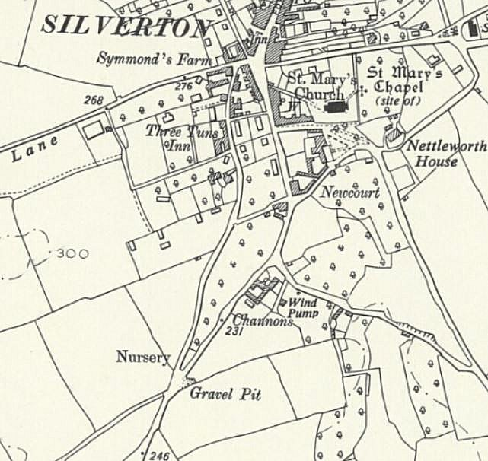
 | Ordnance Survey 1962
Number of pows:
 | 5.5.44 | 10.12.45 | 15.6.46 | 11.7.46 | 9.9.46 | 25.1.47 | 22.2.47 | 12.4.47 | 13.6.47 | 22.6.47 | 19 .9.47 | 29.9.47 | 18.11.47 | 5.2.48 | 4.3.48 | 9.3.48
Silverton |  |  | 240 | 233 | 235 | 101 | 93 | 74 | 95 | 93 | 43 | 42 | ? | 26 | ? | 5

Waterloo Cross, Uffculme, Devon – Hutted camp.

Listed as a hostel for Italian pows in May 1944. Became a camp for German pows on 17th March 1946, until late 1947.

Number of pows:

 | 5.5.44 | 10.12.45 | 15.6.46 | 11.7.46 | 9.9.46 | 25.1.47 | 22.2.47 | 12.4.47 | 13.6.47 | 22.6.47 | 19 .9.47 | 29.9.47 | 18.11.47 | 5.2.48 | 4.3.48 | 9.3.48
Waterloo Cross | No’s ? |  | 120 | 111 | 110 | 91 | 89 | 88 | 97 | 107 | 105 | 71 | ?

Reported as:
“Morale – All PW are from the U.S. and are still resentful at their detention by this country. They are listless and do not appreciate the Cmdt’s efforts on their behalf. Symptomatic is the fact that little use is made of exit passes and films are poorly attended.
Political Progress – Although the majority disavow sympathy with National Socialism, the attitude of the younger element is a negative one and is based more often than not on mere disappointment at Hitler’s failure to “deliver the goods” in the form of victory. There is a marked contrast between the younger generation and the older men, who made the best of the third Reich without having expected anything but war from it. Very few of these had any connection with the Party. Among the politically interested there is a strong trend to the left.”

After the camp: By 1966 the camp had been completely cleared and the site is now occupied by Petroc College and Tiverton High School.

To see the site now - https://repatriatedlandscape.org/england/pow-sites-in-the-south-west/pow-camp-92-bampton-road/

Further Information:

National Archives FO 939/134 – 52 Working Camp, Nether Headon Camp, East Retford, Nottinghamshire and 92 Working Camp, Bampton Road, Tiverton, Devon. Dated 1945-1947

FO 939/172 – 92 Working Camp, Bampton Road Camp, Tiverton, Devon. Dated 1945-1948. COGA education visit reports + letters referring to English Diplomas gained by pows. Many of the reports offer very little detail of the camp.

The Tiverton museum has a copy of ‘Die Eule’, dated September 1946. They also hold photographs of the camp taken in 1947, and several artefacts. The Imperial War Museum has a copy dated 1947, Ref LBY E.J.350. The German Federal Archives also has a copy of the camp magazine, unknown date.

Royal Air Force, Aerial photographs from 1946-1947: 11/04/1947; SDV349478 / SDV349479 / SDV356899 / SDV357046.

Appendix 1: 11-15 July 1946 - Extracts from Report on Re-education and Progress.
HISTORY OF THE CAMP  a) Some 900 Ps/W have arrived from camps Nos 157 [Bourton] and 406 [Scarnecross], mostly from USA and the Channel Islands. This includes some 300 P/W of whom 200 arrived on the 11th July and 90 on 13th July. The latter are advised as being C grade, whom the Commandant has accepted under protest, this being a White camp. Southern Command stated that in accordance with a new W.O. order, all C grade Ps/W are to be kept together. These men are therefore being concentrated in one hostel (at Dulverton); on their arrival it was found that their grading was by ballot screening only.  b) The following new hostels have been opened:-  (i) Axminster formed on 17th April 1946, is a hutted camp with electric light. The Ps/W are mainly from USA  (ii) Little Bray taken over from No.42 Camp on 1st April 1946, is a hutted camp pleasantly situated, electrically lit by its own power unit. The Ps/W are partly es-USA and British prisoners. It has 2 dining huts which serve also for re-educational and recreational purposes.  (iii) Silverton, formerly for Austrians, accommodates Germans since 13th June 1946 and is a hutted camp, electrically lit, composed of Ps/W from the Channel Islands. There are two dining huts only, necessitating the serving of meals in two reliefs. These together with half a hut allocated as a reading room serve all re-educational and recreational purposes.  (iv) Waterloo Cross formed on 17th March 1946, is a hutted camp electrically lit containing British prisoners.  (v) Cruwys Morchard, formed on 11th July 1946, with Ps/W ex-USA, is a hutted camp, having its own power plant. There is ample accommodation at present for all purposes.  (vi) Barronsdown House, Dulverton, formerly an Italian hostel, is a private house with its own dynamo. It is being opened on 13th July to accommodate the C grade Ps/W arriving on this date. The hostel leader his deputy and the re-education staff have been selected by the Commandant from the main camp. Two small dining rooms serve also for re-education and recreational purposes. The following hostels were visited by T.A.:- Little Bray, Cruwys Morchard, Crediton and Silverton.  Camps and hostel leaders, their deputies and re-educational staff are selected and appointed by the Commandant. It is observed however that insufficient attention is paid to their nazi ante decedents and gradings in making these selections. The Commandant will take these factors into consideration making future appointments.  Military badges of rank are not worn by Ps/W. The War Office (PW Branch) have now instructed the Commandant that such will be worn.  [Some details of pows at Wilton Park training camp and those involved in re-education activities + Screening process details and numbers.] |  | MORALE  Morale still remains good. The commandant is universally popular and his influence has a marked bearing on this factor. Another factor is that the camp is situated in beautiful country, and good conditions obtain throughout. The dominant thought ever present, however, still remains; “When shall I get home?” and is still unanswered, and Ps/W search the camp newspapers for every bit of news that may supply a clue and discuss is among themselves endlessly. This is psychologically bad. Other adverse factors are:-  i) The alleged promise made in USA to Ps/W before leaving, that they were on their way home. Although these Ps/W are becoming reconciled to this breach of faith, it still rankles, and is by no means forgotten.  ii) The news from home ranging from requisitioning of homes in French and Belgian zones to food conditions in Germany, lack of support for the destitute, and lack of knowledge of what is happening in the Russian and Polish zones. As regards the latter it was asked that a lecturer be sent who has recently visited these zones and is in a position to give first hand news.  iii) The fact that the Germans were accused of exploiting slave labour and a comparison of their preesent lot at the hands of the Allies in the monds of Ps/W.  iv) The restrictions imposed on them in their correspondence, with relatives etc. in Germany.  v) That they can never for recreational purposes leave the compound except under escort or ever be alone.  vi) The desire to get home to aid their dependants and the realisation of their inability to help them in their present conditions.  vii) Delay in receiving letters estimated at taking 5 weeks from the American and French zones and 6 weeks from the Russian.  Other favourable factors are the excellent entertainments, vocational and educational classes, and lectures together with plenty of occupation.  Political Progress [This is difficult to assess with recent large intakes of pows].  Crediton hostel, exceptionally, is thought by the commandant to be nihilist in complexion and Dr. Uhlmann, who is there, observes a drift towards Communist ideas, largely as a counsel of despair, though the fact that the men’s expectations under a democratic regime are not realised.  [Comments on camp and hostel leaders – and almost a full page is taken listing which newspapers are received by the camps, followed by lists of lectures given].

RECOMMENDATIONS  i) Transfer to another camp the hostel leader at Little Bray, No.603455 Hfw. Karl Daniels (B-). The commandant has asked for this.  ii) Post as soon as possible a selected P/W trained at Wilton Park and having the qualities, age and experience to take charge of re-education of this camp with all its hostels.  iii) Send a lecturer having recent personal knowledge to lecture on conditions in the Russian and Polish zones in Germany throughout the camp including the hostels. |  | iv) Obtain rescission of the WO order to segregate in one hostel C grade Ps/W and secure their dispersal throughout the camp.  v) Regulate the unauthorised disclosure of security documents (CR1s and gradings) by the British staff to Ps/W in this camp.  vi) Obtain rescission of the WO instructions that Ps/W will ear German military badges of rank.  viii) Send adequate supplies of paper and stencils for the New Review.

Appendix 2: 13-15 June 1947 – Extensive Extracts from ‘Introductory and Re-educational Survey’.
Date of Visit: Name of Visitor: Object of Visit:  13-15 June 1947 L.H.P.Thornton Introductory and re-educational survey  - - - - - - - - - - - - - - - - - - - - - - - - - - - - - - - - - - - - - - - - - - - - - - - - - - - - - - - - - - - - - - - -  Strength: Offrs: 3 O.Rs: 1475 Total:1478  of which 677 at H.Q.  81 at Chulmleigh  172 at Cruwys Morchard  73 at Dulverton  138 at little Bray  95 at Silverton  97 at Waterloo Cross  145 in Billets  Screening figures: No. of appeals heard by T.A.: None  A 8 No. of appeals pending: None  B 1470 No. of Ps.W. repatriated to date 634  - - - - - - - - - - - - - - - - - - - - - - - - - - - - - - - - - - - - - - - - - - - - - - - - - - - - - - - - - - - - - - - -  Personnel:  O.C.: : Lt.Co. J.A. MacDonald, DSO., M.C.R.A.  Interpreter: : Sgt. Sales R.E.M.E.  Camp Leader : Fritz Willfuer (B+)  Deputy C/L : Stauch (B+)  German M.O. : Stabsarzt Dr. Lachenicht (B-)  : Stabsarzt Dr Torge (B-)  Hostel Leaders : details under German Camp Staff.  Studies Leader : Beiler (B+)  - - - - - - - - - - - - - - - - - - - - - - - - - - - - - - - - - - - - - - - - - - - - - - - - - - - - - - - - - - - - - - - - |  | 1. RECEPTION  Excellent. I gained the best impression of the Commandant and his staff. The Interpreter seemed satisfactory; he has a sane, humane outlook and stands well with both sides of the camp. The Commandant and his 2.i/c. Major Blomfield will unfortunately be leaving in July.  2. GERMAN CAMP STAFF  Completely satisfactory. The Camp leader is given to fits of moroseness but he conscientiously and ably does his work. His Deputy likewise made a good impression. The German Interpreter and Sgt. Interpreter’s clerk Goeller (A) I consider extremely good in his work, outlook and manner.  The hostel leaders are as follows:  Chumleigh Blank (B)  Cruwys Morchard Dr. (Biol) Zinernagel (B)  Dulverton Somerfeld (B)  Little Bray Daniels (B)  Silverton Riepe (B)  Waterloo Cross Hern (B)  They are satisfactory and give no reason for a change though I thought that the Deputy Hostel leader in Chumleigh Wilhelm Jakobs was a much better type that the Hostel Leader. This view was shared by the Commandant but he felt a change in the same Hostel might lead to upset.  3. MORALE  There are no really adverse factors although repatriation is a big problem and worry. The Commandant was highly praised and the camp is already beginning to regret his impending departure. In the Hostels as in the main camp there is a good spirit and what was especially striking was the deep interest the PsW took in their camp and in themselves.

4. POLITICAL PROGRESS  This camp seems always to have been considered white; it has a good spirit and a healthy political complexion. It is the best camp I have visited so far in the S.W. area.  5. YOUTH  There are 4,000 youths under the age of 25; no special difficulty. Blum (B+) ex Training Centre looks after the Youth Group. Jacobs (B+) formed a Catholic Worker Youth Club in Chumleigh Hostel which seems to have run to seed.  6. RE-EDUCATIONAL ACTIVITIES  Well conducted and controlled by the Studies Leader Beiler (B) he works hard and enthusiastically, having the age (48), the force and conviction. Assisting him Beiler has Blum (B+ and ex Training Centre), Harrer (B+ and about to go to the Training centre), Schuette (B) an artist who makes engravings, painting, etc. for re-educational purposes. Each Hostel is quite well looked after; noteworthy are Dulverton: A committee which controls all activities is elected each month. Chumleigh: Jacobs (B+) ex training Centre. Little Bray Hordlein (B+). The re-educational forces work well and closely with the German Camp Staff.  [Details of some facilities at the camp: Newspapers, Films, Wireless, Camp newspaper].  Press Review: A weekly oral press review is held in the main camp by Beiler; the attendance is normally 400. In each hostel a press review is held weekly also. In addition Gill makes a daily press review which is fixed up in the Information Room.  Lectures: Given regularly once in three weeks. Attendance depends upon the theme, it has been small when the weather was good. Beiler tells me that requests made for certain lectures have never been granted e.g. a lecturer named Grove who spoke on Shakespeare. The Commandant’s view is that too many lecturers come form London and too often, he objects greatly to them. He would prefer that lecturers came from local areas and were people known to him.  Discussion Groups: The situation at present is that Beiler sometimes holds “Anende” [evening meetings] when normally about 90 people attend for discussion of some theme, but sports and other activities (e.g. lectures) have recently been interfering with the only free evening (Thursday) available. In Dulverton there is an enthusiastic Discussion Group: 40% of the Hostel regularly taking part, leadership changes every month. Little Bray has a lively group under Herdelein – 30 men attend.  Information Room: At the time of the visit this was being used as a dormitory cum-conference room for a meeting of German pastors. It is large, roomy and stimulates an active interest. One exhibition is at present touring the hostels – “Political Caricatures”. An exhibition “UNRRA” [United Nations Relief and Rehabilitation Administration] has just been finished and sent off to London. More material is required but the camp cannot bear the expense. |  | English Instruction: See Appendix A.  Library: Adequate to the needs of the camp; Beiler is responsible.  7. OTHER CAMP ACTIVITIES  Religion: The Protestant German camp padre is Zahlmeister Tag (A), who has a wholesome influence on the camp. The conference of pastors just ended seems to ave been enjoyed by all and to have been a success. The R.C. are cared for by the local priest and by Fr. Hugo Zettel of Buckfast Abbey.  Entertainments: The camp possesses a maginificent concert, cinema and theatre hall and good shows are put on. I heard many musicians practising and unerstand that music plays a large part in camp life. Prime interest when the weather is good is sport in many varieties.  Education: Classes have slackenned off lately due to longer working hours, the Ps.W’s privileges and the repatriation odf suitable teachers. Interest is sustained in English. Two years ago the camp bought a motor car engine and practical instruction was given in motor mechanics. A new course is about to start.  8. CONCLUSIONS  The camp is in a satisfactory state; I was very impressed by all I saw. Both camp staffs are very good.  9. RECOMMENDATIONS  That material for exhibition be sent to the camp.  [There is a list without heading – they are contacts to / from the camp]:  a) Toc “H”.  b) Tiverton Art School Exhibitions.  c) Salvation Army concerts and etc.  d) The Society of Friends.  Visits made to the camp by outside bodies:  a) Mr. Alan A. Mister of Landesbury House near Wellington is the YMCA visitor and also represents the Quakers. He visits the camp each Friday and gives talks.  b) The Society of Friends occasionally gives a gramophone recital in the camp.  c) Fr. Hugo Zettel and Fr. Phillibert Korneberg are ever welcome and requent visitors at the camp.  d) A Mrs. Josephine Prettejohn, radio star and singer has given one recital in the camp and would like to give more.

Contacts and projected visits:  Mr.Brooksmith the English teacher at Blundell’s School is seeking permission to have Ps.W. at the school for tours, sightseeing and re-educational purposes. Beyond this there seems to be little in the way of contacts to establish in Tiverton. The hostels move more in the life and ways of their next-door hamlet or village. The Commandant has also had little success in this respect in Tiverton. |  | There are of course private contacts and such things as popular football matches. O am writing to the Warden of the Educational Centres Association at Bristol to see if he can be of assistance. A professor at Exeter University whom I tried to contact had unfortunately moved away.

Appendix 3: 29 September and 4-6 October 1947 – Extracts from ‘Routine Re-educational Survey’.
29 September and 4-6 October 1947  Name of Visitor Object of visit  L.H.F.THORNTON Routine re-educational Survey  Strength given as 1364 in Main camp + 6 hostels + billets.  1. RECEPTION  My personal reception left nothing to be desired and I found the Commandant, already known to me, friendly and helpful as he has always been; re-education is tolerated as a measure laid down and a regulation to be carried out, but the camp’s main function is discipline and work. The new young Interpreter Officer [Lieutenant G.S.C.Grenville] is admirable as regards our aims; is informed and capable, though his style is hampered by the Commandant’s super-efficiency.  2. GERMAN CAMP STAFF  In the main camp the Camp Leader [Fritz Willfuer] and his Deputy [? Stauch] are completely satisfactory in my opinion; conscientious, respected and of balanced outlook; both are finding it somewhat difficult to keep up with the pace set by the new Commandant.  Hostels:  With the exception of Chulmleigh [no Hostel leader at this time] these Hostel Leaders are first rate; especially worthy of mention is Daniels at Little Bray. All these hostel leaders will be repatriated shortly.  The camp has a good staff throughout, though the Commandant certainly intends to make changes and introduce what he calls disciplinarians.  3. MORALE  Is going to pieces; and this camp was a short while ago the happiest in the S.W. area. It is doubtless passing through a period of depression, brought on by the present phase of violent militarism and smartness that is running through the camp and hostels. The indications are that the mood will pass or the camp accustom itself to the new measures and regulations; the actual process is giving rise to some discontent. The area is somewhat friendless and the hostels are set in lonely surroundings. On the whole, morale in the camp is not entirely satisfactory. |  | 4. POLITICAL PROGRESS  No progress has apparently taken place since the last visit and previous interested parties seem to have lost some of their interest; pending changes in the whole camp (closing of hostels and acquisition of others) may possibly alter the complexion. I conversed with a good cross-section of the camp. There was no trace at all of National Socialism, but a better and healthier understanding of democracy and its meaning has not been arrived at as yet. There is room for progress.  5. YOUTH  There is no special difficulty arising from the fact that there is a large percentage (approx. 40%) of youth in this camp. The Camp Leader handles his charges in this regard in a commendable manner.  6. RE-EDUCATIONAL ACTIVITIES  [Comments on change of study leaders].  The hostels and the main camp itself are all in such a state of change, transfer, closing down or taking over, that the time to draw up a programme of full-scale activities is not yet ripe. In the main the usual re-educational routine has been carried out, but with a lesser degree of enthusiasm than previously. Much depends on the Commandant, whose professed aim it is to have every available PW out to work.  Newspapers: [Comments on type and availability]  Films: [Arrangements]  Wireless: Adequate and satisfactory…  Camp Newspaper [Temporarily ceased – one edition in September of 342 copies. Hopes the new SL will improve matters].  Press review [Brief comment]  Lectures [‘restricted’ new commandant does not seem to approve]  Discussion groups  Information room  Library ‘adequate’

7. OTHER CAMP ACTIVITIES  Religion [Some meetings, but ‘No special religious feeling was noticeable’].  Entertainments Choirs, orchestra, musical shows, gramophone recitals… football matches… table tennis, the pows ‘distinguished themselves at Tiverton’s Floodlit Water Gala’  Education French instruction at Little Bray  Shorthand at Cruwys Morchard  Main camp – agriculture + ‘motor engineering has just begun’.  8. CONCLUSIONS  Since the 1st August re-education in this camp has not been satisfactory. Firstly, the S/L was removed from his  post and the PW noted to take his place not sent, and secondly a new Commandant came to the camp and he has reversed the old order completely; his two chief aims are discipline and work and until he has arranged the camp to his liking re-educational activities must wait; e.g. there is no point in completing arrangements if they are to be wrecked straightaway. What will probably happen is that the camp will accustom itself to the new changes and when things are quieter re-educational measures will be possible. On the credit side we have an excellent Interpreter Officer and a first-class Camp Leader.  9. RECOMMENDATIONS  Pro Tempore, i.e. for the next six weeks, nil. |  | OUTSIDE CONTACTS  Contacts from outside. Mr A. Mister, YMCA visitor who gave talks in the camp, and on one occasion a gramophone recital. It is extremely difficult to arrange for people to come inside the camp.  Contacts to outside. …Tiverton Toc H have opened a second social centre for PsW. Tiverton Youth Club have opened their doors to the PsW; musicals have taken place. The camp choir and orchestra have taken part in local fêtes (in fact have formed the main part of the fêtes). Sporting activities have taken place between PsW and civilians.  Contacts by T.A. The WEA Local Secretary has kindly consented to admit a select number of PsW to courses, and brochures are being circulated in the camp; this activity is being sponsored by the Interpreter Officer who also attends courses and furthermore the Commandant can hardly object to an activity which permits his PsW to be back in camp in very reasonable time in the evenings.  Furthermore, it must be stated that the atmosphere of Tiverton, where the camp is situated, is against fraternisation as a general rule (though evidence of personal contacts is there); Tiverton is a British Legion town which has not yet recovered from the Great War which they still attempt to keep up.  I also called on the C.of E. vicar but there is not much he can do. The Methodist minister was absent.

Appendix 4: 5-6 February 1948 – Extracts from ‘Re-education Check’.
5-6.2.1948 Re-education Check  Offs 2 O.R.’s 585  [Comment that it is not expected for the camp to remain much longer]  MORALE  The thought of early repatriation has raised the morale of the camp considerably. The military manner in which the camp is run weighs down on some Ps/W, and others are affected by recent letters from returned comrades describing the appalling conditions in Germany.  POLITICAL COMPLEXION  Non-descript: the previous occasional outbursts against the unfairness of the length of captivity are disappearing now that each P/W knows his repatriation is proximate. There are no definite trends in the camp except towards apathy and a general good-natured grudge against the C.O. However, it is clear that a comparison between these Ps/W and German civilians shows that the former have developed a political sense.  YOUTH  Approx. 25% of the camp. Youth Camp candidates will be examined later in the week.  OUTSIDE CONTACTS  1) Toc H.  2) Salvation Army  3) 7 Ps/W attending WEA courses.  4) Improving private contacts among the more influential English people.  5) Of previous reported contacts, those with the YMCA and Tiverton Youth Club are still flourishing.  On the whole a poor town and neighbourhood for outside contacts. Further-more there is no one from the British side to back up these contacts. In this aspect the S/L. is hopeless and seems unable to grasp the idea of “outside contacts”.  TRAINING CENTRE  Candidates being interviewed later in the week. At present the camp has no ex-students.  RE-EDUCATIONAL ACTIVITIES  On the wane! MEYER the S/L does his best but has never quite succeeded in grasping his job. He seems to spend his time in laboriously working out details: and also has a certain fear of the Commandant which hampers his decisions. Otherwise he makes a satisfactory S/L and it is surprising the amount of enthusiasm he has and effuses. There is satisfactory co-operation between his branch and the German Camp Administration: if there was effective and knowledgeable backing from the British side in this camp, good results would be forthcoming. |  | Lectures: In December, and in January again, Mr.A.Mister (YMCA) spoke on current affairs. The only F.O.(G.S.) lecturer to visit the camp since the last visit was Dr.Eliss on “The new aspect in World Politics”. Although I know the German Camp Staff does its best to persuade as many as possible to attend these lectures, the attendance is poor.  Discussion Groups: Since the last visit there have been nine meetings of the R.C. Study Group (leader – HAEGERMANN) in the Main Camp and 12 meetings in the hostels. The Protestant Circle has met four times (leader Pastor TAG (A)). The much hoped for BCA group (MEYER has attended a course) has failed to materialise.  Camp Magazine: A Christmas edition of “Die Eule” appeared: and knowing the difficulties under which it was produced, I consider it a commendable effort. Since then, however, the duplicating machine has broken down.  Press Review: MEYER makes a daily Press Review which is praiseworthy. It is distributed among the billetees and hostels.  Newspapers: Daily: Times, Herald and Telegraph. Neue Zuericher Zeitg. Weekly: Die Weltwoche, Economist, Spectator, The New Statesman and Nation, The Listener, Time, The Highway, British Survey. German local papers, sent from home. The R.C.’s publish a weekly news sheet.  Library: A War Office order requiring a reorganisation of the library, arrived after Meyer had completed his own reorganisation in the Main Camp and hostels and has resulted in his having to devote more of his time to the library. The books, especially those newly-arrived are a good selection and the state of the camp libraries generally is satisfactory.  Information Room: Two exhibitions are being shown: 1) “Parliamentary Government”. 2) “The Press in Germany and England”. The exhibitions are being sent to the hostels.  Wireless: Satisfactory  Films: Two a month. Some Ps/W appreciate the inclusion of an English film.  OTHER CAMP ACTIVITIES  Education: With the exception of English classes no instruction in other subjects are given.  Religion: There are sufficient church services and sufficient opportunity for each P/W to follow the practice of his religion, although interest is small.

Entertainments: The choir and camp orchestra have both been disbanded as the key Ps/W have been repatriated. There is a certain amount of interest in sport, especially football. |  | 10. CONCLUSIONS  92 Camp is rapidly closing down and interest in re-educational activities is therefore slight. The Commandant is a disciplinarian and has always failed to understand re-education. Unavoidable obstacles have impeded political progress in this camp.  11. RECOMMENDATIONS  Nil.

Appendix 5: 9-11 March 1948 – Full Report of the ‘Final Check’.
Mr Hamilton CONFIDENTIAL  Camp Address No. & Type of Camp Date of Visit  Bampton Road 92 G.P.W.W. Camp 9. – 11.3.48  Devon  Name of Visitor Report handed in L.H.F. Thornton 14.3.48  Tel.No.  Tiverton Object of Visit No.of Visits  2115 Final Check 7  - - - - - - - - - - - - - - - - - - - - - - - - - - - - - - - - - - - - - - - - - - - - - - - - - - - - - - - - - - - - - - - -  Strength: Offs: 1 O.R’s: 475 Total 476  of which  318 at H.Q.  58 Billetees  14 at Chulmleigh  21 at Little Bray  5 at Silverton  7 at Dymond’s Farm [formerly Camp 76/276]  28 at Nadderwater  25 at Chudleigh  Screening Figures: How many Ps/W repatriated to date:  A: 1 1450  B: 475  - - - - - - - - - - - - - - - - - - - - - - - - - - - - - - - - - - - - - - - - - - - - - - - - - - - - - - - - - - - - - - - - |  | Personnel:  O.C. : Lt. Col. G.W.V.Ladds, The Glosters  Interpreter : Capt. Adams, G.S.C.  Camp Leader : STAUGH, Erich (B+)  Deputy : SCIUK [?] Hermann (B)  German M.O. : Dr. HEIMANN (B)  Hostel Leaders :  Chudleigh : PETER (B)  Little Bray : RIEPE (B)  Nadderwater : LOESCHER (B)  Chudleigh : WINKEL (B)  - - - - - - - - - - - - - - - - - - - - - - - - - - - - - - - - - - - - - - - - - - - - - - - - - - - - - - - - - - - - - -  1. RECEPTION:  As in the past, friendly and hospitable. The new Interpreter Officer made a good impression.  2. P/W OUTLOOK:  The biggest recent factor in moulding the outlook of Ps/W in this camp was the change of Commandant some six months ago: this change not only affected the camp administration but also, in the case of the majority of Ps/W, changed their outlook. I have known this camp well, both before and after the change; Ps/W most affected were those in the main camp.  In the past six months grumbling and dislike have grown in the camp, one hundred percent; the rigid enforcement of discipline and orders formed the immediate topic of conversation from the PW’s side just as soon as he was asked how he found things in England; their vision thus always hindered.  There is no doubt that the Ps/W have had many irritations which have shaped their thoughts considerably. Old and young were equally affected and the nett result is that Ps/W simply wish to be left in peace. The degree of distrust and indifference varied

according to the PW’s own personality – e.g. some are harder-skinned than others and a ranting would leave them less affected.  The older Ps/W (at the present time 80% of the camp), complain of the length of their captivity (mostly Channel Islanders) and persist in their argument that they belong or should have belonged to an earlier release group; the attitude of a former Studies Leader (BEILER) did not help in this respect and finally he was removed from his post because of certain articles he published in the camp magazine.  Approx. 80% of the Ps/W (i.e. taking an average over a long period) have been affected by the none too friendly attitude of the local population, though here there are big exceptions in individual cases (fir which I allow in the 20%). The majority of the PW have however had too little outside contact.  Six in ten Ps/W seem to have a genuine regard for certain features of the British character and British national life and in some this regard amounts to a real liking, but this is purely individual. In a repatriation group of 55, all said they were sympathetic towards democracy and the majority thought they had arrived at these conclusions because of the fair way the British act as a rule. I personally put it down to the excellent way the camp was kept informed (wireless, newspaper and word of mouth).  One cannot say the influences in the camp have been bad as such: the Ps/W have not been harshly treated, but too strictly treated and under an excessive military discipline. There is dislike and indifference which is not however directed at the British nation but simply at the military system under which they live. The remedy is obvious and has already been recommended.  3. RESETTLEMENT PROBLEMS:  Worry and uncertainty face them all on their return and nearly 100% go back knowing what they have to face. See appendix for report on the Resettlement Officer’s visit.  4. OUTSIDE CONTACTS:  Have always been poor and have in no way improved. The few activities noted in previous reports are still functioning.  W.E.A. 8 Ps/W each Wednesday; musical studies.  Toc H.  Rev. Horne (whose interest is in the problem of reconciliation)  Alan Mister, the popular and excellent YMCA visitor; among other things he holds a most interesting weekly discussion in the camp on current affairs; it is a great pity that he does not speak German.  5. CAMP FACILITIES:  Emphasis is being laid on the news services, library work and personal contacts among the Ps/W. Klaus MEYER does an able best and keeps the flame of interest alive. |  | 6. REACTIONS TO SWISS AND DUTCH LECTURERS:  No Dutch lecturers have visited this camp. No great interest (cf. the numbers at attendance) was shown in Swiss lectures but those who did go claimed they took something positive away with them. What was of interest was the Swiss point of view although the lecturers themselves have long been forgotten.  7. FINAL IMPRESSIONS:  The militarism of this camp in the past six months has certainly weighed heavily on many of the Ps/W. “Why keep up this farce” is the question which they all ask. The camp is clean ad perfectly ordered.  Those going on repatriation are indeed glad to be going and are happy.  8. CONCLUSIONS:  Re-education on the whole has been impeded – of course in no way wilfully; the Commandant looks upon it as an order to be carried out, but soldiering is too much in his blood to allow him to understand the subject. Under the former Commandant re-education flourished and had good results.  Activities have all times been carried out as well as the circumstances allowed and in many respects have proved of great usefulness to the Ps/W, as they themselves frequently admit. Latterly the news services have greatly improved and have been of positive use. One can say that the Ps/W have really learned something which they will not forget.  APPENDIX  On the visit of the Re-settlement Officer to 92 Camp  Dr. Huppertz:  Visited Tiverton on 20th February 1948.  Before he came, news of his visit had been circulated in the camp and it became known that he was an “Askoten” i.e. member of the camp at Ascot before his repatriation. Immediately it created the worst impression because, I am told, many Ps/W had to suffer at the hands of the staff in this camp. So before his visit there was a certain amount of hostility against him, and naturally some interest. Everybody’s opinion – “I was pleasantly disappointed”. He apparently therefore made a good impression although he was able to relate nothing new; in fact the majority of Ps/W claimed to know more than he himself.  Ma. Re. L.H.F. Thornton

