UK Policy for Pow Camps During WW2.

Responsibilities for Prisoners of War

The Cabinet (or War Cabinet), usually chaired by the Prime Minister, set national policy. The War Office was responsible for carrying out those policies and for the overall administration of pows.

The principle departments with responsibilities for prisoners of war established by the War Office were:

British War Office (WO) - Overall responsibility for pows
Adjutant-General’s Department (AG)  Providing administrative services to the army including overseeing arrangements for pows – allied and axis |  |  |  |  |  | Dept. of the Permanent Under Secretary of State for War | Director of Military Intelligence
Directorate of Prisoners of War (DPW) |  |  |  |  | AG.3 | Cas(PW)  Cas(L) | MI.9 / 9a | MI.19
PW.1 | PW.2 | PW.3 | PW.4 | PW.5 | Wide range of duties, some finance, also AG3(war Crimes) | Casualty branch for pows. Enquiries about missing personnel. | Escaped British pow debriefing, escape & evasion + enemy pow interrogation until 1941. | Enemy pow interrogation - formed from MI9a in December 1941.
Enemy pow matters | Enemy pow matters | British Empire pows | Censorship and intelligence | Camp security, inspections and records (war diaries)

A highly influential body making recommendations about pows was the Home Defence (Security) Executive (HD(S)E). The HD(S)E was established on 27 May 1940 by, and reported directly to, Winston Churchill. It consisted of members of the Home Office, Commander-in-Chief of the Home Forces, the Security Service and the Secret Intelligence Service. Its title changed to the Security Executive (SE) in October 1941.

The Foreign Office was involved where policy on pows in the UK was likely to affect matters in other countries, for example on pows being repatriated. The Home Office was involved in matters relating to security matters and policing outside of the camps.

The Ministries of Agriculture and of Labour made requests for pow labour camps to work in certain areas. This often meant providing accommodation. They worked in liaison with other ministries, local councils and other agencies. An Inter-Departmental Committee on the Allocation of POWs was established from various ministries (e.g. supply, transport, etc) to decide locations and numbers available for work, (for an example, see Appendix 1).

The Prisoner of War Information Bureau (PWIB) was established a few days after the outbreak of war - funded by the War Office, but staffed by civilians. The PWIB acted in accordance with provisions set out in Article 77 of the Geneva Convention. They provided information to the International Red Cross and others.

In 1941 an ‘Imperial Prisoners of War Committee’ was set up in order to; “…co-ordinate the action of the Governments of the UK, the Dominions and India… “ Its purpose was to consider the circumstances and interests of the various countries across the Commonwealth; “in our own and in enemy hands”. ⁽¹⁾

Many other agencies (Armed Forces, Royal Mail, local councils….) were involved with pows held within the UK. There were also unofficial groups such as those working for the welfare of pows.

1. House of Commons, 14 October 1941, Vol 374
Policy for German and Italian POWs held within the UK –

“What is a prisoner of war? He is a man who has tried to kill you and, having failed to kill you, asks you not to kill him.”
- Winston Churchill, House of Commons, 1 July 1952.

Prisoners of war held within the UK during World War 2 were mainly members of the European Axis armed forces, there were also some merchant mariners. Axis forces were mainly Italian, German and Austrian, but there were also pows from – Argentina, Belgium, Bulgaria, Czechoslovakia, Denmark, Danzig, Estonia, Finland, France, Greece, Holland, Hungary, Latvia, Lithuania, Luxembourg, Poland, Romania, Spain, Turkey, Ukraine, USSR, Yugoslavia, and probably others.

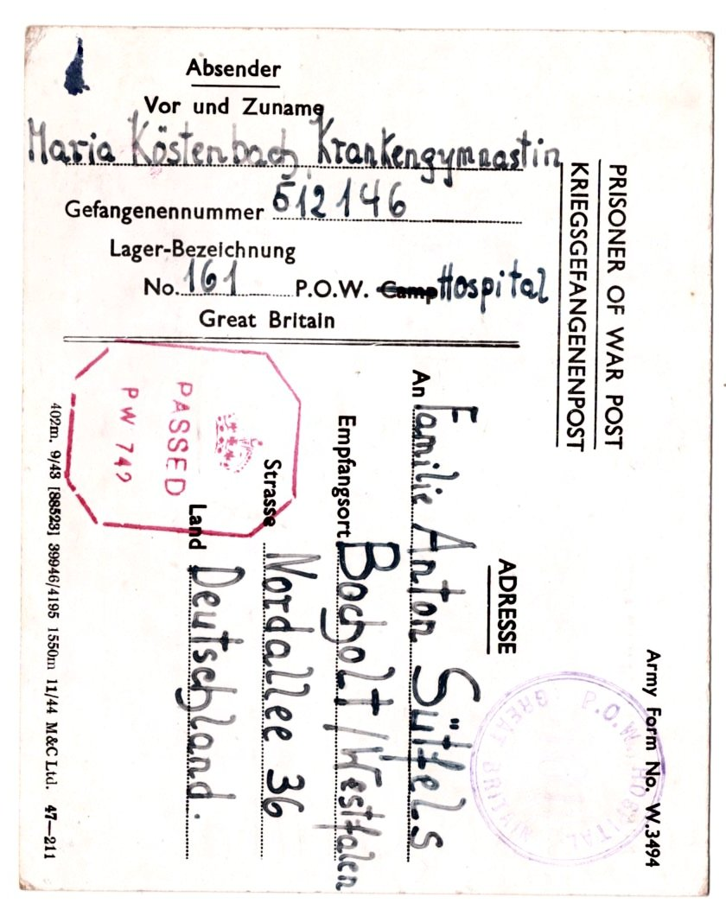 | There are no records of any female POWs being held within the UK. There were some female ‘protected personnel’ accommodated in some camps, for example 17 female nurses accompanied Ukrainian pows to Britain in 1947.
 | < Pow postcard sent by Maria Köstenbach, (aka Maria or Ria Sűtfels) to her family in Germany. She was working as a Krankengymnastin (physiotherapist) in Camp 161 Belfast Military Hospital. Her husband was a pow in the USA at the same time.
Civilians from enemy countries were classed as possible ‘Enemy Aliens’ and many were interned. Internment is not included here.

The vast majority of pows held in the UK were German* and Italian. For these, some general phases of policy within the UK are outlined below.

* Many documents do not distinguish between German / Austrian / other Axis pows).

- 1939 – ‘phoney war’ – Mid 1940: Small number of pows held in the UK.

At first, it was considered there would be little need to hold pows within the UK. It was expected that prisoners from land-based forces would be imprisoned in any country bordering Germany that was attacked – and surely the Maginot Line and French forces would hold German invaders at bay. It was recognised there may be prisoners arising from expected air-attacks on Britain; German pilots had already been in action against civilian targets during the Spanish Civil War. Naval prisoners were also a possibility.

Shortly before the start of war, an inter-departmental meeting was held on 9 June 1939 to discuss how pows would be received and interrogated. The Tower of London was to be used for a short time for this purpose. In order to provide for the limited number of expected prisoners, only two pow camps were planned; Grizedale for officers, and a larger camp for other ranks at Glen Mill, Oldham. If there was need in excess of these camps, then Canada was requested to take pows and some civilian internees.

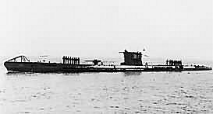
The first German pows were the 44 members of the crew of the U-39 sunk off the north-west coast of Scotland on 14 September. They were landed at Kirkwall on 15 September then transported to the Tower of London for interrogation before being sent to the pow camps at Grizedale and Oldham.

< U-39 the first U-boat sunk and the first German pows in the UK. All 44 crew survived.

The crew of U-39 were closely followed by the crew (38 men) of U-27, sunk on 20 September.

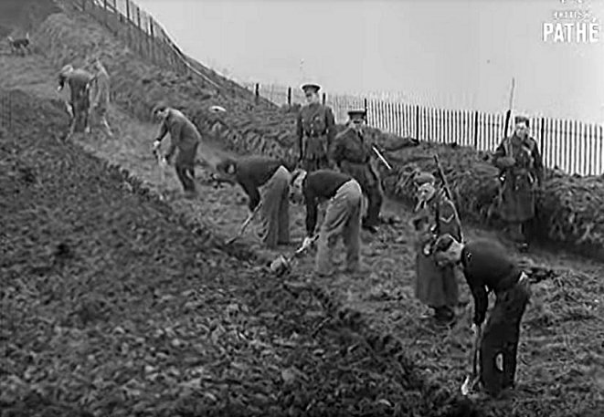 | 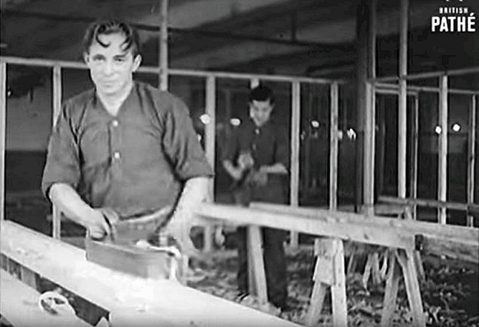
1939 Pathé Gazette showed POWs from Glen Mill Camp at work around the camp and a workshop

There was a very slow increase in numbers held until mid-1940.

In October 1939 there were; ‘no more than 110 German sailors and airmen as prisoners’. ⁽¹⁾

By December 1939; ‘about 250 military and naval German prisoners of war in British hands and between 1,200 and 1,400 civilian internees. The military as opposed to the civilians are interned in two camps, one for officers and one for other ranks. Crews taken off merchant ships are regarded as civilian prisoners of war and are sent to civilian camps.’ ⁽²⁾

Three months later in March 1940, there were still only 257 pows in the UK ⁽³⁾. Italy at this time had not entered the war.

1. The Under-Secretary of State for War (Viscount Cobham) - House of Lords, 24 October 1939; Vol 114; Col 1484.

2. Memorandum by the Secretary of State for Foreign Affairs to the War Cabinet – ‘German Prisoners of War in Great Britain’ –

18 December 1939 WP(G) (39) 157.

3. Sir Victor Warrender, (Financial Secretary to the War Office) answering a question in the House of Commons, 11 March 1940, vol 358 c824.

- Mid 1940 – North Africa – Late 1940: Pows and plans to remove them.

10 May 1940, King George VI appointed Winston Churchill as Prime Minister.  Some German pows arrived during 1940 after being captured by Dutch and Belgian forces when their countries were invaded. A British Pathé news film shows about 250, (from 1,200 in total) mainly paratroopers, arriving in Britain guarded by Dutch soldiers.  At the end of May further prisoners were brought back from Narvik, in part of the Norwegian campaign.  26 May – 4 June, 1940  Evacuation at Dunkirk | 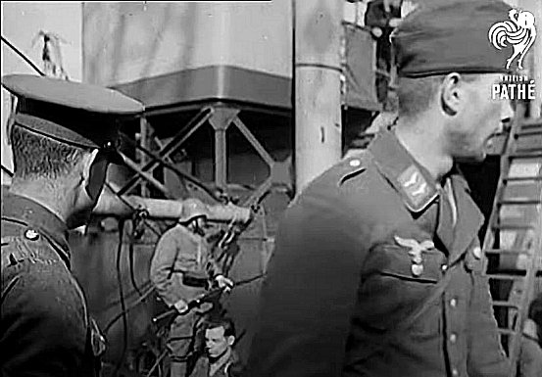
 | German paratrooper brought to the UK – a Dutch soldier seen in background.

Italy entered the war on 10 June 1940, and the North Africa campaigns started on that day. Increasingly large numbers of pows were held and the problem was what to do with them. Although most Axis pows from these campaigns were sent to India, Australia, South Africa, Kenya, Rhodesia, Tanganyika and Uganda, some were sent to the UK. With food shortages in Britain, and a fear of uprisings in the camps if there were to be an invasion of Britain, it was planned to transfer as many pows, (and undesirable alien citizens, “dangerous characters”) as possible to Canada (7,000), Newfoundland (1,000), and later to Australia (6,000) and New Zealand (4,000). ⁽¹⁾

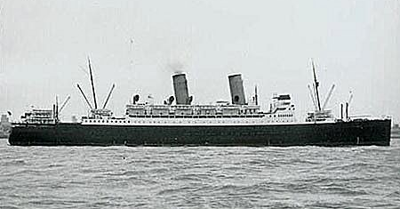 | There were objections to this as it meant transporting pows across the Atlantic, a ‘war zone’, which was theoretically against the Geneva Convention. However, a counter argument was made that the pows were actually being taken away from an even more dangerous war zone, (Britain under air-raids) – and the pows were a potential threat if Britain were to be invaded - and so the plan continued.  Questions were raised within the Foreign Office about the danger of Germany likewise
‘Duchess of York’
transporting British pows to other places, e.g. Poland. These comments came too late as the first transfer was made on 21 June 1940 with 500 German pows being sent to Canada on the SS Duchess of York, (together with 2,100 German internees).

On 2 July 1940, the second transport ship ‘Arandora Star’ bound for Canada and Newfoundland, carrying 1,213 internees, 86 German pows, 200 guards and 174 crew, was hit by a torpedo fired by U-47. 805 people were killed.

The loss was reported to the War Cabinet in a Memorandum on the same day as the attack. Despite this the Cabinet agreed that transfers should continue. This decision may seem callous, however, in context, the reasons for the transfer still prevailed, and British children were being sent abroad to safety at this time by the same route.

1. Memorandum by the Lord President of the Council – ‘Internees and Prisoners of War’ – 2 July 1940 WP (G) (40) 170.

The Cabinet was informed that two more ships were due to sail for Canada – the ‘Ettrick’ on the following day, with 1,263 internees and 1,348 German and Italian pows – and the ‘Sobieski’ on 7 July with about 1,000 internees and 450 German pows. Three more ships were identified to send internees and pows to Australia and New Zealand.

The two ships bound for Canada arrived safely, however the ships for Australia and New Zealand were allocated to different purposes and no pows were sent from the UK to those countries.

By September 1940, there were about 850 pows in the UK, with more arriving at the rate of about 100 per week. It was proposed that a further 1000 should be sent to Newfoundland – taking the place of the internees who did not arrive after the attack on the ‘Arandora Star’. ⁽¹⁾ This was approved, subject to there being time to build a suitable camp before winter. ⁽²⁾

Objections to this idea came from the Canada-United States Joint Defence Board, due to the location of the camp near to Conception Bay, Newfoundland and the ‘remote’ possibility that there could be a German attempt to rescue their men. ⁽³⁾ The proposal was changed to ask Newfoundland to accept merchant seamen instead of combatant pows. ⁽⁴⁾

By the end of 1940 it was stated that there were 11 pow camps and 1 pow hospital within the UK; ⁽⁵⁾

POW Camps
No. |  | No. |  | No.
1 | Grizedale Hall | 2 | Glen Mill | 4 | Windlestone Hall
6 | Glenbranter | 8 | Warth Mills | 9 | Kempton Park
10 | Cockfosters | 12 | Donaldson’s School | 13 | The Hayes
14 | Holywood | 20 | Wilton Park
Hospital
4 | General Hospital, Knutsford

Note – There was also a Camp 5 at Duff House in 1940, but it was omitted from this list for unknown reasons.

Also listed – Alien Internment camps:
001 | Oratory Schools, London SW3 | 003 | Racecourse Aliens Camp, York
005 | Winter Quarters Camp, Ascot, Berkshire | 006 | Lingfield Racecourse, Hampshire
009 | Huyton Camp, Liverpool | 010 | Isle of Man Camps, Mereside, Douglas
015 | Knapedale Camp, Lochgilphead, Argyll | 018 | Holywood, Belfast (Special War Office camp)
020 | Ham Common (Latchmere House), London

Some of these later became pow camps.

1. Memorandum by the Secretary of State for War – ‘Sending Prisoners of War Abroad’ – 20 September 1940 WP (40) 379.

2. War Cabinet conclusions, 24 September 1940, 257(40)

3. Memorandum by the Secretary of State for War – ‘Internment Camp in Newfoundland’ – 17 November 1940 WP (40) 449.

4. War Cabinet conclusions, 20 November 1940, 292(40)

5. Recorded as being opened during 1940, (Appendix to WO 199/405).

- Early 1941 - Africa campaigns – 1943 Italian armistice: Italians in – Germans out.

In January 1941, there was a suggestion in the War Cabinet of treating Italian pows differently from Germans. There was a major shortage of manpower for general labour works with so many young men signed up for the services, or working in protected war industries. The Minister of Agriculture and Fisheries therefore suggested, “that 2,000 to 3,000 North Italian peasants from among the prisoners of war taken in Libya should be brought to this country at once to be formed into gangs to work…” ⁽¹⁾

He did not ask for pows in general, or the available German pows already held in the UK, but specifically for North Italians to be brought to this country. This was based on intelligence reports that for German pows who had been U-boat or Luftwaffe crews, “…morale is high and their attitude inclined to be defiant, not to say hostile” ⁽²⁾ in comparison to many Italians who had been reluctantly conscripted.

Utilising other-rank pows as workmen was allowed under Section III of the Geneva Convention, provided the work did not directly contribute to the war effort. Most pows already worked inside their camps at general tasks, clearing areas, growing food, etc, but not as organised work groups. The War Cabinet agreed to this providing the HD(S)E were satisfied about security and that the Home Secretary agreed. ⁽³⁾ Officers could not be required to work, so very few Italian officers were sent to the UK. By September 1943 there were just 364 Italian officers, and 76,491 other ranks.

Meanwhile, for German pows, the Prime Minister approved the transfer of an additional 1,000 prisoners to Canada, and later in the year requests were made to ship yet more: “At present there are in the United Kingdom some 2,000 German prisoners of war and merchant seamen fit to travel. They are all of a dangerous type, and their security would be a matter of grave anxiety in the event of invasion….” ⁽⁴⁾

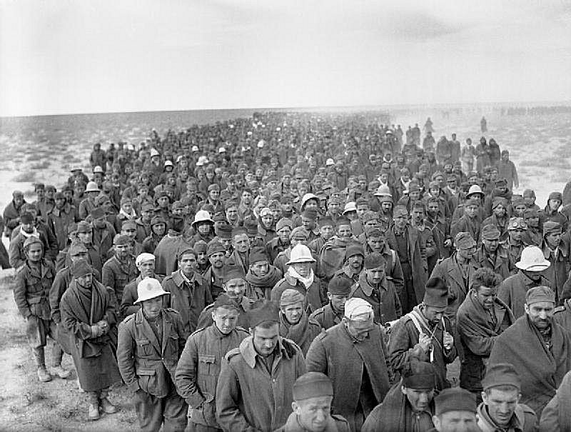 | Although shipping Germans to Canada continued, the idea of shipping Italians to the UK was increasingly seen as a method to solve several problems:  * The number of Italian pows held in North Africa was an issue. General Wavell requested additional support.  * The shortage of manpower in the UK, especially working on the land.  * An increasing difficulty in hiring Irish workers at a time when there were increased national targets for manufacturing and agriculture.  When a call came from the Secretary of State for War to remove more pows at a faster rate from North and East Africa, a proposal was made to bring a much higher number of 25,000
Italian POWs captured at Bardia, Libya, 6 January 1941.
(later amended to 28,000) Italian pows at a rate of 5,000 per month to the UK to work on the land. There was also a suggestion of using them in ordnance works and other industries, but this was later removed as it contravened the Geneva Convention. ⁽⁵⁾

Churchill, who originally opposed the idea of employing Italians, changed his mind;

1. Memorandum by the Minister of Agriculture and Fisheries – ‘Italian Prisoners of war for Land Reclamation Work’ – 13 January 1941 WP(G) (41) 6.

2. Memorandum by the Secretary of State for Foreign Affairs – ‘German Prisoners of War’ – 18 December 1939 WP(G) (39) 157

3. Memorandum by The Secretary of State for War – ‘Transfer of German Prisoners of War…’ - 8 August 1941 WP(G) (41) 75 and for agreement, see War Cabinet conclusions, 11 August 1941 79(41)

4. War Cabinet conclusions, 16 January 1941 7(41)

5. Memorandum by the Lord President of the Council – ‘Proposal to bring 25,000 Italian Prisoners of War to this country’ – June 1941 WP (41) 120.

“It occurs to me that we must now consider using these Italian white* prisoners in Great Britain. A plan was set on foot to bring 2,000 over here for the Ministry of Agriculture. I was not myself attracted by the idea, as it seemed to be on such a small scale but raising all kinds of novel complications. However, it might be better to use these docile Italian prisoners of war instead of bringing in disaffected Irish over whom we have nothing like the same control. It would be worth while to make a plan for bringing in say 25,000 of these Italians, and employing them as an organised mobile body on the land.” ⁽¹⁾

(* ’white’ was being used here as a classification code for non-political pows.)

The issue of security was overcome with a decision that members of the Pioneer Corps currently engaged on land work, could instead be used as guards, and the proposal was accepted. ⁽²⁾

Finding sufficient transportation was a problem. The ships would be unescorted, with only a vague promise by the First Lord of the Admiralty that, “While the ships could not have ocean escorts, he would see whether escorts could be provided in dangerous areas”. ⁽³⁾

After initial vetting in Africa to reject any ardent fascists, anti-British or malcontents, the first Italian pows to be transported to the UK to be land workers arrived in the UK on 26 July 1941.

The Minister of Agriculture stated;  “The first 2,000 Italian prisoners of war for employment on the land have now arrived in this country and will shortly be distributed to working camps. Further parties are expected to arrive during the next few months. These prisoners will be employed mainly on ditching, drainage and land reclamation…” ⁽⁴⁾  The Italian pows were soon recognised as being a positive asset. With this change came demands for more, and a definite change of attitude towards employing Italian pows:  “…although the Minister of Agriculture is not at present in favour of allowing them to live and work individually on the farms, it should be | 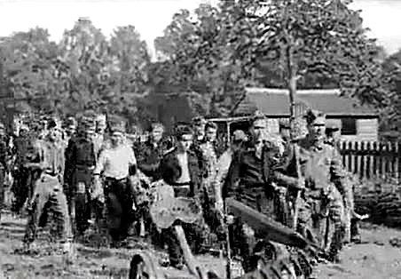
 | Italian pows going to gather the harvest in England, 1941. Patches on trousers can just about be seen.
possible to devise some plan by which their services could be put to more profitable use in meeting the shortage of agricultural labour. If this could be done, it would be possible to bring larger numbers of these prisoners to this country.” ⁽⁵⁾

A major issue was where to accommodate additional pows. On 9 December 1941, a meeting was held with the DPW, the Ministries of Agriculture and Labour and other officials to sort out the growing problem of finding sufficient accommodation. At that time, it was recorded that there were 6,400 Italian pows in the UK. So, in order to distribute the expected large number of pows in 1942, the Ministry of Agriculture requested that new camps be built rather than existing ones expanded. 21 new sites were identified and Italian pow construction gangs were allocated from other camps. ⁽⁶⁾

7 December 1941, Pearl Harbour – 11 December 1941, the US declares war on Germany.

After December 1941, the United States, with some reluctance, started to accept pows from the UK and Africa. However, with the usefulness of Italian pows working on the land becoming all the more important, the UK started to ship some back from other countries, including Canada and the US.

1. PM’s Office Papers, 29 May 1941, WC to Sir Edward Bridges, Perm. Sec. of Cabinet Office: National Archives file PREM 3.

2. War Cabinet conclusions, 5 June 1941 57(41)

3. War Cabinet conclusions, 26 June 1941 63(41)

4. Minister of Agriculture to House of Commons, 7 August 1941 (vol 373 cc2089-90).

5. Memorandum by the Lord President of the Council – ‘Man Power’ – 27 October 1941 WP (41) 247.

6. Minutes of meeting ‘Employment of Italian Prisoners of War’, held 9 December 1941 – see Appendix 1.

The increasingly desperate demand for land workers was shown in one incident, which seems remarkable that the matter even needed consideration:

“The Secretary of State for War said that there were a number of Italian prisoners of war on the Aquitania, which was now in New York. A proposal had been made that they should be disembarked and their places on the ship taken by members of the United States Army Air Force. The result would be to delay considerably the arrival in this country of these prisoners of war, who were urgently needed in order to build hutted camps for further consignments of Italian prisoners who were being brought to this country.

The War Cabinet –

Decided that priority should be given to members of the United States Army Air Force.” ⁽¹⁾

18 – 19 August 1942 Dieppe Raid (Operation Jubilee)

As a result of prisoners taken by the Allies during the Dieppe Raid having their hands tied, and a previous incident at Sark, the ‘shackling crisis’ arose. Many pows on both sides were placed in shackles. The incident was not resolved for many months.

1. War Cabinet conclusions, 21 April 1943, 57(43)

- Late 1943 – Italian armistice to 1944 – D-Day: Large numbers of Italian pows working in UK.

3 / 8 September 1943, Italian Armistice.

Although the Italian Armistice was excellent news for the Allies, it did create a legal problem about what to do with Italian pows. Their status was considered with regard to those already in the UK - and those captured, but still awaiting transport to the UK. Britain certainly did not want to immediately release its useful working pows even though Italy was then considered to be a co-belligerent.

A memorandum set out the situation for the War Cabinet:

“…74,900 Italian prisoners are at present at work in this country. Arrangements have been made to bring a further 11,000 before the end of 1943…”

and there had been a request that the;

“importation of 36,000 more prisoners should be authorised as a first instalment of a 1944 programme.” ⁽¹⁾

A further complication arose from a promise made in July 1943 by General Eisenhower to encourage an Italian surrender. In a radio broadcast Eisenhower stated that if Allied pows held in Italy were returned, then the hundreds of thousands of Italian pows in Tunisia and Sicily would likewise be released.

Although the UK did not hold prisoners from Sicily, 23,000 pows had been sent to Britain from Tunisia, and 5,000 more were expected. The Lord President believed that there would be discontent amongst Italian pows captured earlier, if those captured later were released first. He then offered a possible excuse not to go ahead with the release of prisoners by citing a report that 2,500 British pows had recently been sent to Germany from Italy, thus breaking the condition set by Eisenhower. ⁽²⁾

At the War Cabinet on 13 September 1943, the Secretary of State for War stated that Italian pows were anxiously asking Camp Commandants about their future and an answer needed to be given, but the meeting deferred any decision to later in the week. ⁽³⁾

A proposed text, (amended by the cabinet) was prepared to guide Camp Commandants with regard to Italian pows:

“The cessation of hostilities with Italy as a result of the signing of the Armistice does not of itself make any difference under International Law to the status of Italians held in this country. They remain prisoners of war. We shall continue to treat them with respect and all consideration. Discipline must however be maintained and orders obeyed.” ⁽⁴⁾

This statement was technically legal at that time, though still dubious, especially with regard to Article 75 of the Geneva Convention; “the repatriation of prisoners shall be effected as soon as possible after the conclusion of peace.” The technical argument was that peace was not concluded until a peace treaty was signed by an elected government in Italy.

The next Cabinet meeting agreed that arrangements in hand to bring 8,000 Italian pows should go ahead, but they should not be Sicilians. It seems that this new shipment did not go ahead according to figures released in January 1944, (below). Further requirements for pow workers were to be set at a later date, but they were certainly still expected. ⁽⁵⁾

Winston Churchill commented on 16 September 1943: “I certainly look forward to getting 100,000 more Italians into England for work purposes during 1944.” ⁽⁶⁾ Though it turned out that due to difficulties with transport and accommodation, Churchill’s target of such high numbers was not met.

1. Memorandum by the Lord President of the Council - ‘Employment of Italian Prisoners of War’ 10 September 1943 WP(43)392.

2. Annex to 1 – ‘Most secret cypher telegram, Concrete No 362 of 19th August, from the Lord President to the Prime Minister’.

3. War Cabinet conclusions, 13 September 1943 127(43).

4. Memo from SSofW re Position of Italian Prisoners of War after Armistice 14 September 1943 WP (43) 395. Two sentences at the end were cut by the cabinet: “All Italians must realise that their country is short of food and other necessities, in obtaining which she must look to the United Nations for assistance. They are urged to work hard in this country because by so doing they will be helping their families in Italy.”

5. War Cabinet conclusions, 16 September 1943 128(43)

6. PREM 3/364/2, Churchill to Lord President, 16 September 1943.

Discussions with the new Italian government included the status of Italian pows ⁽¹⁾. The Italians did not press for any immediate release of their men, but there were growing demands from some M.P.’s, members of the public, and the pows themselves, for a date to be set for their repatriation. Meanwhile the Ministry for Agriculture and others were insisting on the necessity to retain them as a workforce, and the calls for their release were resisted. It was not until early 1944 that the continued employment of Italians was discussed again by Cabinet.  A memorandum dated 18 January 1944 stated that there were 74,900 Italian pows employed in the UK – the same number as in September 1943, so the plan for an additional 8,000 can not yet have gone ahead. It set out that government departments had requested a further 250,000 Italians to be brought to the UK. This high number of Italians would not be realised, partly because of transportation difficulties, and partly due to many new German pows after D-Day. It was possible to transfer 32,500 Italians from India, the Middle East, North Africa and Sicily from February to May 1944 – and there were plans for a further 73,000 from East and South Africa later in the year. Even these lower numbers were going to cause accommodation problems which needed to be resolved. ⁽²⁾ | 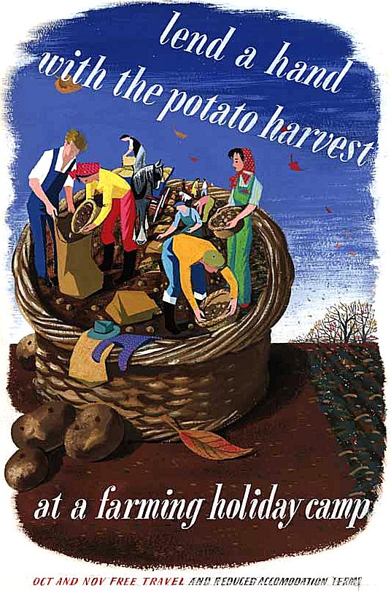

Studies in nutrition and health with extreme rationing carried out at Cambridge University ⁽³⁾ proved to the government that widespread health problems due to food shortages could be avoided, even under a totally successful blockade. However, it was necessary to meet home food production targets in order not to have to resort to extreme measures and a great deal of public disquiet. The Minister for Agriculture and Fisheries emphasised that the predicted number of new pows arriving as workers would be vital in order to reach these targets for 1944. ⁽⁴⁾

Under the threat of increased food rationing, it is not surprising that cabinet wanted to increase the number of Italian pows as workers. This was not despite fine points of law – but that the legal issues were open to interpretation. Thoughts were applied on how to change the pow status of Italians, while still keeping them – and how to utilise existing accommodation rather than using material and labour building new camps. ⁽⁵⁾

In order to encourage higher productivity and increase the range of occupations they were allowed to be employed in, during May 1944, Italian pows were asked if they wished to work as, 'co-operators'. They could then be designated as members of Italian Labour Battalions, rather than as pows which would remove employment restrictions imposed by the Geneva Convention. Again, this was in general terms supported by the Italian government, but with calls for a repatriation date to be set.

Each co-operator labour battalion consisted of about 250 men commanded by Italian Warrant Officers. Rates of pay were increased and some limited greater freedoms were allowed. Perimeter fences around many co-operator camps were taken down.

Those pows refusing were held in 'non-co-operator' camps. They were still required to work, but on a more limited range of occupations.

Some restrictions still applied to both groups of Italian pows, including limited fraternisation and access to public houses and places of entertainment. Censorship also continued to apply; "Existing arrangements for censorship of correspondence will be maintained, and attempts to evade censorship are forbidden." ⁽⁶⁾

1. War Cabinet conclusions, 4 October 1943 134(43)

2. Memorandum by the Lord President of the Council – ‘Employment of Prisoners of War…’ 18 January 1944 WP(44) 36.

3. See various reports on the work of Cambridge University physiologists Elsie Widdowson and Robert McCance.

4. Memorandum by the Minister of Agriculture and Fisheries – ‘Employment of Prisoners of War’ 22 January 1944 WP(44) 44

5. War Cabinet conclusions, 1 February 1944, 14(44)

6. Home Office Letter, 10 May 1944.

The Secretary of State for War, Sir (Percy) James Grigg in answer to a question in the House of Commons stated that;

“Sixty per cent. of the Italian prisoners of war in this country have elected to co-operate in the common war effort on employment by civilian and Service Departments on various types of work. Other Italian prisoners of war who have not so elected are, however, also employed on useful work. German prisoners of war available for work outside camps in the United Kingdom are at present only employed on agriculture.” ⁽¹⁾

This 60% was a far lower number than had been expected. Reasons suggested for this included fear of reprisals against their families in northern Italy, or for the pows within the camps, and indifference.

In the House of Commons:

“Sir J. Grigg - …Italian prisoners of war under the control of His Majesty's Government in the United Kingdom who volunteer are being formed into units organised on a military basis. These units will be under the ultimate command of British officers, but will be staffed, so far as practicable, by Italian officers and non-commissioned officers. Members of the units will wear Italian badges of rank and will enjoy certain
improvements in treatment, particularly in respect of liberty and pay, in comparison with prisoners of war who do not volunteer and whose treatment will remain as at present.

Mr. Thomas - Is the Minister aware that the improvements are so negligible as to offer practically no inducement to these men to volunteer?” (Hansard, 9 May 1944 – Vol 399)

It was recognised that more needed to be done to encourage more co-operation. One method was to allow Italian pows to live in hostels and billets – this also aided the accommodation shortage. By mid-1944 there were 153,779 Italians held in the UK – 78,763 in camps, 54,214 in hostels and 20,802 in billets. ⁽²⁾ As extra accommodation was needed for incoming German pows after D-day, billeting was increased rapidly for the Italians. Mixing German and Italian pows in a camp was not a good idea, it was also discouraged in the Geneva Convention, (Article 9 - Belligerents shall as far as possible avoid bringing together in the same camp prisoners of different races or nationalities). In camps where it is recorded that there were Italians and Germans at the same time, they were certainly segregated.

Further inducements for co-operators were proposed; increased wages, access to shops, post offices and cinemas, use of telephones, free movement up to 5 miles, use of bicycles, extended curfew, and a slight removal of restrictions on fraternisation. ⁽³⁾ The number of co-operators did gradually increase, but many of these inducements also raised complaints from members of the public.

There was also some ill-will regarding the employment and accommodation of Italians, especially in the London region where there was a housing shortage. Within London the pows were employed on railway engineering works, loading and unloading stores, clearance of debris, food processing, and at a gas works. ⁽⁴⁾ The Trade Unions needed to be re-assured that pows would not compete with British workers. A general campaign against pows working, frequently featured in the press. Despite this, no government department employing pows wanted to give them up and the official line was that, “Generally speaking, the prisoners work well and hard…” ⁽⁵⁾

1. House of Commons, 4 July 1944, Volume 401.

2. Memorandum by the Minister of Labour and National Service, 31 July 1944; WP(44)421

3. Imperial Prisoner of War Committee, May 1945, WO 32/9890.

4. Inter-departmental Committee of the Allocation of Prisoners of War, 16 October 1944 Annex to WP(44)686.

5. Memorandum by the Minister of Labour and National Service, 24 November 1944, WP(44)686.

- Mid-1944 D-Day to 1945 Victory in Europe: Greater number of German pows

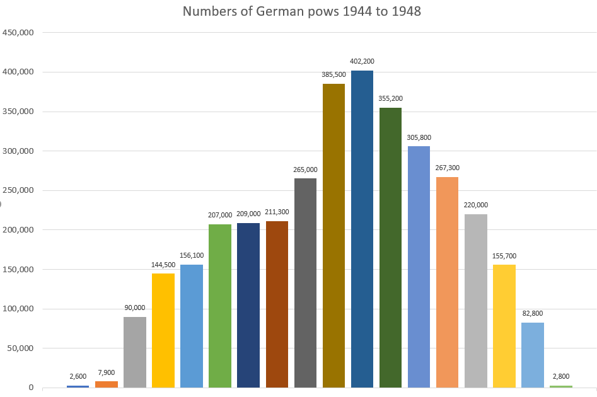
Q | M44 | J44 | S44 | D44 | M45 | J45 | S45 | D45 | M46 | J46 | S46 | D46 | M47 | J47 | S47 | D47 | M48 | J48
% | 5 | 5 | 10 | 14 | 25 | 26 | 33 | 56 | 79 | 77 | 85 | 71 | 65 | 60 | 64 | 50 | 40 | 30
Q - Quarterly (March, June, September, December) returns rounded to the nearest hundred. (Prior to March 1944 < 2,000).
% - Percentage of German pows working, rounded to whole number.

There was a huge increase in the numbers of German pows brought to the UK after D-Day. Britain had agreed with America to take 50% of prisoners arising from joint actions, but increasingly found this difficult to manage. (“Germans” – included Austrians and other nationalities in the German armed forces).

By November 1944, most of the ‘American-owned’ pows had been sent on to the States with 17,000 remaining in the UK, (4,000 in hospitals; 4,000 awaiting shipment; 9,000 kept to work for the Americans). The British total of German pows was 113,000 and rising, and the Secretary of State for War was asked to consider what was to be done with them – they were a security risk and a drain on resources.

He reported that accommodation was still the biggest problem with over-crowding in camps and the use of tents. Though the situation was slowly improving, there were likely to be breaches of Article 10 of the Geneva Convention which stated; “Prisoners of war shall be lodged in buildings or huts which afford all possible safeguards as regards hygiene and salubrity”. To temporarily off-set the numbers of pows arriving in the UK, the French Provisional Government had agreed to take 50,000 pows, (25,000 ‘British-owned’), and a further 60,000 could be held in transit and holding camps on the continent. The United States and Canada were also asked to take more. ⁽¹⁾

The pow camps in France turned out to have; 'extremely unsatisfactory conditions’, ⁽²⁾ to the extent that they were an unacceptable embarrassment to the Allies. This led to an emergency decision to bring 7,500 pows from France to the UK in early 1945. ⁽³⁾

1. Memorandum by Secretary of State for War – ‘Prisoners of War Captured in Western Europe since 6th June’ - 16 November 1944 – WP(44)655

2. War Cabinet, 29 September 1944, (44)129

3. Memorandum by the Secretary of State for War to the War Cabinet, 10 February 1945, WP(45)89

Employment of some, carefully screened, German pows started in early-1944. They were clearly a much greater security risk than the Italians, but 969 selected Germans were sent to Britain from Africa to begin this work on an experimental basis.

After D-Day, although the employment of German pows was needed, at this point in the war there were still serious security issues to be considered. This was reported to the War Cabinet in July 1944:

“The conditions under which German prisoners could be employed have been considered by the Security Executive. They take the view that it would be most undesirable to employ German prisoners without guards on any work whatsoever even in small parties and recommend that:
- For the time being at least, German prisoners should be employed only in gangs of twelve or more under armed escort;
- Members of submarine crews or of the German Air Force should not be employed.
On this basis the Departments concerned estimate that, subject to satisfactory arrangements in regard to accommodation, they could employ forthwith the following numbers of German prisoners:
Ministry of Agriculture 15,000
Ministry of Supply (forestry) 1,200
Ministry of War Transport (quarrying) under 1,000
Total up to 17,200 ⁽¹⁾

This target was nearly reached. By the end of 1944 there were 16,000 German pows in 22 camps who were being employed. It was not until after VE day that large scale unescorted employment began.

The cabinet were faced with predictions that the number of German pows that may need to be brought to the UK could number in the hundreds of thousands. This high number was down to various factors such as food supply, health conditions, and security. Failure to accommodate them adequately throughout winter would not just risk disease, but might also bring retaliation from the Germans against British prisoners.  More drastic measures were needed. The Minister of Labour therefore proposed that no more Italians should be brought to the country and that German pows should be utilised much further. ⁽²⁾  A week later, on 30 November 1944, Cabinet accepted a variety of recommendations to try to | 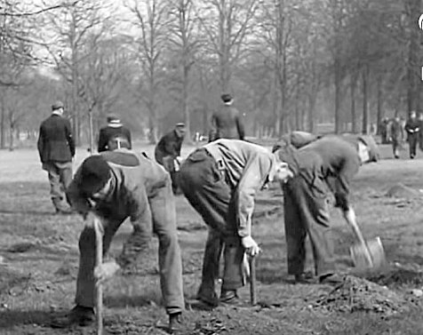
 | Patched German pows at work in Kensington Park.
ease the looming crisis. There were to be slight relaxations of security to allow an increased number of German pows to be employed in work gangs. Attempts would also be made to encourage a less hostile press to the idea of having Germans working in the community. ⁽³⁾

A further effect from over-crowding was raised regarding politically negative conditions for some pows where the; ‘Nazi element in certain prison camps was at the moment bearing heavily on the non-Nazi element’. The problem was a vicious circle, as over-crowding also, ‘made it almost impossible to segregate the Nazis from the non-Nazis’. ⁽⁴⁾ (Wolfgang Rosterg was murdered at Comrie in December 1944, though his murderers’ trial was not started until July 1945).

1. Memorandum by the Minister of Labour and National Service to the War Cabinet, 31 July 1944, WP(44)421

2. 2nd Memorandum by the Minister of Labour and National Service, 24 November 1944, WP(44)687.

3. War Cabinet conclusions, 30 November 1944, 160(44).

4. War Cabinet discussions, 12 February 1945, 18(45).

- 1945 to 1948: Post war labour force and re-education: Gradual return of pows

Two days after VE Day, the Secretary of State for War, issued a memorandum on ‘Employment of German Prisoners of War Outside Germany After The Cessation Of Hostilities In Europe.’ In his paper he calculated the total demands made for German pow labour from government departments to be 730,000 - plus another 150,000 for labour purposes overseas.

He pointed out that to bring an additional 570,000 Germans to the country was out of the question and quite unrealistic.

He gave a breakdown of the numbers of German and Italian pows held, and those working in the UK, the Dominions and British controlled territories on 31 March, 1945, which I have consolidated here:

 | UK |  | Dominion & British Territories + N.W.Europe
 | German | Italian | German | Italian
Officers | 4,368 | 661 | 3,932 | 19,124
Other ranks | 156,130 | 154,072 | 149,821 | 198,570
Total | 160,498 | 154,733 | 153753 | 217,694
 | 315,231 |  | 371,447
Of which No. are employed = | 39,289 | 150,882 | 15,395 | 150,256
Total | 190.171 |  | 165,651
 |  | TOTALS of all locations above
 |  | German | Italian
 | Officers | 8,300 | 19,785
 | Other ranks | 305,951 | 353,303
 | Total | 314,251 | 373,088

He then set out an alternative approach with principles for selecting, retaining and utilising pows which included replacing Italians with Germans, and the use of Nazis. ⁽¹⁾

This paper led to disagreements about the approach to take and the numbers needed. The Minister of State for Economic Warfare stated, “To replace the Italians now working in England by Nazis who can only operate in large guarded gangs would be a disaster to British agriculture.” ⁽²⁾ While the Minister of Agriculture and Fisheries also issued his own memorandum continuing to press the need for 250,000 pows. ⁽³⁾

12 July 1945, the shock election result brought in a Labour Government under Clement Attlee.

At first, the new War Cabinet came to a general view that pows; “..who, because of their extreme Nazi views, could not easily be employed here, should be returned to Germany, where they could be put to work under more onerous conditions, suitable non-Nazi prisoners of war being brought to this country to replace them, as opportunity arose…” This was not actually carried out. Apart from the practicality of sorting and then shipping large numbers of pows in and out of the country, it would mean that Nazis would be sent back to their country before co-operating pows, which would undoubtedly be seen as unfair and potentially troublesome back in Germany.

They also agreed that; “As many as possible of the German prisoners now in this country should be put to work, and, with this in view, the existing limitation on the total numbers to be employed in agriculture and forestry was removed, and restrictions on the conditions of employment of prisoners… should be suitably relaxed.” ⁽⁴⁾

Accommodation shortages continued with calls made for departments, especially the air ministry, to release land and huts. ^{(4 & 5)}

1. Memorandum by the Secretary of State for War to the War Cabinet, 10 May 1945, WP(45) 292.

2. Memorandum by the Minister of Economic Warfare to the War Cabinet, 16 May 1945, WP(45)309

3. Memorandum by the Minister of Agriculture and Fisheries to the War Cabinet, 17 May 1945, WP(45)304

4. Cabinet meeting, 18 July 1945, 15(45) and 5. Memorandum by the Ministry of Works to Cabinet, 27 August 1945, CP(45)128
With regard to Italian pows, the Cabinet concluded that they; “…would not be returned to Italy for some months to come; and no steps should be taken for their return without further reference to the War cabinet.” ⁽¹⁾

Events however, soon affected these deliberately vague plans. In early June, without consultation, the United States Government announced that with the agreement of the Italian Government, they would start to return their Italian pows.

There was some public support that Italian repatriations should also start in the UK, or at least a date be set for this, and the Minister of State for Education called on Cabinet to support the idea. ⁽²⁾

The Prime Minister’s views were that, “…it was unnecessary for us to hasten to make any concession to meet the needs of the Italian Government on this question: and no Italian prisoners need be repatriated from this country at least until after the harvest.”⁽³⁾ No announcement was made for a release date which caused increasing disaffection amongst the pows and some disruption such as strikes, go-slows and disobedience.

On 15 June 1945, the Italian ambassador to the UK Count Nicolò Carandini, wrote a letter with clear increasing frustration, begging the government to reconsider its position and to set a date for the start of repatriation. He talks of the moral depression and cases of nervous and mental break-down amongst the Italian pows who were being held for an indeterminate length:

“….I consider it is my duty to take up again my visits to the camps and urgently to send them a message. I have up to date abstained from doing it awaiting to know the formula I should follow in order to promise nothing more and nothing less than what the British Government are prepared to guarantee. But the time is going by and silence has a worst effect than any painful truth.” ⁽⁴⁾

He was supported by the Foreign Office in the need for clarification of a time-frame for returning Italian pows to be made. They requested permission to issue a statement that:

“While there can be no question of repatriating any of these prisoners of war in the immediate future or before the completion of the harvest (the success of which is a general and not a peculiarly British interest) His Majesty’s Government are glad to give the Italian Government an assurance that once the harvest is over and adequate shipping is available, steps will be taken to repatriate the prisoners of war in batches as quickly as shipping conditions permit.”⁽⁵⁾

And still, no decision was announced. This was largely due to Ministers with production and supply targets insisting on retaining as large a workforce as possible.

In September, (with harvest well-underway) the new Foreign Secretary, Ernest Bevin, argued that it was time to make a decision about the Italians. By then not only had the US started repatriating its prisoners, the USSR and France had announced they too would start as soon as possible. ^{(6}}

Recognising the inevitable, the Minister for Labour backed the Foreign Secretary and asked for a wider rationalisation of the allocation of all pows. He pointed out that, at that time, up to 225,000 German pows were being held on the Continent and could be brought to the UK if required. His memorandum also provided the following information: ⁽⁷⁾

1. War Cabinet conclusions, 18 May 1945, 62(45)

2. Memorandum by the Minister of State for Education to the War cabinet, 7 June 1945, CP(45)20

3. Cabinet meeting, 15 June 1945, 9(45)

4. Letter from Italian Ambassador to the Foreign Office, 15 June 1945, FO 954/14B/437

5. Letter from the FO to the Prime Minister, 21 June 1945, FO 954/14B/437

6. Memorandum by the Secretary of State for Foreign Affairs to Cabinet, 10 September 1945, CP(45)163.

7. Memorandum by the Minister of Labour and National Service to Cabinet, 15 September 1945, CP(45)172

Annex A - Number of Prisoners of War in Employment.

User Department | Italians | Germans | Total POW Employed
Agriculture (including Scotland) ………… | 62,022 | 101,178 | 163,200
Air Ministry ………………………………… | 9,987 | … | 9,987
Admiralty …………………………………… | 2,052 | … | 2,052
Food ………………………………………… | 5,157 | 70 | 5,227
Fuel and Power ……………………………. | 1,346 | 102 | 1,448
G.P.O. ………………………………………. | 150 | … | 150
Health ……………………………………….. | 378 | 70 | 448
Health for Scotland ………………………… | 60 | … | 60
Supply ……………………………………….. | 15,577 | 5,188 | 20,765
War Office …………………………………… | 34,088 | 32,084 | 66,172
War Transport ………………………………. | 16,299 | 1,041 | 17,340
Works ………………………………………... | 7,418 | 14,163 | 21,581
Miscellaneous employment from Base Camps | … | 2.003 | 2,003
 | 154,534 | 155,899 | 310,433

At the cabinet meeting on 18 September 1945, it was agreed that the Italian Government should be informed that the UK would begin to repatriate Italian pows in the near future.⁽¹⁾ Over a month later and as there was still no sign of this actually happening, the Foreign Secretary raised the matter yet again.⁽²⁾ He received reassurances that repatriations would begin before the end of the year.⁽³⁾ This did occur – and Italian prisoners started to be released with the first batch of 6,639 in December 1945.

After initially arguing against it, the Home Office also decided that Italians who wished to stay in the UK would be allowed to remain. The initial number of volunteers was small, but later many ex-pows returned to work and settle under the European Volunteer Worker scheme.

The decision for Italian pows was followed-up with a proposal by the Foreign Secretary to begin repatriating ‘white’* German pows. This plan was to be carried out as the Control Commission for Germany and Austria (COGA) made requests for additional labour for shortage occupations, and after ‘white’ pows held in Germany were released. They were to be replaced by ‘unclassified’ pows held in the Britsh zone of Germany. He distinguished between German and Austrians, stating that with parallel arrangements, ‘white’ Austrian pows should be replaced not by other Austrians, but by further German pows. He stated that though it may be undesirable to return British-educated prisoners to the Russian zone at the present time, the return of prisoners to the British, American and French zones with “reliable political views” would be useful for creating a stable, British-friendly, democratic society in Germany.

He argued that; “These “white” German prisoners are those who have been segregated from the mass of German prisoners in this country and the Middle East and concentrated where possible in special camps. They have been segregated on the basis of their political opinions, and consist of non-Nazis and anti-Nazis. Theyhave been subjected to a process of re-education. This work, which has involved considerable expenditure of man-power and resources, is being carried out, by arrangement with the War office, by the Political Intelligence Department of the Foreign Office.” ⁽⁴⁾

There were 18,972 ‘white’ German pows and 2,802 ‘white’ Austrian pows in the UK, (+ a further 9,847 German/Austrian ‘white’ pows in the Middle East).

The proposal was accepted in principal by Cabinet providing repalcements could be made and at a rate to be determined.⁽⁵⁾

*White (A) – politically indifferent / anti-Nazi; Grey (B) – politically intermediate; Black (C) – Nazis.

1. Cabinet meeting, 18 September 1945, 33(45)

2.Memorandum by the Secretary of State for Foreign Affairs to Cabinet, 2 November, 1945, CP(45)265

3. Cabinet meeting, 6 November 1945, 49(45)

4. Memorandum by the Secretary of State for Foreign Affairs to Cabinet, 8 October 1945, CP(45)219

5. Cabinet meeting, 23 October, 1945, 45(45)

There continued to be further totally unrealistic demands for pow labour in 1946 being made by various departments. The Minister for Labour set these out: ⁽¹⁾

Demand –
 | Prisoners now in employment and continuing to be required by the Departments to which allocated………………………………………… | ……………. | 334,000
 | Additional prisoners required :-
 | Immediately……………………………………………………………….. | 28,000
 | By end of 1945 …………………………………………………………… | 43,000
 | During 1946 ………………………………………………………………. | 160,000
 |  |  | 231,000
 | Grand total of Prisoners estimated to be required by Departments in 1946………………………………………………………………………… | ……………. | 565,000

Supply-
 | Italian Prisoners now in this country ……………………………………………………. | 153,000
 | Employable German Prisoners now in this country …………………………………… | 182,000
 | German Prisoners held here by United States Army and to be transferred to us …. | 15,000
 | German Prisoners in Canada ……………………………………………………………. | 33,000
 | German Prisoners held in Germany against our possible need to bring them here for employment…………………………………………………………………………….. | 225,000

The Minister pointed out that the ‘Supply’ figures could not just be added together – the Italians were to be (gradually) repatriated – ‘white’ pows were to returned - there was insufficient accommodation to bring many more pows from Germany – there were issues over transportation of pows from Germany and Canada which restricted numbers – and, a further 20,000 could not be compelled to work, (e.g. officers).

On this basis he estimated that the pow labour force would not exceed 430,000 during 1946. A little later, he said that the United States might be willing to divert some of its German pows to Britain as well if requested. ⁽²⁾ He expected to receive 175,000 Germans from the United States and possibly some from Norway. He duly revised his estimate of numbers available for 1946 upwards to between 452 - 462,000. ⁽³⁾

This demand for pow labour, especially for agriculture, was not entirely self-serving by the UK. Food shortages were occurring across Europe, and Britain was shipping food-stuffs, grown here, to the continent. For example, in December 1945, the Minister of Food arranged for the following to be sent to the British zone in Germany –

50,000 tons of national flour from the United Kingdom.
25,000 tons of barley from the United Kingdom.
16,000 tons of United States white flour, now afloat, to be diverted to Germany.

Other shipments were to be made in the following months.

During 1946 the number of employed German pows increased, as the number of Italians decreased. Pows made-up 20% of all agricultural labour in the UK.

On 15th May 1946, 338,000 German prisoners of war were held in this country and were employed as follows: ⁽⁴⁾

1. Memorandum by Minister of Labour and National Service to Cabinet, 26 November 1945, CP(45)305

2. Cabinet meeting, 6 December 1945, 60(45)

3. Memorandum by the Minister of Labour and National Service, 17 December 1945, CP(45)341

4. House of Commons, Oral answers to questions, 4 June 1946, Volume 423, Column 1823.

Numbers | Employment | Remarks
163,000 | Agriculture ………………... | Numbers employed include minimum proportion of Camp Staffs.
22,000 | Preparation of building sites
94,000 | Other useful work
46,000 | Unemployed ……………… | 11,000 sick and in detention.
 |  | 35,000 recently arrived and held in transit.
13,000 | Unemployable ……………. | Mainly Officers and Protected Personnel.
338,000 | Total.

The total number of German pows in work from the table above = 279,000, up from 182,000 in November 1945. By July there were 326,000 working pows, by the end of August 420,000, just in time for the harvest.

While working pow numbers grew, at the same time it was noted that average production rates declined. This was put down to a similar reason to the Italians earlier – the need for at least an announcement of a scheme for repatriation. It was suggested that members of the newly formed Polish Resettlement Corps would be able to make up for some labour shortage, though there were Trade Union objections to this. Again, there was resistance to releasing pows and it was stated that a minimum of 215,000 would be needed for the harvest in 1947. ⁽¹⁾

Public campaigns for the release of pows were slow to gain support, or attract much sympathy at all. A generally negative public attitude is hardly surprising considering what they had been through, and the revelations of what the Germans and their allies had done in many countries – including to pows. The call was also harmed by extreme views expressed by some MPs such as Richard Stokes. At a time when many UK citizens were still suffering from the effects of the war, Stokes repeatedly referred to pows as ‘slave labour’. This did not go down well when people were told that pows were receiving greater ration allowances than civilians, and were being paid, albeit at a low rate, for their work. ⁽²⁾ It was in fact correct that many pows did receive greater rations if they were working. They were placed on an allowance equivalent to a working British soldier – which was higher than a non-working British citizen, (Geneva Convention – “Article 11. The food ration of prisoners of war shall be equivalent in quantity and quality to that of the depot troops”).

A change in attitude came with calls to move on from the past, to let Germany build itself as a democratic ally, and to at least establish a repatriation programme in moral fairness. In August 1946, The Daily Mail stated that it was time for a date to be set, as without one the pows were suffering an ‘indefinite detention’ which was not acceptable. ⁽³⁾

A memorandum gave details of the effect on pows of not having any details for their release – in the same way as had been stated for Italians:

“The morale of these prisoners is deteriorating and there is ample evidence to show that this is due very largely to their ignorance of their future and to the remote prospect of any re-union with their families, whom they fear they may never see again.” ⁽⁴⁾

Although the fall in morale was resulting in apathy and despondency, the fear was that it would soon lead to ‘real trouble’ and that would in turn completely negate the pow value as a labour force.

A ‘Memorial’ signed by 875 members of the church and M.P.s was sent to the Prime Minister. The Trades Unions were increasingly questioning about pow cheap labour, and there was a growing public campaign in the UK and in Germany.

1. Memorandum by the Parliamentary Secretary to the Minister of Labour and National Service, to Cabinet, 29 August 1946, CP(46)325

2. House of Commons debates, 4 March 1946, Vol 420, col 30; 26 March, Vol 421, Cols 202-3

3. The Daily Mail, editorial, 21 August 1946.

4. Memorandum by the Parliamentary Under-Secretary of State, The War Office, to the Cabinet, 30 August 1946, CP(46)327.

The Foreign Secretary again gave his support for repatriation and went further by stating that it was not enough to just announce a scheme, but that it should begin as soon as possible and operate at a ‘steady flow’. “If the German prisoners are given some good inducement to work we shall get more out of them and we shall also get rid of them quicker.” He repeated the point that the return of ‘white’ prisoners would help establish a democratic force in Germany. ⁽¹⁾

There was resistance to the idea that all pows should be repatriated, particularly from the Ministry of Agriculture. The Joint Parliamentary Secretary of State at the Ministry, Percy Henry Collick, stated that the number of 215,000 pows for the harvest in 1947 would be sufficient, but then went on to say that pow labour would be required for; “spring plantings and for the summer cultivations.” In his view, whenever repatriation did start it should only be for a limited number of prisoners:

“In the interests of agricultural production, therefore, any repatriation scheme for German Prisoners should be so devised as to leave a considerable number available up to the end of the 1948 harvest.”

He put the ‘considerable number’ for 1948, (yet alone 1947) at 100,000. He did however suggest that “further measures designed to improve the material conditions of the prisoner’s life will be needed.” ⁽²⁾

With hindsight, these demands seem remarkable – but, at the time they were understandable. The UK was economically bankrupt. Not only had the country lost foreign assets, it also had major international debts. To re-build the economy required restructuring industry from the one needed for war effort. Many industries and the national infrastructure had been neglected for years – and some destroyed. The more food that could be produced in Britain meant the less food needed to be bought from abroad. And, as many saw it, the responsibility for this mess lay with the pows and the countries they came from.

The Cabinet debate to decide on German pow repatriation was held on 4 September, 1946. When the demands made by various departments was described as ‘disturbing’, several ministers lowered their requests. Account was also taken of growing public protests regarding the lack of a repatriation scheme. The Cabinet decided that: ⁽³⁾
- A scheme should start as soon as possible, without an end date being set.
- Departments should plan for a progressive reduction of pow labour, and that “in the later months of 1947 and in 1948 the use of prisoner labour should be confined, in the main, to food production, housing and industries ancillary thereto.”
- The rate of repatriation from the UK should be 15,000 a month until further notice.
- Anti-Nazi prisoners should, if possible, be returned before the elections in Germany on 15 September and 13 October.
- The scheme should set priorities for returns – 1. men needed to work in the British-zone, then other zones – 2. family circumstances or compassionate grounds – 3. length of captivity – finally, 4. senior officers and ardent Nazis, “for whose return no provision should yet be made.”
- German prisoners should be allowed to volunteer to remain to work.
- Most pows held in the Middle East would probably be needed for construction work in the Canal Zone until mid-1947
- Dominion Governments would need to be informed and invited to take parallel action.

Committees were formed to produce schemes to refine these decisions and a memorandum summarising the recommendations was issued on 10 September, 1946. ⁽⁴⁾

An initial scheme was approved by Cabinet on 12 September 1946. ⁽⁵⁾ For ‘white’ pows the first embarkation was ready by 26 September. A shipping lift of 500 a day on the Hull-Cuxhaven route was planned allowing 8,000 pows to reach Germany by the 13 October elections. This should be followed by the return of pows who were unfit. Repatriation of others would then start on 1 November.

1. Message from the Foreign Secretary circulated to the Cabinet, 3 September 1946, CP(46)335

2. Memorandum by the Joint Parliamentary Secretary to the Ministry of Agriculture and Fisheries to the Cabinet, 2 September 1946, CP(46)332

3. Cabinet meeting conclusions, 4 September 1946, CP 79(46)

4. Memorandum by the Lord Privy Seal to Cabinet, 10 September 1946, CP(46)342

5. Cabinet Meeting conclusions, 12 September 1946, 81(46)
The numbers repatriated in the first few months of the scheme were:

November 1946 | 15,429
December | 14,236
January | 16,932
Total: | 46,597

An idea to allow extra benefits for pows who postponed their repatriation was rejected as this might cause difficulties within the camps – however it was agreed that pows could stay on without additional benefits.

Meanwhile, to encourage a ‘good work output’ from pows, an inducement scheme was introduced whereby a ‘good worker’ could earn up to 15 shillings per week. ⁽¹⁾ This additional money had to be saved up for repatriation when it would be paid to them in Reichsmarks, it was not available for them to spend in this country. However, they could send up to 5 shillings a week to relatives in Germany.

There were also further incentives in the form of relaxation of regulations restricting pow movement and meetings with civilians. This came just in time for Christmas and the Daily Mail announced that many camps had received invitations from UK families for pows to join them.

In March 1947, the restrictions were relaxed further. A new chocolate coloured battledress was issued without patches and pow marks. The five-mile travel limit was extended for some pows. Organised parties of pows were allowed to attend football matches if invited. Music bands formed by pows could play outside their camp, without payment. The pows could take part in approved educational activities outside of their camp. ⁽²⁾

From July, pows were allowed to take part of their pay in sterling for use outside of their camp, but not in licensed premises – a rule very frequently broken. ⁽³⁾

The repatriation scheme was intended so that there would still be sufficient German pows held in the UK by the end of 1947 for agricultural work. However, with an increasing demand for labour in Germany, the Foreign Secretary proposed the UK should increase the rate of return for its pows. It was hoped that this would also bring pressure on the USSR to do the same with its huge numbers held in captivity. It was suggested that a large number of displaced persons in Europe could be encouraged to come to the UK to make up for the loss of pows. There were also objections coming from the United States over the UK continuing to use German prisoners as labour.

As to be expected, the Minister of Agriculture, along with the Secretary of State for Scotland and the Minister of Labour, opposed the suggestion of expediting the repatriation of pows, pointing out that there was no guarantee that sufficient displaced people would wish to come to the UK.

The Cabinet hedged its bets by authorising the Foreign Secretary to state; “the possibility of increasing this rate of repatriation would be considered by His Majesty’s Government in the light of the information provided by the Soviet and French Governments about the rate at which they intended to repatriate the German prisoners still in their hands.”

They also agreed immediate arrangements to enable German volunteers to remain in this country. ⁽⁴⁾

The last Italian prisoners were returned in July 1947 with about 1400 Italians remaining in the UK for various reasons, mainly as agricultural workers. Many other returned in later years.

The last returning Germans, with a few exceptions for those medically unfit to return, left in July 1948, with about 15,700 remaining voluntarily. ⁽⁵⁾

1. House of Commons, 11 February 1947, Vol 433, Col 176

2. House of Commons, 18 March 1947, Vol 435, Cols 184-6

3. House of Commons, 24 June 1947, Vol 439, Cols 184-6

4. Cabinet Meeting conclusions, 13 March 1947, 28(47)

5. House of Commons, 13 July 1948, Vol 453.
APPENDIX 1

Security

Employment of Italian Prisoners of War in the United Kingdom.

Minutes of a Meeting held in Room 512 (5th Floor) Curzon Street House on Tuesday 9th December, 1941, at 10.30 hours to discuss:-

Plans for expediting the provision of accommodation for future Flights.

Present:-

[List of people representing – D.P.W. members / D.D.F.W / G.H.Q. Armed Forces / P.W.1. /D.A.D. Labour / Q.1.(a) / M. of Agriculture / Dep.of Agric.for Scotland / Ministry of Labour]

The Chairman reminded the meeting that the War Cabinet’s original decision was to bring 28,000 Italians to the U.K. In June, 1941, it was realised that owing to difficulties of shipping and accommodation only 7,000 could be brought by the winter of 1941 and the remaining 21,000 would have to come in 1942.

Minute.

1. Allocation of 28,000 Italians.

A schedule of figures was presented to the meeting and was agreed by all present as follows:-

6,400 are in U.K. 4,700 of which are engaged on agriculture and
1,700 are technicians allotted to D.F.W. (of whom
500 are engaged on camp construction under command arrangements).

2.600 are en route to the U.K.
(600 of these are selected technicians for the Orkneys and
2,000 are allotted to D.F.W. and D.Lab).

5,500 of future arrivals “ “ “ “ making with 2,000 above
7,500 as quid pro quo for British Guard troops.
D.F.W.’s total allotment is therefore 9,200 of which 1,000 may be used by
D.Tn. for Railway construction.

10,500 of future arrivals are allotted to Ministry of Labour and allocated to agriculture.
Agricultures allotment is therefore 10,500 plus 4,700 above = 15,200.

3,600 of future arrivals are allotted to Ministry of Labour and further allocation is awaited.
______
28,000

The Chairman emphasized the urgency of a decision as to the allocation of the last 3,000 in view of the difficulties of providing accommodation by next winter and the possibility of having to house another 5,000 over and above the 28,000.
An immediate answer was essential.

2. Accommodation of 10,500 Agriculturalists.

After discussion on the various ways of obtaining accommodation in the shortest time, giving consideration to the Ministry of Agriculture’s desire for new camps rather that the expansion of existing ones and D.F.W’s difficulties, it was agreed to record provisional decisions as follows:-

List of 21 new sites for agricultural labour camps to accommodate 10,500.

 | (a) Sites accepted by Ministry of Agriculture and Home Forces.
Number of camp in order of priority. | 39. Coleshill, Warwick | Shustoke Hall. 72/677102
 | 40. Pluckley, nr Maidstone. | Boxes Farm, nr.Tudeley, 056641.
 | 41. Stockbridge – Andover district, Hants. | Lopcombe Corner 122/705557.
 | 44. Bridgwater, Somerset. | Haswell Park, Goathurst.
 | 46. Horsham, Sussex | Wisborough Green.
 | 47. Blandford – Shaftesbury. | Motcombe House Park, nr.Shaftesbury 286480.
 | 50. Ormskirk, Lancs. | Garswood Park, 36/0319
 | 55. Buckingham | North of Water Stratford at 94/103562
 | 48. Kington Hereford. | Greenfields camp, Presteigne, at 80/85373
 | 53. Doncaster. | Part of No.2 Command Cage at Racecourse Doncaster.
 | 52. Retford. | Nether Headon about 4 miles S.W. of Retford.
 | 51. Brant Broughton, Lincs | Leadenham Village at Leadenham House Park.
 | (b) Sites accepted by Ministry of Agriculture awaiting approval of Home Forces.
 | 45. Cambridge Area. | Trinity College New Ground, Grantchester Road, Cambridge.
 | 58 Belper Derby | Nether Heage.
 | (c) Sites still to come from Q.1.a.
 | 43. Wheatley
 | 42. Holsworthy – Hatherley – Okehampton.
 | 49. Market Harborough
 | 54. Bromsgrove – Droitwich – Hanbury.
 | 56. Bury – St. Edmunds - Ixworth
 | 57. South of Guildford.
 | 59. Sawtry, Hants.

3 (a). If construction gangs are housed in existing camps to work on building at new camp sites in the vicinity, it was agreed that the distance between should not exceed 30 miles.

(b). Maximum endeavour must be made to house construction gangs in:-

 |  | Existing Camp. |  |  |  |  | New Site. | Distance away.
No. | 31 | Ettington | to work at |  | No. | 39 | Coleshill, Warwick | 30 | Miles.
No. | 25 | Lambourn | “ “ “ |  | No. | 41 | Stockbridge, Hants. | 30 | “
No. | 8 | Bury | “ “ “ |  | No. | 50 | Ormskirk, Lancs | 30 | “
No. | 33 | Bicester | “ “ “ |  | No. | 43 | Wheatley, Oxon | 13 | “
No. | 36 | Aylesbury | “ “ “ |  | No. | 55 | Buckingham | 18 | “
No. | 27 | Ledbury | “ “ “ |  | No. | 48 | Kington Hereford | 30 | “
No. | 17 | Lodge Moor | “ “ “ |  | No. | 52 | Retford | 30 | “
No. | 26 | Ely | “ “ “ |  | No. | 59 | Sawtrey } | 25 | “
 |  |  | “ “ “ |  | No. | 56 | Bury St.Edmunds } | 25 | “
No. | 29 | Royston | “ “ “ |  | No. | 45 | Cambridge | 15 | “
No. | 35 | Boughton Park | “ “ “ |  | No. | 49 | Market Harborough | 15 | “
No. | 37 | Sudeley | “ “ “ |  | No. | 54 | Bromsgrove | 30 | “
No. | 28 | Loughborough | “ “ “ |  | No. | 58 | Belper | 20 | “

