Camp 262 RAF Camp, Langar, Nottinghamshire (+ Bunny Camp)

Included in the 1945 ICRC Camp list – Labour Camp. 262. RAF Camp, Langar, Barnstone, Nottingham.

1947 Camp List
262(G.W.C.) | R.A.F. Camp, Langar, Barnstone, Nottingham | N | Priswar, Barnstone | Harby 279 | (Blank) | Lt.Col.N.A.Mc.D. Walker | v/1453/2

Prisoner of War Camps (1939 – 1948) - Project report by Roger J.C. Thomas - English Heritage 2003
OS NGR | Sheet | No. | Name & Location | County | Cond’n | Type 1945 | Comments
SK 739 333 | 129 | 262 | RAF Camp, Langar | Nottinghamshire | 5 | German Working Camp | Former RAF Langar. Precise location not identified, NGR given for centre of airfield. Numerous dispersed accommodation sites.

Location: NGR shown at X. From the EH description and some similar sites, there may have been a main HQ / administration centre ( probably to the SW of the location shown) and some accommodation at the airfield, with other buildings for pows sometimes several miles from the HQ.  Before the camp: The airfield was opened in 1942 and then used by the RAF and USAAF. The RAF returned to the base in October 1944 until March 1945.  Pow Camp: POW Camp from the end of the war.  There was a camp magazine – Der Lagerspiegel – (The Camp Mirror).  German POWs who worked with No.1 Bomb Disposal Squadron were administered from this camp. Some were based in a satellite-camp at the village of Bunny, Nottinghamshire – with detachments located in other camps. See below for notes and an Inspection Report on Bunny Camp.  Reference to Ukrainians at the camp – but without dates so it is uncertain if this was as pows or as displaced persons.  Camp commandant c1947 Lieutenant Colonel N A McD Walker, from the Sherwood Foresters.  After the camp: Used as accommodation for displaced persons. From 1952 the Royal Canadian Airforce used the base as a supply station. | 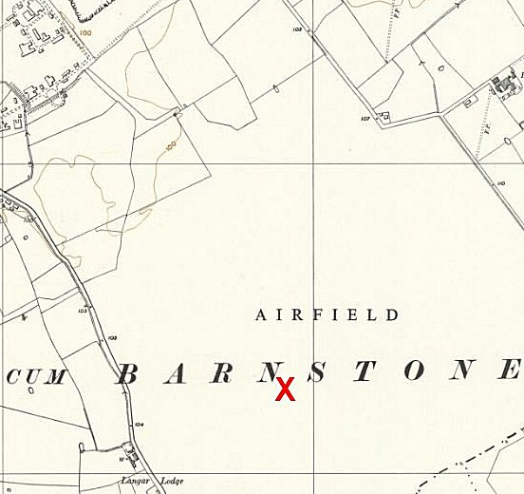
 | Ordnance Survey 1956
Further Information:
National Archives FO 1120/239 – Re-educational survey visit reports for camps 260 to 263. Dated 1 January 1946 – 31 December 1948.
National Archives FO 939/83 for inspection Report carried out by the Control Office for Germany and Austria (COGA) – ‘1 Bomb Disposal Camp, Bunny Park Camp, Bunny, Nottinghamshire – dated 1947. See below for full transcript.
The Imperial War Museum has copies of the magazine, dated February/September 1947 and February 1948, Ref LBY E.J. 381. The German Federal Archives also has a copy, date unknown.

Transcript of re-education inspection report carried out for COGA on 262 sub-camp at Bunny village, (Ref: FO 939/83).
Mr.Hamilton  CONFIDENTIAL  Camp Address No. & Type of Camp Date of Visit  Bunny 1. Bomb Disposal Squadron 16. - 18.12.47  Nottingham  Name of Visitor. Report handed in  A.G.George 20.12.47.  Object of visit No. of Visits  Re-educational Survey 1  - - - - - - - - - - - - - - - - - - - - - - - - - - - - - - - - - - - - - - - - - - - - - - - - - - - - - - - - - - - - - - - - -  Strength: Offs: 173 [Crossed out] O.R’s: 175 Total: 175  of which  24 at H.Q. (Bunny) administered by PW Camp 262  Detachments:  12 at Sheffield administered by PW Camp 296  31 at Birmingham “ “ PW Camp 39  20 at Buckton “ “ PW Camp 250  25 at Hull “ “ PW Camp 136  61 at Sibsey “ “ PW Camp 79  - - - - - - - - - - - - - - - - - - - - - - - - - - - - - - - - - - - - - - - - - - - - - - - - - - - - - - - - - - - - - - - - -  Personnel:  O.C. : Major R.A. Shorter, R.E.  Interpreter : Nil.  - - - - - - - - - - - - - - - - - - - - - - - - - - - - - - - - - - - - - - - - - - - - - - - - - - - - - - - - - - - - - - - - -  I was very cordially received by the O.C. who was most cooperative. He told me that he had made arrangements with Northern Command for his widely scattered detachments of P’sW to be administered by the nearest P.W. Camps as shown above. A special stores check was made on the detachment at Sibsey, some 70 miles from Bunny, and the O.C made arrangements for me to travel on the P.W. used for that purpose. I was also able to accompany the Guards Officer on his Contact Visit to 262 P.W. Camp. Judging by the conditions at HQ Bunny & Sibsey, it appears that the PW Camps responsible take very little notice of these detachments. This may be due to the fact that the Ps’W have been specially trained with Royal Engineers for Bomb disposal work and are therefore regarded as “untouchables” by the Camps concerned or perhaps to the rather isolated locations of the detachments. | At the detachments I visited, there were no signs of either educational or reeducational activities. Neither film shows nor lectures are given at the detachments. In the first place the numbers are small, secondly the sites are very isolated and thirdly petrol restrictions do not permit PsW to be transported to the main camps or nearest hostels.  News papers, usually 2 or 3 English ones, are supplied locally and charged to the Welfare Funds of the main Camps concerned. No German papers have been received by the detachments so far. Wochenpost and Ausblick are received from the Main Camps as also Camp newspapers. No contributions have been made to the latter. Library books are exchanged monthly by the Main Camps.  No accommodation is available for the Information Rooms, and official notices and copies of Nachrichtendienst der Wochenpost are displayed in the small recreation rooms.  The detachment at Bunny has a wireless set which was supplied by 262 Camp but the detachment at Sibsey is at present using a set belonging to the British staff. News is received both from Hamburg and Leipzig.  As already mentioned there are no educational activities and religious interest appears to be very low. Padres from the Main Camps have not yet visited these detachments, although plans have been made for Christmas services to be held by them.  Table tennis and cards are the chief form of entertainment.  RECOMMENDATIONS:  As the detachments of this B.D. Squadron have been handed over to local P.W. Camps for administration I recommend that the respective T.A’s be advised forthwith so that they may deal with them on their next visits to the camps concerned.  It is recommended that an appropriate parcel of German newspapers be sent to Major R.A. Shorter, R.E., O.C. No.1 B.D.SQ.Bunny, Nottingham, for initial circulation to his detachments and that the P.W. camps concerned be asked to ensure that these small detachments are considered in their future distributions.  It is strongly recommended that contact be made with DBD (Director of Bomb Disposal) at the War Office to ascertain the present locations and dispositions of P’sW employed by Bomb Disposal Squadrons in other parts of the country.  Ma. Re.  Wochenpost – German weekly newspaper.  Ausblick – magazine for pows.  O.C. Officer commanding  T.A.’s training advisers

Location for Bunny Camp – a local resident informed me there was an army bomb disposal unit on Wysall Road – and a list of BD POW units gives a slight extra clue of ‘Bunny Park’. (FO939/83).  The 1952 OS map shows Wysall Road running down the middle of the map – with Bunny Park alongside on the West. There is a small cluster of buildings at NGR SK 598 297 which may have been the army camp / pow camp. The buildings do not show on the 1922 map and are not on the modern map. | 