Camp 1014 - Ordnance Storage Depot Camp, Queen’s Ferry, Deeside, Flintshire

1947 Camp List
1014(G.Wkg.Coy) | W | O.S.D. Queens Ferry, Chester | Hawarden 2288 | 23 | V/1270/4

Prisoner of War Camps (1939 – 1948) - Project report by Roger J.C. Thomas - English Heritage 2003
OS NGR | Sheet | No. | Name & Location | County | Cond’n | Type 1945 | Comments
 |  | 1014 | Ordnance Storage Depot, Quuensferry | Flintshire |  | German Working Company | Wales

Location: Approximate NGR SJ 316 683, provided by Clwyd-Powys Archaeological Trust  Before the camp:  Pow Camp:  After the camp:  Further Information: | 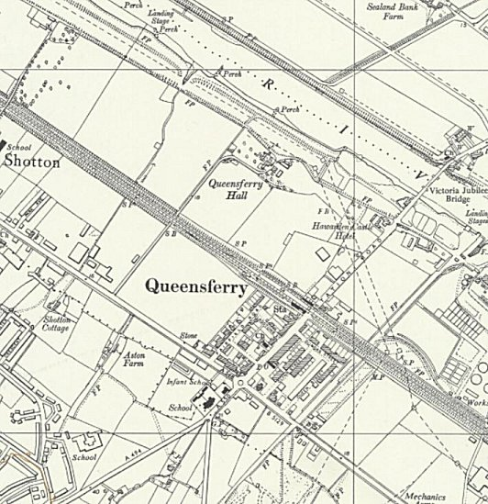
 | Ordnance Survey

