Camp 801 Castel Camp, Guernsey, Channel Islands / Camp 802 Fort Regent, Jersey, Channel Islands

Prisoner of War Camps (1939 – 1948) - Project report by Roger J.C. Thomas - English Heritage 2003
OS NGR | Sheet | No. | Name & Location | County | Cond’n | Type 1945 | Comments
 |  | 801 | Castel Camp, Guernsey | Channel Islands |  | Base Camp | Opened May 9th 1945 closed May 1946.
 |  | 802 | Fort Regent, Jersey

NOTE – these were two separate camps. However, as a good deal of the history of the German pows on the Channel Islands is shared, I have placed the information together, here.

Before the camps: The original plan made in 1944 was to locate German pows to a camp on Alderney, but this was later changed. At the end of the German occupation, British soldiers landed in Guernsey and Jersey on 9 May 1945. The last months of the occupation saw major food shortages – including for the German troops – many needed medical treatment.

Location:

Guernsey - There was a POW camp down the road from Saumarez Park where the King George V playing fields now are. This was a slave worker camp during the Occupation and after Liberation it was a POW camp where former occupying soldiers were kept while put to work re-building Guernsey. (Information from Merrie Jee at the Folk and Costume Museum – set within the park I would highly recommend for a wonderful day out!).

Jersey – I assume it was withing the Fort and surrounding barrack buildings.

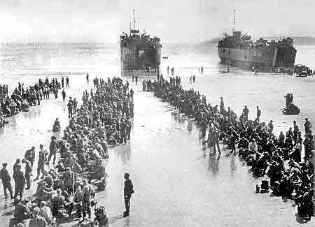
Pow Camps: At the start of the liberation, on 9 May, German troops were instructed to remove troops for a distance of 1 mile from the landing points on Guernsey and Jersey. A few were allowed to remain for a short time in the hospitals, to guard ammunition dumps, and to assist unloading at the ports. Shortly after, the Germans handed in their weapons and were confined to barracks while the pow camps were established.

By 10 May the number of Germans was notified as – 11,671 on Jersey, 11,755 on Guernsey, 3,202 on Alderney, 281 on Sark.
The pows on Sark remained there under the charge of the Dame of Sark until 17 May when most were removed.
The pows on Alderney were not removed until 20 May.
From 13 / 14 May, as supplies were brought in to the Islands, the pows were shipped out. About 800 pows could be loaded onto the LSTs (Landing Ship, tank). The picture shows German pows lined up waiting to board LST’s at St Aubin’s Bay, Jersey on 19 May, 1945. (theislandwiki.org).

Most of the pows were transferred to UK pow camps. Some remained on the Islands to clear mines, barbed wire and dismantle military installations. There were fatalities amongst the pows involved in the clearance work.

After the camp:

Further Information:

National Archives – WO 166/17826 – 801 Prisoner of War Camp at Plymouth dated February 1945

Two books. Not seen by me:
‘The post office of the German prisoners of war in the English POW Camps 801 and 802 on the islands Guernsey, Jersey, Alderney and Sark, camp and censorship postmark, historical background’ - Olaf Beecken

‘German prisoners of war on the Channel Islands: 1945 – 1947’ - Olaf Beecken – 2005

