Camp 793 Bulwell Hall, Nottingham

ICRC – Labour Camp. 793. Bulwell Hall, Nottingham.

Location: Bulwell Hall is just to the N of the town of Bulwell.  Before the camp: Country house and park. The house was built in 1770. Later becam a public park and part golf course. During the 1930’s used as a sanitorium and an approved school. Requisitioned by the army shorty after the start of WW2.  Pow Camp: Opened as a pow camp for Italians in 1943/4.  After the camp: House demolished in 1956/8.  Further Information: | 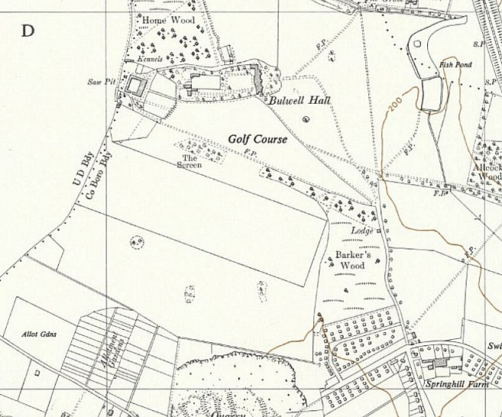
 | Ordnance Survey 1955

