**Camp 785** **AA Camp, Thrybergh, Rotherham, Yorkshire**

ICRC – Labour Camp. 785. A.A. Camp, Thrybergh, Rotherham, Yorks.

**NOTE – there was a sub-camp for Camp 127 Potter’s Hill at Ravenfield Park which is close to Thrybergh. I am not sure if this is the same camp – but from some descriptions I have doubts that it was.**

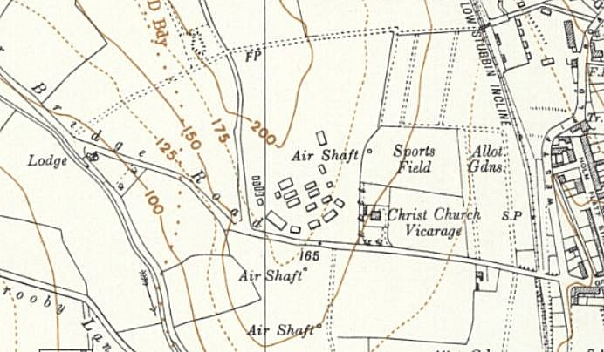The ‘AA Camp’ was an Anti-Aircraft camp which was recorded as being in the Thrybergh area. One entry about a POW camp near Thrybergh stated::

“*There was one on Greasbrough tops, it was situated next to an anti-aircraft battery that was behind the old rectory on the road from Parkgate to Greasbrough. The guns were placed there because the German bombers would follow the rother Valley on bombing missions to Parkgate/sheff steelworks. And the prison camp was placed alongside to try to dissuade any attack on the gun placement.”* This may be the site at SK 431 954 (OS1956) >

Another put the camp “*behind the Rawmarsh swimming baths*… (1 km away) *… as you went down into Greasbough on the left hand side used the same road as the access to the old pit there.”*

I really do not know if this is the site – but the memory of the anti-aircraft battery makes it a possibility.