Camp 784 Thorndon Hall, Brentwood, Essex

ICRC – Labour Camp. 784. Thorndon Hall, c/o GPO Brentwood, Essex.

Location: NGR for the house TQ 6165 9176  Before the camp: Large country house and park. Leased and later sold to Thorndon Golf Club. Part of the parkland was used as Marshalling area S5 prior to D-day.  Pow Camp: I have only seen a reference to Italian pows.  After the camp: 1976 converted to apartments and cottages.  Further Information: | 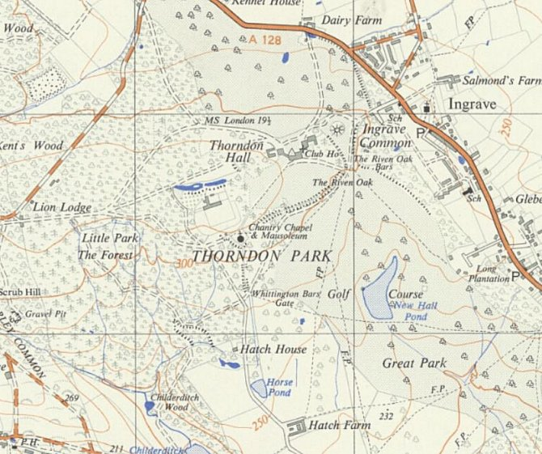
 | Ordnance Survey 1955

