Camp 667 / 667a Stoneleigh Camp, Coventry, Warwickshire (& Packington)

1947 Camp List
667(G.W.Coy) | N | Stoneleigh Park Camp, Stoneleigh, Coventry, Warwickshire | (Blank) | 36(W.O.) | V/1270/4

Prisoner of War Camps (1939 – 1948) - Project report by Roger J.C. Thomas - English Heritage 2003
OS NGR | Sheet | No. | Name & Location | County | Cond’n | Type 1945 | Comments
SP 3430 7184 | 140 | 667 / 667a | Stoneleigh Camp, Stoneleigh, Coventry | Warwickshire | 4 | German Working Camp | Camp associated with Military Hospital.

Location: About 7km S of Coventry. The NGR above is indicated on the map.  On a 1943 plan of the military hospital at this site, the place indicated is labelled as “Company Orderly Rooms”. The oval shaped arrangement of huts just above is labelled as an “Irish Labor Camp (off limits)” and may also have been used to accommodate pows.  Before the camp: The site was used as a US Rehabilitation Center and general hospital from October 1943.  Pow Camp:  After the camp: The Coventry German Circle was established in 1946 by local residents who had lost businesses and family members during the war. They wanted to form peace links between themselves and Germans – Jewish refugees and pows from Stoneleigh camp were among the first German members of the Circle.  Further Information: | 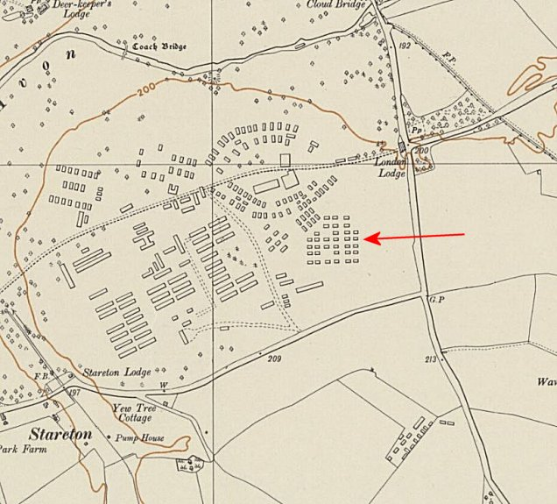
 | Ordnance Survey 1955

Packington Park

I am not sure if this was a satellite camp for Stoneleigh. Packington Park is 17km NW of Stoneleigh, and just 3km SW of Maxstoke Camp 39. NGR SP 2202 8402

There was a large camp at the north of Packington Park – it is marked there before the war on the OS map – but is a possible location for a later pow camp.  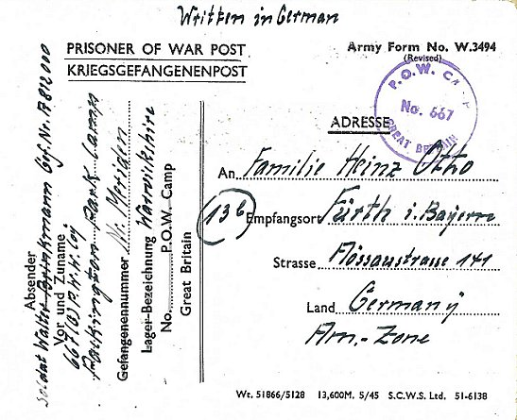  < Pow postcard dated 15 Dezember 1946.  Address given –  667 (G) PWW Coy,  Packington Park Camp, Nr Meriden, Warwickshire.  The IWM have a copy of a magazine from the camp – “Weihnachten 1946” (Christmas 1946) produced at Packington Park.  (Ref LBY EJ 437). | 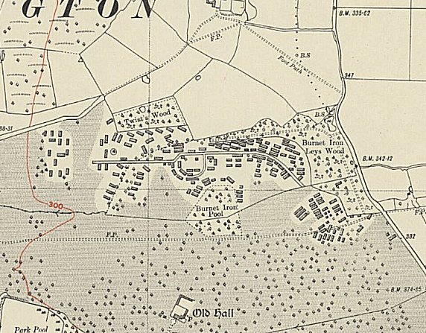
 | Ordnance Survey 1937

WEIHNACHTEN 1946

WEIHNACHTEN 1946

