Camp 640 Mansecroft Camp, Twynholm, Dumfries and Galloway

Location: NX 6683 5422  Most likely linked to Camp 640 St Andrew’s Hall, Kircudbrightshire, 5 km to the S.  Before the camp:  Pow Camp: Air photographs show at least 7 huts, probably Nissen inside a rectangular perimeter fence.  Leo McClymont, interviewed for The Daily Record in April 2020 recalled – ‘ “Italian prisoners of war came from a camp near Twynholm,” he said. “They worked for the Forestry Commission in the woods and came in a truck with a British driver. “It was supposed he had a rifle but he read the paper and slept all day. The prisoners would have to wake him up to get back to their camp.” ‘  After the camp: Secret Scotland records Polish refugees at the site. Agricultural Hostel. 2020 housing on site.  Further Information:  Canmore - http://canmore.org.uk/site/294647  RAF vertical air photographs - 106G/UK42 421, frames 4033-4034, flown 19 June 1945 | 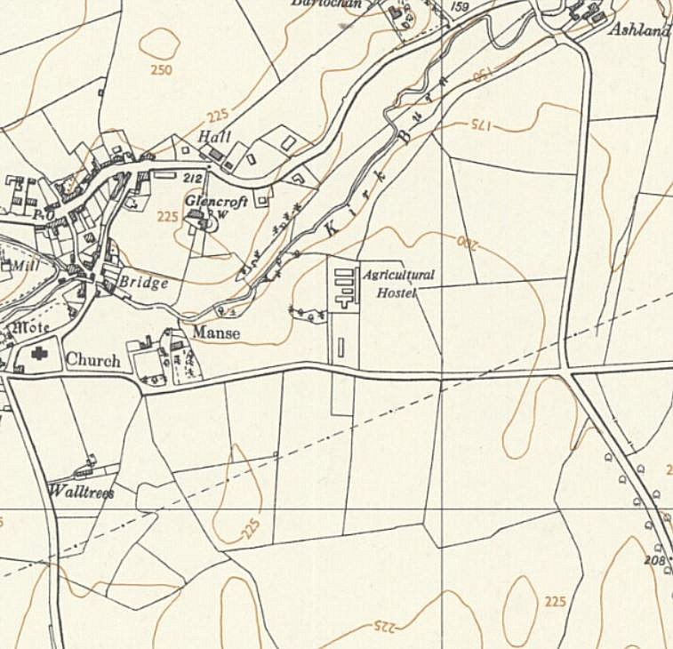
 | Ordnance Survey 1957

