Camp 634 (& 1008) Alvaston Camp, Alvaston, Derby, Derbyshire (aka Allenton ?)

1947 Camp list
634(G.W.Coy) | N | Alvaston Camp, Meadow Lane, Derby | Derby 59454 | 27(W.O.) | V/1456/2
1008(G.W.Coy) | N | Allerton [sic] Camp, Nr.Alvaston, Derby | Derby 59214 | 27 | V/1456/2

Prisoner of War Camps (1939 – 1948) - Project report by Roger J.C. Thomas - English Heritage 2003
OS NGR | Sheet | No. | Name & Location | County | Cond’n | Type 1945 | Comments
SK 3786 3455 | 128 | 634 | Alvaston Camp, Meadow Lane, Alvaston, Derby | Derbyshire | 4 |  | Former RAF barracks associated with the nearby barrage balloon centre. See Camp no.1008.
 |  | 1008 | Allerton Camp, Alvaston, Derby |  | 5 | German Working Company | See Camp 634

Note – I am not sure that Camps 634 and 1008 are the same camp though they are listed as linked in the English Heritage Report – see notes at end.

Location: On the SE of Derby. Allenton (not Allerton) is the district next to Alvaston. Three other nearby pow sites in Derby at Stores Road, Sunny Hill and Boulton Lane.  Before the camp: Victorian villa and estate. The owner set aside land to create Alvaston Park open to the public.  Pow Camp: The camp was built in the park. Reported that part of the camp was for Germans and the other for Italians. The Italians worked in the fields of local farmers and the Germans worked at the ordinance depot on Sinfin Lane.  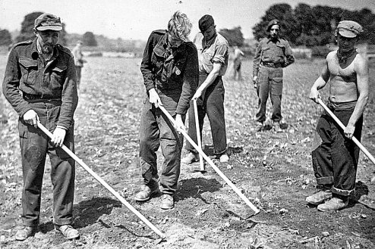  “Prisoners of War based at Alvaston employed doing farm work off Ford Lane, Allestree, in 1945” – www.derbytelegraph.co.uk – article by Jane Goddard, 18 August 2018.  After the camp:  Further Information: | 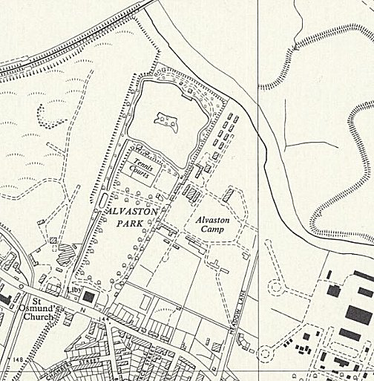
 | Ordnance Survey 1955

Alvaston / Allenton?  Alvaston Park is N of Allenton, it is not the same area. Why would the camp have the two names Alvaston / Allenton?  There is a site with perimeters marked on Sinfin Avenue, Allenton at NGR 3700 3190. This is near to the Sinfin Depot where it is known that German pows from various camps were working. Is this the Allenton Camp – or part of the Depot? | 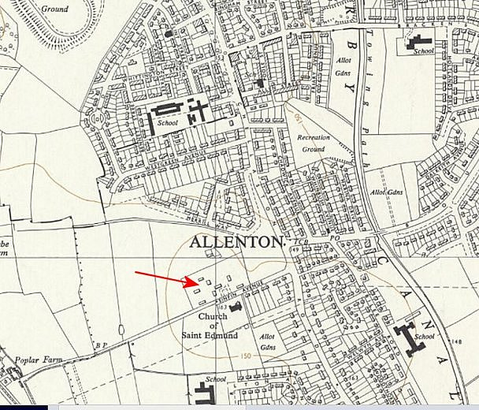
 | Ordnance Survey 1955

