Camp 118 - Mardy Camp, nr Abergavenny, Monmouthshire (Gwent) (+ notes on Bulwark Camp)

Included in the 1945 ICRC camp list – Labour Camp. 118. Mardy Camp, Abergavenny, Monmouthshire.

1947 Camp list
118(G.W.C.) | Mardy Camp, Mardy, Abergavenny, Mon | W. | Priswar, Abergavenny | Abergavenny 556 & 7 | Abergavenny (G.W.R.) | Lt.Col.A.E.Tawney, M.C. | v/1453/2

Prisoner of War Camps (1939 – 1948) - Project report by Roger J.C. Thomas - English Heritage 2003
OS NGR | Sheet | No. | Name & Location | County | Cond’n | Type 1945 | Comments
 |  | 118 | Mardy Camp, Abergavenny | Monmouthshire (Gwent) |  | German Working Camp | Wales

Location: NGR SO 305 163. Just to the NW of Mardy. 2 km N of Abergavenny.  Before the camp: Farmland  Pow Camp: Italian and then German pows.  The purpose of the camp was raised in Parliament in 1947 –  “Mr. Stokes asked the Secretary of State for War why 134 German prisoners of war, graded "White A," have been collected from other camps in the neighbourhood and now held at No. 118 Camp, Abergavenny, and whether he is aware that they were told on their removal to this camp that they were on their way to Chepstow for repatriation.  Mr. J. Freeman This camp is used as a collecting centre for prisoners who are graded "White"; from it they are sent forward to a transit camp for repatriation as soon as vacancies are available; the reason given to them for their transfer was, therefore, correct.” (House of Commons, 1 April 1947, Volume 435. In Hansard the camp number is recorded as ‘18’, this seems to be a typing error).  Camp commandant c.1947 Lieutenant Colonel A E Tawney, M.C., from the Royal Regiment of Artillery.  Postal items: Mail to Italy seen for March 1945 and February 1946.  Pow letter-sheet dated June 1947 to Germany.  After the camp: 2019 residential area, school grounds and field.  Further Information:  National Archives FO 1120/227 – Re-educational survey visit reports for camps 117 to 119. Dated 1 January 1946 to 31 December 1948. | 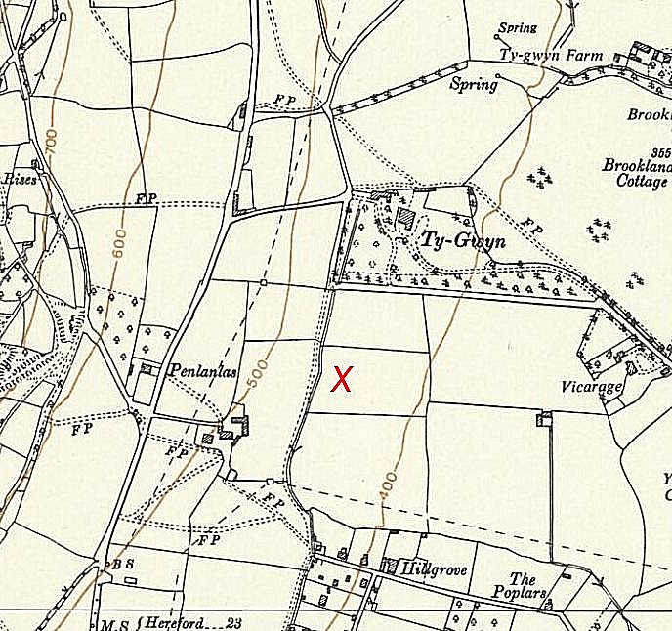
 | Ordnance Survey 1964

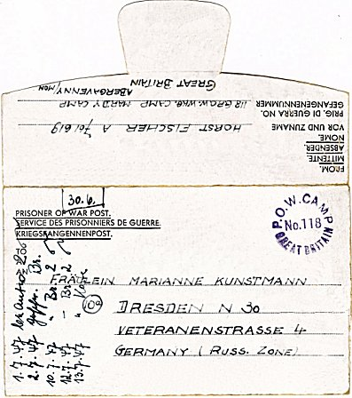
< Pow letter-sheet dated June 1947 to Germany.

- - - - - - - - - - - - - - - - - - - -
Bulwark Camp - Notes
I think this was a sub-camp – but I do not know if it was linked to Camp 118 Mardy, or to Camp 197 The Mount.
Bulwark is an area just to the S of Chepstow where The Mount Camp was located. Mardy Camp was about 25 miles away.
The IWM have a copy of a camp magazine, dated February 1947 – ‘Unsere Bote: Nachtrichtenblatt des Lagers 118’ (Our Messenger: Newsletter for Camp 118). Ref LBY E.J. 429. Listed as published by German pow in Camp 118, Bulwark Camp, Wales.
Memories of Bulwark Camp: "Prisoners of War were in the camp at Bulwark (where Critchcraft now stands). They used to arrive at a stop away from the main Railway Station at Chepstow. This was at the end of Caird Street, in Garden City. My young brother and his friends, complete with home made wooden guns - not many toys in the shops at that time - would march behind the poor prisoners, all the way up to Bulwark Camp. I think most of these men were glad that their part of the war was over. We used to go and chat to them (as best we could) through the fences, and if we took some raw materials, and a few cigarettes, they would make us the most lovely slippers, and wooden toys in exchange. [http://www.bbc.co.uk/history/ww2peopleswar/stories/02/a4066102.shtml]

