Camp 1025 Histon Camp, Milton Road, Histon, Cambridgeshire

1947 Camp List
1025(G.Wkg.Coy) | E | Histon Camp, Milton Road, Cambridge | Cambridge 56981 Ext.27 | 71 | V/1270/4

Prisoner of War Camps (1939 – 1948) - Project report by Roger J.C. Thomas - English Heritage 2003
OS NGR | Sheet | No. | Name & Location | County | Cond’n | Type 1945 | Comments
TL 4566 6371 | 154 | 1025 | Histon Camp, Milton Road, Cambridge | Cambridgeshire | 4 | German Working Camp | Precise location not identified. NGR for Milton Road.

Location: ? There was an army camp – recorded as later being used as a pow camp – by the village of Milton at NGR 467 623. Was this the camp?  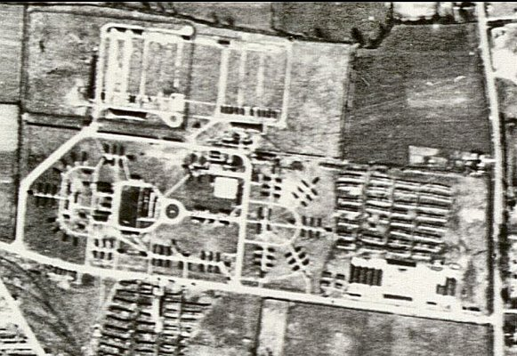  Before the camp:  Pow Camp:  After the camp:  Further Information: | 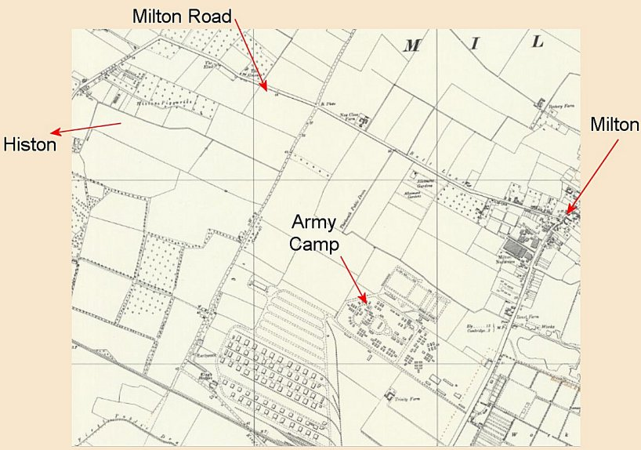
 | Ordnance Survey

