Camp 1022 Bradninch Camp, Bradninch, Exeter, Devon

1947 Camp List
1022(G.Wkg.Coy) | S | Bradninch Camp, Bradninch, Exeter, Devon | Hele 248 | 37 | V/1270/4

Prisoner of War Camps (1939 – 1948) - Project report by Roger J.C. Thomas - English Heritage 2003
OS NGR | Sheet | No. | Name & Location | County | Cond’n | Type 1945 | Comments
SS 9987 0395 | 192 | 1022 | Bradninch Camp, Bradninch, Exeter | Devon | 5 | German Working Camp | Precise location not identified. NGR for centre of village.

Location: NGR SS 000 036 - alongside Kensham Avenue, (just NE of ‘Cemy’ on map). About 14km NE of Exeter.  Before the camp: The US 955th Field Artillery Battalion were based in Bradninch in 1943. The camp was mainly Nissen huts erected on the cricket pitch.  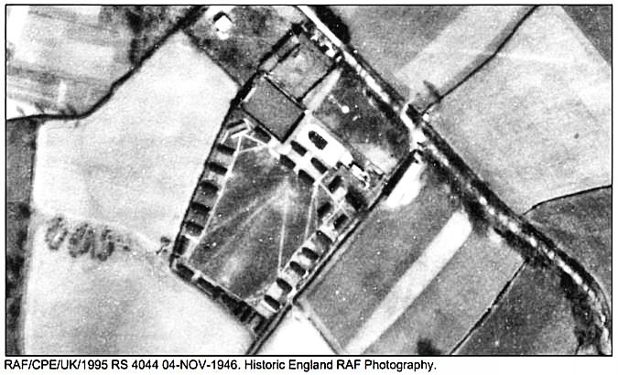 | 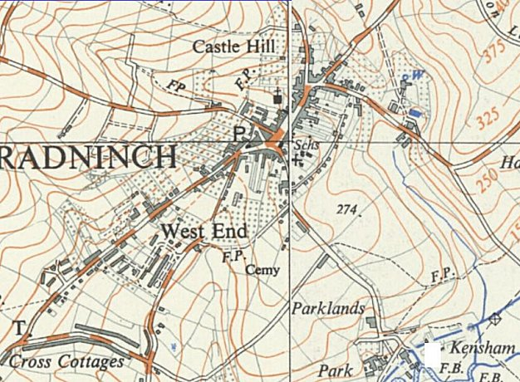
 | Ordnance Survey 1962

Pow Camp: The US army camp was taken over as the German pow camp. (I have seen one report that Italian pows were held here – this is not confirmed and is unlikely. However, an Italian hostel or sub-camp was believed to have been based at nearby Ashclyst Forest).

The 1946 aerial photograph shows 28 Nissen huts and 2 larger buildings around a large quadrangle.

The camp was demolished in 1947.

After the camp: Recreation ground.

https://repatriatedlandscape.org/england/pow-sites-in-the-south-west/pow-camp-1022-bradninch/

Further Information:

Aerial Photographs - RAF, 1946, RAF/CPE/UK/1823 RS, RAF/CPE/UK/1995 RS 4043-4044 04-NOV-1946 SDV356902.
Hegarty, C. + Knight, S. + Sims, R., 2014-2015, East and Mid Devon River Catchments National Mapping Programme Project (Interpretation). SDV356883. https://research.historicengland.org.uk/Report.aspx?i=15681

