Camp 1021 Merley Park, Wimborne Minster, Dorset

1947Camp List
1021(G.Wkg.Coy) | S | Merley Park Camp, Wimborne Minster, Dorset | Wimborne 637 | 37 | V/1270/4

Prisoner of War Camps (1939 – 1948) - Project report by Roger J.C. Thomas - English Heritage 2003
OS NGR | Sheet | No. | Name & Location | County | Cond’n | Type 1945 | Comments
SZ 0132 9830 | 195 | 1021 | Merley Park Camp, Merley, Wimborne Minster | Dorset | 5 | German Working Camp | Pre-existing camp. Bird garden and caravan site.

Location:  Before the camp: Area used as a military base for British and then US troops  Pow Camp:  POW mail seen for 1946 and 1947.  After the camp: 2020 sports ground and camping site.  https://repatriatedlandscape.org/england/pow-sites-in-the-south-west/pow-camp-1021-merley-park/  Further Information: | 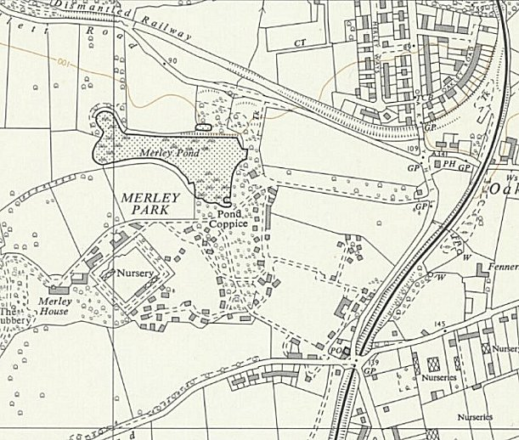
 | Ordnance Survey 1963

