Camp 1019 Beaumont Barracks, Aldershot, Hampshire

1947 Camp List
1019(G.Wkg.Coy) | S | Beaumont Barracks, Aldershot, Hants | Aldershot 380 Ext.0321 | 30 | V/1270/4

Prisoner of War Camps (1939 – 1948) - Project report by Roger J.C. Thomas - English Heritage 2003
OS NGR | Sheet | No. | Name & Location | County | Cond’n | Type 1945 | Comments
SU | 186 | 1019 | Beaumont Barracks (South Cavalry  Barracks), Aldershot | Hampshire | 4 | German Working Camp | Demolished 1975 for housing.

Location: NGR SU 8534 5064. Part of the huge Aldershot barracks area.  (Nearby West Cavalry / Willems Barracks also used as Camp 1006).  Before the camp: The South Cavalry Barracks were built in 1855. They were renamed as Beaumont Barracks in 1909. Stabling was on the ground floor, accommodation on the first floor.  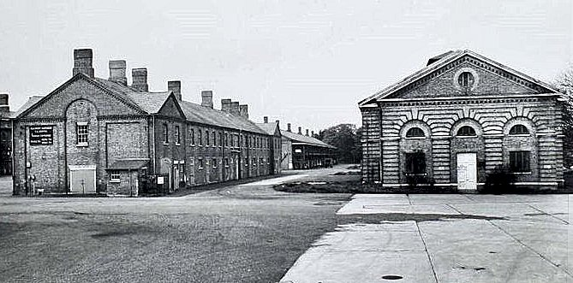  Pow Camp:  After the camp: Barracks demolished in the 1970’s. 2020 residential area. | 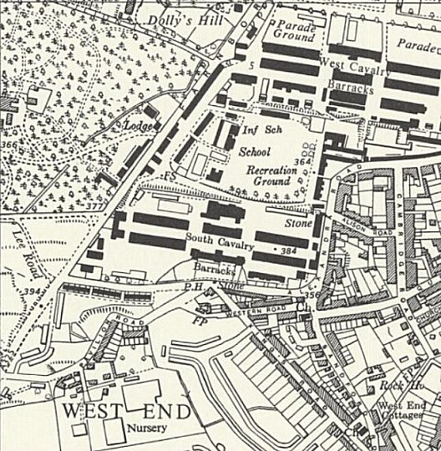
 | Ordnance Survey 1961

https://repatriatedlandscape.org/england/pow-sites-in-the-south-east/pow-camp-1019-beaumont-barracks/

Further Information:

