Camp 1017 No 2 Camp, Sheffield Park, Uckfield, Sussex

1947 Camp List
1017(G.Wkg.Coy) | E | No.2 Camp, Sheffield Park, Uckfield, Sussex | Danehill 139 | 33 | V/1270/4

Prisoner of War Camps (1939 – 1948) - Project report by Roger J.C. Thomas - English Heritage 2003
OS NGR | Sheet | No. | Name & Location | County | Cond’n | Type 1945 | Comments
TQ 4137 2414 | 198 | 1017 | No.2 Camp, Sheffield Park, Uckfield | Sussex | 5 | German Working Camp | Precise location not identified. NGR for Sheffield Park house. National Trust property.

Location:  Before the camp: Large country house and very large estate. Requisitioned by the War Office to house British troops in two large camps. More than 100 Nissen huts were built over East Park. The camps were taken over by Canadian troops.  Pow Camp:  After the camp:  Further Information: | 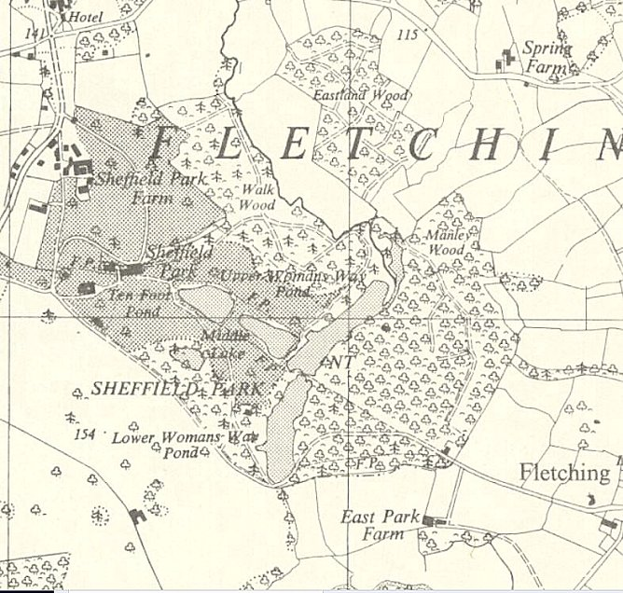
 | Ordnance Survey 1959

