Camp 1015 Station Road, Tadcaster, Yorkshire

1947 Camp List
1015(G.Wkg.Coy) | N | Station Road Camp, Tadcaster, Yorkshire | Tadcaster 3151 | 14 | V/1270/4

Prisoner of War Camps (1939 – 1948) - Project report by Roger J.C. Thomas - English Heritage 2003
OS NGR | Sheet | No. | Name & Location | County | Cond’n | Type 1945 | Comments
SE 4798 4323 | 105 | 1015 | Station Road, Tadcaster | Yorkshire | 5 | German Working Camp | Precise location not identified. NGR for Station Road.

Location:  Before the camp:  Pow Camp:  After the camp:  Further Information: | 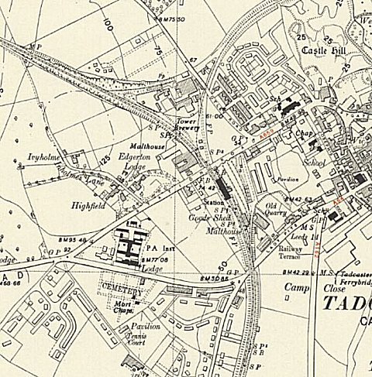
 | Ordnance Survey 1953

