Camp 1012 Canwick Camp, Lincoln, Lincolnshire

1947 Camp List
1012(G.Wkg.Coy) | N | Canwick Camp, Canwick, Lincoln | Lincoln 10324 | 14 | V/1270/4

Prisoner of War Camps (1939 – 1948) - Project report by Roger J.C. Thomas - English Heritage 2003
OS NGR | Sheet | No. | Name & Location | County | Cond’n | Type 1945 | Comments
SK 9891 6949 | 121 | 1012 | Canwick Camp, Canwick, Lincoln | Lincolnshire | 4 | German Working Camp | Pre-existing camp of Nissen huts located on the edge of woodland, arranged around a playing field.

Location: Canwick is just to the SE of Lincoln. The NGR gives a site alongside the allotment grounds – these later became a playing field.  Before the camp: Land belonging to Canwick Hall. Royal Signal Corps camp.  Pow Camp:  After the camp: 2020 part residential, part open space + recreation ground.  https://repatriatedlandscape.org/england/pow-sites-in-yorks-humber-and-lincs/pow-camp-1012-canwick-camp/  Further Information: | 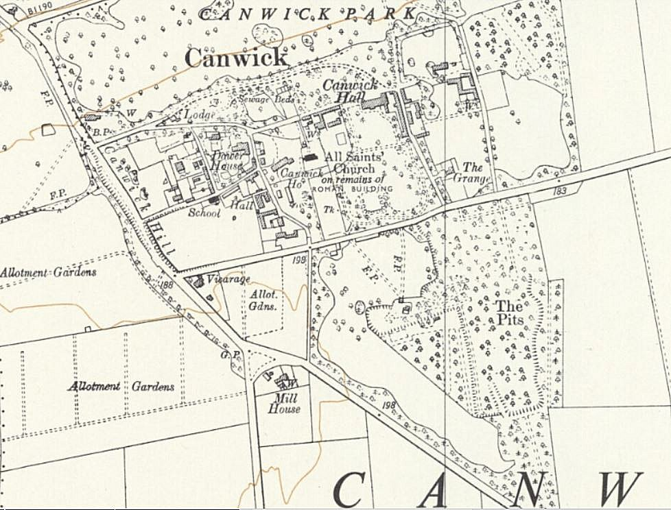
 | Ordnance Survey 1956

