Camp 1009 Northway Camp, Ashchurch, Gloucestershire

1947 Camp List
1009(G.W.Coy) | S | Northway Camp, Ashchurch, Tewksbury, Glos | Cheltenham Sub Trunks 27 Ext.63 | 37 | V/1270/4

Prisoner of War Camps (1939 – 1948) - Project report by Roger J.C. Thomas - English Heritage 2003
OS NGR | Sheet | No. | Name & Location | County | Cond’n | Type 1945 | Comments
SO 9301 3315 | 150 | 1009 | Northway Camp, Ashchurch | Gloucestershire | 3 | German  Working Camp | Camp enclosed by an irregular  perimeter with watch towers. Predominently demolished.

Location: Ashchurch is about 3.2 km E of Tewkesbury. NGR shows the site to the S of the Road next to the Sewage Works.  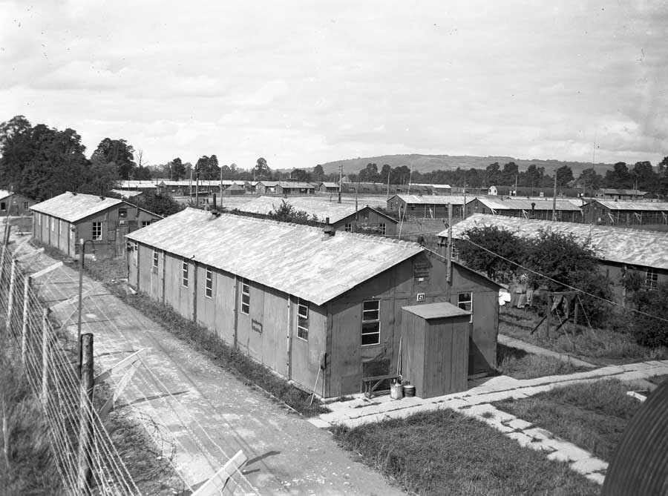  Before the camp: Part of Northway House estate. Accommodation for troops, built in 1943 as part of the very large Ashchurch military camp, N of the road. Mainly hutted accommodation, but aerial photographs from 1944 also show some tents.  Pow Camp: A German working camp. Barbed wire perimeter fence with watch towers probably built in late-1944/early1945 as they do not appear on earlier 1944 aerial photographs. Approximately 300m long by 185m wide. Accommodation was in wooden huts and Nissen huts.  Photograph taken from a guard tower – reprinted with permission from Tewksbury Museum.  “It was thought to be a collection of nineteen huts, in dormitory style each had electricity and stove heating with a capacity of 800 men. Most of the prisoners were Germans captured in France and Germany after D-Day. The prisoners included One SS and 420 Wehrmacht Heer. | 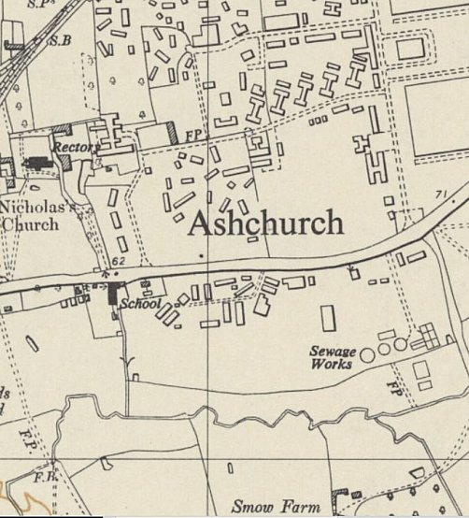
 | Ordnance Survey 1955

The majority of the prisoners worked at the RAOC Depot (Ashchurch Army Camp G25), reached by the metal foot bridge which the prisoners built over the railway line. This camp closed in 1947 and remained largely empty until it was created into a housing estate.” [From Tewksbury Museum website].

Inspected by the International Red Cross on 9 March 1947. Capacity 800. Actual number on day of inspection was 443 – 3 protected personnel, 1 officer, 30 NCO’s and 412 other ranks. All were German serving in - 420 army, 3 navy, 16 air force, 1 SS, and 3 from the Reich Labour Service. The pows were graded 250 B / grey and 180 C / black, with 13 ungraded.

The camp had its own chapel which appears to be a converted wooden hut. Sports facilities included a football pitch and sports ground. There was a band and an orchestra.

Camp Commandant in 1947 Major Reginald Arthur Sweet (1890-1960) from the Pioneer Corps.

After the camp: For a short time used to accommodate displaced peoples. 2020 residential area and school.

Further Information:

There is a chapter about the camp in – ‘Inside The Wire’ by Ian M C Hollingsbee – The History Press, 2014

Tewkesbury Museum with information and a series of pictures –
https://www.tewkesburymuseum.org/the-collection/the-image-collection/pow-camp-1009-northway/

Air photographs - https://britainfromabove.org.uk/image/eaw000720

