Camp 1007 No 14 Armoured Fighting Vehicle Depot, Burn, Selby, Yorkshire

1947 Camp List
1007(G.W.Coy) | N | No.14 A.F.V.D. Burn, Nr.Selby, Yorks | Burn 216 Ext.13 | 14 | V/1270/4

Prisoner of War Camps (1939 – 1948) - Project report by Roger J.C. Thomas - English Heritage 2003
OS NGR | Sheet | No. | Name & Location | County | Cond’n | Type 1945 | Comments
SE 6002 2848 | 105 | 1007 | No.14 Armoured Fighting Vehicle Depot (A.F.V.D.), Burn, Selby | Yorkshire | 5 | German Working Camp | Former RAF Burn airfield. Precise location not identified. NGR for approx. centre of airfield, numerous dispersed accommodation sites.

Location: One memory was that the depot was located in the middle of the runways after the war.  Before the camp: Details found state that the site was RAF Burn during WW2, then a pow camp, and only afterwards did it become a RASC Armoured vehicle storage depot.  Pow Camp:  After the camp: Glider club using the airfield.  https://repatriatedlandscape.org/england/pow-sites-in-yorks-humber-and-lincs/pow-camp-1007-no14-afv-depot/  Further Information: | 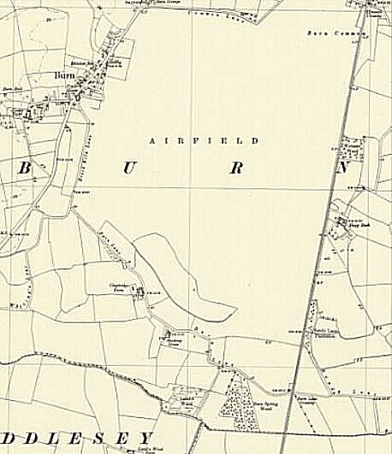
 | Ordnance Survey 1961

