Camp 1006 Willems Barracks, Aldershot, Hampshire

Prisoner of War Camps (1939 – 1948) - Project report by Roger J.C. Thomas - English Heritage 2003
OS NGR | Sheet | No. | Name & Location | County | Cond’n | Type 1945 | Comments
SU 8571 5098 | 186 | 1006 | Willems Barracks (West Cavalry Barracks),  Aldershot | Hampshire | 5 |  | Precise location not identified. NGR for  centre of Willems Avenue. Tesco store and housing.

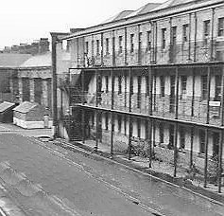  Location: West Cavalry Barracks shown off Wellington Avenue – (nearby Beaumont Barracks also used as Camp 1019).  Before the camp: Cavalry and various army unit barracks  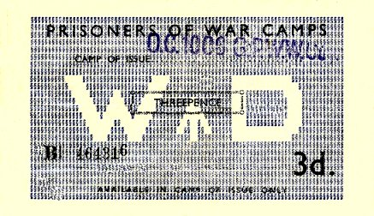  Pow Camp:  < the barrack buildings  Pow money vouchers were issued in various values and could only be used in the camp of issue.  After the camp: 2020 motel.  https://repatriatedlandscape.org/england/pow-sites-in-the-south-east/pow-camp-1006-willems-barracks/  Further Information: | 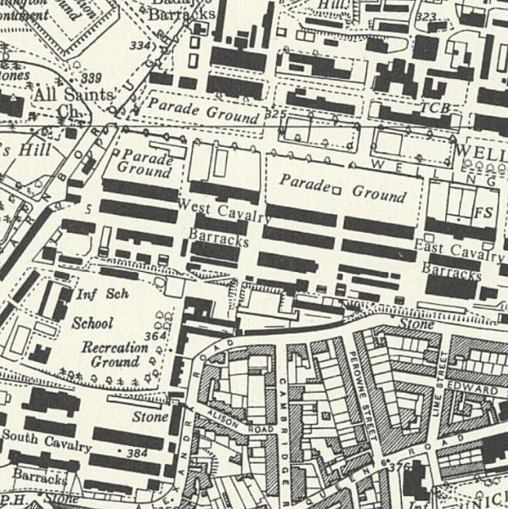
 | Ordnance Survey 1961

