Camp 1003 Capel House Camp, Bullsmoor Lane, Enfield, Middlesex

1947 Camp List
1003(G.W.Coy) | L.D. | Capel House Camp, Bullsmoor Lane, Middlesex. Postal Address:- Bullsmoor Lane Camp, Enfield, Middlesex | Waltham Cross 2696 & 4083 | 17 | V/1270/4

Prisoner of War Camps (1939 – 1948) - Project report by Roger J.C. Thomas - English Heritage 2003
OS NGR | Sheet | No. | Name & Location | County | Cond’n | Type 1945 | Comments
TQ 3446 9962 | 166 | 1003 | Capel House Camp, Bullsmoor Lane, Enfield | Middlesex | 5 | German  Working Camp | Precise location not identified. NGR  given for parkland near Capel House.

Location:  Before the camp:  Pow Camp:  As part of the re-education programme administered by the Control Office for Germany and Austria (COGA), Paul Bondy, a German-speaking refugee gave a lecture at the camp, which he called ‘Waltham Cross’, on 10 December 1946.  POW mail seen for ?/1947  After the camp:  Further Information: | 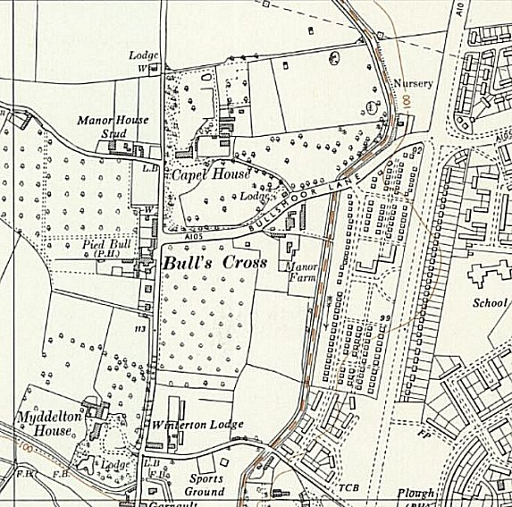
 | Ordnance Survey 1961

