Camp 1001 Crookham Common Camp, Thatcham, Newbury, Berkshire

1947 Camp List
1001(G.W.Coy) | S | Crookham Common Camp, Thatcham, Newbury, Berks | Thatcham 2174 | 52 | V/1456/2

Prisoner of War Camps (1939 – 1948) - Project report by Roger J.C. Thomas - English Heritage 2003
OS NGR | Sheet | No. | Name & Location | County | Cond’n | Type 1945 | Comments
SU 5271 6471 | 174 | 1001 | Crookham Common Camp, Thatcham, Newbury | Berkshire | 3 | German Working Camp | Former RAF camp.

Location: About 5.5 km SE of Newbury.  Before the camp:  Pow Camp: German pow camp.  POW mail seen for December 1946.  After the camp: Became a mink farm.  Further Information:  https://www.systonimages.co.uk/p787309082/hc7506603#hc7506603  The site was surveyed by Thames valley Archaeological Services Ltd in 2019 – the report is available: http://tvas.co.uk/reports/pdf/MFC18-213bldreport.pdf | 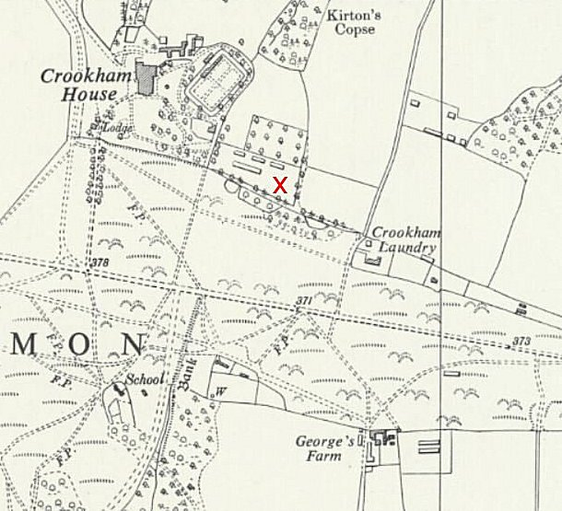
 | Ordnance Survey 1961

