Camp 1000 Oakhanger Camp, Bordon, Hampshire

1947 Camp List
1000(G.W.Coy) | S | Oakhangers Camp, Bordon, Hants | Bordon 48 Ext.98 | 30 | V/1270/4

Prisoner of War Camps (1939 – 1948) - Project report by Roger J.C. Thomas - English Heritage 2003
OS NGR | Sheet | No. | Name & Location | County | Cond’n | Type 1945 | Comments
SU 789 356 | 186 | 1000 | Oakhanger Camp, Bordon | Hampshire | 5 | German Working Camp | Precise location not identified. NGR given for Prince Phillip Barracks.

Location: I think the map shows the location of the camp at NGR SU 789 362 – based on two descriptions:  The Canadians who used the camp before the pows, had their own fire station at the junction of Budds Lane and Station Road and could access either Lower or Upper Oakhanger camp.  Lower Oakhanger Camp was situated below the level crossing in Station Road.  Before the camp: Bordon had a military training camp. The camp (and nearby Longmoor Camp) was taken over by Canadian forces from September 1939. The Canadians built two new sub-camps using Canadian built and shipped, prefabricated, wooden huts. The camps were Oakhanger Camp (aka Upper Oakhanger) and Lower Oakhanger Camp.  Lower Oakhanger Camp was used by the Canadians until D-Day, it then became the German pow camp.  Pow Camp:  After the camp: Used by European Volunteer Workers scheme until the mid-a950’s. The huts were dismantled and the site used as a helicopter practice landing ground.  Further Information: | 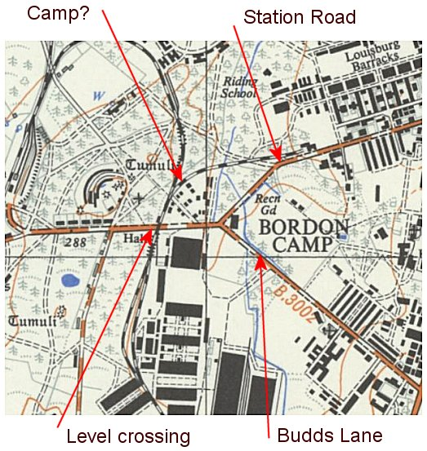
 | Ordnance Survey

