Camp 783 Dinorben Court, Dinorben Avenue, Fleet, Aldershot

ICRC – Labour Camp. 783. Dinorben Court, Dinorben Avenue, Fleet, Hants.

Location: NGR for the House SU 8040 5310  Before the camp: Large house and grounds. Parts of the estate being sold off from 1935 for housing. Grounds and large houses were used to accommodate troops.  Pow Camp:  After the camp: Squatters moved into the house after the war. Soon after the house was demolished. 2020 residential area and school  Further Information: | 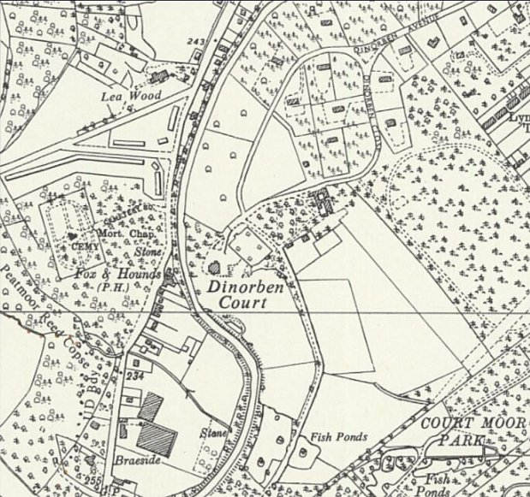
 | Ordnance Survey 1961

