Camp 782 Huntercombe, Henley-on-Thames, Oxfordshire

ICRC – Labour Camp. 782. Huntercombe, Henley-on-Thames, Oxon.

Location: Several sites would be possible including the Huntercombe Place Prison / Borstal (SU 679 881).  Before the camp:  Pow Camp:  Postal item seen for February 1946  After the camp:  Further Information: | 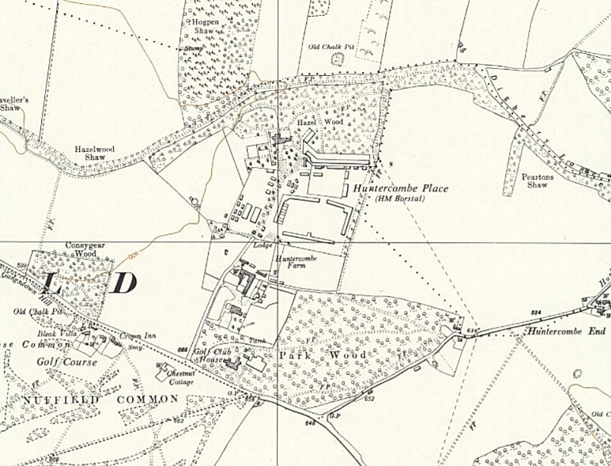
 | Ordnance Survey 1960

