Camp 779 Walton Hall, Wellesbourne, Warwickshire

ICRC – Labour Camp. 779. Walton Hall, Wellesbourne, Warwick

Location: There was a military camp just to the SE of the Hall, a few buildings are shown on the map at NGR SP 2865 5220. There is also a possible site a little to the NE at SP 2885 5292.  Before the camp: Walton Country House and parkland. Location for US troops involved in deception / camouflage prior to D-day.  Pow Camp:  After the camp: 2020 hotel.  Further Information: | 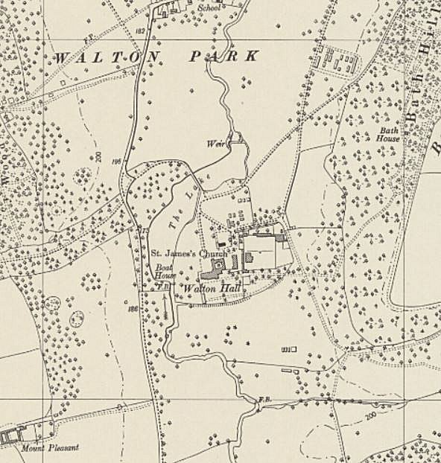
 | Ordnance Survey 1955

