Camp 702 Jurby, Isle of Man

Prisoner of War Camps (1939 – 1948) - Project report by Roger J.C. Thomas - English Heritage 2003
OS NGR | Sheet | No. | Name & Location | County | Cond’n | Type 1945 | Comments
 |  | 702 | Jurby, Isle of Man | Isle of Man |  |  | Isle of Man

Location:  Before the camp:  Pow Camp:  Air Ministry / RAF label with the POW 702 oval cachet. Postmarked 6 May 1947  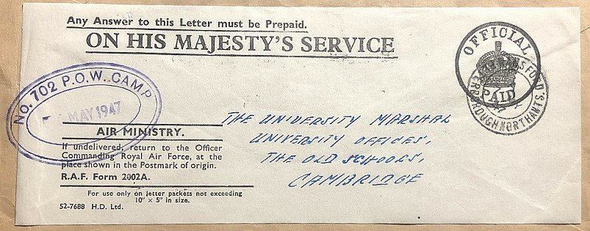  After the camp: Industrial estate.  Further Information: | 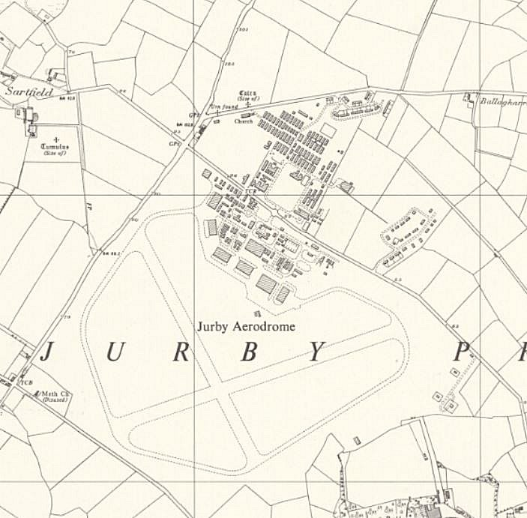
 | Ordnance Survey 1957

